COLOUR SONG
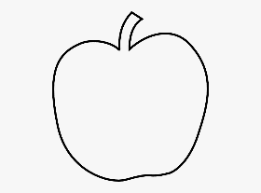
RED
RED
THE APPLE IS RED.
THE APPLE IS RED RED RED.
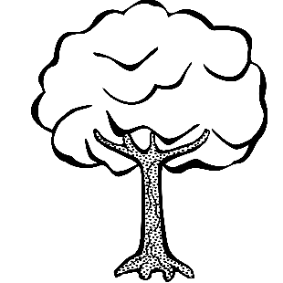
GREEN
GREEN
THE TREE IS GREEN.
THE TREE IS GREEN GREEN GREEN.

BLUE
BLUE
THE BALL IS BLUE.
THE BALL IS BLUE BLUE BLUE.

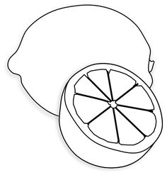
YELLOW (=yellow)
YELLOW (=yellow)
THE LEMON IS YELLOW. (=yellow)
THE LEMON IS YELLOW YELLOW YELLOW.
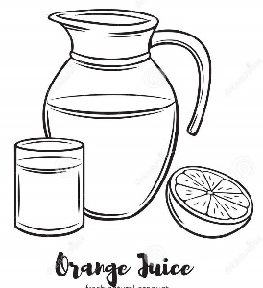
ORANGE
ORANGE
THE JUICE IS ORANGE.
THE JUICE IS ORANGE ORANGE ORANGE

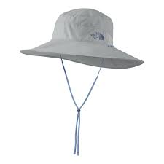
BLACK
BLACK
THE HAT IS BLACK
THE HAT IS BLACK BLACK BLACK.
(Busy Beaver)

