

Culture – connectedness in diversity

Part two: Spring traditions

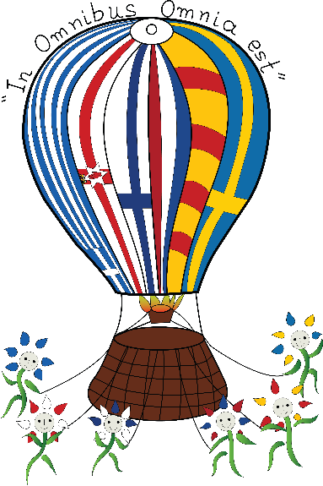

1st theme: Culture

2016-2017

Apokries ~ Carnival Season in Greece
H Αποκριά στην Ελλάδα

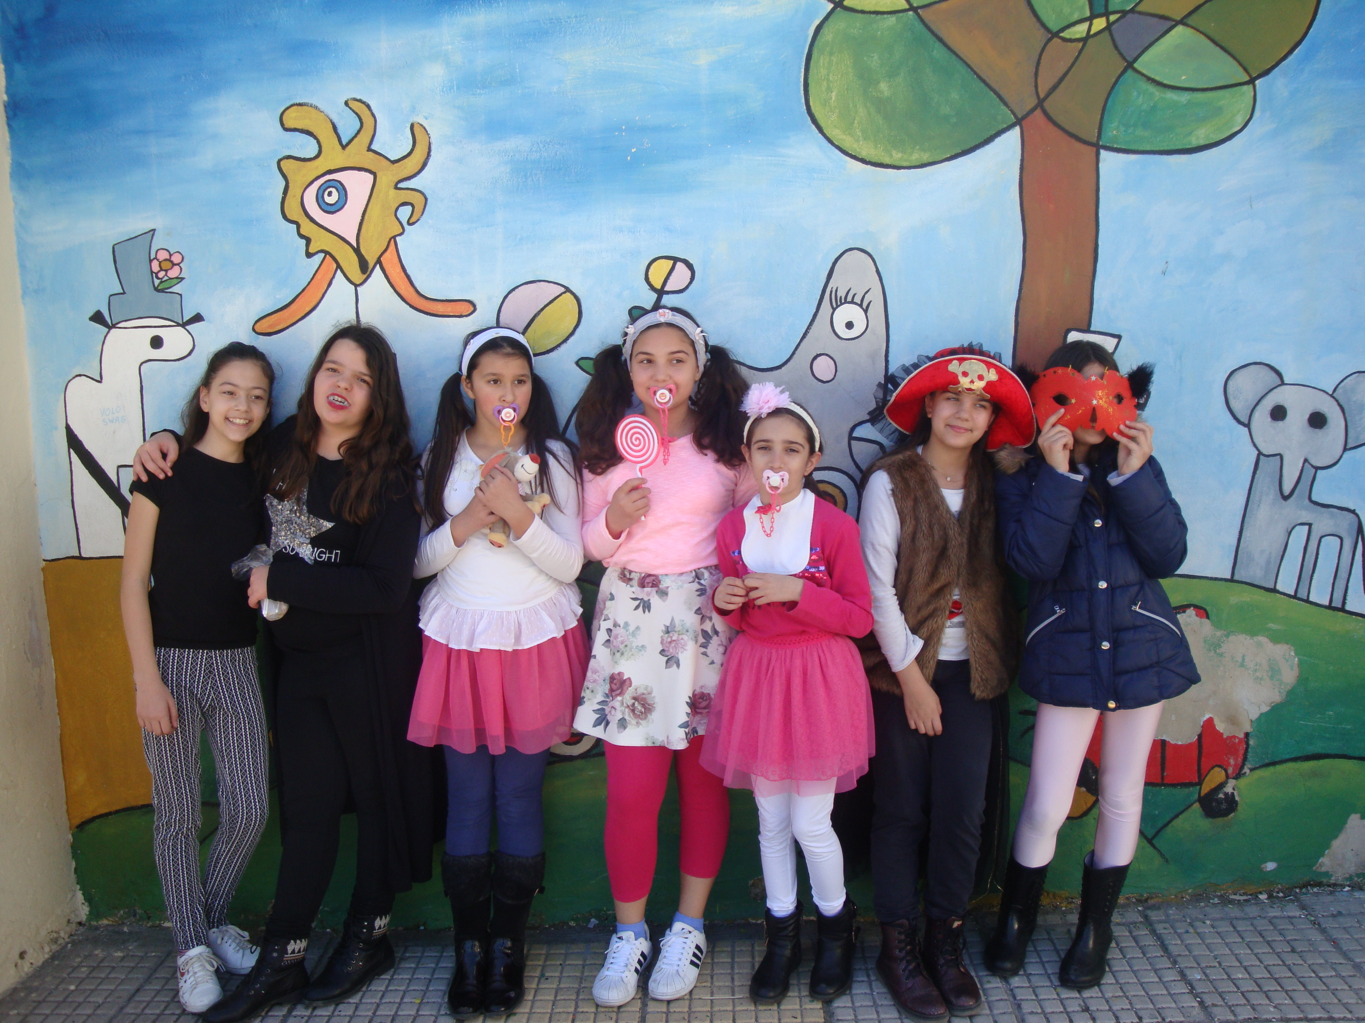





Carnival Traditions in Greece
Every region of the country has got its own customs during Apokries rooted in ancient Greek ceremonies and adapted to Christian Faith.
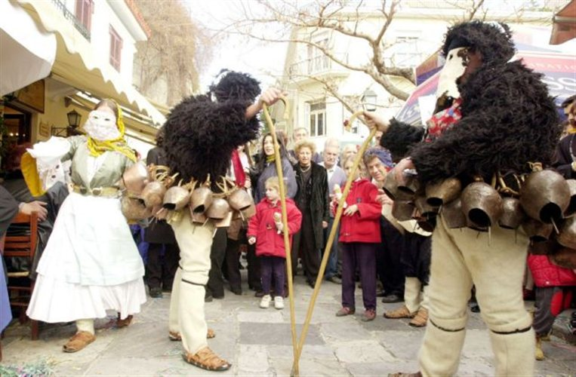

The customs of “Geri”~old men and “koudounati” ~ Bell bearers: Skyros

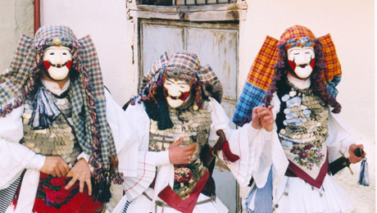

Genitsari & Boules: Naoussa

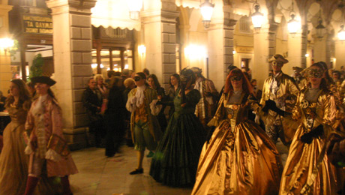

Venetian costumes in Corfu
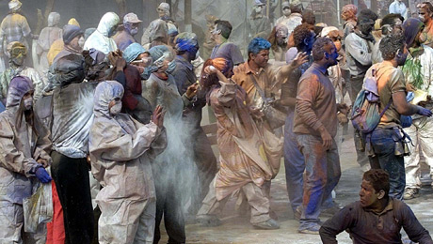

“Flour war” in Galaxidi
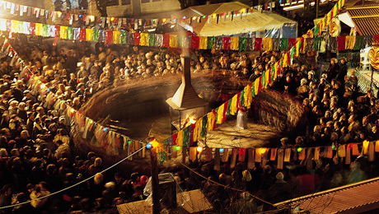

Dancing around a big fire: Kozani

The Carnival season in Greece is known as
“the Apokria”

Rooted in Ancient Greece

The Greek Carnival has its roots in Ancient Greece.
It is connected with the worship of Dionysus, God of wine and joy.

In ancient Greece, a lot of festivities in honour of Dionysus took place in early Spring, as Dionysus symbolised the rebirth of life and nature after winter.

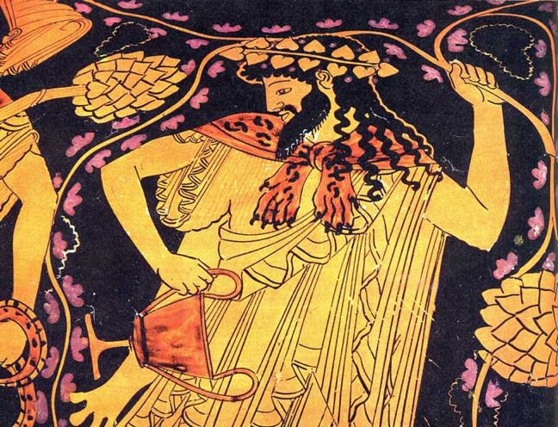

- Today, carnival is held in the same period but not on a fixed date, as it depends on the moveable feast of Easter.

According to the Christian Orthodox Faith, the tradition of Apokries started so that the Christian people could celebrate and indulge before the great 40 day Lent of Easter. People can now dance and sing and eat dishes with plenty of meat and dairy products.
It lasts for three weeks before this period of fasting begins. The word “Apokria” literally means “say goodbye to meat”.
Apokries is celebrated usually in February. It's rare to see February without Apokries, but of course it depends on when the Orthodox Easter is, being a moveable Holy Day.
Today, there are many different carnival parades and festivities going on all over Greece. Hundreds of groups take part in those parades dressed in fancy colourful costumes, wearing masks, singing and dancing! Anyone who wishes to participate can just join a group.

“Apokries” is the children’s most favourite time of the year along with Christmas time.

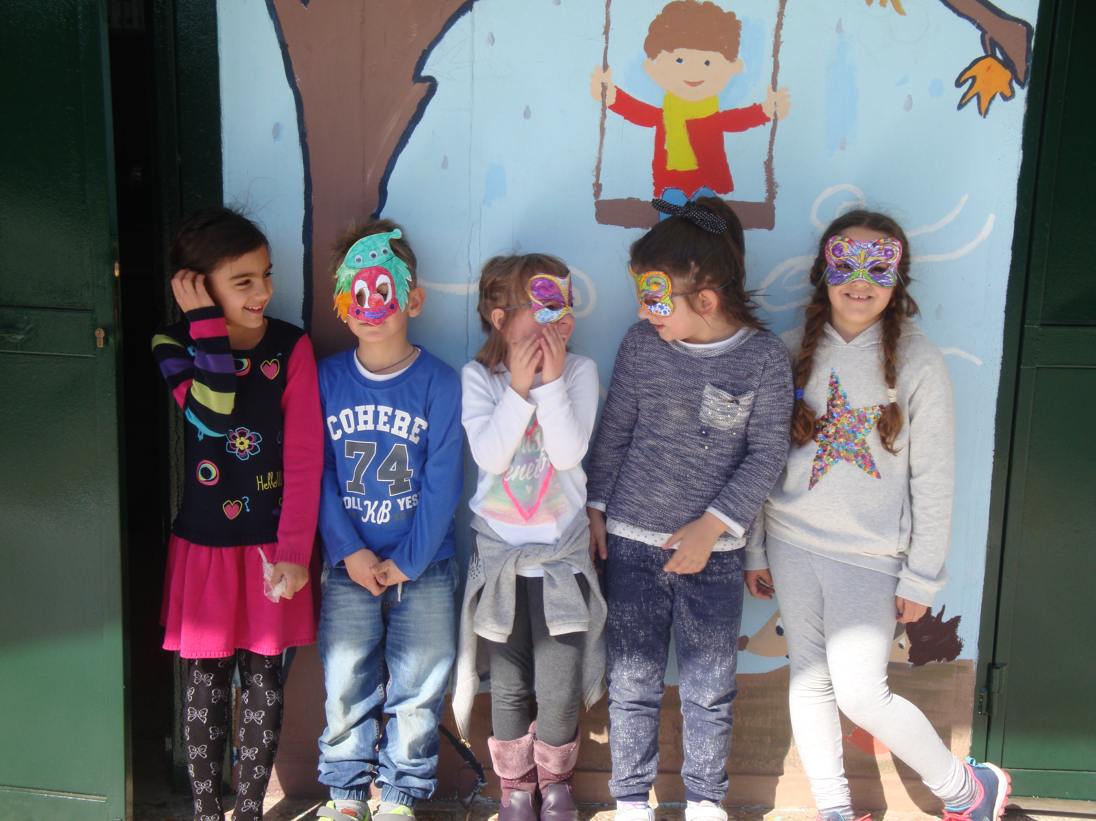

Elsewhere, plays are put on in the streets. People are dressed in costumes with masks, depending on the local traditions, and play jokes on the pedestrians

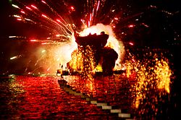

The most famous carnival , however, is the Big Carnival of the city of Patra. People dress in
masquerade, play games and jokes, have a huge float parade, and throw sweets to the observer. After the Grand Parade, and when the sun sets, the King of the Carnival is cast into flames at the Port of Patras. This is called the Closing Ceremony.

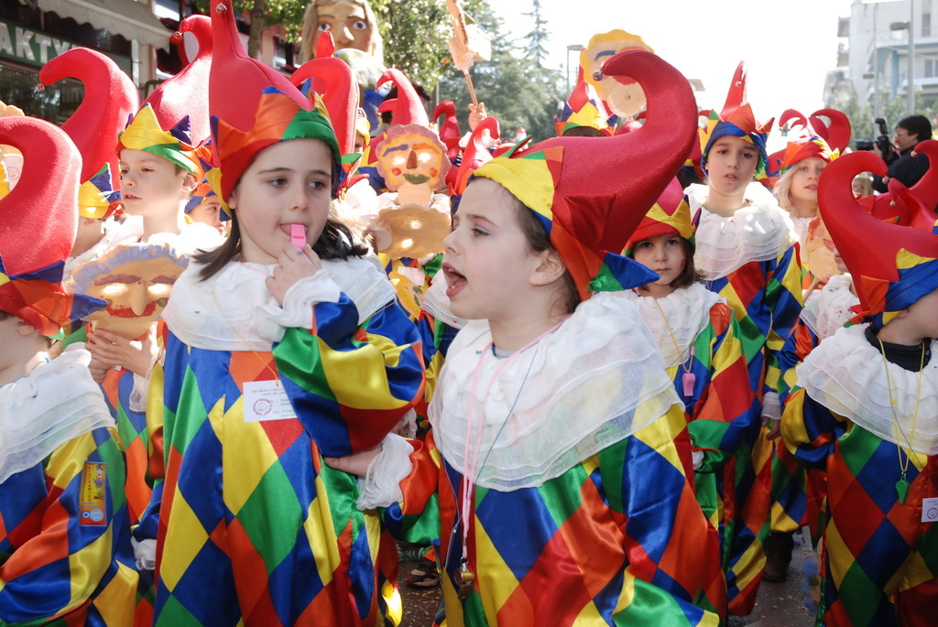

Smoke Thursday

The second Thursday of the 3 week-carnival -season before the beginning of Lent is called Tsikno Pempti (Smoke Thursday), a day when meat should be cooked at every house.
This name is taken from the smoke of the grilled steaks in the yards of the houses.

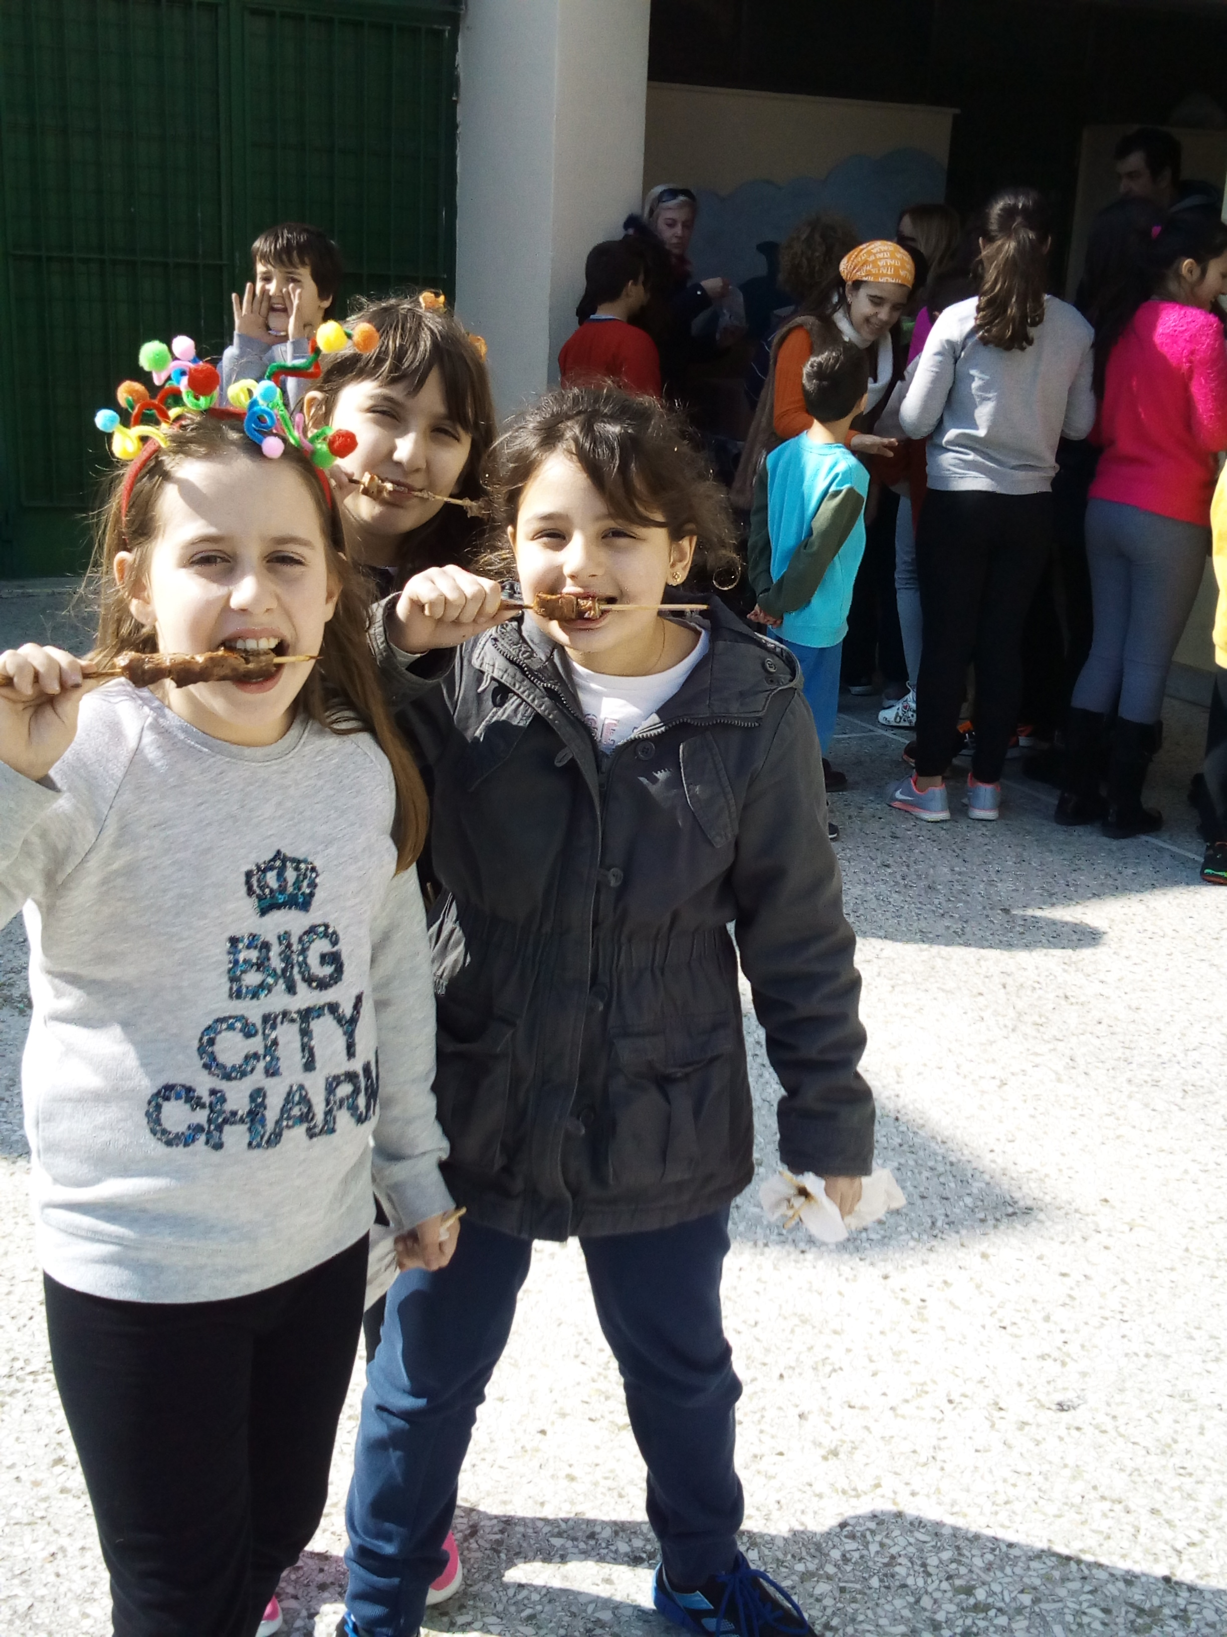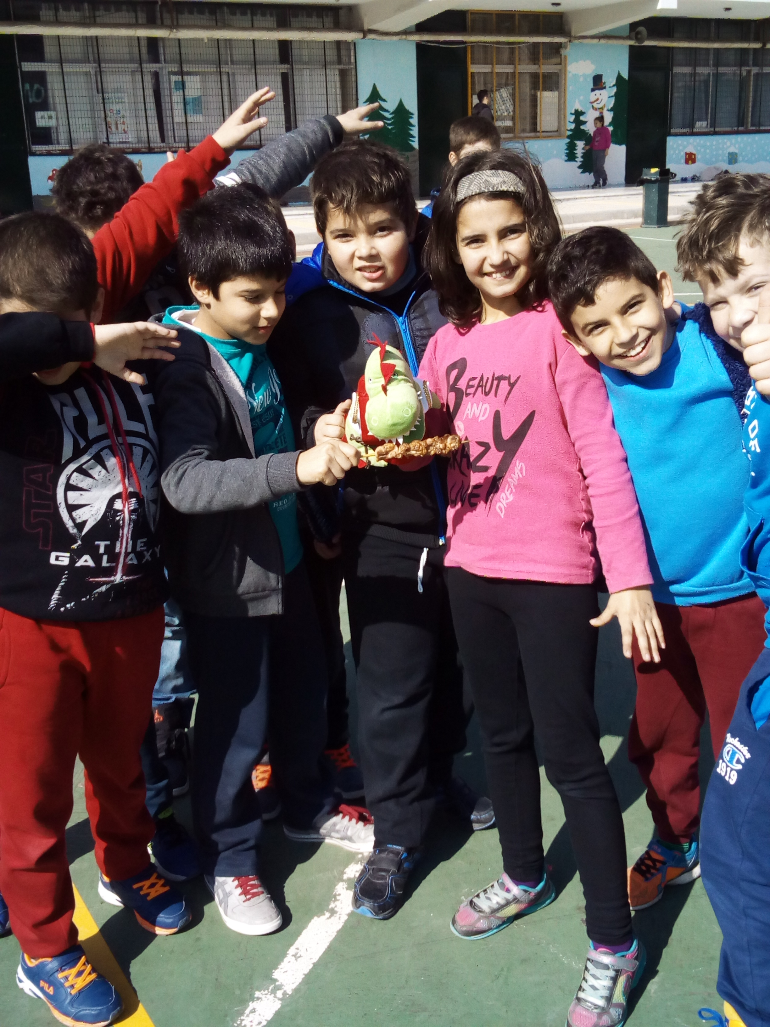

Yaitanaki

Yaitanaki is a traditional Carnival dance. One of the dancers holds a pole from which 12 colourful ribbons start. The dancers hold the colourful ribbons and dance around the pole. The dance symbolizes the circle of life.

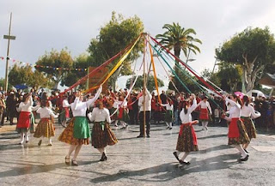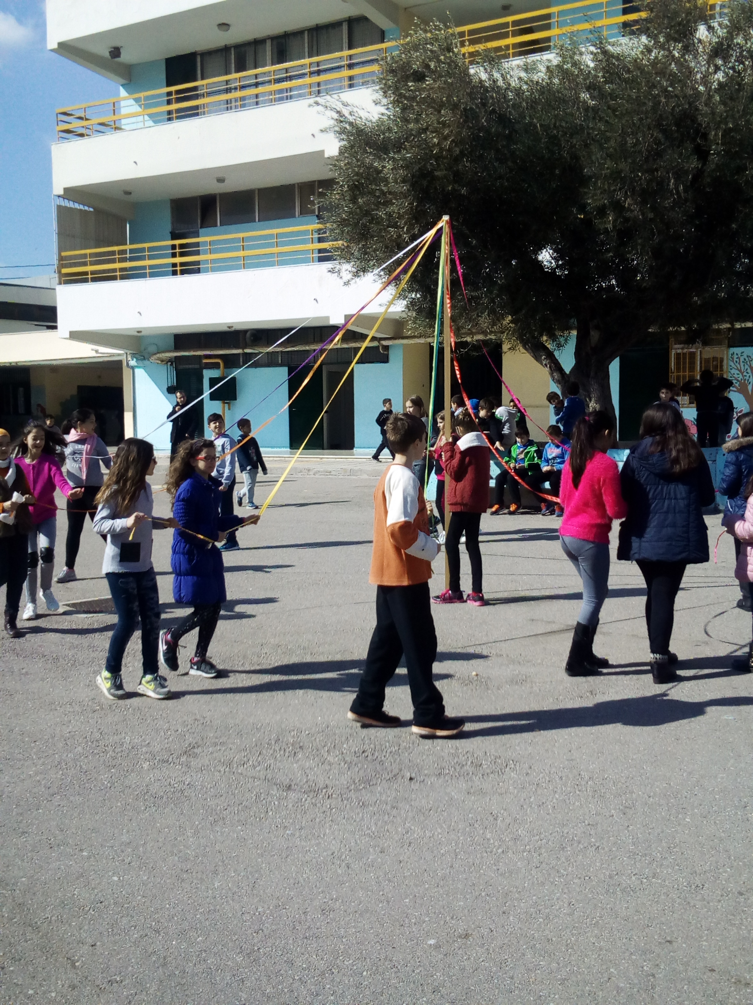

Yaitanaki in our schoolyard!

This year we celebrated Smoke Thursday in our school ….actually every year we do!
Puff was with us!

Look! Our pupils trying to fly their kites in the schoolyard. kites in the schoolyard!

Shrove Monday

Shrove or Clean Monday is the first day of the Lent. It is a public holiday in Greece. After the rich in meat and dairy products meals during carnival days, it’s time to start fasting. Families usually have a picnic in the countryside with Lenten food and they fly colourful kites in the sky. They usually compete to each other on whose kite is going to fly higher.

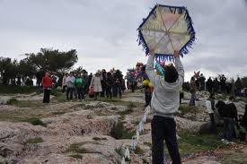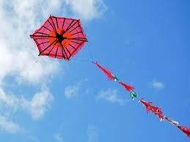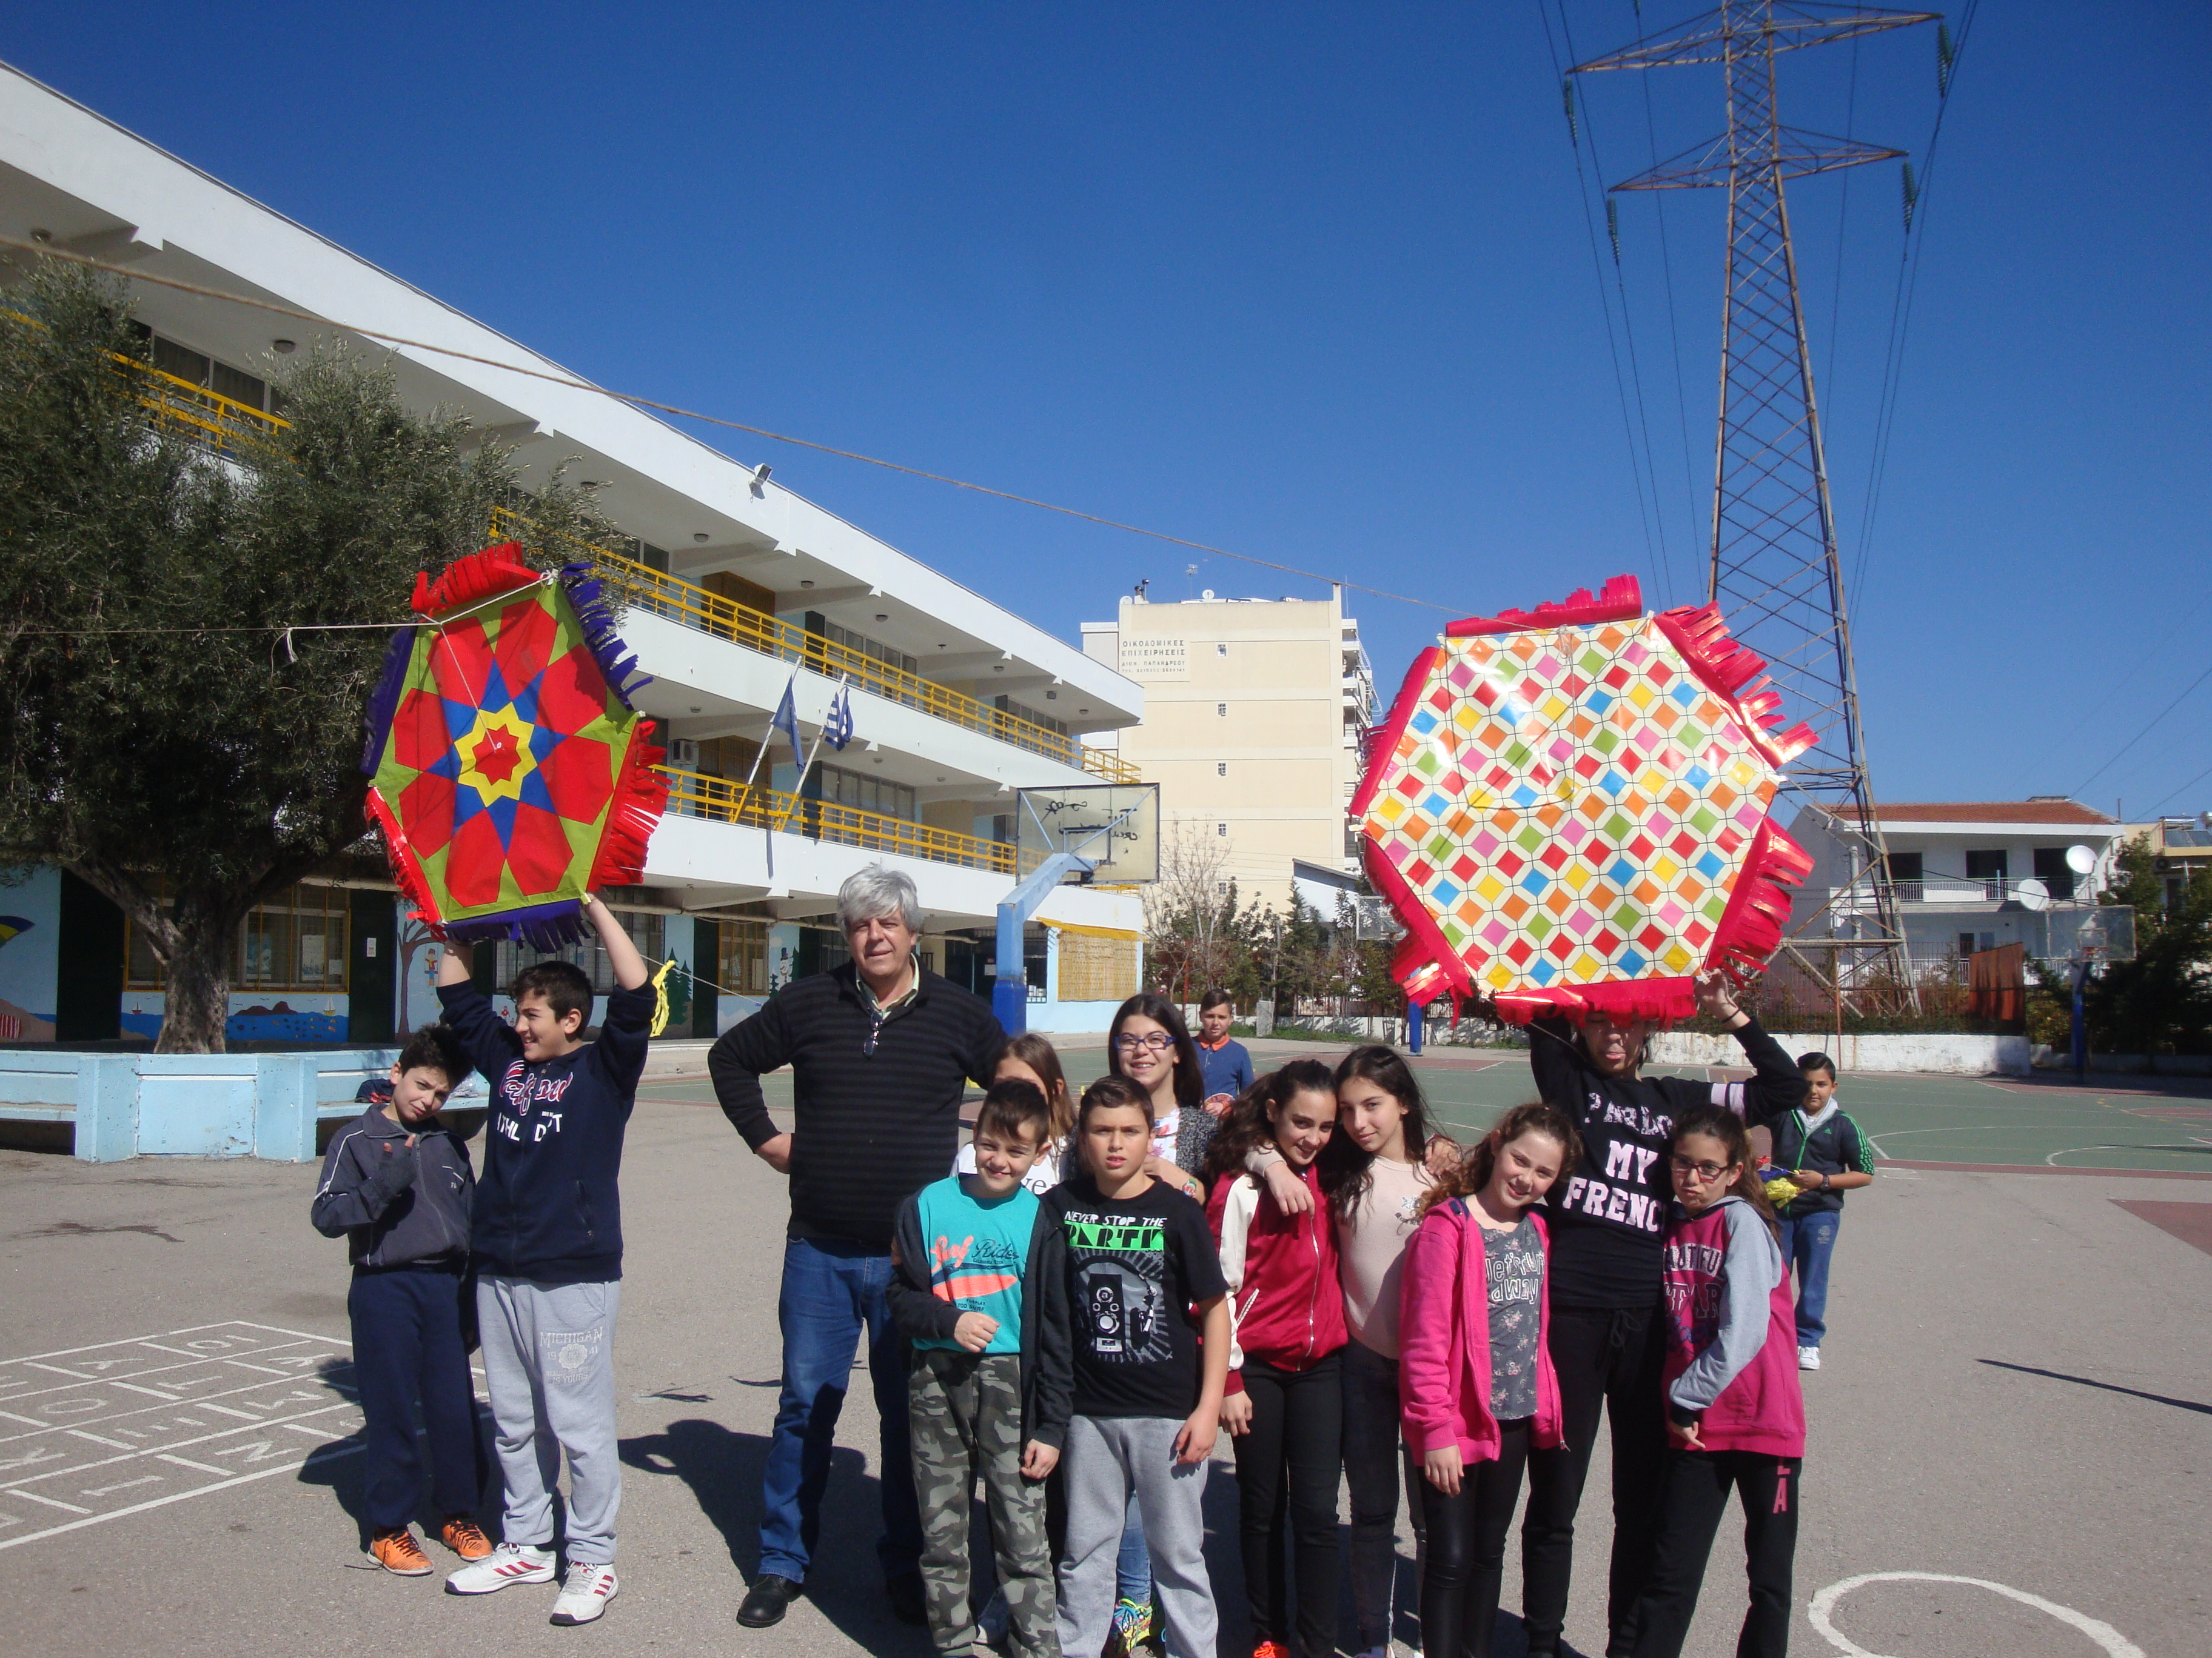

Typical Clean Monday Food

Beans soup octopus stuffed vine leaves seafood
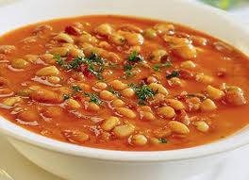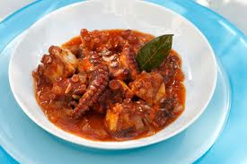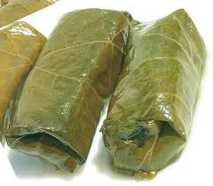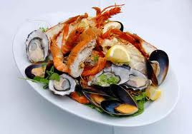
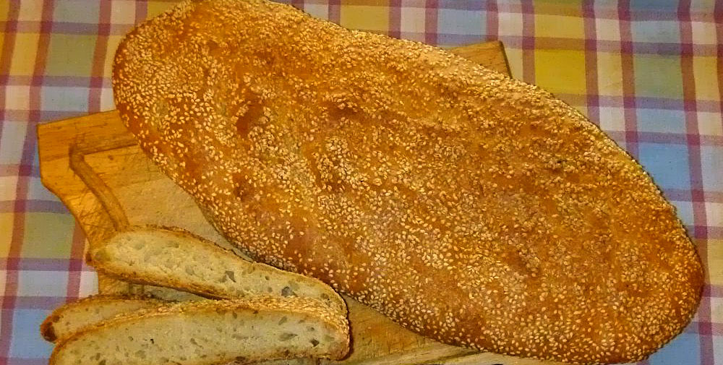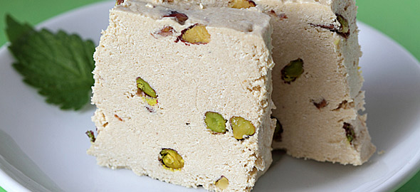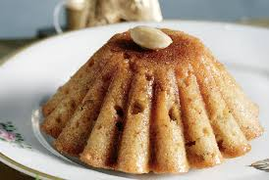

“lagana” “chalvas” semolina chalva

Kira Sarakosti ~Miss Lent

Kira Sarakosti is a lady with seven legs, each one representing the seven weeks before Easter. It can be made by pastry or it can be made of paper. At the end of each week you cut off a leg and in this way you can count the time left until Easter. Miss Lent has not a mouth because she must keep the rules of fasting through the whole period of Lent.

Here you can see 1st graders making Kira Sarakosti at school

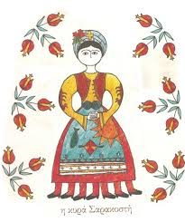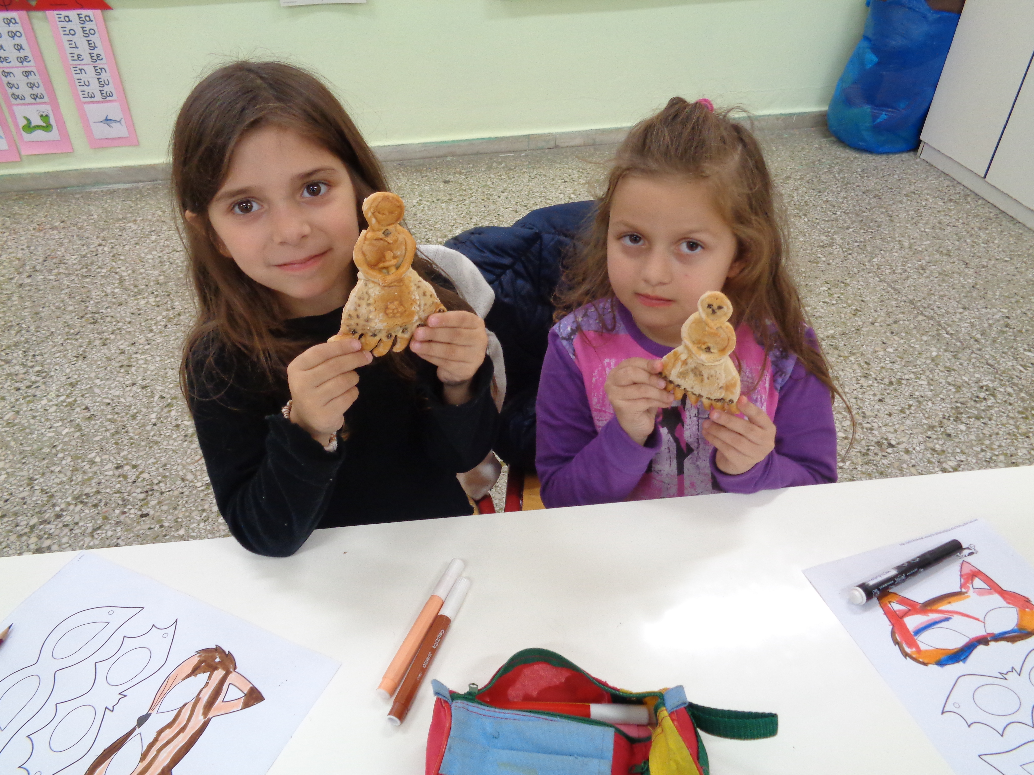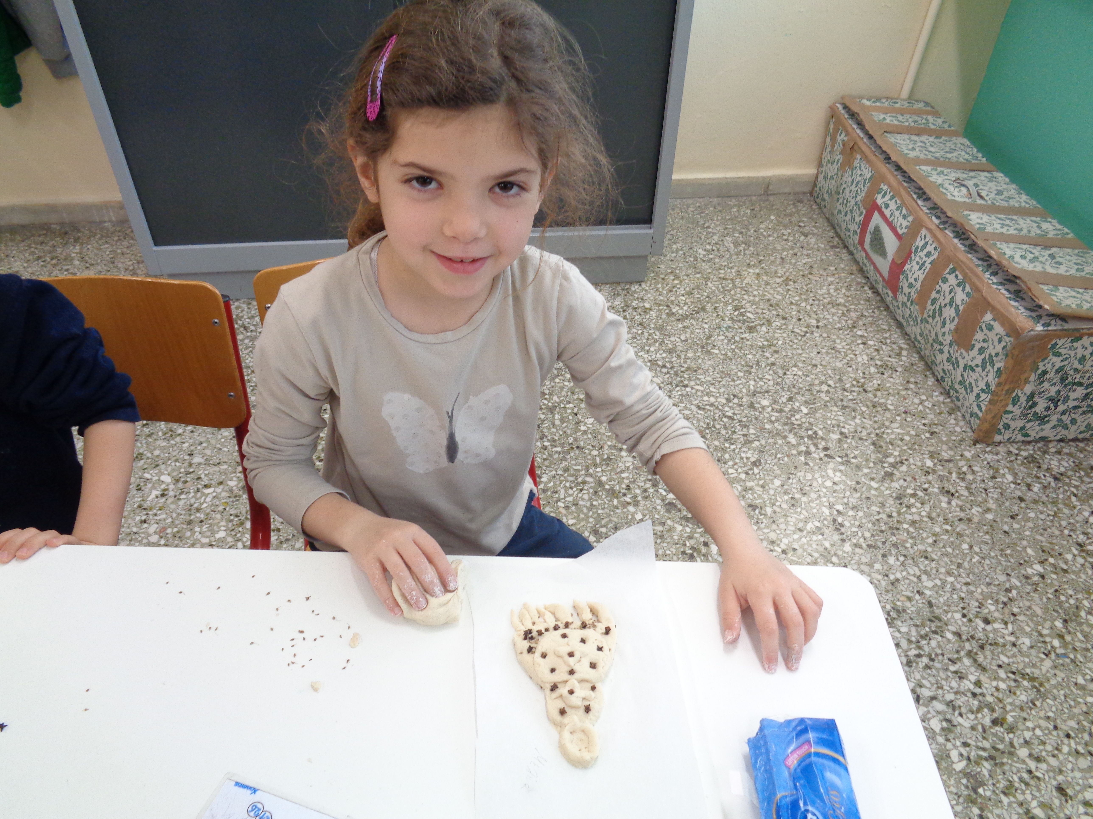
The period of Lent is leading to Easter the most important holiday for Christians, alongside with Christmas. Children have a new holiday to wait for now: Easter time in spring time!

