Boleras Sevillanas
- The folk song "Boleras Sevilianas" – what could be the origin of this song?
- What is the character of the song?
- Listen to the song:
https://www.youtube.com/watch?v=GB-C0kg2N64
https://www.youtube.com/watch?v=-QefStB0KRo
https://www.youtube.com/watch?v=_-iFFj7JbL4

- Which musical instrument could accompany this song?
- Play the rhythm of the song.
Example from theory lesson:
https://youtube.com/shorts/8RyTC9XeiT8?feature=share

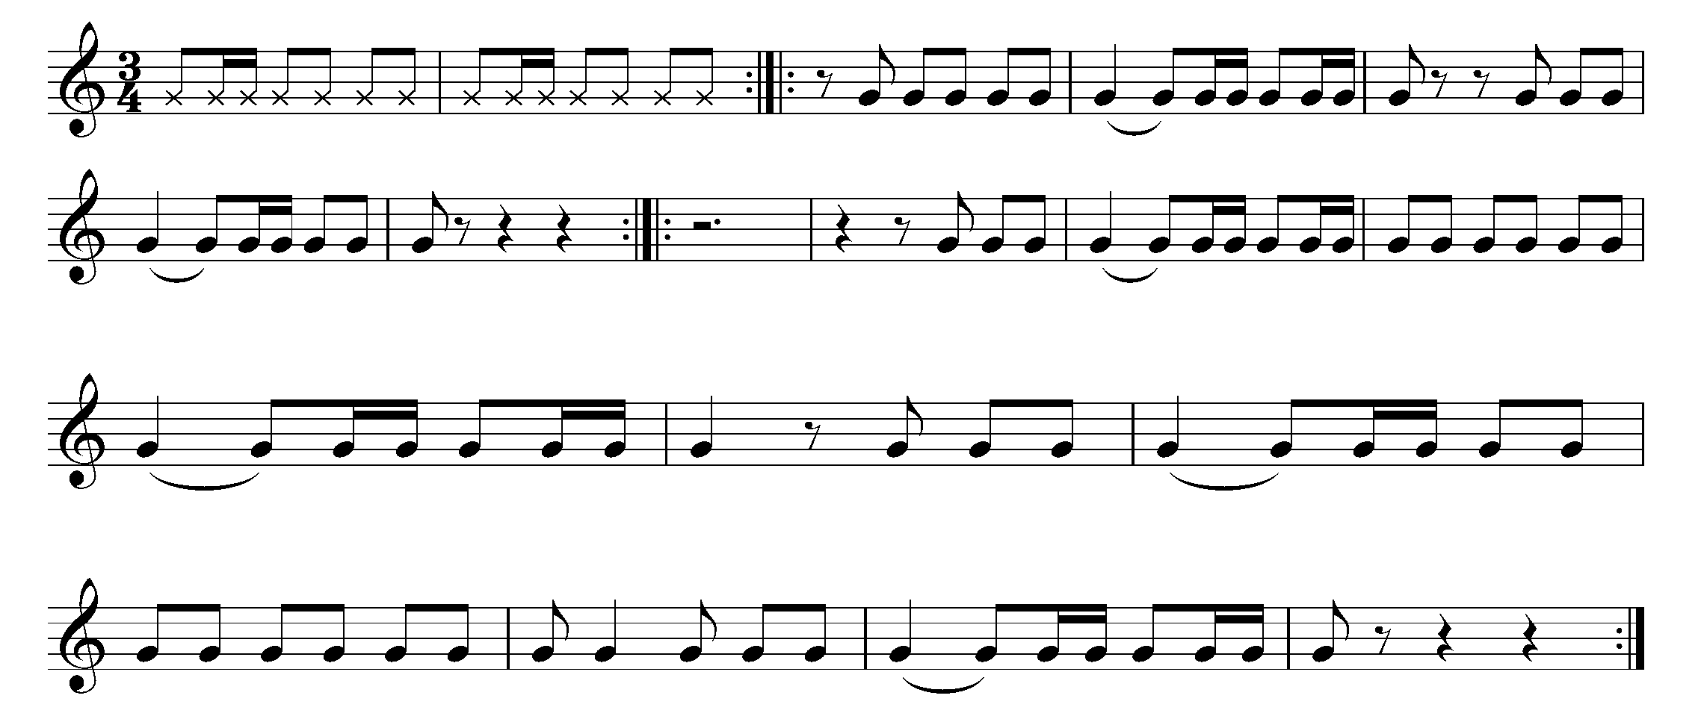
- Sing the melody of the song.

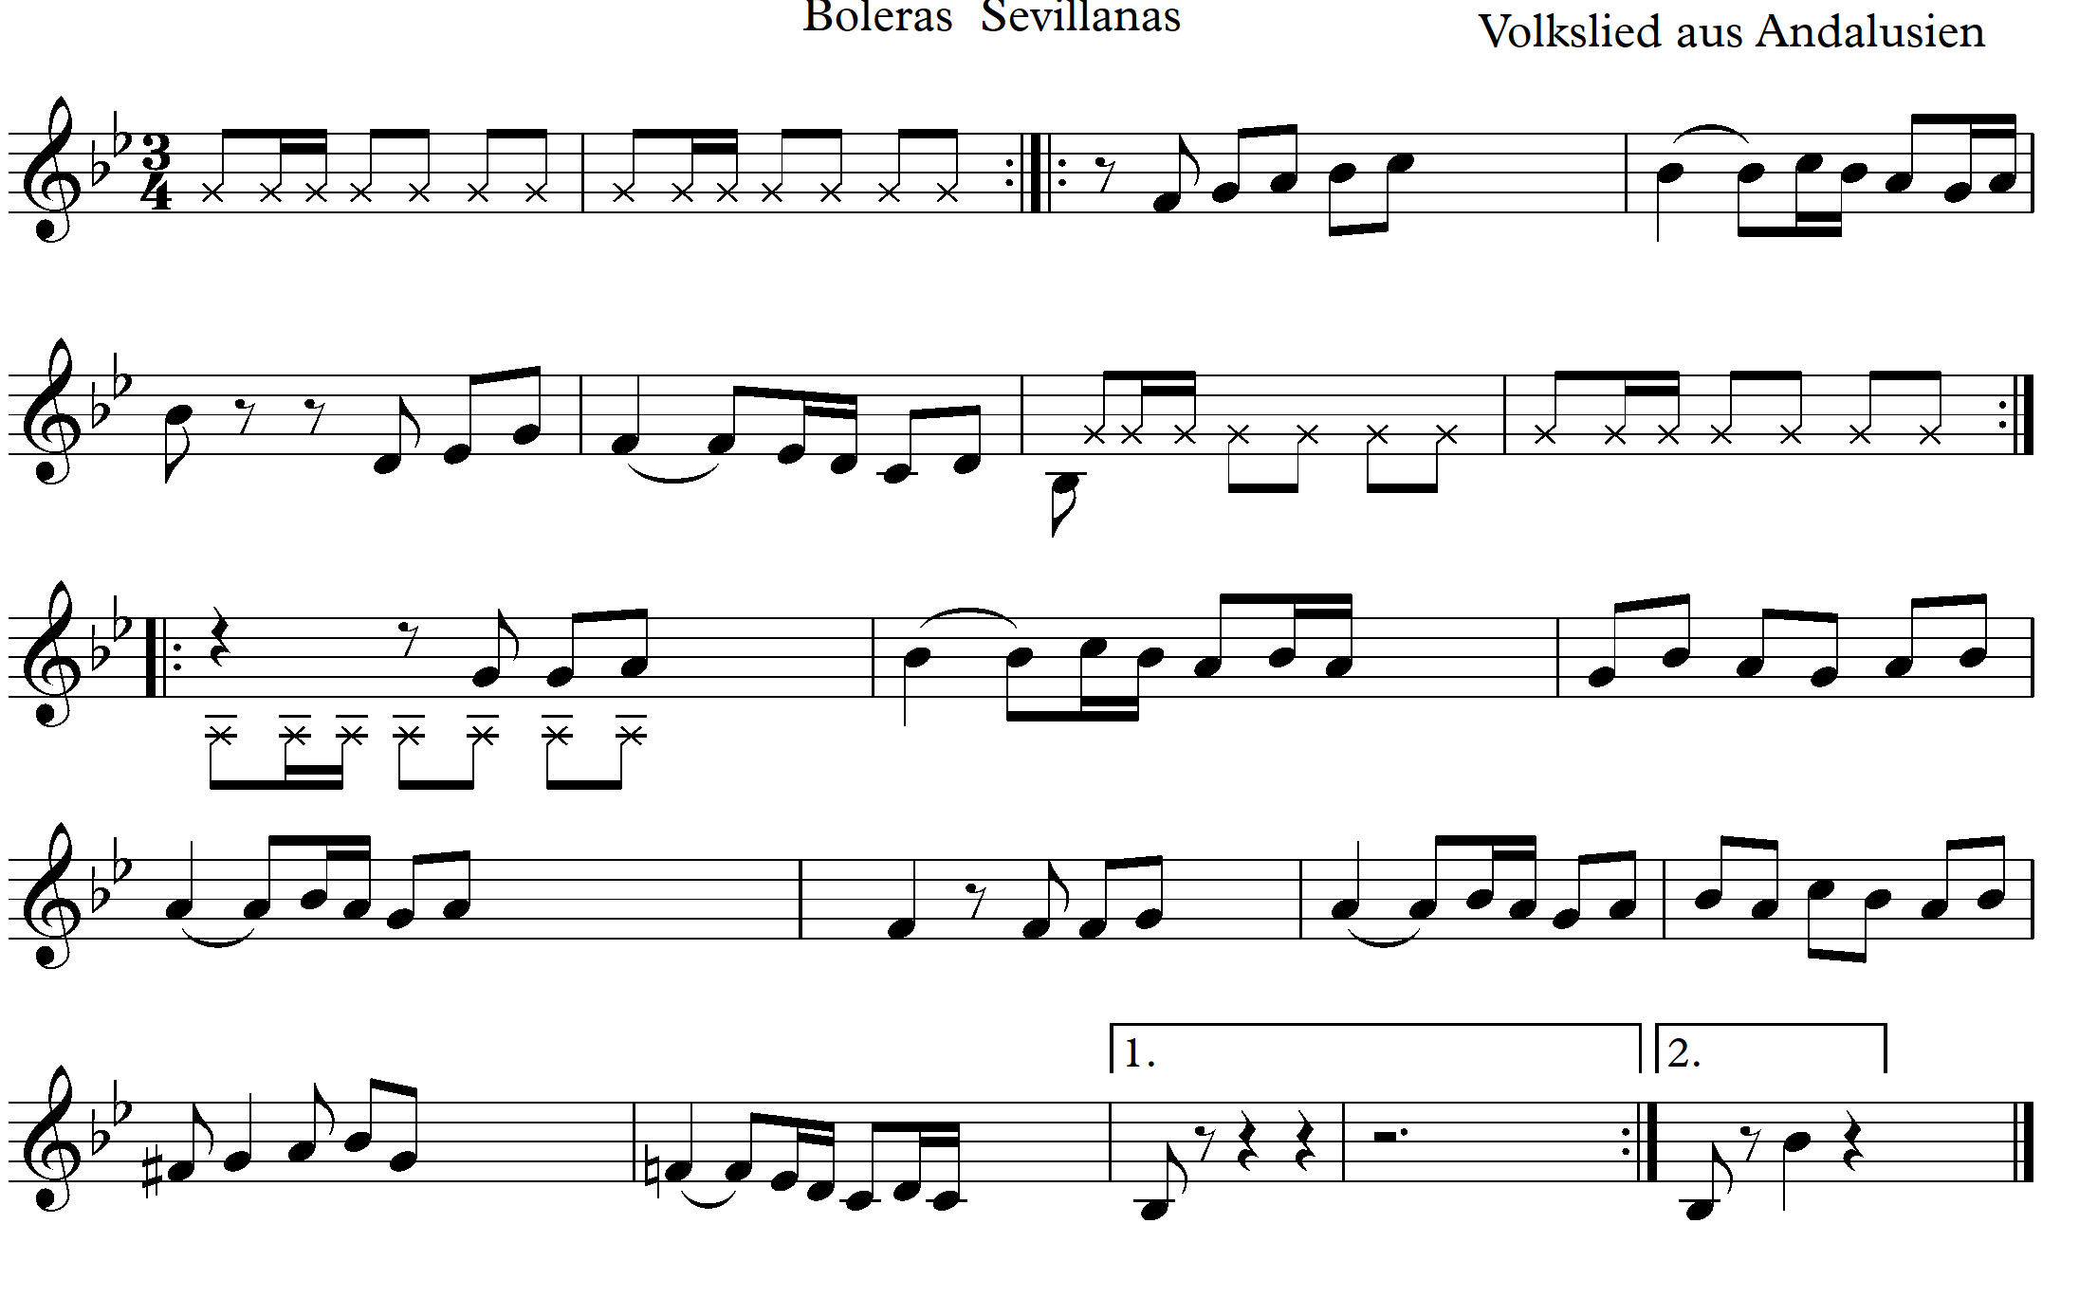

- Make a sequence from this motive.
Example from theory lesson:
https://youtube.com/shorts/kr_Oi8ATxTY

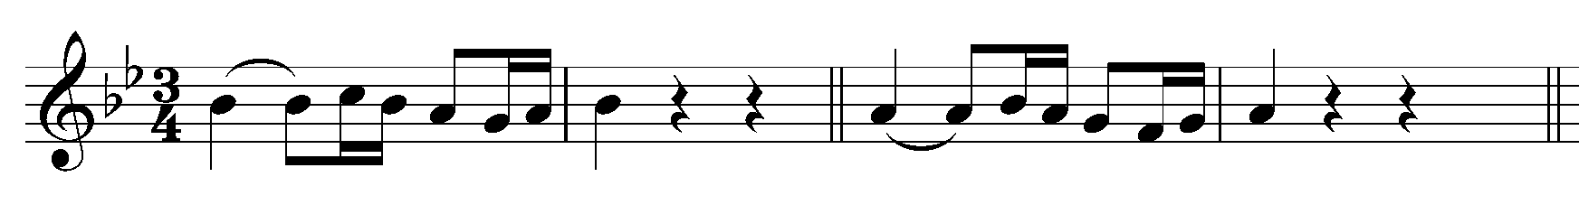
- Sing the melody and play the rhythm in the interludes.
Example from theory lesson:
https://youtu.be/cV9mlaonHrM

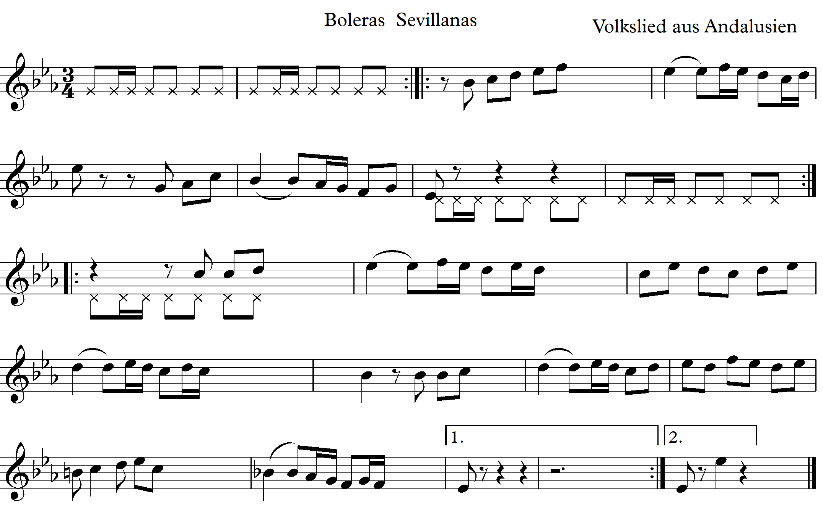

Lesson 2
1. Revise the rhythm acquired during the previous lesson.
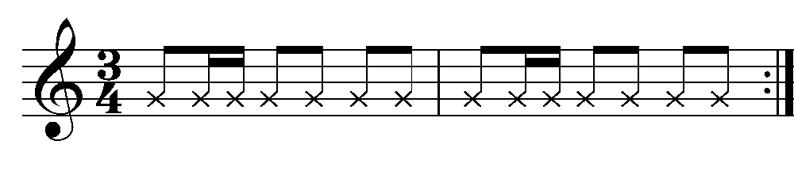
2. Sing the sequence acquired in the previous lesson.
3. B-flat (Ti) major scale (B dur)
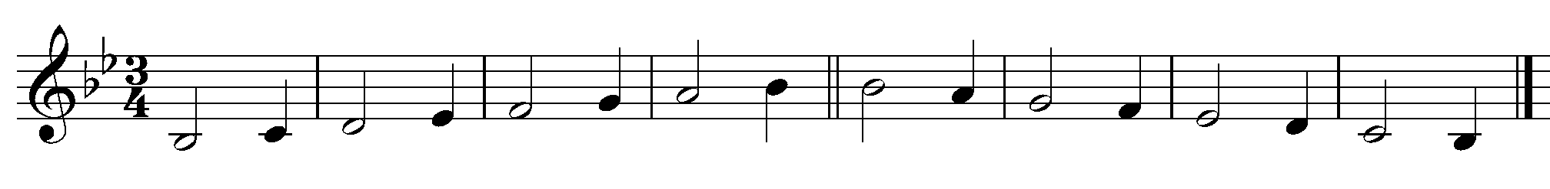
4. A scale with a rhythmic accompaniment.
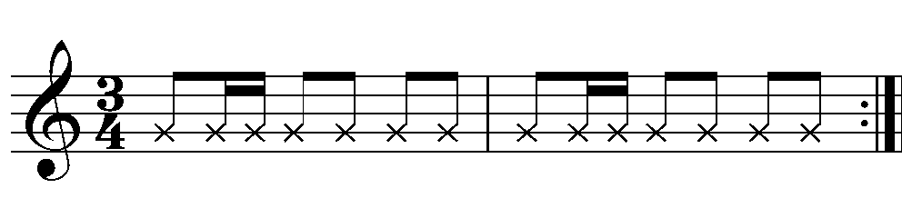
5. Harmonic G minor scale (g moll) with a rhythmic accompaniment. Why did I choose to sing the G (Sol) minor scale? (Because the song has a deviation to G minor.)
6. Divide the class into 2 groups. Group 1 sings the B-flat (Si) major scale (B dur), Group 2 sings G (Sol) minor (G minor) (at the same time). Repeat the exercise with the given rhythm.
7. Spanish folk song for three voices an a soloist.
Example from theory lesson:
https://youtu.be/6Zwl5ei4YVc

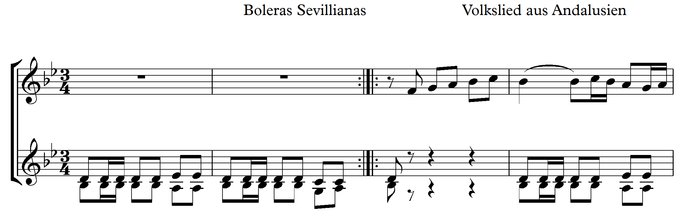
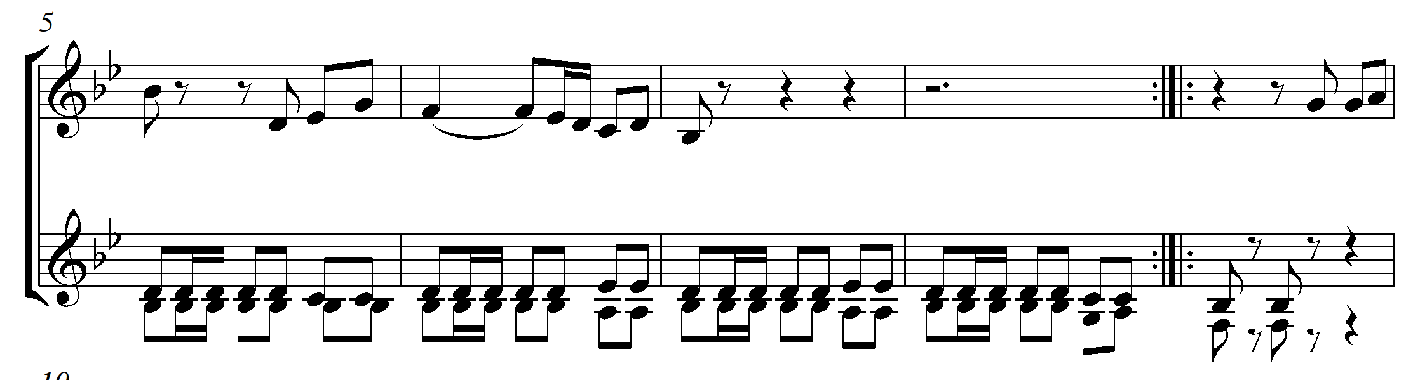
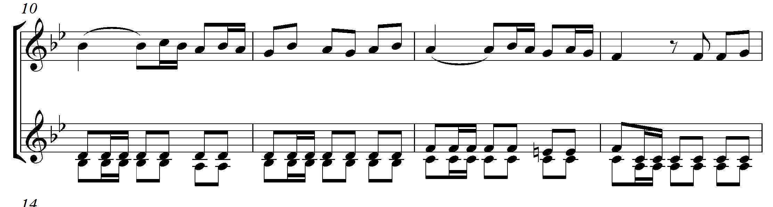
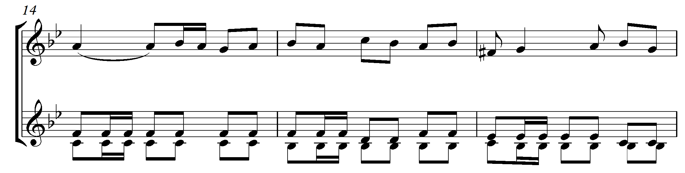
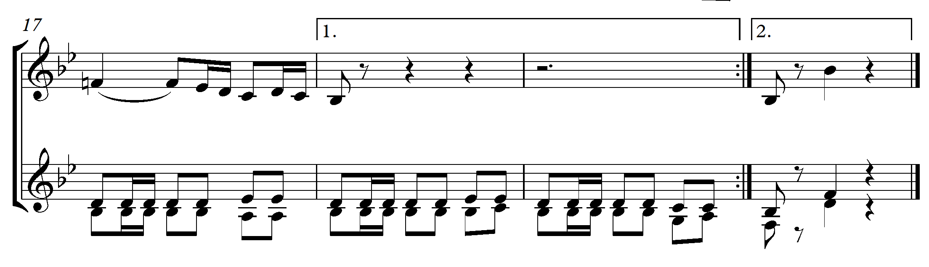
7. Add a rhythmic accompaniment to the song (preferably castanets).

Good luck!

8. Spanish folk song for three voices an a soloist.
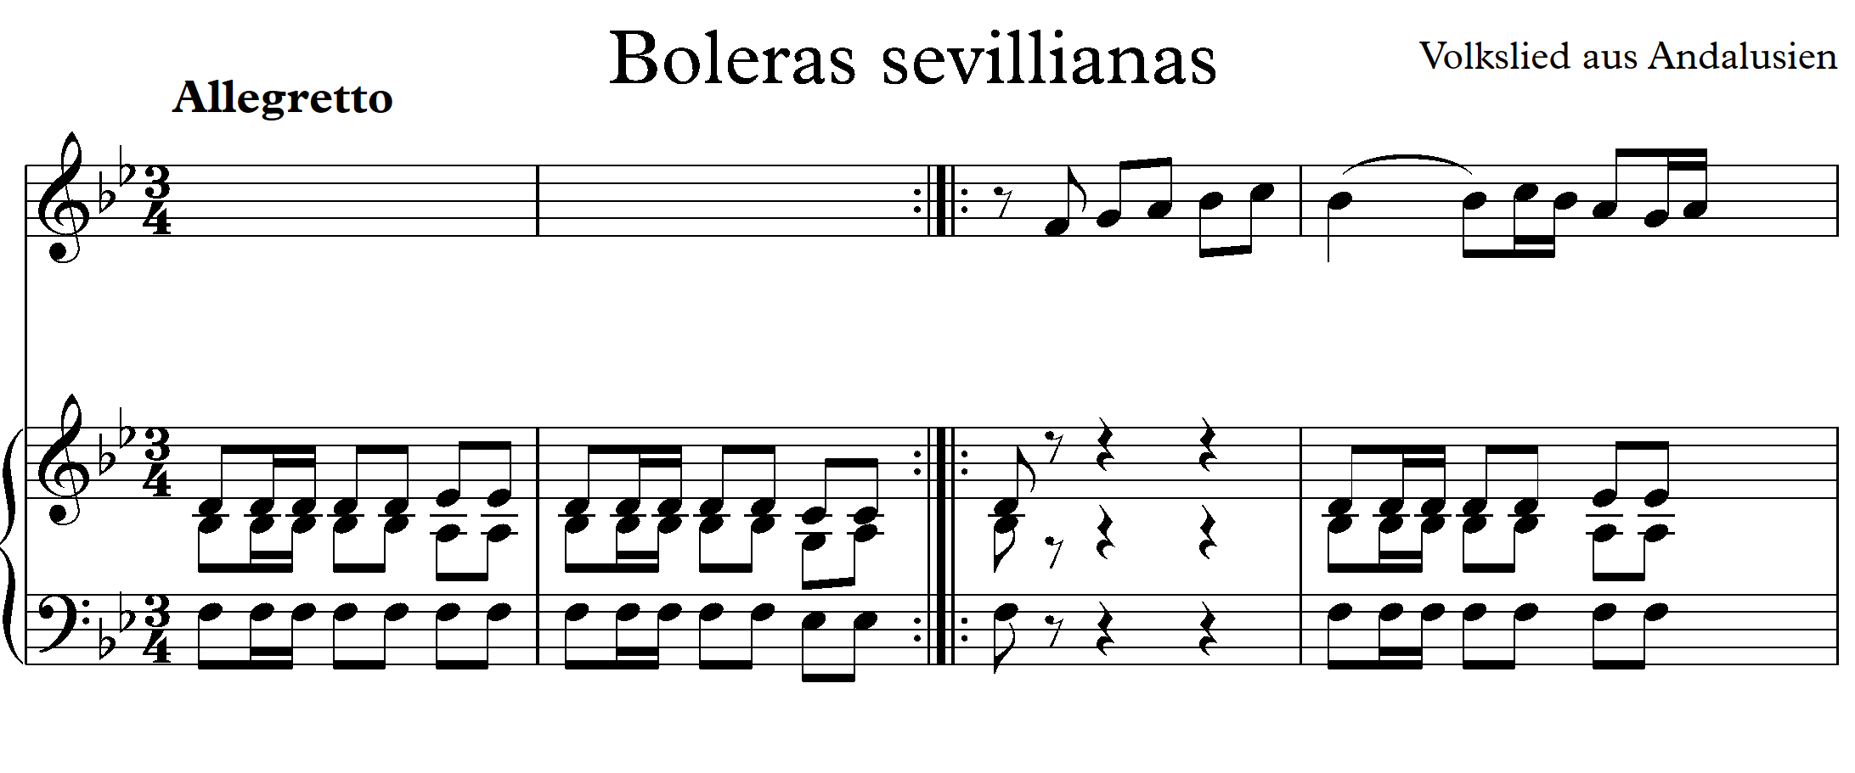
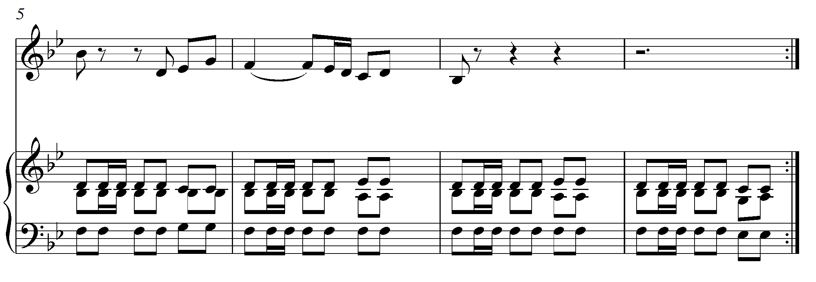
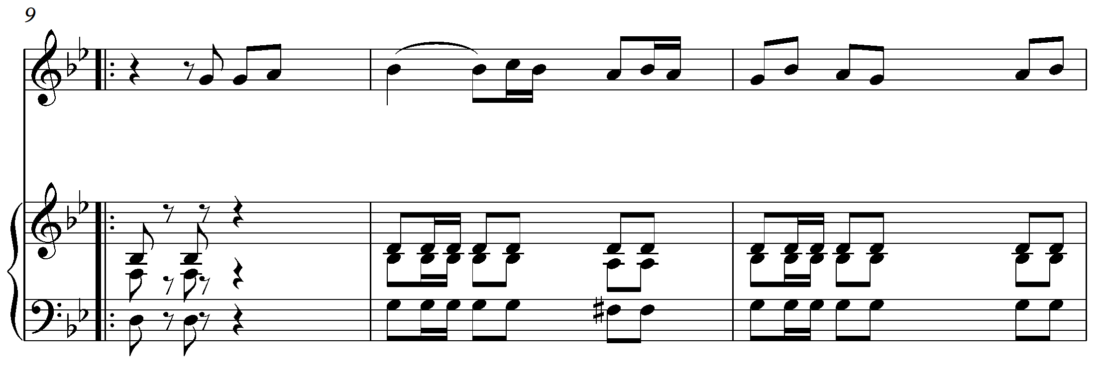
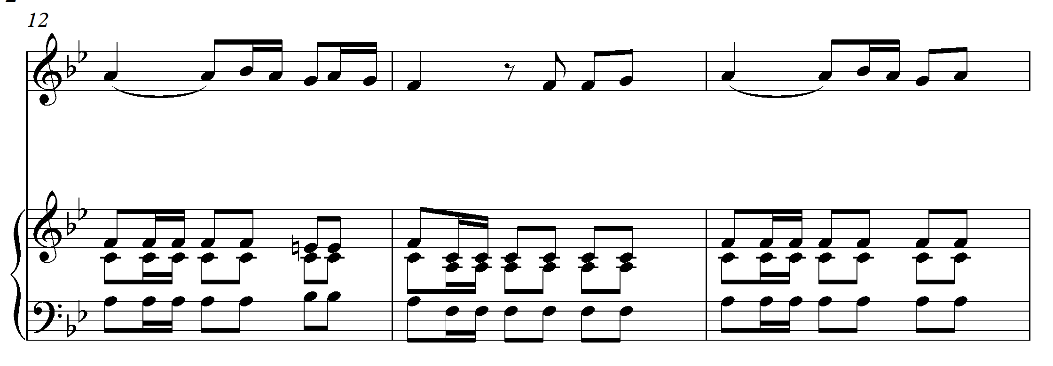
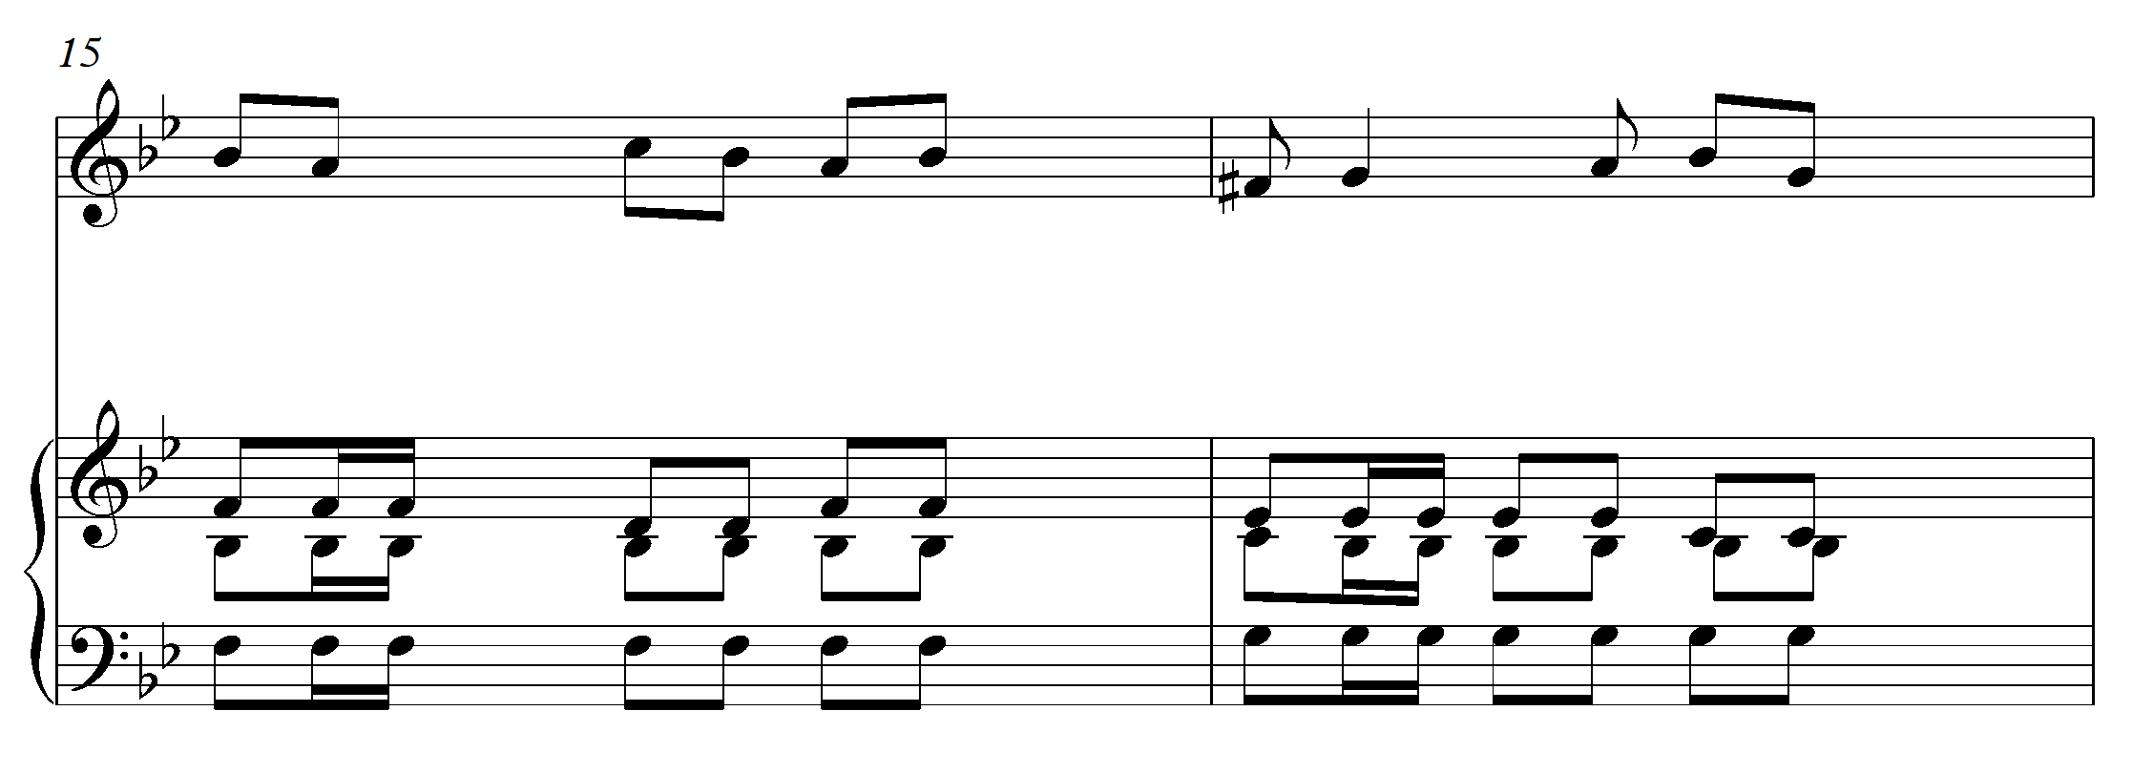
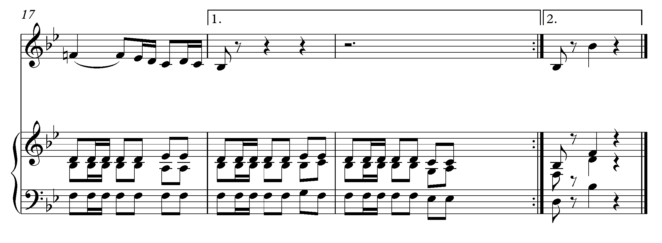
9. Version in D-flat (Re) major (D dur).

