Children lobby for recycling Boxes
  - saints and scholars integrated primary school and nursery unit

Recycling at Saints and Scholars ips Armagh

Scholars IPS Armagh

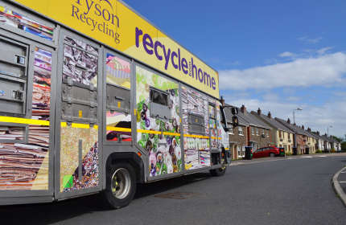
Omnibus Omnia Est all the

The children in Saints and Scholars IPS have been encouraged to recycle more. Bryson House agreed to collect recycling boxed every Tuesday so the children set to work to set up recycling boxers in each classroom office staffroom and dining hall.

Kerbside Collections
Byrson House now collect our kerbside boxes recycling every Tuesday morning. Over 170,000 households in Northern Ireland have a kerbside collection service every week.

Customer Survey

Tell us what you think of our Kerbside service, click here to complete the survey.

Each household will be provided with the containers required for the collection service in their area. Depending on where you live you may have kerbside boxes, a Wheelie Box and/or food waste bins. If you need to order containers please click here.
•Your containers will be collected on the same day each week.
•Leave them at the kerbside by 7.30am on your collection day.
•If you have difficulty presenting them please contact us.
•If either kerbside box or a section of your Wheelie Box is full you can use overflow bags to present extra materials. Only put one type of materials in each bag. Never put glass in overflow bags as we can’t accept this for safety reasons.
Each class was given two recycling boxes- blue one and a black one. Each box has different materials put in them. The P7 made notices for each box showing what had to be placed in it.
Every Monday the pupils collect the boxes and leave them out to be collected.

Black Boxes
- Paper
- Tin
- Plastics
Blue
- Cardboard
- Glass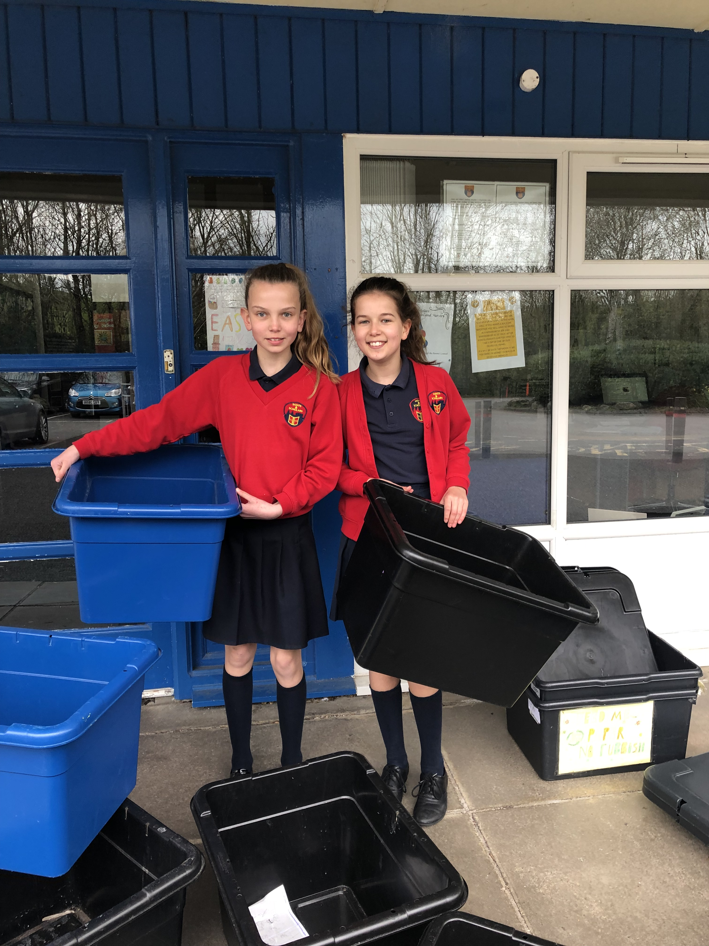

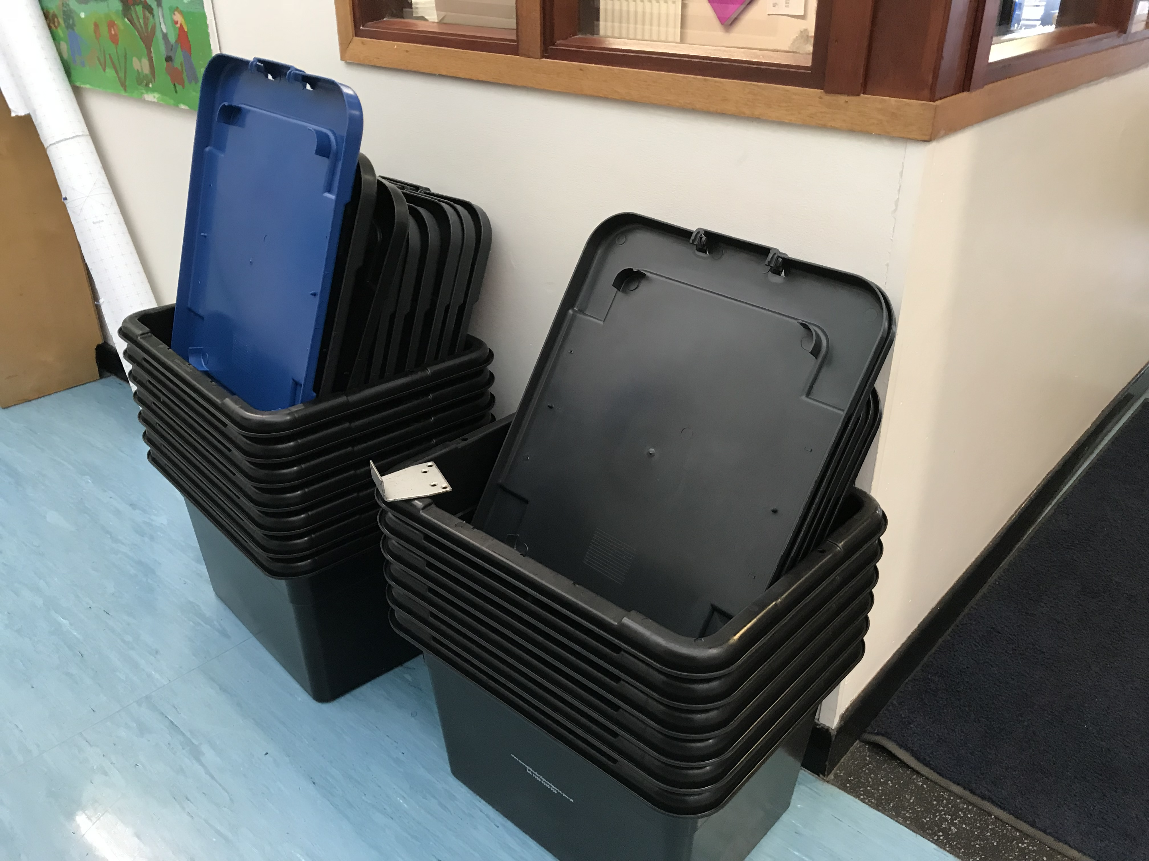

Byrson House now collect our kerbside boxes recycling every Tuesday morning. Over 170,000 households in Northern Ireland have a kerbside collection service every week.

EACH CLASS WAS GIVEN TWWO RECYCLING BOXES A BLACK AND A BLUE ON

The chidlren in P7 made a recycing noticeboard

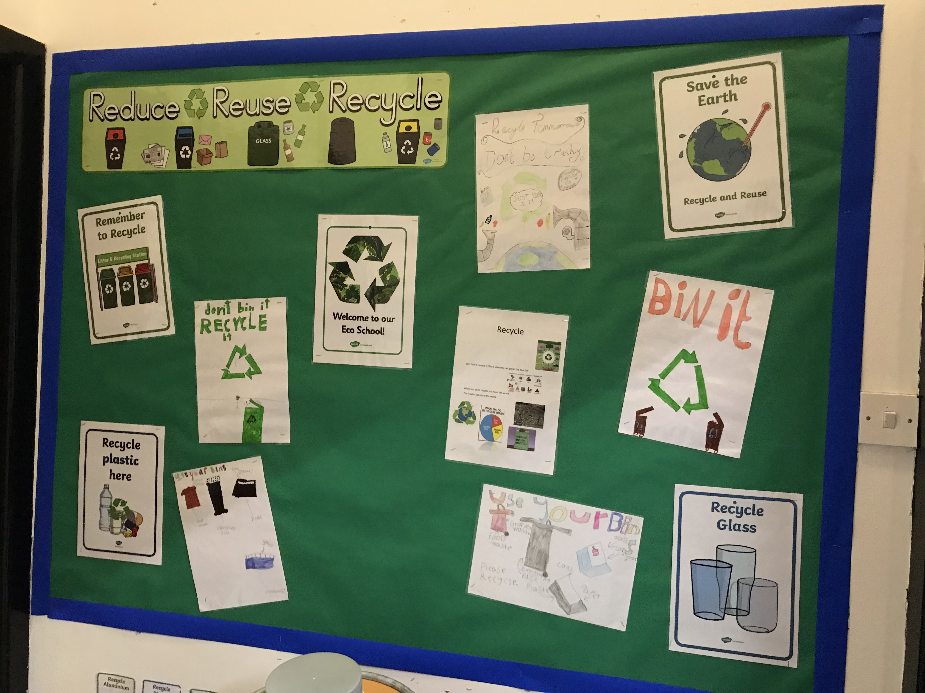
Recycling will make ourworld a better place

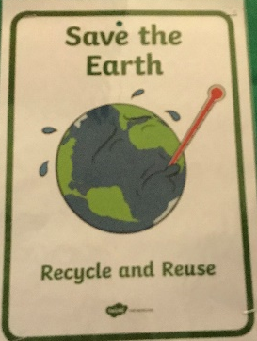
Story Subtitle or summary

Reduce

Reuse

Recycle

