Latvian folk song „ The little, little apple tree”
Four lessons about the interval “third”.
1st lesson:
An introduction song to use the interval „ third” :
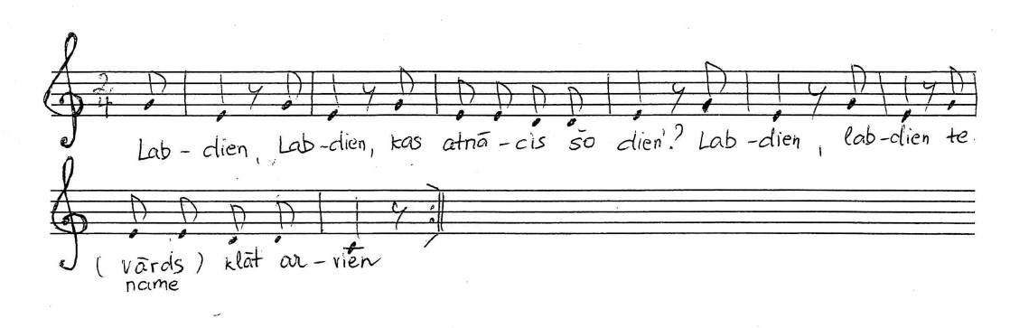
„ Good day, good day, who came today?
Good day, good day, here Evita came today.”
Sing the C major scale starting with an upbeat (also in canon):
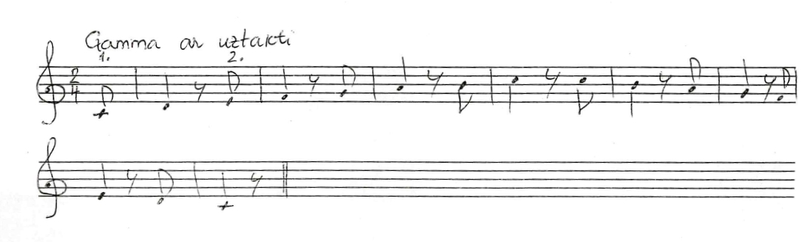

Sing and play „ the stairs of thirds” and then note which intervals are Major
thirds and which minor thirds
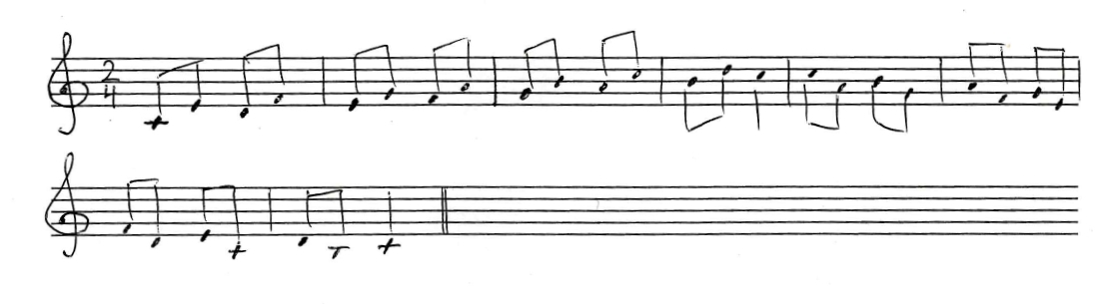
Sing the same „stairs of thirds” in a minor key. What notes should be changed?
Ask help from your teacher, if needed!
Fresh your memory about intervals:
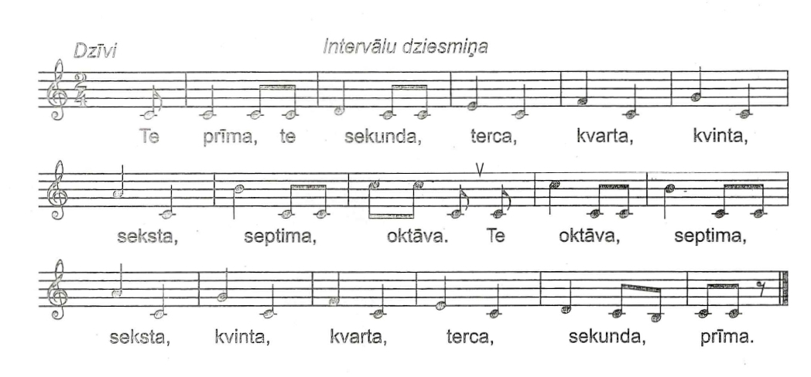

Then connect each interval with a certain movement:

unison – touch your nose with your index finger
minor/major 2nd – rub your palms together
minor/major 3rd- swing your hands like carrying a handful of water in them
perfect 4th – put your thumb and ring finger together (like making a ring )
perfect 5th – put your thumb and little finger together (like making a ring )
minor/major 6th – raise your hands above your head
minor/major 7th - extend your arms to the sides
perfect 8th (octave) – show “the long nose” according to the drawing below

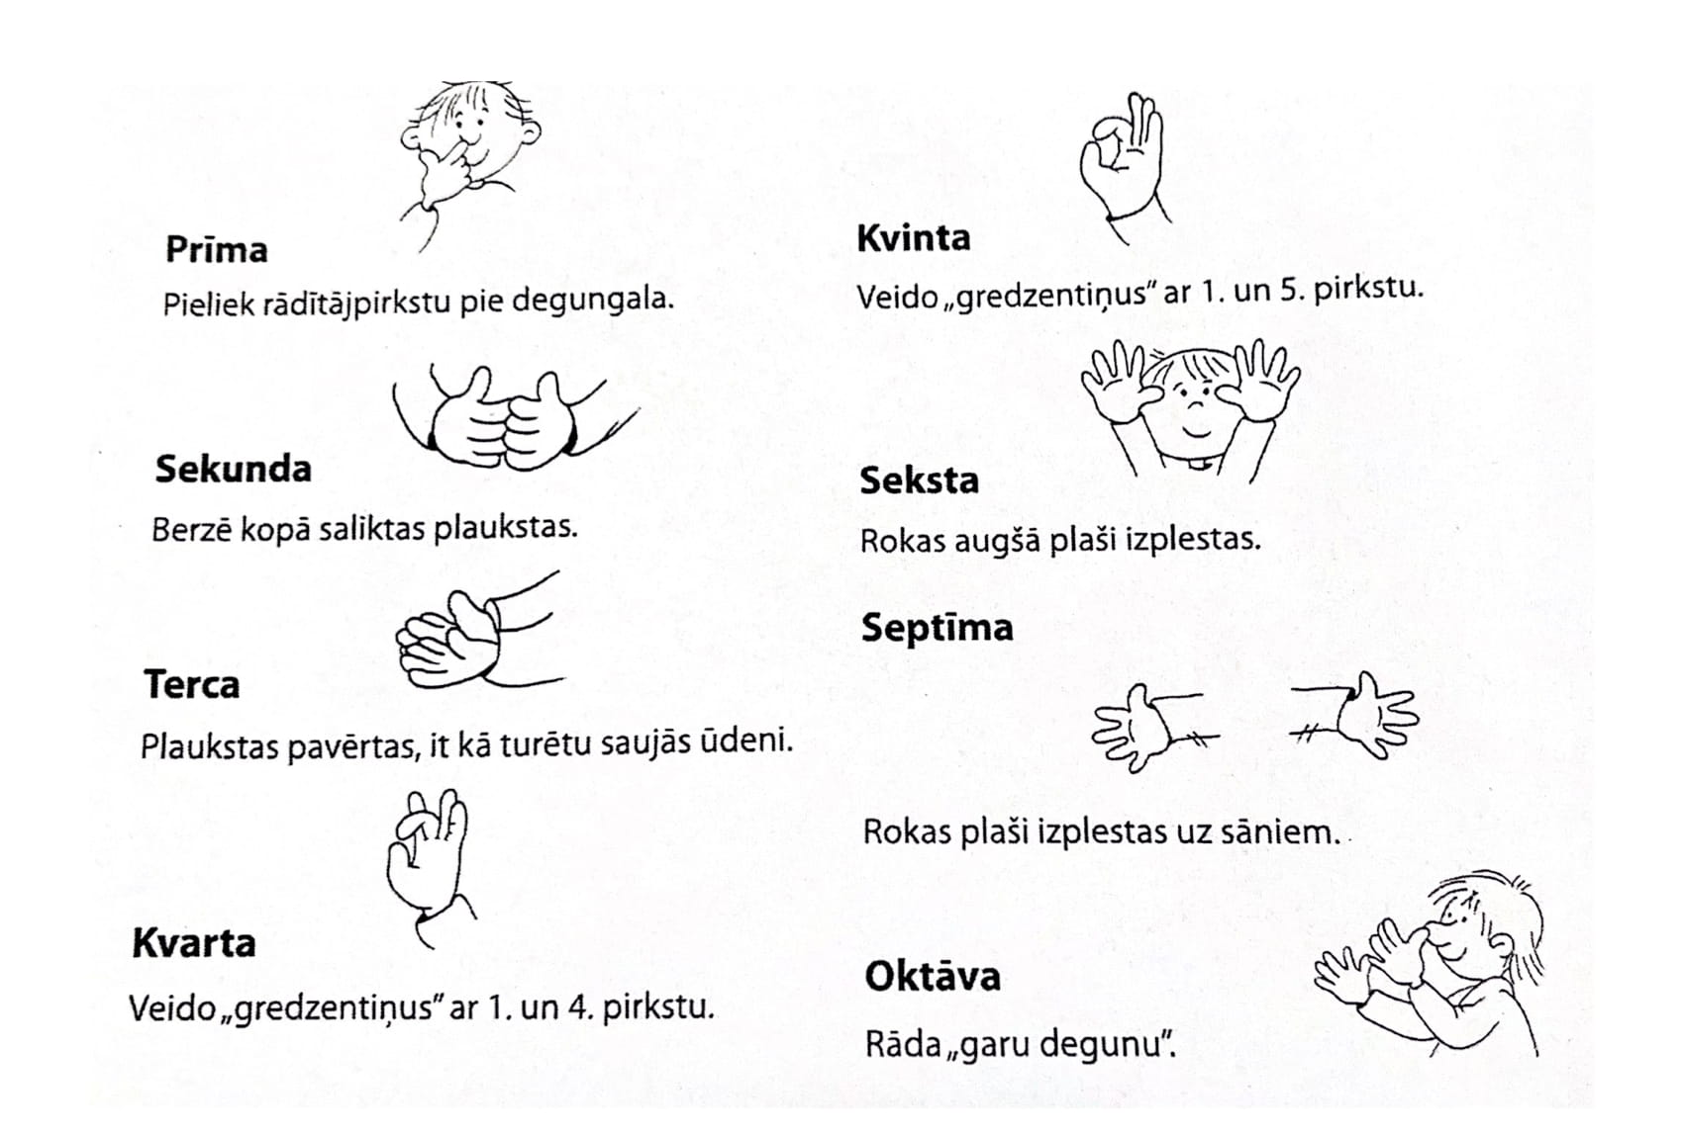

Or maybe the next picture will help you to understand the movements:
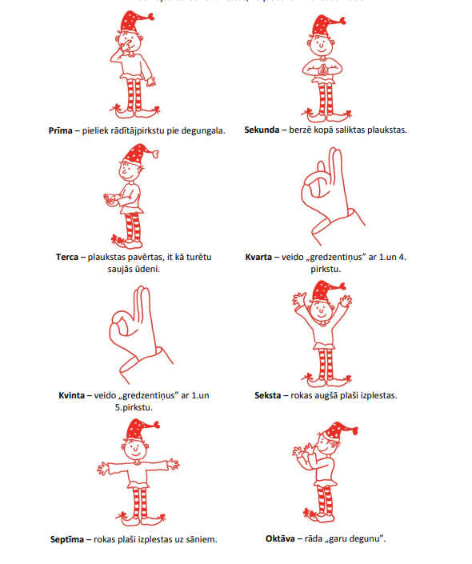

Sing „ a voice – echo -exercise” using thirds:
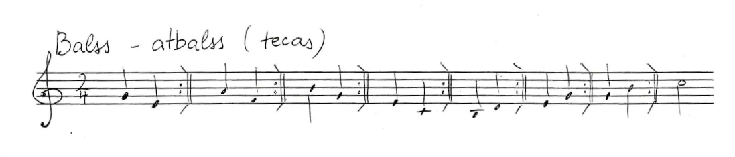
Which of the thirds are Major and which minor?

2nd lesson:
The interval „third”, second part
Please sing the song „ Maza, maza ābelīte” using the note names.
Create the second voice.
Get inspired by these examples!

https://youtu.be/zfBtlbEFr98

https://youtu.be/C-aEr017FpY

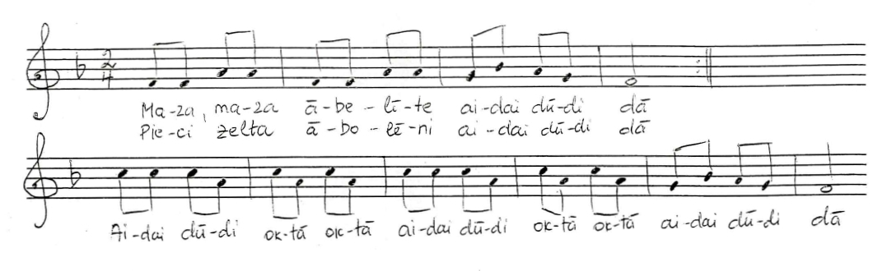
1st verse:
„ Maza, maza ābelīte Little, little apple tree
Pieci zelta abolēni” with five golden apples

2nd verse:
„Divus devu brālīšami, two of them I gave to my brother
Trīs es pati paturēju.” three I kept for myself

3rd verse:
„ Trīs es pati paturēju Three I kept for myself
Ar ko daiļi rotāties.” To make myself more beautiful

4th verse:
Par to vienu zirgu pirku, For one apple I bought a horse

par otro novadiņu” for the second I bought land

Par trešo sev maizītes arājiņu by third I bought for myself boyfriend😉 who will help me to work on the field
Analyse the intervals and quality of them.
Sing this song in two voices with piano accompaniment and percussions.
https://youtu.be/ttDs6ISvG3E
Try to sing the 1st voice and play the 2nd
https://youtu.be/cT8PEfm7XeU
Try to sing the 2nd voice and play the 1st:
https://youtu.be/HexYHKuyiP8

Learn all the 3 verses by heart and write down the same melody in your exercise book using another key signature: Two flats!

3rd lesson:
Recall the song „ Maza, maza ābelīte” (The little, little apple tree)

https://youtu.be/nX5p13yWres

Ask your kids to sing or play it like soloists!
Introduce them with another melody for the same text
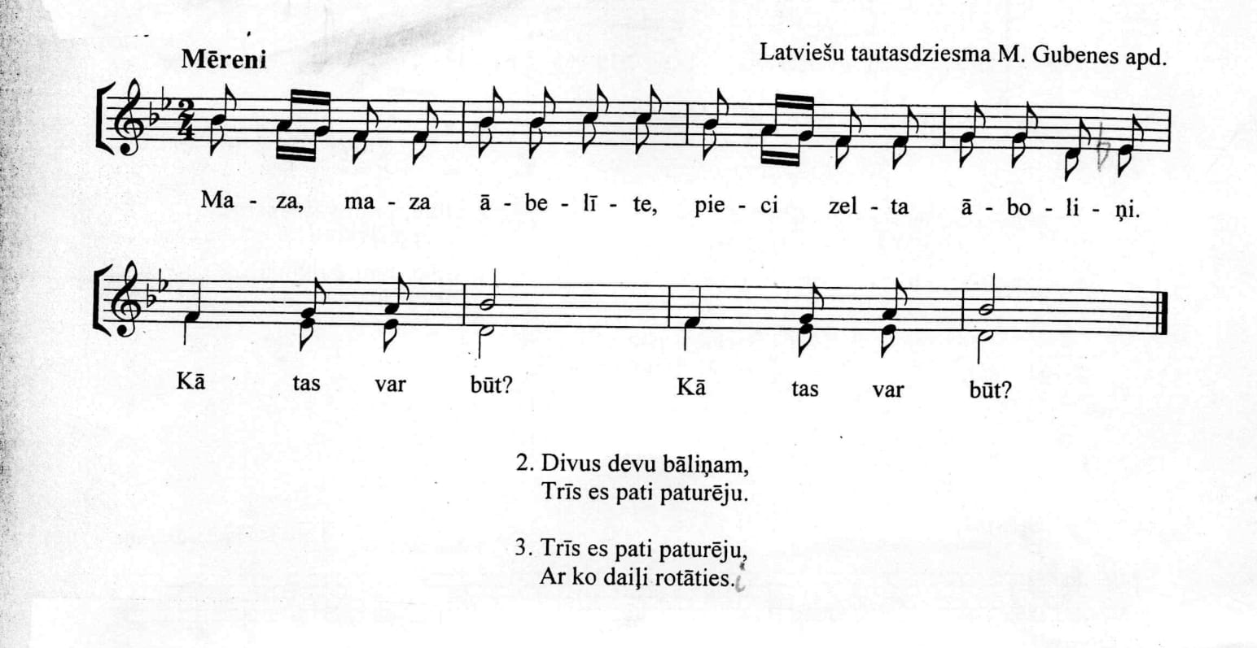

Analyse the intervals on the second line.
Learn each voice separately, then sing together.
Find the thirds and analyse their quality

4th lesson:
Start this lesson with singing the G major scale, in a canon form, too:
https://youtu.be/KleuLoaNqdc
https://youtu.be/NIuV5W1kGe8
Use body percussions!
Kn = Snap your fingers!
Kr = Beat your chest!
Pl = Clap your hands! (Back of the palm agains palm.)
https://youtu.be/Mz6IKfV6v5Q
Learn all three voices separately
Pay attention the the note change in the melody line both in the 1st bar and in 5th bar!
Train the glissando technique! Choose different intervals and try!
