

Culture – connectedness in diversity

Part one: How Christmas is celebrated

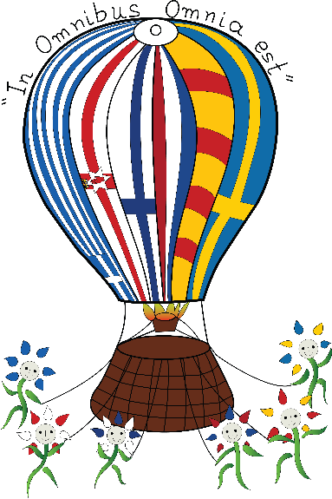

1st theme: Culture

2016-2017

Swedish Christmas traditions

Typical ways to celebrate Christmas in Sweden

Like any other thing we all do things differently in different families and social circles. This poster contains information about the more common traditions surrounding Christmas in Sweden.

Before Christianity grew big in Sweden we celebrated Julblot (Yule) during the shortest days of the year. This is a “heathen” tradition from around/after the Viking age, stemming all the way back to before the 13th century. As Christianity grew in Sweden around the mid-1100s the pagan and Christian traditions began to mix. Most of the current traditions surrounding Christmas in Sweden is from the 1800s and 1900s.




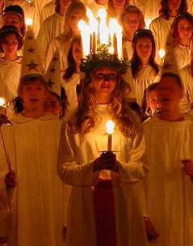
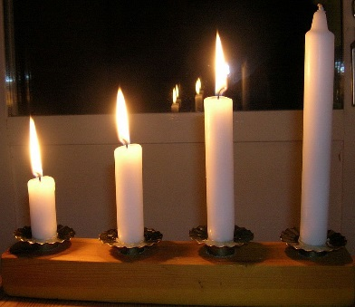
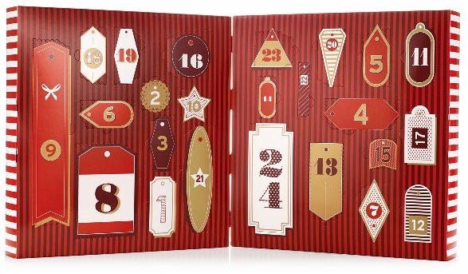
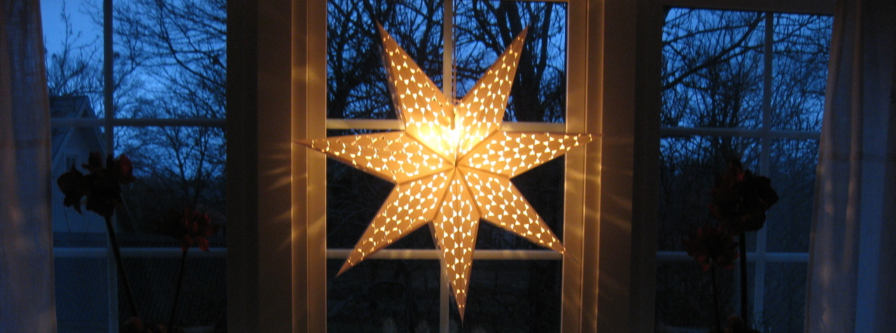
One of the first tradition to start Christmas off in Sweden is advent, which is the 4 Sundays before Christmas. The first, the second, the third and the fourth Sunday in advent. “Advent” is a
Version of the Latin
word meaning
“coming”. Each advent
(Sunday) you light
another candle. When
all 4 candles are lit you
know that Christmas Adventsljusstake/Advent candlestick
(December 24th) is almost here!

During December, and advent, a lot of Swedes puts an “advent star” in the window. This star is supposed to remind of the Star of Bethlehem/Christmas star. Although today it mostly just represents Christmas and the purpose is to spread Christmas spirit.

The Christmas tree is also a common tradition, like in a lot of other countries. Lights is another common tradition around November/December to brighten up the homes in those dark times during early
winter time.

1

Common Christmas traditions

A few of the more common Christmas traditions in Sweden is advent, Lucia, lights, decorations, advent calendar and of course all sorts of sweets and delicious foods.
Another common tradition is the advent calendar, which came to Sweden in 1932. Each day of December until Christmas eve you get to open a “window” on the calendar as the days grow closer to Christmas eve.

Adventskalender - Advent calendar

Lucia is celebrated on December 13th and is
a feast of light. Lucia walks
slowly in with a long white
robe on December 13th with
candles in her hair followed
by the “lucia train” – others
in long white robes/dresses,
holding candles. At Lucia we
usually eat “lussebullar” and Lucia
gingerbread cookies.

Each Christmas Eve at 3 o’clock in the afternoon over 3 million people in Sweden tune in to watch Donald Duck on TV. The program, featuring several clips and shorts from Disney, started airing on national public TV in 1960 and has become a large part of the Swedish Christmas traditions.

Christmas foods
All families have different traditions and dishes they make around the holiday, but a few of the more common and traditional foods in Sweden around Christmas is lussebullar (saffron buns) which you eat at Lucia, gingerbread cookies, chocolate, oranges, Christmas ham, potatoes, meatballs, prince-sausages, herring pickled in different sauces, beetroot salad and much more.

Around Christmas it is also very common in Sweden to eat “tomtegröt” (santa porridge) or risgrynsgröt (rice pudding), as it’s called. This is eaten with or without milk and usually with sugar and cinnamon on top. After Christmas Eve you can take the leftover porridge and make ris à la malta, which is cold rice pudding/porridge dessert, whipped cream, sugar, vanilla sugar and sometimes pieces of orange.

During Christmas it is very common for families to dance around the Christmas tree to traditional songs and dances. You walk/dance
around the tree as
you sing and do
the movements
that goes with the
song. This is very
similar to a
tradition
surrounding the
Swedish holiday
Midsommarafton
(midsummer’s eve) in June, where you dance around the midsummer- or maypole to similar songs.

In some families you write a rhyme on the Christmas gifts. These are relatively short, rhyming verses that you attach to the gifts. The rhyme usually suggests what’s inside the gift without directly revealing the contents.

Last but not least; the most important thing around Christmas, above any tradition, is spending time with your family and loved ones.

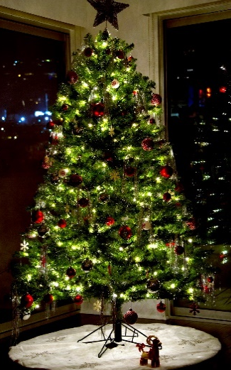

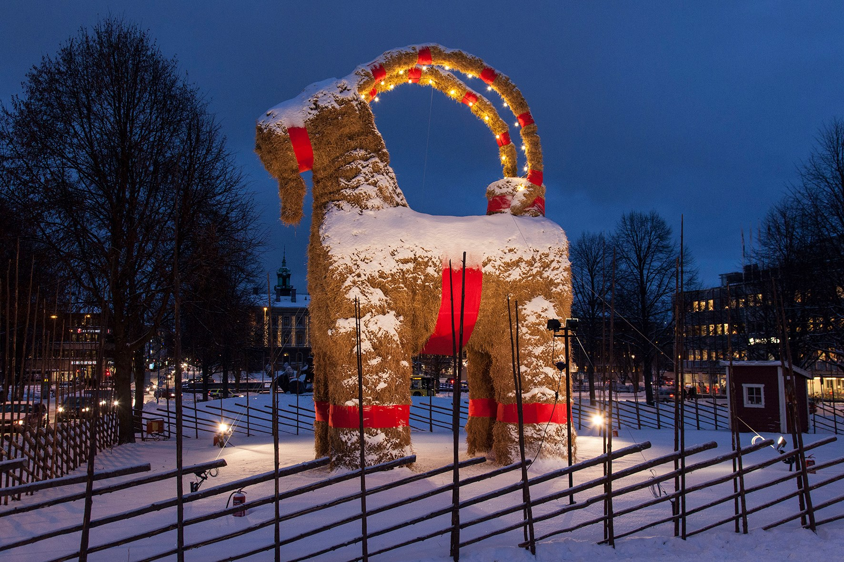

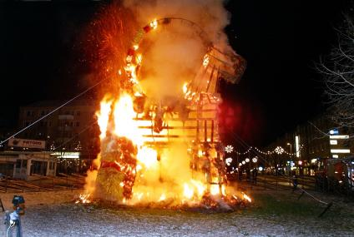

Gävlebocken
Or the Gävle Goat is a traditional display of a giant “Yule/Christmas Goat” figure made of straw. Every year it is put up in Gävle city’s center at the beginning of advent.

The yule goat has become world famous for burning down almost every year since its first appearance in 1966. As of December 2016 it has been illegally burned and damaged 37 times.

