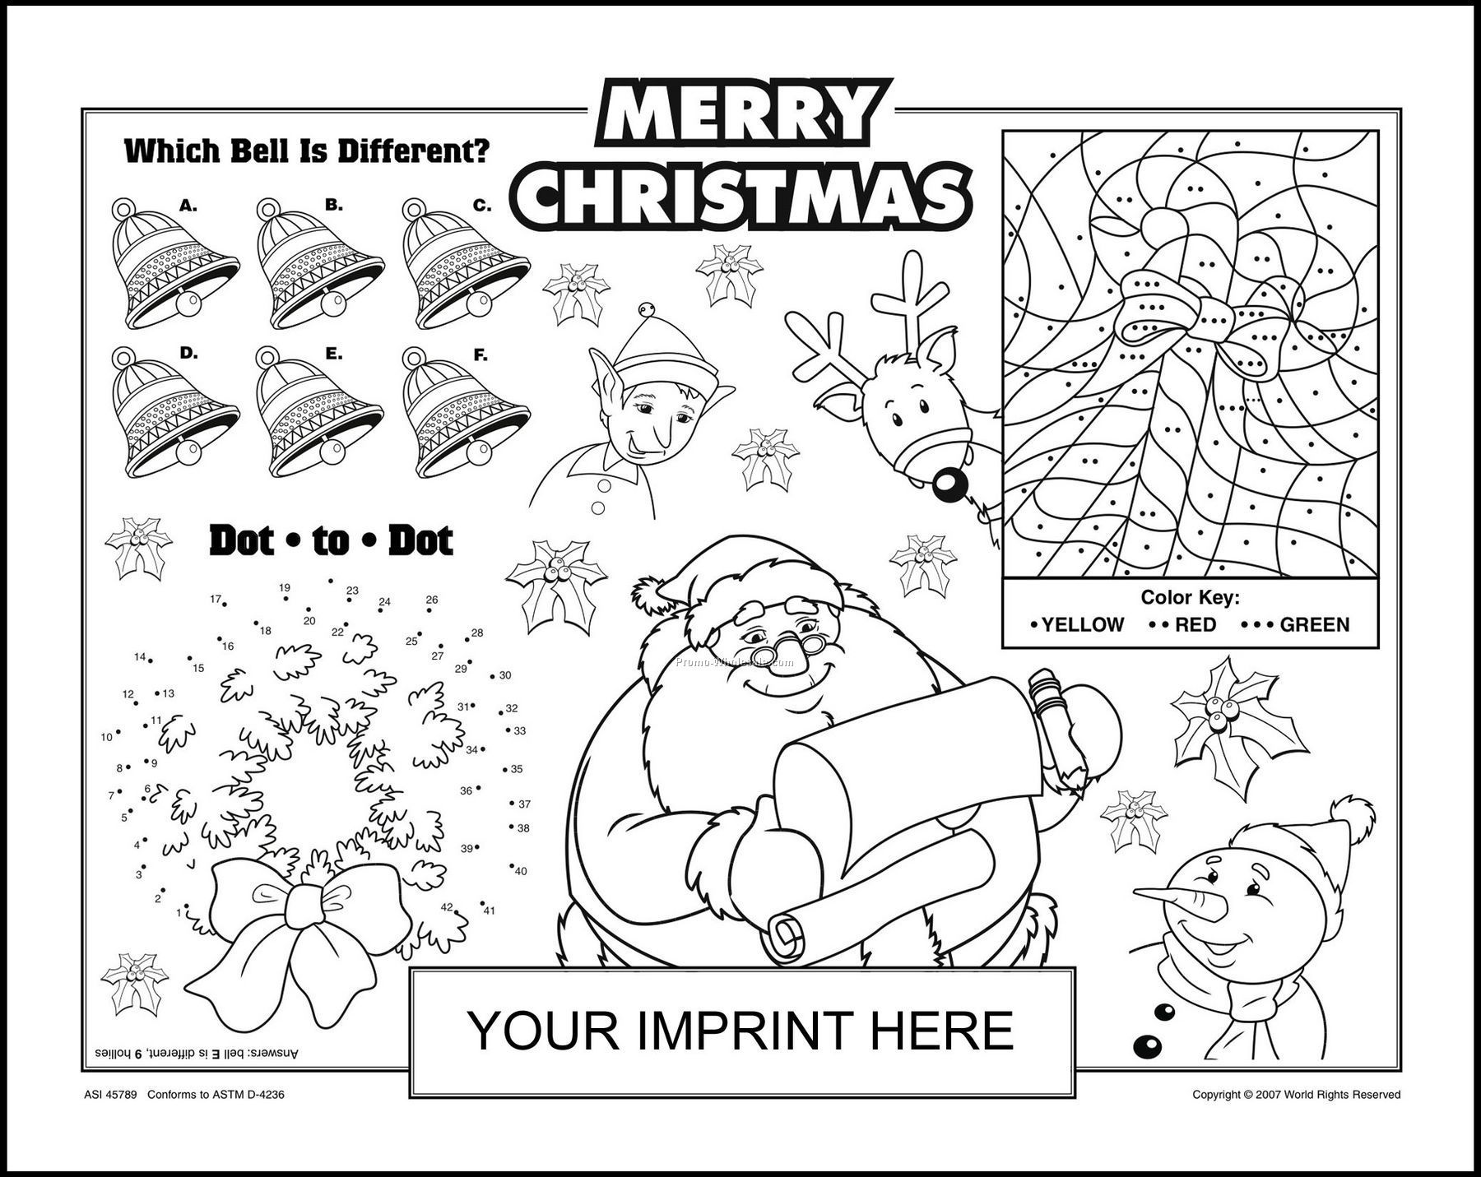
Sally
MERRY CHRISTMAS FROM

