
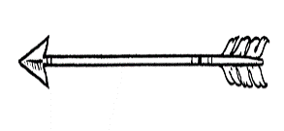


This beast was found on the coast of Bundoran at 7:30 am Monday 18th of October 2012 Jellyfish have tiny stinging cells in their tentacles to stun or paralyze their prey before they eat them. Inside their bell-shaped body is an opening that is its mouth. ... Tentacles hang down from the smooth bag like body and sting their prey. Jellyfish stings can be painful to humans and sometimes very dangerous.

This was someone after being stung by a box jelly fish while swimming in the water in Bundoran
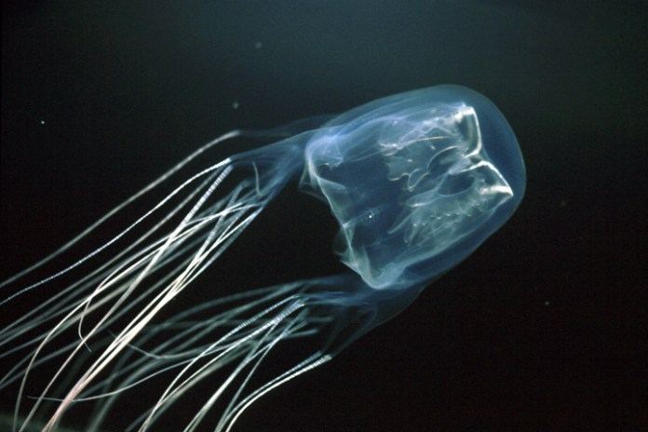

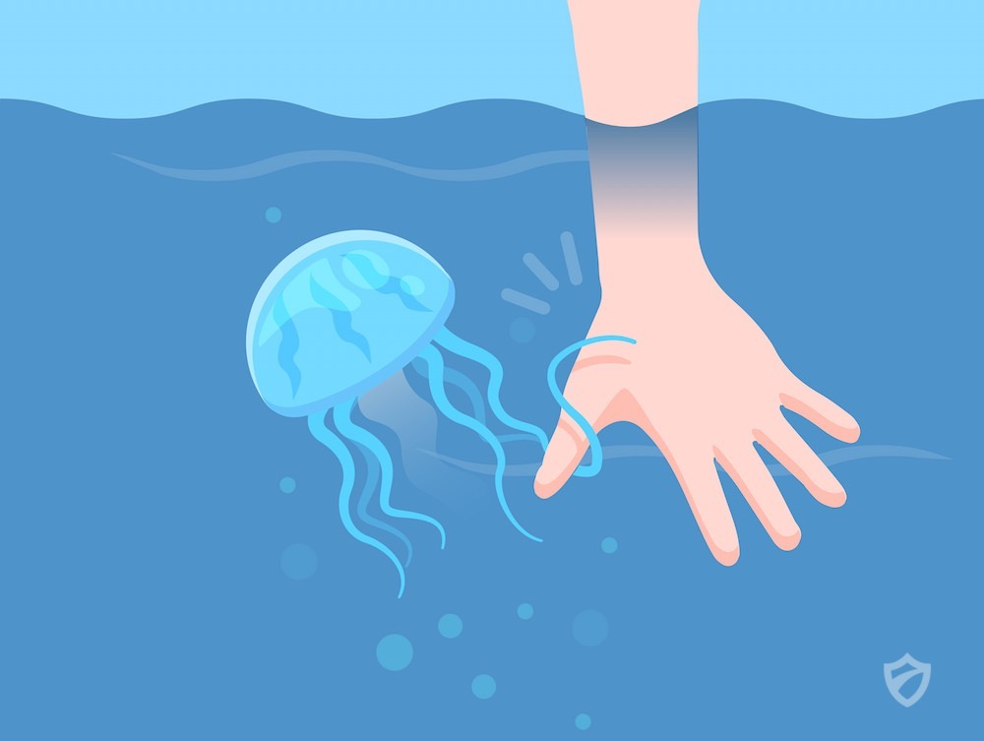
Here is the fish that did this to this poor person. do not do this you will get badly stung

