Perusraportti
Old music notation course feedback by teachers

Vastaajien kokonaismäärä: 18

1. My knowledge of the old music notation before the course was
Vastaajien määrä: 18
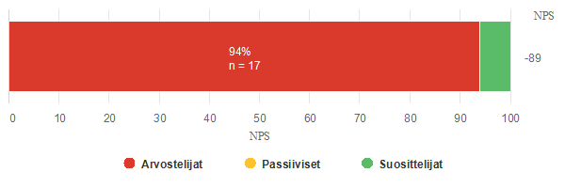

Arvostelijat |  |  |  |  |  |  | Passiiviset |  | Suosittelijat
0 | 1 | 2 | 3 | 4 | 5 | 6 | 7 | 8 | 9 | 10
n = 17 |  |  |  |  |  |  | n = 0 |  | n = 1
94,4% |  |  |  |  |  |  | 0,0% |  | 5,6%
2 | 3 | 3 | 3 | 3 | 2 | 1 | 0 | 0 | 1 | 0
11,1% | 16,7% | 16,7% | 16,7% | 16,7% | 11,1% | 5,5% | 0,0% | 0,0% | 5,5% | 0,0%

Yhteensä
Vastauksia | NPS | Keskiarvo
18 | -89 | 3,1

2. My knowledge of the old music notation now after Pieter's online course n, but before the Belgian mobility is
Vastaajien määrä: 18
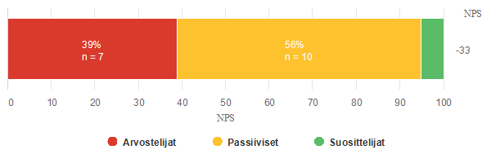

Arvostelijat |  |  |  |  |  |  | Passiiviset |  | Suosittelijat
0 | 1 | 2 | 3 | 4 | 5 | 6 | 7 | 8 | 9 | 10
n = 7 |  |  |  |  |  |  | n = 10 |  | n = 1
38,9% |  |  |  |  |  |  | 55,5% |  | 5,6%
0 | 0 | 0 | 1 | 0 | 4 | 2 | 6 | 4 | 1 | 0
0,0% | 0,0% | 0,0% | 5,6% | 0,0% | 22,2% | 11,1% | 33,3% | 22,2% | 5,6% | 0,0%

Yhteensä
Vastauksia | NPS | Keskiarvo
18 | -33 | 6,6

3. I took part in the course because (many answers are possible):
Vastaajien määrä: 18, valittujen vastausten lukumäärä: 51
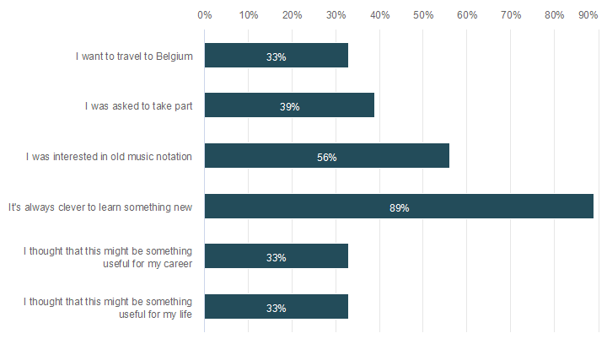

 | n | Prosentti
I want to travel to Belgium | 6 | 33,3%
I was asked to take part | 7 | 38,9%
I was interested in old music notation | 10 | 55,6%
It's always clever to learn something new | 16 | 88,9%
I thought that this might be something useful for my career | 6 | 33,3%
I thought that this might be something useful for my life | 6 | 33,3%

4. I rank the old music notification online course
Vastaajien määrä: 18
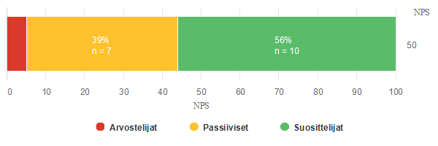

Arvostelijat |  |  |  |  |  |  | Passiiviset |  | Suosittelijat
0 | 1 | 2 | 3 | 4 | 5 | 6 | 7 | 8 | 9 | 10
n = 1 |  |  |  |  |  |  | n = 7 |  | n = 10
5,5% |  |  |  |  |  |  | 38,9% |  | 55,6%
0 | 0 | 0 | 0 | 0 | 0 | 1 | 4 | 3 | 1 | 9
0,0% | 0,0% | 0,0% | 0,0% | 0,0% | 0,0% | 5,5% | 22,2% | 16,7% | 5,6% | 50,0%

Yhteensä
Vastauksia | NPS | Keskiarvo
18 | 50 | 8,7

5. I found the course
Vastaajien määrä: 18
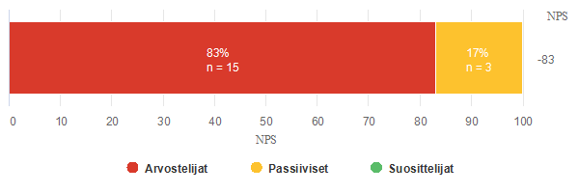

Arvostelijat |  |  |  |  |  |  | Passiiviset |  | Suosittelijat
0 | 1 | 2 | 3 | 4 | 5 | 6 | 7 | 8 | 9 | 10
n = 15 |  |  |  |  |  |  | n = 3 |  | n = 0
83,3% |  |  |  |  |  |  | 16,7% |  | 0,0%
0 | 1 | 0 | 2 | 4 | 6 | 2 | 3 | 0 | 0 | 0
0,0% | 5,6% | 0,0% | 11,1% | 22,2% | 33,3% | 11,1% | 16,7% | 0,0% | 0,0% | 0,0%

Yhteensä
Vastauksia | NPS | Keskiarvo
18 | -83 | 4,8

6. My positive remarks and comments about the course
Vastaajien määrä: 13
Vastaukset
Pieter is really a wonderful teacher- very structured, patient, interesting, with excellent sense of humor and, of course, a real professional of the old music. Thanks a lot! It was great experience, and I am waiting for next Belgium events with great pleasure!
It is always great to have a teacher whose whole heart is in the subject he teaches. This was really nice introduction to old music and opened my eyes to new possibilities in music making.
Very interesting and good quality, Pieter was very patient and explained very well.
Great teacher, understandable language, interesting examples, the opportunity to work in practice. Thank you.
I always had positive emotions after each lecture!
I would like to practice with all group and Pieter in reality. To train more and more.
This course was an excellent opportunity to learn old music notation. It expand our knowledge about music and definitely make us better teachers. I am looking forward to travel to Belgium and keep learning as much as possible. Peter was a wonderful person, charming and lovely. It was very easy to study this music with him. Thank you so much.
Very well done
I liked the way things were explained; it's always nice to follow the lesson when the lecturer is genuinely interested in subject.
I really liked the way how Pieter Stas presented Belgian part which take care of early music. He described the background: history, examples of other arts, impacts to society etc. really in a stirring way. Anyway this repeat, repeat method is in generally so good way to learn things like this maybe not so familiar. In generally the course was an excellent work: logical, illustrative and so many-sided.
I really enjoyed a lot how he built up this absolutely fabulous adventure to the world of Franco-Flemish polyphony!
Best compliments to Pieter!
it was really interesting, and the explaining was full of patience and nice.
This course opened me up a musical world I had never thought about!

7. What could have done differently on the course?
Vastaajien määrä: 14
Vastaukset
It was a little bit hard for me to see all of the wonderful old manuscripts in my small computer screen... But I suppose it was the problem of my glasses and the screen, not Pieter's course😁
A lot of the subjects in the lessons were quite difficult to understand. I would have liked to have more examples during the lessons. I'm sure the lessons would have been more clear and easier to understand in an classroom environment, but in online it was more difficult to get a grasp on things.
Everything was perfect.
Everything was great.
A little bit slowly temp!
More to sing for examples! Maybe then could be easier to understand
Course was very good, but this was so new thing for me and short time that I should have study my own much more.
I would repeat exactly the same lessons.
It was a bit difficult to see the notes on the screen. Would it have been possible to use more readable scores?
Nothing
Time was limited so it's challenging to teach such a large subject. It also depends on students and their activity...
Nothing ,this was Perfection:)
Some short exercises again and again to remember the basic skills.
More exercises, more singing, more repetition to build up the self-confidence!

8. What else I would like to say?
Vastaajien määrä: 12
Vastaukset
It was a great start to get to know the world of the old notation. Let's continue!
Thank you for an excellent course. It was really interesting, and I have watched the recording of the sessions many times, to understand old music well enough to teach it to my students. I can't wait coming to Belgium and try it in a larger group with masters of old music.
Thank you, Pieter!
I would like to attend such international courses more often.
Thank you!
It is quite interesting, but also quite difficult and demanding course. Thanks for very good and understandable English, Pieter!
Thank you!
Skillful and professional teacher!
Thank you! :)
Congratulations, work of Genius !
I would like to repeat this theme again, because unfortunately I had forgotten most of it already...
Good start! I couldn't wait for the meeting in Belgium!

