My little project on course Express Yourself:

Short film reviews and recommendations
by Elina Tötterström

Here I have chosen four animations I found entertaining and interesting which can be found on YouTube. Two of them are made by students and only one is an actually a commercial. All these short films contain absolutely beautiful art and they have something to say about the world.

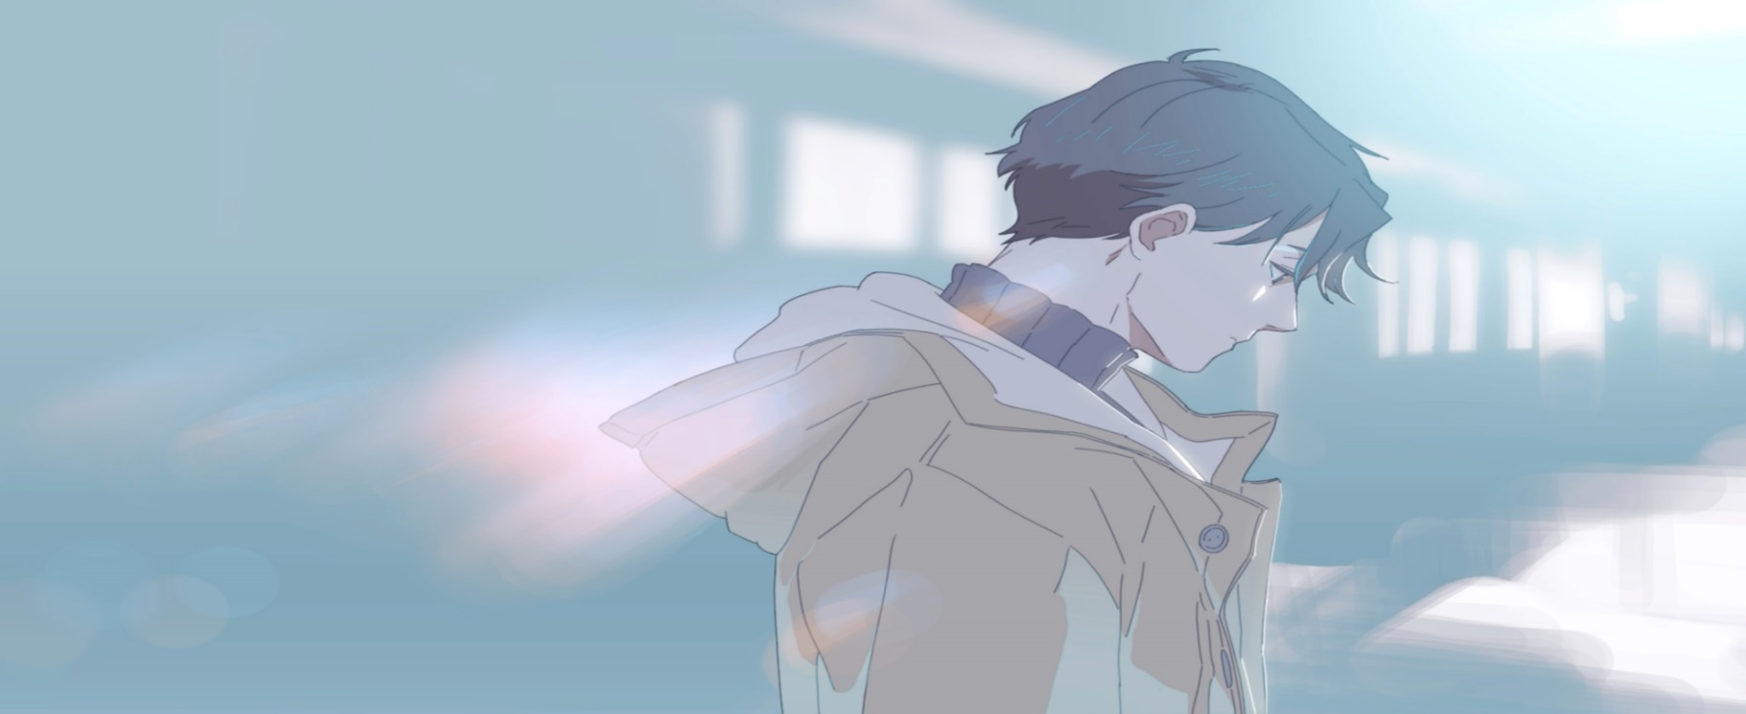
Hyperventilation
Probably the best short animation series that I have ever seen and I’ve seen dozens

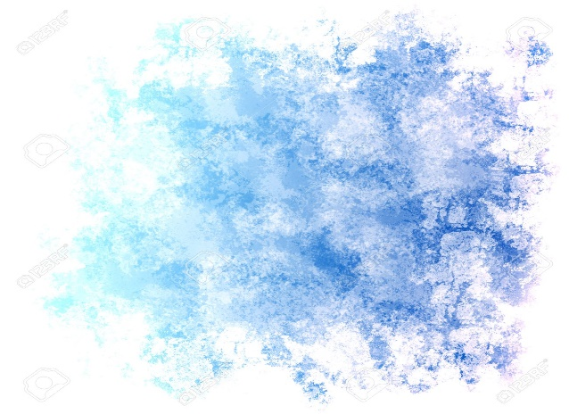

Basic Info:
Title: Hyperventilation
Genre: BL
Homepage/ channel: Laftel
Made by:
Korean animation project
Studios:
Language: Korean
Episodes: 6 (about 3 mins each)
Unfortunately this is a show you can’t watch straight from YouTube. Also Hyperventilation isn’t a short movie but a short animation series that consists of six, two to three minutes long episodes. It’s most easily available from Laftel’s international page where anybody can watch the first three episodes for free and pay minimal two bucks to unlock rest of the episodes.
It might feel like a pain compared to free and easy YouTube, but Laftel gives you excellent quality, sound and English subtitles.



The storyline isn’t something we haven’t seen before: high schoolers have grown up and meet again at class reunion.
Hyperventilation’s appeal is based on glamorous but simple art, unique way of cutting and building the scenes to easy and addictive to follow.
I think the way Hyperventilation combines past and the present moment so the episodes seem have much more time to tell than a normal series could ever put into three mins.

Also the voice quality and voice acting on this series is made by pros. The characters sound humane and realistic. As a love series Hyperventilation also succeeds to bring up it’s topic of hyperventilating without sounding ridiculous. To sum up for all who don’t find boy love unattractive Hyperventilation definitely hooks up the watcher to thirst more.

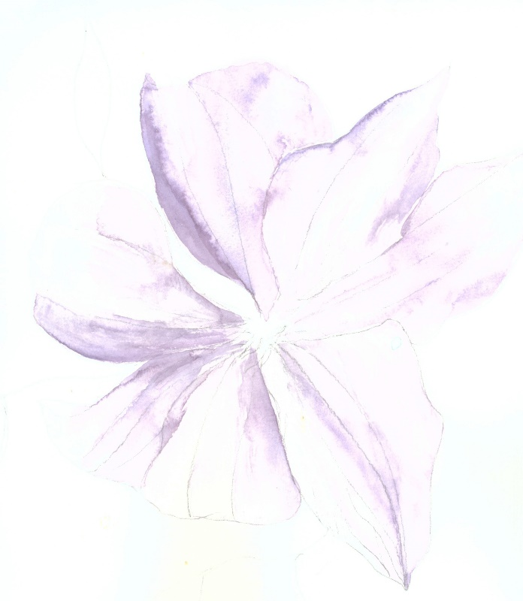
Basic Info
Produced by : Water Lily Team
Directed by : Justine Cunha, Alexandra, Batina, Clémentine Delcourt, Margaux Lahuppe, Pascal miller
Made in Supinfocom University, France
Music : Sabrina Duval
time: 8 minutes
Presented in 2015, published on YouTube in 2017
distributed by: CG meetup, Homepage

Water Lily – Birth of the Lotus

Water Lily is a Supinfocon animation school students’ graduation work. It is an invented Japanese tale about the birth of the lotus flower which is known from many Asian tales and as the symbol of the imperial royal family

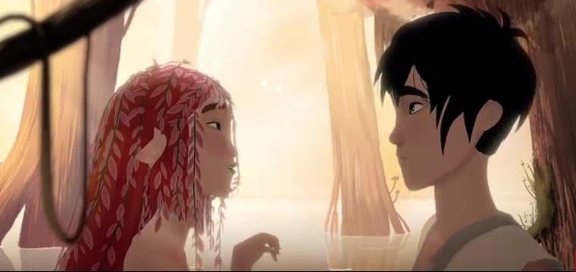
This short film takes with by its plot. It keeps the watcher’s eyes nailed on the screen for every second. The movie succeeds to touch hearts with its wistful storyline. In conclusion water lily is a beautiful and entertaining eight mins for all romantics.
The movie takes place in a peaceful dreamlike forest on a shore of a small pond The colours are light and look like an aquarelle. Light waves between trees and scenes bewitches

The animation of Water lily looks beautiful. You can tell animators have put an effort on it. It is made by, nowadays quite typical, 3d animation but holds up the quality. Movements of the characters are smooth and realistic. They don’t look like levitating as badly as cheap 3d animations are tend to do.
Despite the beautiful look, the film is concentrated around the storyline. It’s easy to fall in love with this short film.



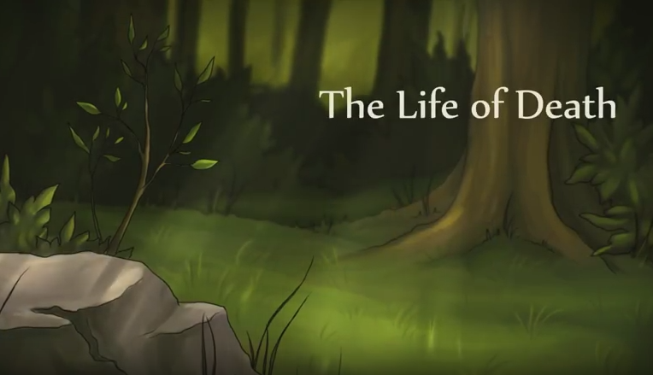

One of most entertaining moments and it only takes only 5mins!

Have u ever wondered how would it feel to be immortal? How would look like a slice of a Grim Reaper’s day? Well here’s a touching short film gives u the answer.



For a film made by one person and small group of handy helpers The life of Death’s animation is fluent. In its category the art is neat and has but a lot of effort. You can see crappy computer outlines but this girl has made it work richly.
The milieu is green and has successfully brought soft light and darkness together.

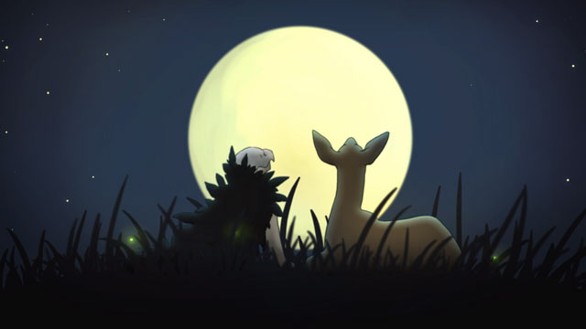

Basic Info: Made by: Marsha Onderstijn Music by Ramon de Wilde
Made in Academy of Art and Design St. Joost
Presented in 2012 published on YouTube on 2016
Time: 5 minutes Homepage: www.marshaonderstijn.com

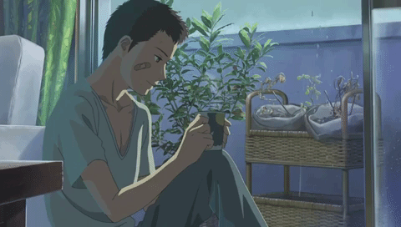
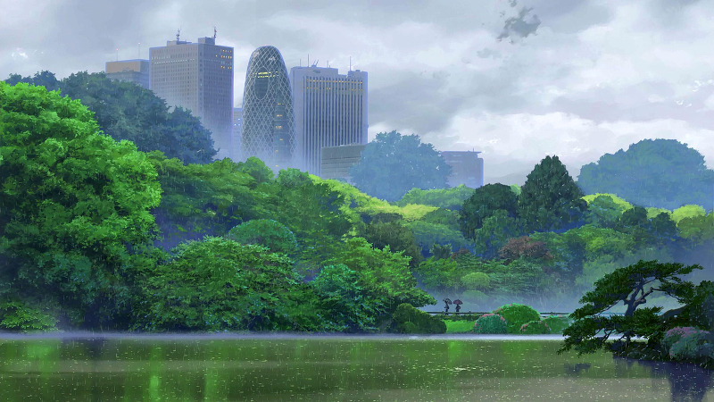

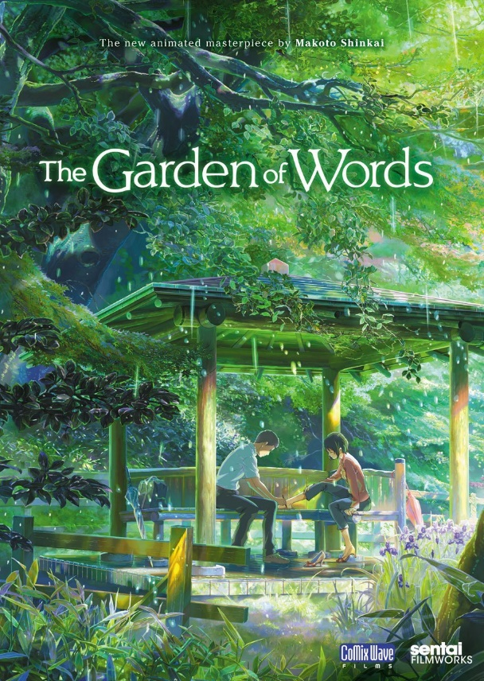
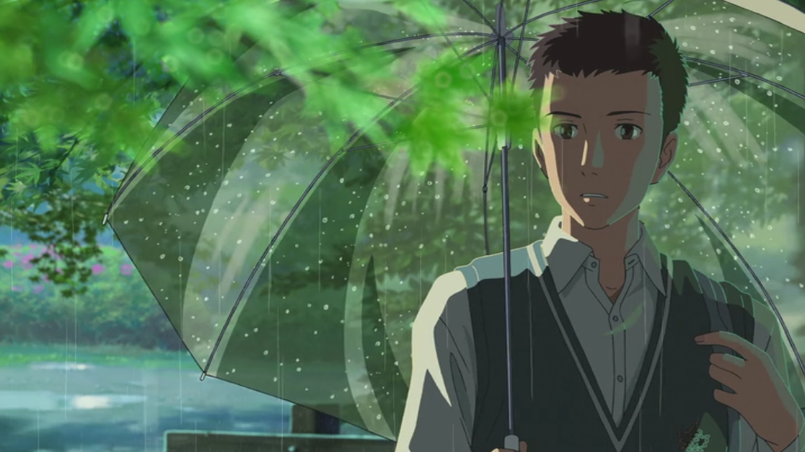
Different to the earlier reviews The Garden of Words is a professional animated movie distributed by Toho which is a huge exchange-listed company. This gives the movie free hands when it’s comes to budget compared to films made by art students.
On it’s own class The Garden of Words is exceptionally beautiful piece of art. This movie could be watched only for its amazing nature, background views and meticulous details. Shortly said the animation on this film is just OMG.
And that’s not the end of it! The Garden of Words has also interesting thoughts about love and slice of life. It takes stand on many important themes like bullying, the busy lifestyle and brings up the beauty of nature and silence.
The movie is calm but strong rebel for how we treat each others and helps us to understand that if you don’t know about peoples backgrounds so how could you judge them?

Basic info
Title: The Garden of Words (Koto no ha no Niwa)
Released in: 2013 in Japan
Language: Japanese
Genre: anime drama film
Written, directed and edited by: Makoto Shinkai,
animated by CoMix Wave Films
distributed by Toho
Go on and fell in love with those backgrounds! Especially the sceneries of nature.

