- Go to http://www.footprintcalculator.org/ to calculate your own ecological footprint. The calculator has a middle-aged and American bias, but does still give you an idea of the width of your footprint.

- Go to http://data.footprintnetwork.org/#/ to find out what the concepts
- ecological deficit/reserve
- total ecological footprint
- ecological footprint per person
- total biocapacity
- biocapacity per person
mean. Compare the Finnish figures with one other country of your choice.

- Answer to the content questions.
a) Mitä “World Overshoot Day” tarkoittaa?

b) Miten vuosittainen “Overshoot Day” -ajankohta lasketaan?

c) Mitkä eri tekijät vaikuttavat päivän ajankohtaan?

- Find the following words in the box

hiili uusiutuva
kuitu biopolttoaine
ekoteko päästö
paperimassa aurinko-
vesivoima saaste

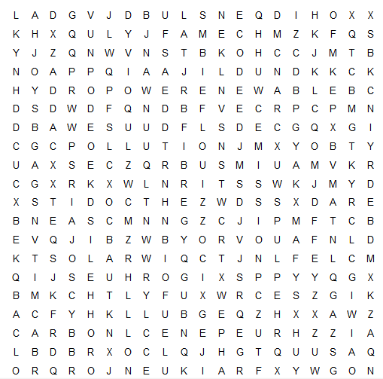

- Complete the crossword
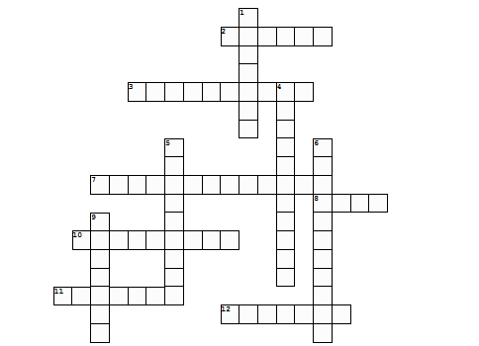

Across Down
2. hiili(dioksidi) 1. elinympäristö
3. keinokastelu 4. ylikalastus
7. metsien hävittäminen/hakkuu 5. kasvimyrkky
8. maaperä 6. kuluttaminen
10. hyönteismyrkky 9. hedelmällinen
11. ilmasto
12. (maaperän) kuluminen

Mathis Wackernagel: How much Nature do we have?

- Mitä Wackernagel tarkoittaa ’ecological bankruptcy’ –käsitteellä?
- Mitä tarkoittaa ’biocapacity’?
- Miksi maapallon biokapasiteetti on kasvanut?
- Miten ’ecological reserves’ maailmankartta on muuttunut puhujan syntymästä (60-luvulla?) nykypäivään?
- Miksi 70-luvun öljykriisi oli puhujalle upeaa aikaa.
- 40-luvulla YO määritteli ihmisoikeudet, 2010-luvulla sustainable development goals
-> selitä, mikä kestävän kehityksen tavoitteiden idea on.
- Millä mittareilla kestävää kehitystä voi mitata? Selitä laskukaava.
- Miksi Wackernagel mainitsee Lontoon ja Abu Dabin?
- Mitä tarkoittaa ”thinking inside the box”
- selitä nämä kolme ydinpointtia
Measure – you can manage what you measure
When you have the metrics -> Use you voice
Your life

I am delighted to welcome you all to the 26th United Nations _________________ _________________ ____________________; and it is perhaps fitting that you have come together in Glasgow, once a heartland of __________________ _________________, but now a place to address climate change. This is a duty I am especially happy to discharge, as the ___________________________ ___ ___ _______________________ ____ ___ ____________________ ________________________ was a subject close to the heart of my dear late husband, Prince Philip, The Duke of Edinburgh. I remember well that in 1969, he told an academic gathering: “If the world _______________________________ ________________________________ is not critical at the moment, it is as certain as anything can be, that the situation will become increasingly intolerable within a very short time … If we fail to cope with this challenge, all the other problems will ____________________ ____________ _______________________________.” It is a source of great pride to me that the leading role my husband played in encouraging people to ____________________ ____ __________________ ____________________, lives on through the work of our eldest son Charles and his eldest son William. I could not be more proud of them. Indeed, I have drawn great comfort and inspiration from the relentless enthusiasm of people of all ages – especially the young – in calling for everyone to play their part. In the coming days, the world has the chance to join in the ________________ ______________________ of creating a safer, stabler future for our people and for the planet ___ _____________ ________ _________________. None of us underestimates the challenges ahead: but history has shown that when nations come together in common cause, there is always room for hope. Working side by side, we have the ability to solve the __________ __________________________ ______________ and to triumph over the __________________________ _____ _____________________. For more than seventy years, I have been lucky to meet and to know many of the world’s great leaders. And I have perhaps come to understand a little about what made them special. It has sometimes been observed that what leaders do for their people today is ______________________ ___ _________________. But what they do for the people of tomorrow — that is ______________________________ . I, for one, hope that this conference will be one of those rare occasions where everyone will have the chance to rise above the politics of the moment, and achieve true statesmanship. It is the hope of many that the ___________________ ___ _______ ___________________– written in history books yet to be printed – will describe you as the leaders who did not pass up the opportunity; and that you answered the _________ _____ _____________ _________________ _______________________. That you left this conference as a community of nations with a _____________________________, a ____________________, and a ________________ , to address the impact of climate change; and to recognise that the time for words has now moved to the _______________ ____ ________________. Of course, the benefits of such actions will not be there to enjoy for all of us here today: we none of us will live forever. But we are doing this not for ourselves but for our children and our children’s children, and those who will__________________ ___ __________________ ____________________. And so, I wish you every good fortune in this _____________________ ____________________________.

