Erasmus-project / Royan France

Wednesday 5.4.2016

The day started at 7.30 when our bus left from home to school.
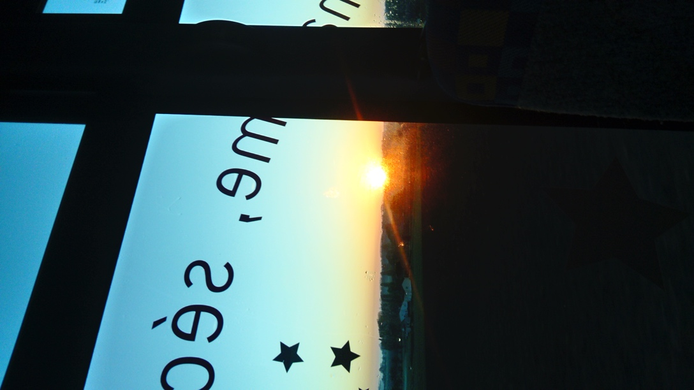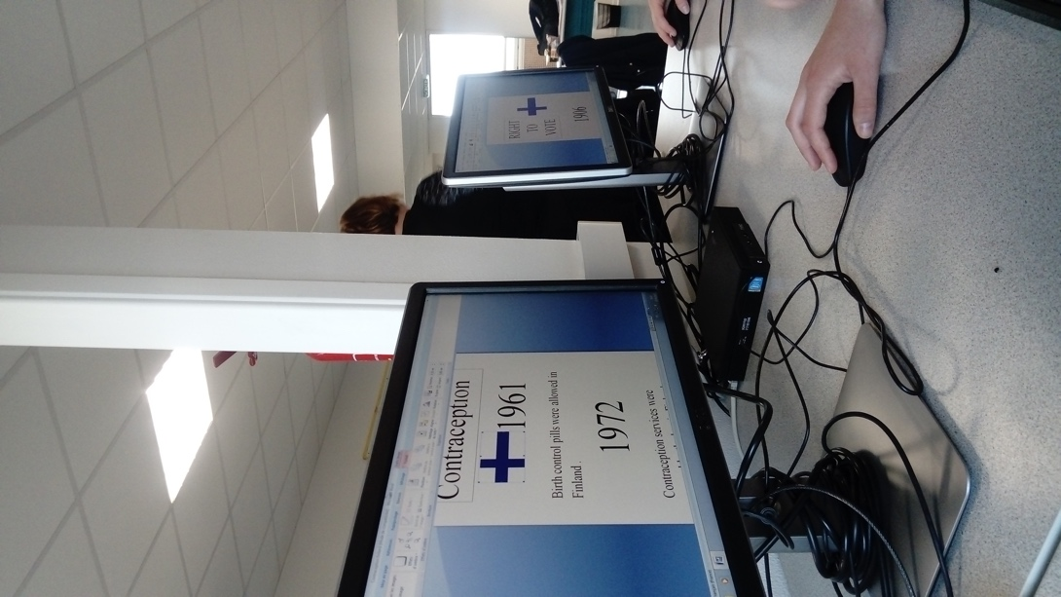
View from the bus

In school we worked on the computer and wrote the important dates of Finnish women rights. Every group made a study of the legislation of their own homecountry.

Then it was lunchtime! The schoolfood is extra delicious there, ut then again, the French have to pay for it.. We ate salads, French fries and some soft-boiled eggs. As dessert, we had yogurt and fruit.
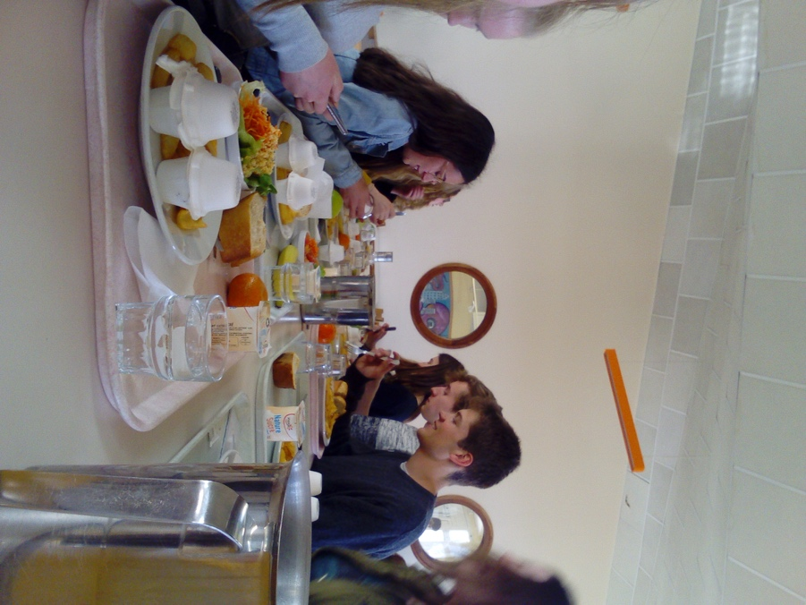

We heard speeches about humanrights.
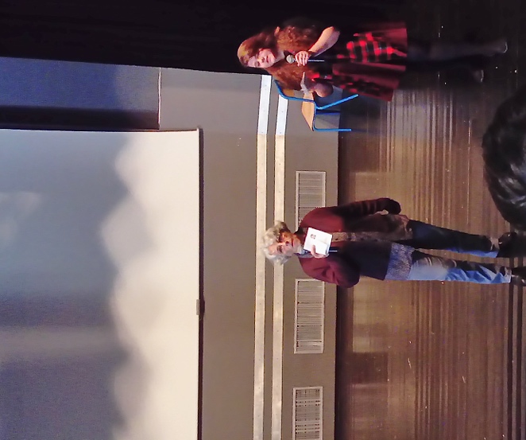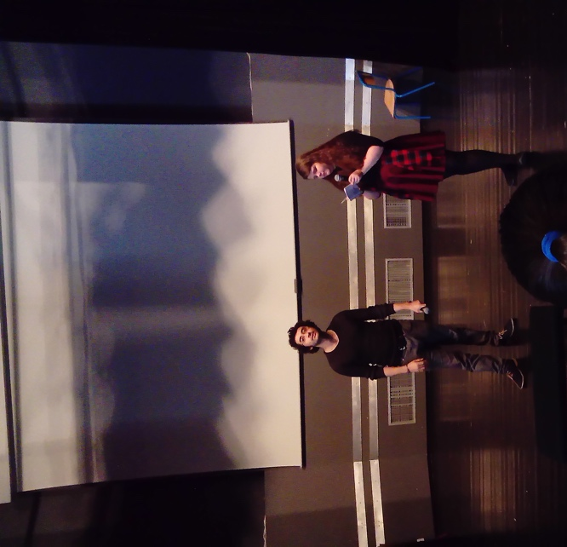
Marie-Agnes Bretenou talked about history of human rights. A Syrian journalist and poet Omar Souleimane talked about the situation of Syria. (Rachelle translated into English.)

The schoolday finished already 13.00 and most of the students went to La Palmyre Zoo! We spent there almost five hours because it was so large. There were many amazing animals and the environment was so beautiful in zoo.
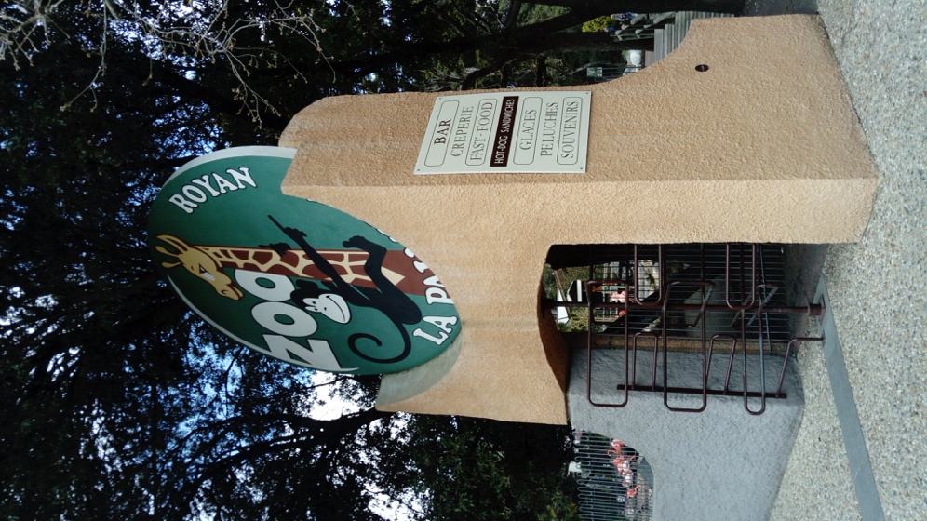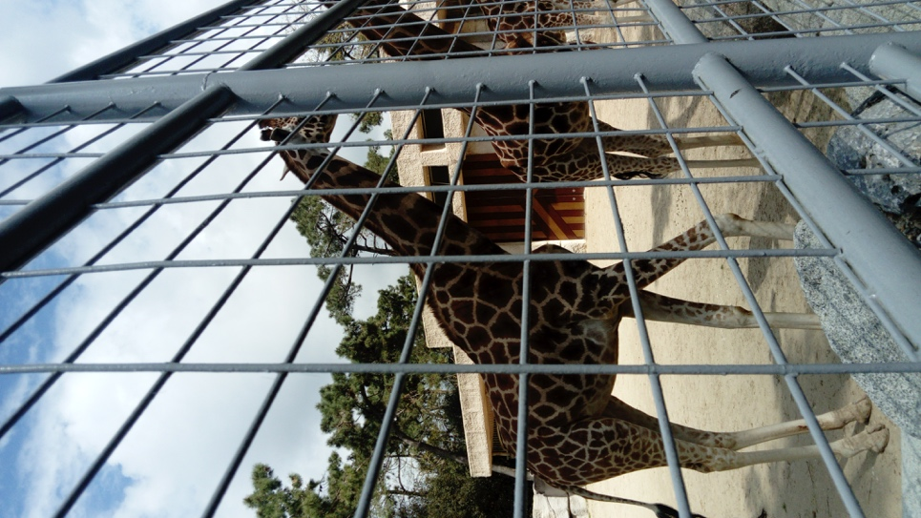
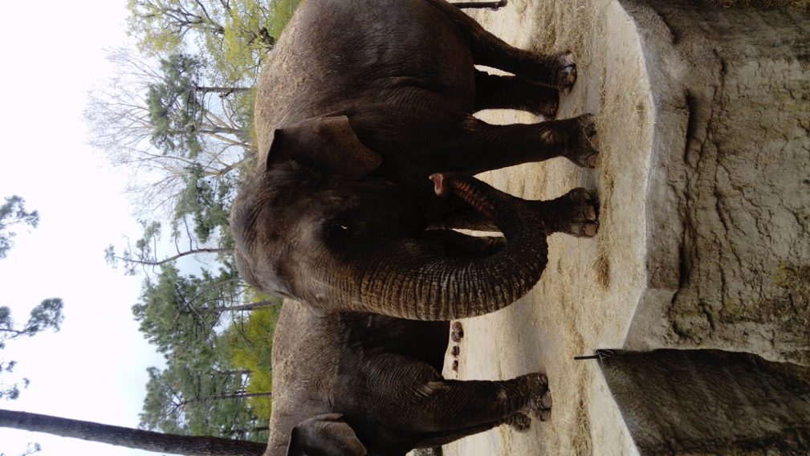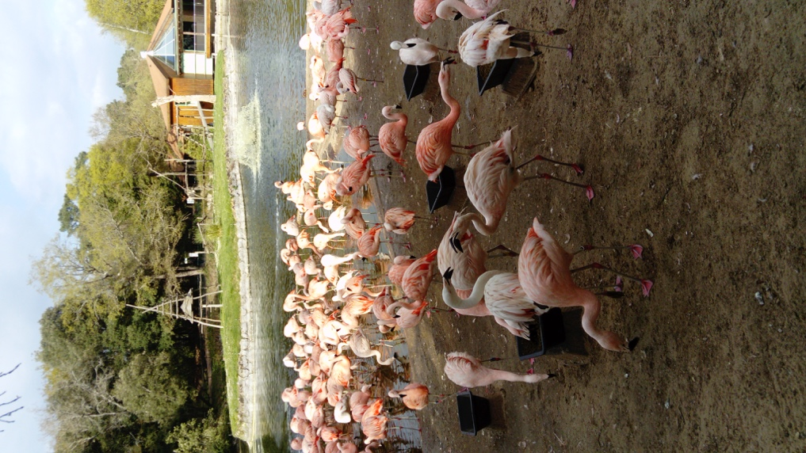
Giraffes, elephants, flamingos…

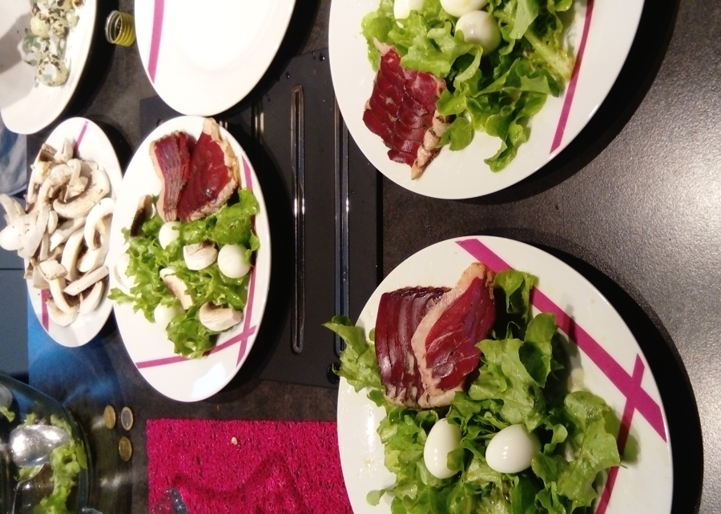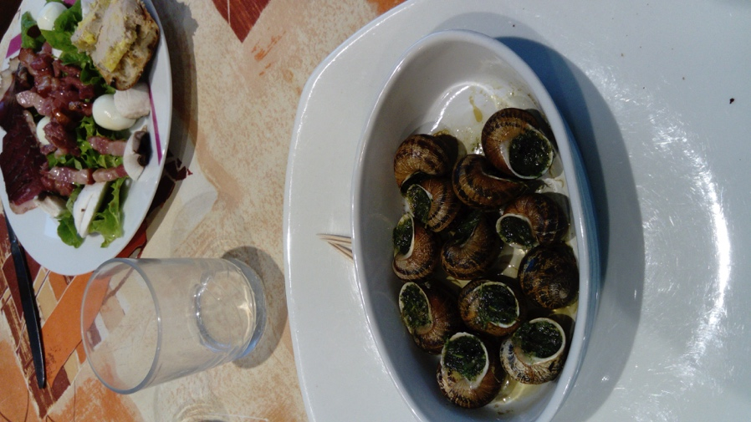
At home, we cooked dinner: salad, bacon, quail eggs, claims and of course baguette.
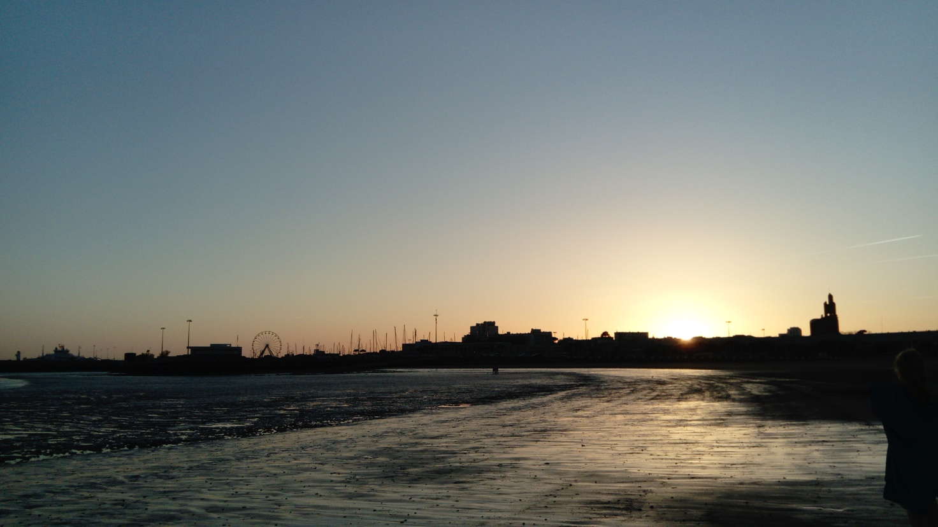
We went to bed about 23.00 Good night!

By Amalia Oja solu15

