Finnish folk song “On suuri sun rantas autius”

“Great Is the Desolation of Your Shore”

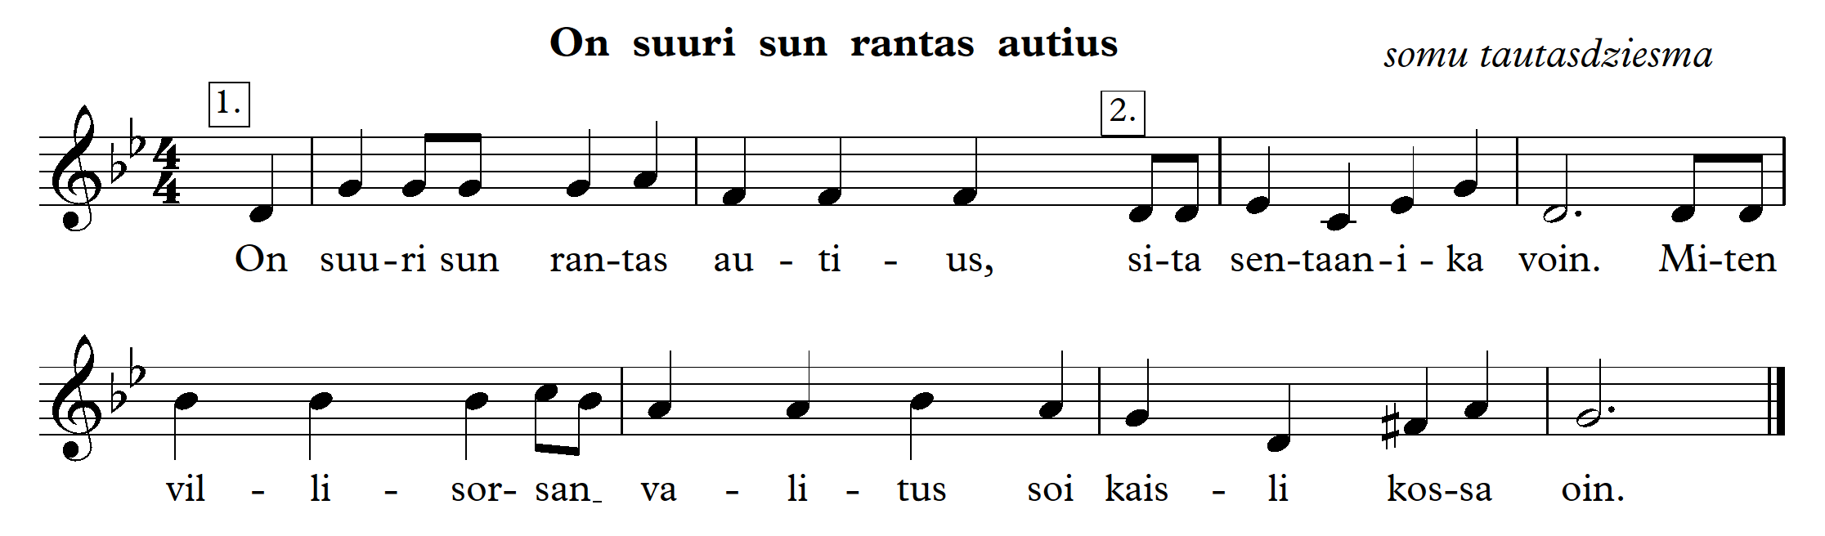

<https://www.youtube.com/watch?v=DqsOq3BcZVM>

1. G (Sol) minor (g moll) – types of minor scale

* A scale with a rhythmic accompaniment.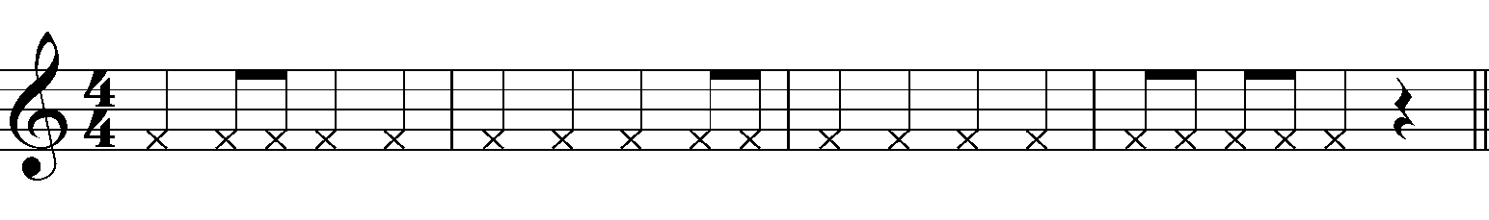

1. Clap the rhythm of the song, slightly accenting the first beat.

* Pulse with your left hand and play the rhythm with your right hand.
* Play the rhythm with your feet.
* Play the following rhythm with your hands 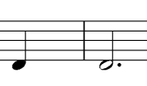, with your feet.

1. Sing the melody and pulse.

* Sing the melody and conduct in 4/4.
* Sing the melody with a rhythmic accompaniment.

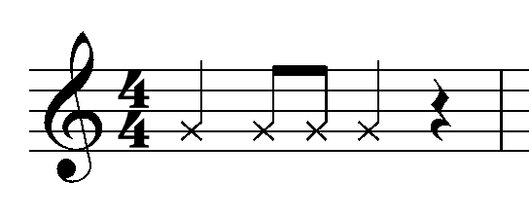

* In the melody, sing only perfect fourths (t4), minor sixths (m6) and minor thirds (m3).
* Divide the class into 2 groups – Group 1 sings , Group 2 sings 

**Lesson 2**

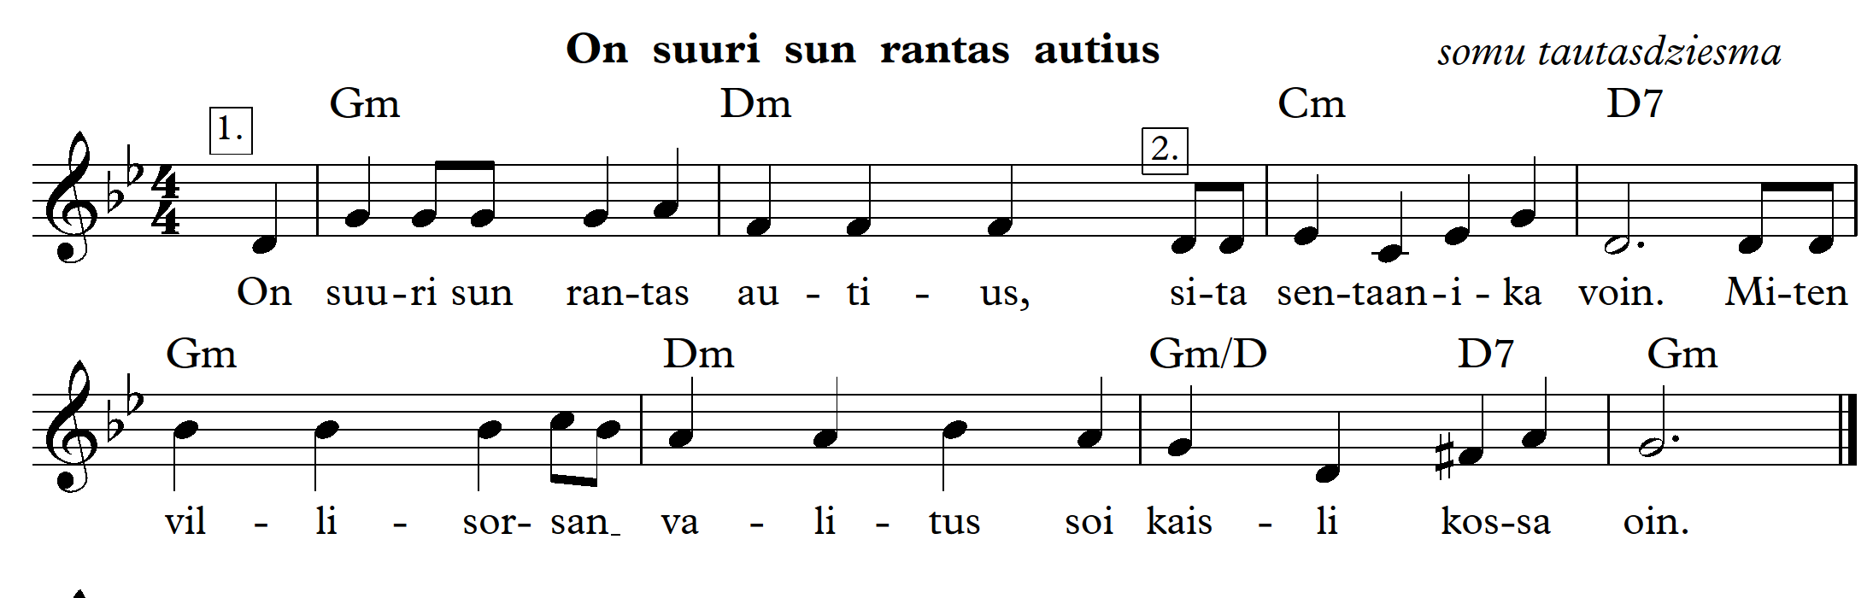

The song in two voices

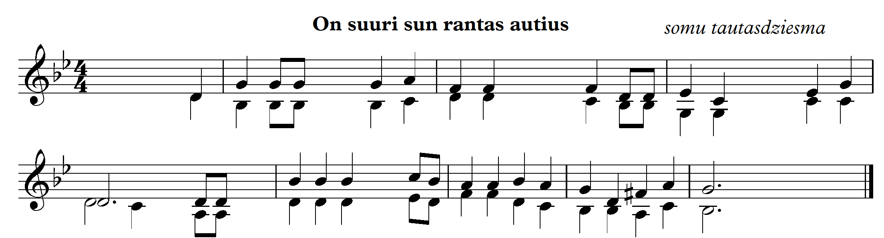

1. Create an accompaniment (write down the given chords Gm, Dm, Cm, D7, Gm/D). Write the chords with notes.

2. Sing in two voices.

3. Sing in two voices with percussions.

4. Listen to the song arranged in a different style.

<https://www.youtube.com/watch?v=QoZwHkYu6aM>

5. Sing the song in a different singing manner, add your own accompaniment.