**Belgian folk song “Komt, vrienden, in het ronde“**

**„Friends in the round“**

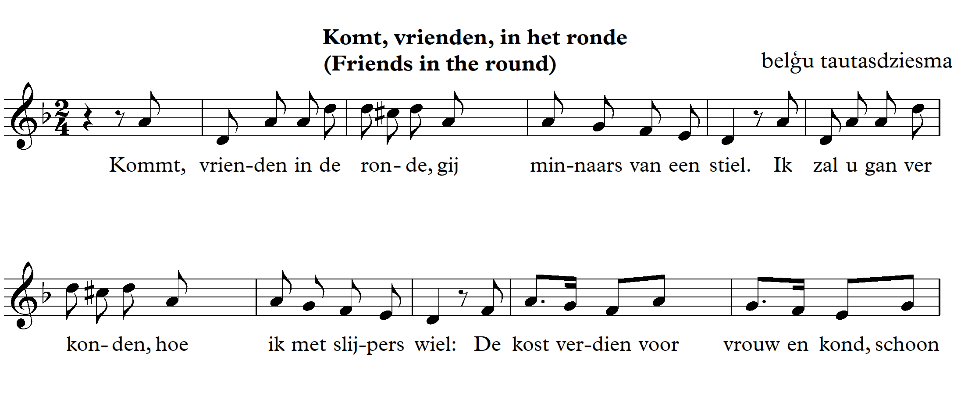

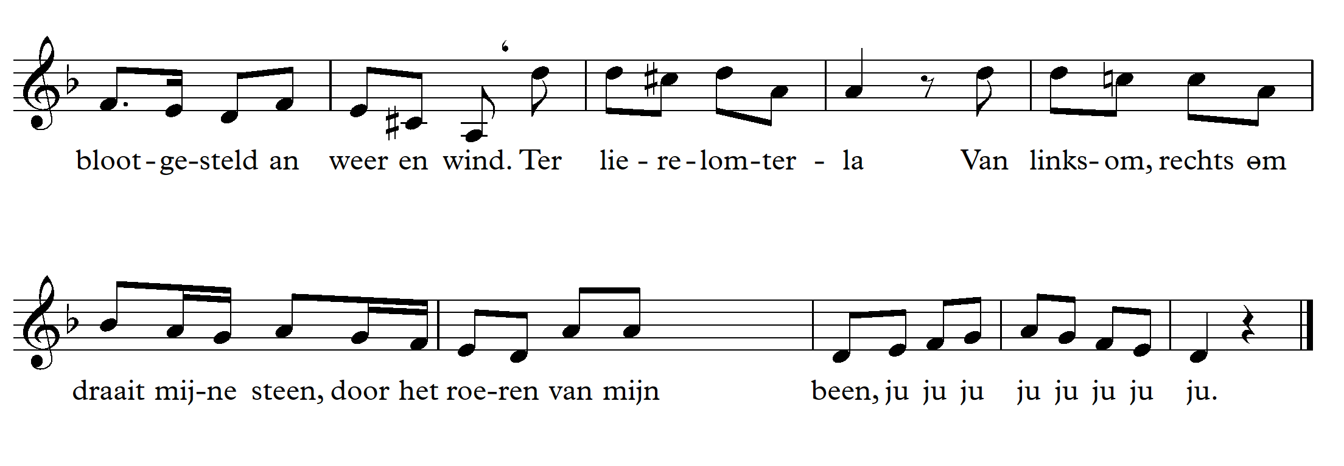

1. Play a rhythm.

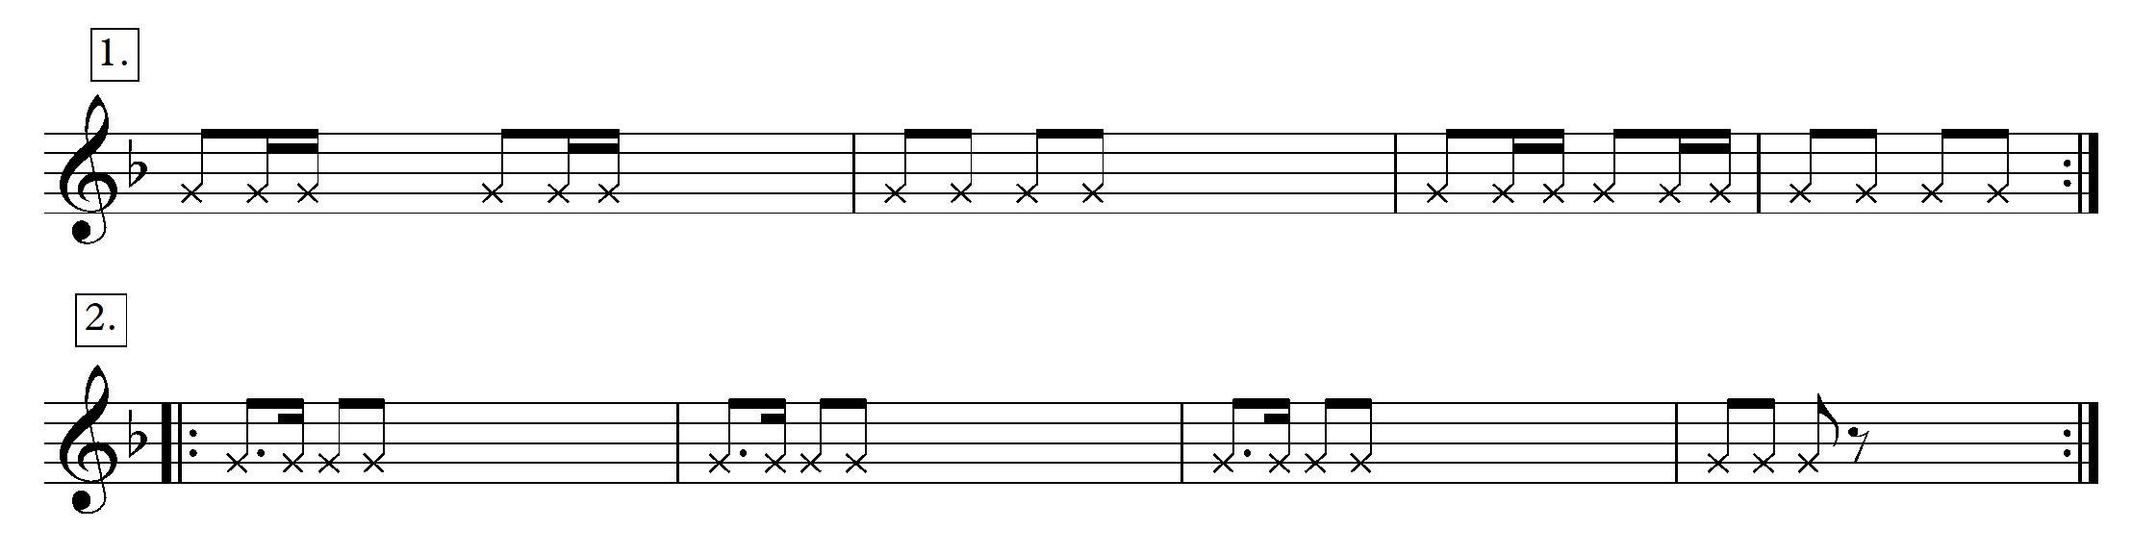

1. Sing the song with the note names.

Example from theory lesson:

<https://youtu.be/up53LlPe6o4>

1. Listen to the song.

<https://www.youtube.com/watch?v=bn4P5GLqnnI>

<https://www.youtube.com/watch?v=g7eYqacZGMU>

<https://www.youtube.com/watch?v=TnSE4939mx8>

1. What is the character of the song?
2. What could the song be about?
3. What is the tempo?
4. What is the key like (happy, sad)?
5. What is the range of the melody? What does the range suggest about the time when it was composed?
6. At the beginning, there are skips in the melody. What are the intervals that make up the melody of the song?
7. Sing the stable intervals in D minor (d moll) (on scale degrees I and V)
8. Sing the D minor (d moll) – natural and harmonic.
9. Sing the D minor (d moll) with the given rhythm.
10. Measures 9, 10, 11 of the song – continue the sequence.
11. Measure 16 of the song – in a sequence.
12. Last two measures – sing in two and three voices.
13. Upbeat – sing the upbeat of each measure (the last sound of each measure and the first sound of the following measure).
14. Sing only the notes in the melody that contain the rhythm of Group 1. The second time, sing the eighth notes of the melody, beat time for the rest of the sounds.
15. Two groups (Group 1 sings the upper rhythms of the melody, Group 2 – the lower rhythms).

Example from theory lesson:

<https://youtu.be/7rEf7sSWIic>

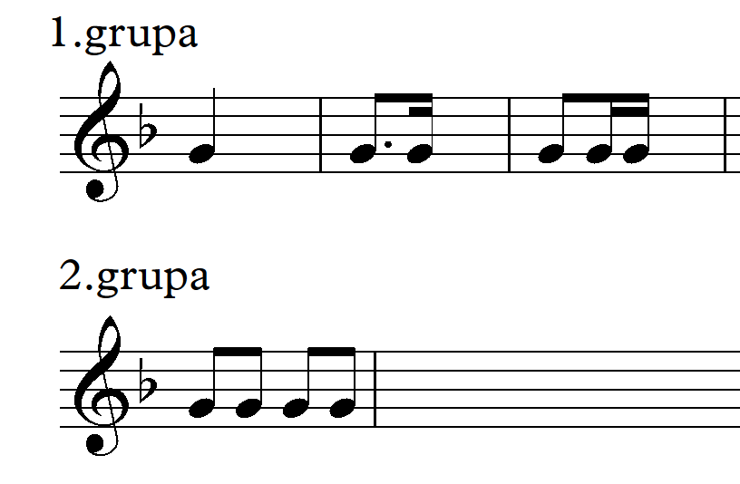

**Lesson 2**

1. Sing the song in one voice.





2. Sing with a rhythmic accompaniment.

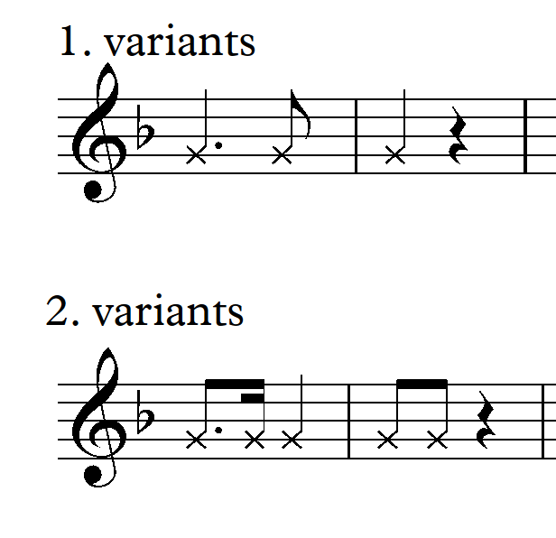

3. Play the rhythm of the Version 1 with the feet.

4. Sing in two voices (last 3 measures – in three voices, the middle voice holds D (Re).

Example from theory lesson:

<https://youtu.be/5DRny8Rxr7A>

<https://youtube.com/shorts/Wkv9pvKjlsE>

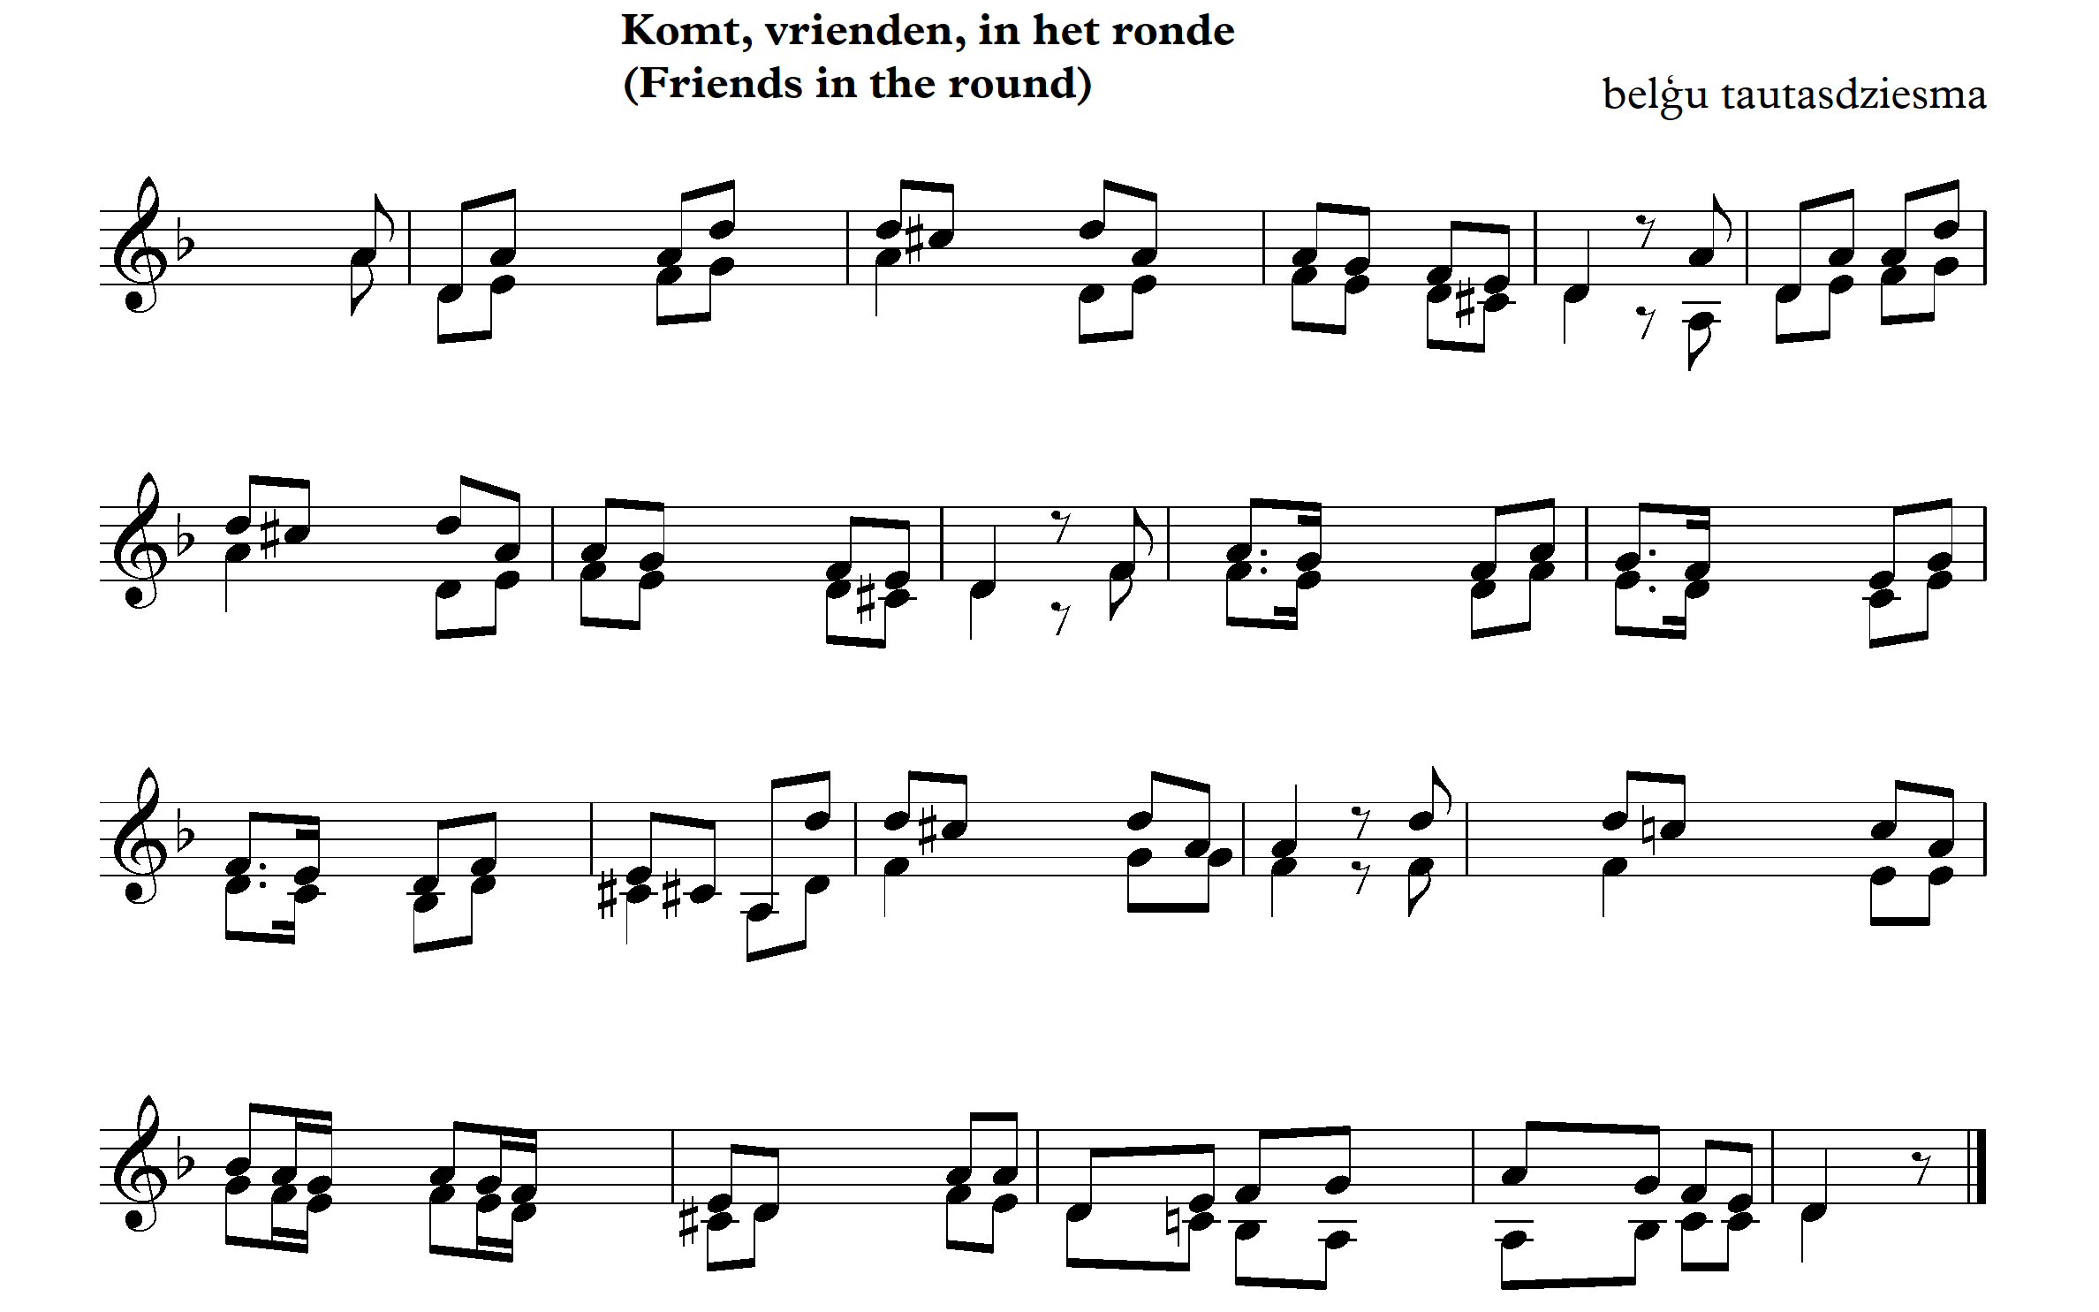

5. Add an accompaniment.

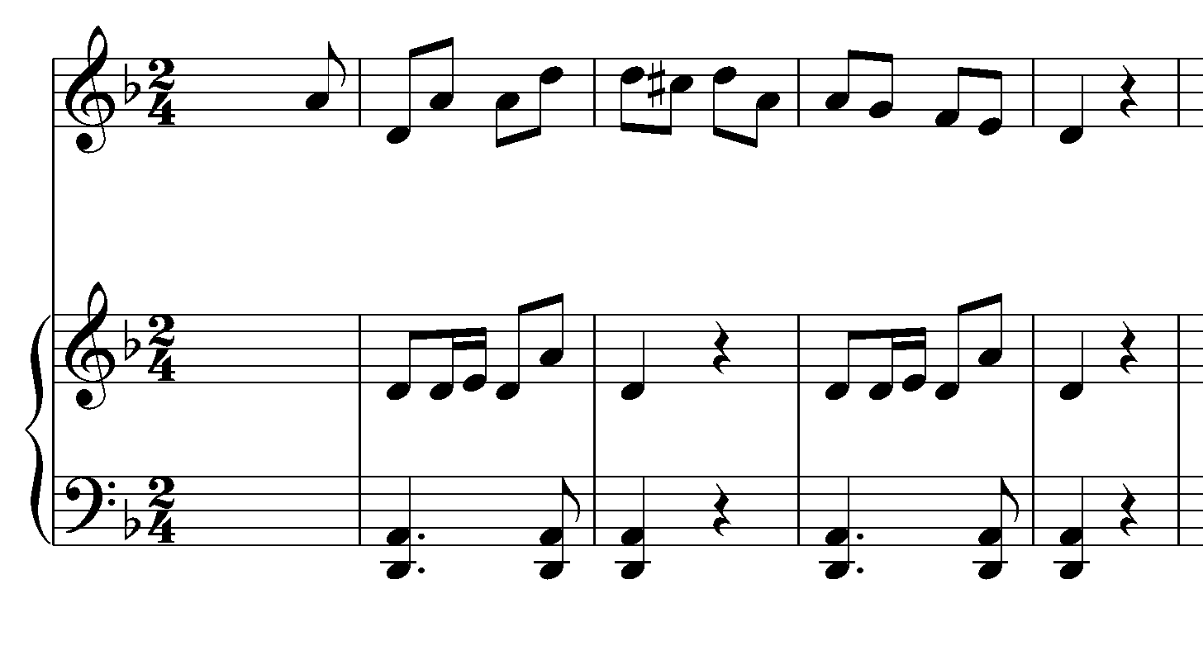

6. Sing the song in two voices – add a rhythmic and piano accompaniment.

Good luck!

Attached is the English translation of the song.

**FRIENDS IN THE ROUND**

The song is about the craftsman who went past the doors with a cart to sharpen the knives and explains why his profession is the best. The current text about the scissor sharpener was recorded in 1895 by Jan Bols from Lubbeek,Flanders. Two years later it was included in the collection Hundred old *Flemish songs.*

1.Come friends in the roundLovers of a craft! I will tell youHow I get through the grinder's wheel Earning a living for wife and childCleanly exposed to weather and wind

(Refrain)

Terlierelomterla! From the counterclockwise my stone turns By stirring my legJujujujujujujujuju!

2. The blacksmith who has to work hard,Steady for the four,He does not dare to strengthen himself,With one can good beer,While I go at ease,Sometimes also with an empty bag.

(Refrain)

3. The shoe pick stiff seated,On a pitch chair,May cheese and dry beer eat,But if I feel need,Then I sharpen until the evening,And so I never have poverty.

(Refrain)

4. My wife who calls victoria,About the grinder's stall,She finds the biggest gloria,In the turning of my wheel,My children have no discomfort,Theywalkwith the begging bag!

(Refrain)

5. Sa, friends, for the last,All' crafts are good,But mine is still the best,Clean I sometimes have to sleep,On hay and sprinkle in one stable,There I have a cost for nothing.