Comenius meeting Poznań April 2014
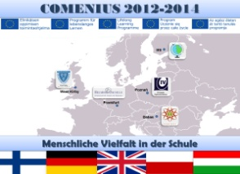

- Wednesday 02.04.2014:
19:00 supper in the restaurant

- Thursday 03.04.2014:
09:00 meeting in school, opening ceremony
10:00 arrival of German head teacher
12:00 lunch
13:00 trip round Poznań
18:30 supper in the restaurant

- Friday 04.04.2014
09:00 meeting in school
11:00 meeting with coordinators
12:00 lunch
13:30 visiting Palace of President in Poznań
17:00 supper in the restaurant
19:00 opera’s performance

- Saturday 05.04.2014
09:30 surprise: trip
12:30 departure of English head teacher
18:00 supper in Agata’s house

- Sunday 06.04.2014
11:30 meeting in school
12:00 lunch
13:00 presentation of workshops
18:00 departure of German head teacher
18:00 official revision of Comenius Project

- Departure day

