**CONSERVATORIO PROFESIONAL DE MÚSICA DE OSUNA - CALL FOR SELECTIONS**

**STUDIES PROJECT DURING ACADEMIC YEAR 2024/2025 WITHIN EUROPEAN COMISSION OF ERASMUS+ PROGRAM**

**(2024-1-FI01-KA220-SCH-000244269 -**

**COMMON - Creation Of a Master Musical Of Nature)**

The Conservatorio Profesional de Música de Osuna CALLS FOR THREE POSTS with the aim of participating in the International Students Program COMMON, doing an academic collaboration with other institutions within the CPM-Osuna partner agreements.

COMMON (Creation Of a Master Musical Of Nature) is an Erasmus + project whose main objective is to create and perform a Musical Theatre workpiece. The organization of the whole creative process and all the issues needed for its development will be held by the next institutions:

***\* Ylä-Savon musiikkiopisto -Finland***

***\* Fondazione Scuola di Musica di Fiesole Onlus Italy***

***\* Academie Muziek Woord Dans Bornem-Belgium***

***\* Lielvarde District Music and Art School Latvia***

***\* Conservatorio Profesional de Música de Osuna. Fundación Pública de Estudios Universitarios Francisco Maldonado-Spain***

This way, a practical training is offered and integrated into an international context to students from the 2nd to 6th years inside the CPM-Osuna

Through this announcement, participation conditions are established for this Erasmus+ programm

**BASES OF THE CALL**

# **AIM OF THE CALL**

The main objective of this call is the selection of a certain amount of students to be granted with a post to conform a work team that will elaborate the libreto/screenplay of the Musical Theater piece.

The total amount of posts is: THREE

***ACTIVITY DESCRIPTION***

The making of the libretto is the first phase of the COMMON project and it will take place from October 2024 to February 2025 (exact dates will be confirmed soon). The selected students will participate in eight online sessions with a duration of 90 minutes/each. The students will have to be present at the CPM-Osuna but connected with the students from the other teams.

Then in early 2025, a live meeting will be held at CPM-Osuna to end and refine the whole libreto.

1. **PARTICIPATION REQUIREMENTS**

To take part in the selection process, applicants must meet, on the date of the deadline for submitting applications, the following requirements:

1- Be enrolled in the Professional Conservatory of Music of Osuna, in the 2nd to 6th years

2-In the case of minors, authorization from the father / mother or legal guardian

3-Have passed the previous year in full.

4-The age limit for participants will be 18 years old (in 2024)

# **3. SELECTION CRITERIA**

For the selection of students who meet the aforementioned requirements, the following parameters will be assessed:

1. Academic record: average grade of all the subjects taken the previous year at the Conservatory (maximum 4 points):

* Average grade between 9 and 10: 4 points
* Average grade between 8 and 8,99 puntos : 3 points
* Average grade between 7 and 7,99: 2 points
* Average grade between 6 and 6,99: 1 point
* Average grade between 5 and 5,99: 0 points

1. Accreditation of language level- english/french/german/italian (maximum 2 points):

* Level A2 : 0,5 points
* Level B1: 1 point
* Level B2 2 points

1. Preparation of a creative work (maximum 5 points): aspiring students must submit an original written expression, with a theatrical script structure, a minimum length of one page, Times New Roman font, with font size 12 and line spacing at 1.5. The premise from which the written expression must be developed will be the headline indicated below. Annex II of this call shows a model of theatrical script on which to base the structure of written expression.

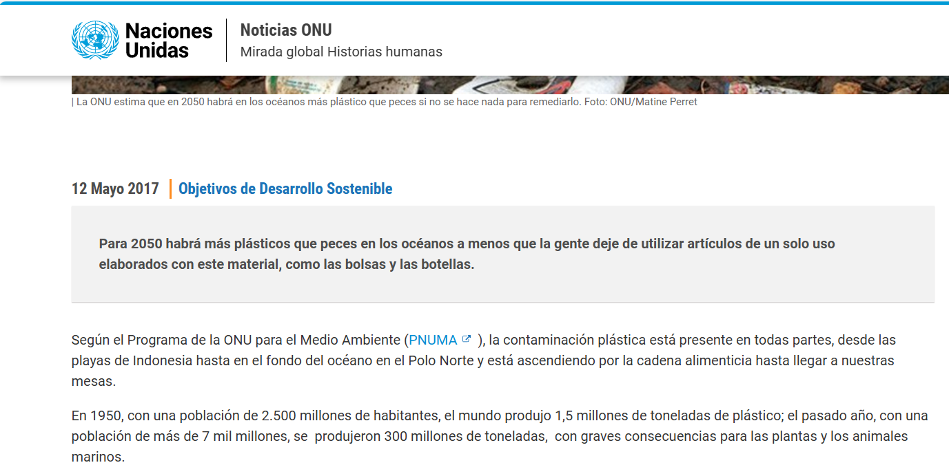

1. Personal motivation interview (maximum 2 points)

In the case of students with the same score, priority will be given to students who have not previously been selected in any Erasmus or Erasmus + programme, and a report will also be requested made by the teaching team and signed by the tutor in the first place, on the requirements in the following order: academic record, level of knowledge of the language, socioeconomic situation and degree of disability, if any.

**4. EXCLUSION FROM THE CALL**

Possible reasons for exclusion may include:

-Delivery of documentation after the deadline.

-Delivery of incomplete or incorrectly completed documentation if, after being reviewed, the incident is not corrected within the indicated period.

-Irregular situation in the country

-Criminal record

-Other reasons duly justified by the Selection Board.

The Tribunal is empowered to resolve any doubts that may arise and make the necessary agreements in relation to the selection process convened, as well as for everything not provided for in these Bases.

**5. SELECTION PROCESS**

The assessment and selection of the applicants will be carried out by the Qualifying Tribunal, whose composition, members and alternates, will be approved by Resolution of the Presidency of the "Francisco Maldonado" University Studies Foundation together with the approval of the list of Admitted Candidates.

***COMPOSITION OF THE SELECTION BOARD:***

* President: Appointed by the President of the Foundation.
* Vocals:
  + Manager of the University School, or person delegated.
  + Vocal, appointed by the President of the Foundation.
* Secretary: The Secretary of the Professional Conservatory of Music of Osuna or person delegated by him.

**6. APPOINTMENT AND PRACTICAL CONSIDERATIONS OF THE FELLOWS**

For the final award of the scholarships, the beneficiaries must record their acceptance by means of a written declaration, within a maximum period of 3 calendar days from the notification of the granting of said scholarship. The aforementioned declaration must be sent by email to the address XXXXXX@XXXXXX.XXX. If the period of three days has elapsed without having expressed acceptance, without justified cause, this concession will be automatically revoked.

Acceptance of the status of Erasmus + Fellow entails the acceptance of the following obligations:

a.- Sign the Learning Agreement to make the objectives to be achieved transparent for all parties involved.

b.- Comply with all negotiated agreements and do everything in their power to make the project successful.

c.- Comply with the rules, regulations, working hours, codes of conduct and confidentiality, established by the organizing institution

d.- Communicate to the organisation or person in charge of their training centre any problem or change related to their selection.

e.- To participate in any pedagogical, linguistic and cultural preparation activities organized by the promoting entities, before and after the project.

f.- To inform this Entity as soon as possible in the event of resignation of the scholarship or any other serious incident that could affect the normal development of the scholarship.

Once these procedures have been completed, the Management of the Centre will proceed to his/her definitive appointment as an Erasmus + Fellow.

**7. SUBMISSION OF APPLICATIONS**

The deadline for submitting applications will be open from the day following the publication of this call, for 7 calendar days. These applications must be submitted according to Annex 1 of this call with the documentation indicated therein, either at the Secretary's Office of the Centre in physical form or electronically by sending it to the email address: XXXXX@XXXX.XX. The application form will also be available, during the submission period, on the website XXXXXXXXXXX

**8. LIST OF ADMITTED CANDIDATES**

Once the deadline for submitting applications has ended, the Presidency of the Municipal Foundation for University Studies will approve the list of admitted and excluded candidates that will be made public on the Notice Board of the Professional Conservatory of Music of Osuna and, for information, on the website of the Professional Conservatory of Music of Osuna, for a period of two working days during which the interested parties may present the allegations they deem appropriate and that will be resolved by the Presidency.

Once the complaints of the excluded applicants have been resolved, the final lists of admitted and excluded candidates will be published, by the aforementioned procedure