WOLF ENRICHMENT AT THE UK WOLF CONSERVATION TRUST
INCLUDING NATURAL WOLF BEHAVIOUR

Dissertation: Wolf Enrichment at the UK Wolf Conservation Trust Including Natural Wolf Behaviour
Agricultural science
Animal Attendant
Suvi Hall
Northern-Central Finland’s Studying Institute
04.06.2014

Northern-Central Finland’s Studying Institute SUMMARY
Department  Natural resources and Environmental sciences | Vocational qualification  Animal Attendant
Author
Suvi Hall
Name of dissertation
Wolf Enrichment at the UK Wolf Conservation Trust Including Natural Wolf Behaviour
Vocational level
Agricultural science, undergraduate
Date of presentation  2.6.2014 |  | Pages  85
Links / Attachments
5 / 3
In this work, I go through thorough descriptions of the grey wolf and its natural behaviours, include important comparisons to domestic dogs, go through different types of enrichment and its important key points, and end with concrete examples of enrichment used at the UKWCT.

Keywords
Grey wolf, enrichment, natural behaviour, domestic dog, stereotypical behaviour, UK Wolf Conservation Trust

Table of Contents
- INTRODUCTION 1
- WHAT IS THE UKWCT? 1
  - MY EXPERIENCE 2
- ABOUT WOLVES 2
  - HISTORY 2
  - THE WOLF AS A SPECIES 3
  - THE WOLVES AT THE UKWCT 5
- WHAT IS ENRICHMENT? 17
  - WHAT ARE A WOLF’S NATURAL BEHAVIOURS? 17
    - GENERAL TRAITS 17
      - SENSES 21
    - THE LIFE CYCLE OF A WOLF PACK 30
    - MYTHS, MISBELIEFS AND MISCONCEPTIONS 44
- WHY ENRICHMENT? 57
  - WHAT IS A STEROTYPICAL BEHAVIOUR? 58
    - STEREOTYPICAL BEHAVIOURS IN WOLVES 58
- ENRICHMENT TYPES 59
  - SENSORY ENRICHMENT 59
  - ENVIRONMENTAL ENRICHMENT 59
  - FEEDING ENRICHMENT 59
  - SOCIAL ENRICHMENT 60
  - TRAINING ENRICHMENT 60
  - MANIPULATION ENRICHMENT 60
  - PROBLEM SOLVING ENRICHMENT 60
- POSITIVE AND NEGATIVE ENRICHMENT 61
  - SUCCESSFUL ENRICHMENT 61
- ENRICHMENT IN PRACTISE AT THE UKWCT 61
  - SENSORY ENRICHMENT 62
  - ENVIRONMENTAL ENRICHMENT 66
  - FEEDING ENRICHMENT 69
  - SOCIAL ENRICHMENT 72
  - TRAINING ENRICHMENT 74
  - PROBLEM SOLVING ENRICHMENT 75
  - CELEBRATIONS 77
- WORKING TOGETHER 80
  - STUDENTS 80
  - OTHER ANIMAL COLLECTIONS 81
- CONCLUSION 81
- LINKS AND ATTACHMENTS 82

INTRODUCTION
From November to December 2013, I carried out a work-training period for 5 weeks. This work-training period was meant to take place with animals, of virtually any kind, and to carry out work with them. I discovered, through the internet, the UK Wolf Conservation Trust in England, where I applied, and did my 5 weeks there.
I got to take part in most things and learnt a lot about wolf behaviour. One of my tasks was to create and carry out enrichment.
Through this, I got interested in all the different kinds of enrichment and their different results, and started studying it in depth and applying my knowledge to the two pygmy goats that the trust owned. These two pygmy goats are kept more as pets, and although cared for, were not noticed as much as the wolves when concerning enrichment.
As of now, I enjoy making animals feel content and comfortable, and seeing it in their behaviour, those same natural behaviours that it would show in the wild.
Studying and getting involved in all this enrichment, was also very enriching for me.
Most of my information and photos come from the Trust, where the latest wolf studies and information can always be accessed, for a mixed collection of professional and knowledgeable people work there, such as animal trainers, experienced wolf owners and scientists who study wolves. In particular, I would like to mention the site manager and wolf keeper, Mike Collins, a scientist specialised in animal behaviour, evolution, microbiology and molecular systematics, and takes a keen interest in studying wolves in depth.

WHAT IS THE UKWCT?
UKWCT stands for The UK Wolf Conservation Trust. It is located in a village called Beenham, in Berkshire, United Kingdom. The site sits in the middle of 50 acres of land, used for wolf walks, as this land consists of fields, woods, streams and ponds, and is also packed full of wildlife.
It is a non-profit organisation, a conservation trust run by volunteers to raise awareness of the problems wolves face, to educate about the wolf, its image and the importance of their place in the ecosystem, and to break myths that surround them. Their main goal is to raise money to fund wolf project charities worldwide, aiming to keep wolves in the wild.
It started back in 1995, when the current owner Tsa Palmer and the former owner, her late husband Rodger Palmer decided to make use of their mutual hobby and to do good for wolves globally. Now, everyone is happy to say that it has given away more than 200,000 pounds towards wolf conservation projects worldwide.
The trust is currently going strong, and open each Wednesday to the public. As well as open days, the trust holds public wolf walks and children’s walks, wolf keeper days, photography days, predator days, bat & wolf evenings, howl nights, lupine experiences, seminars, membership visits, school group visits, workshop, painting and writing sessions, work parties, holiday events and releases a Wolf Print magazine quarterly (Link 1).

MY EXPERIENCE
During my time at the trust, I took part in most of the jobs on site.
In regards to the wolves, I took part in things like food preparation, feeding, cleaning, observation, ethograms, enrichment and giving the wolves certain attention.
In regards to the two pygmy goats, I took part in feeding, general care, exercise, enrichment, cleaning and keeping them company.
On top of these jobs, I also engaged with the public, helped organise, set up and run events, set out camera traps to observe and monitor the wildlife, tend to the wildlife such as filling up bird feeders and badger traps and occasionally helping with some office work.

ABOUT WOLVES

HISTORY
Wolves have had a long history, both good and bad, with humans for thousands of years. In each human culture, you can find some form of attention, either positive or negative, towards wolves. For example, certain Native American groups respected wolves and thought of them as teachers, whereas in Wales they were hunted, for humans paid their taxes in wolf skins.
Wolves have been persecuted pretty much for as long as humans have lived beside them. Often believed to kill and eat livestock and children, and associated with the devil and witches, humans have set it as their mission to get rid of these “cruel and dangerous” animals.
This is far from the truth. In the last 100 years, only two attacks on a human from a healthy wild wolf has been made, with most factors being human error. As humans have moved in, the wolves’ territory has got smaller, resulting in them living closer to humans and livestock, and also domestic dogs. Wolves getting rabies from dogs and crossbreeding has always been a big problem and many wolf attacks have been from, for example, a rabid wolf or a wolf dog.
Wolves have also been feared for their howls. In the past, going out with no electricity, living highly surrounded by nature, it would be very likely to frequently hear wolves howling. Not understanding what this is, or more importantly why this is, has resulted in fear.
Wolves have also been admired for their power, their elegance and beauty, their mystique, and their cleverness. Fur has always been highly sought after, and wolves have been, and still remain, hunted for their pelts. Back around the 1600’s in Wales, taxes were paid with wolf skins, until wolves went extinct after a mere three years. Elsewhere, in England, it was wolf heads. In North America, it remains a common sport, with some states having no regulations, and some granting more wolf hunting licences than there are wolves.
It hasn’t all been bad. Wolves have been respected and left alone in many cultures, for example certain Native American cultures considered them as teachers and respected and learnt from them, others saw them as guides for hunting, while one tribe believed that wolves were once men, and viewed them as brothers. Although some of these tribes occasionally killed them for fur, they only did so when necessary for warmth, and only when needed, and were always sorry to see one go.
Wolves have been kept in captivity for a long time for different reasons. These reasons vary from negative fascination (having the animal that humans have always feared), to conservation purposes, trying to protect these species that are so radically declining.

THE WOLF AS A SPECIES
There are only three species of wolf left, as of today. These are the grey wolf, the red wolf and the Ethiopian wolf. The grey wolf consists of many subspecies, which could change weekly, for scientists argue about them on a day-to-day basis. An example of this is the Northwestern wolf. Previously, wolves known as the rocky mountain wolf, tundra wolf, Alaskan wolf, Mackenzie Valley river wolf and Northern timber wolf were argued to be their own subspecies. Recently, it was decided that they would all be enrolled into one subspecies, the Northwestern wolf. The reason for this being the discovery of their distribution overlapping, with the wolves tending to mingle and breed with each other, meaning there is nothing anymore to determine they are separate subspecies.
The red wolf was declared extinct in the wild in 1980, and is currently considered critically endangered, with only about 300 pure individuals left, of which about 200 of those are in captivity. The red wolf is deeply discussed whether it is truly its own species, a subspecies of the grey wolf or a wolf-coyote hybrid. Its origins are extremely unclear, but as of now, it is classed as its own species, with discoveries of it possibly having split from the coyote hundreds of thousands of years ago. Many modern red wolves are coyote hybridised however, due to vast hybridisation around the 1900’s.
The Ethiopian wolf is considered endangered, with about 500 individuals left in the wild, but none in captivity, and are highly threatened by disease such as rabies. Although the red wolf and Ethiopian wolf have dangerously few individuals left (being more endangered than the giant panda), the grey wolf as a species is considered to be thriving, with numbers slowly rising and wolves being seen in countries that have not had wolves for hundreds of years.
Grey wolves are actually the third most widespread mammals, after humans and orcas. Saying this, their distribution has changed drastically (picture1). Although not considered endangered globally as a species, wolf subspecies are locally threatened, the main reason being overhunting. As previously mentioned, some states in the US give out more than twice as many hunting permits as there are wolf individuals. The reasoning for this is they think not everyone will be successful, though it only takes one time for enough to succeed for wolves to be wiped out in that state. Russia is another example, where wolf hunting is permitted all year round without being controlled. Other factors continue to threaten wolf subspecies, such as global warming threatening the Arctic wolves.
The importance of wolves cannot be emphasised enough. Wolves are a keystone species, meaning that if something happens to them, everything else in the whole ecosystem is affected and altered too. Wolves are so important to the ecosystem, that they can change the whole environment and physical geography, for example changing the courses of rivers (link 2). Although, as of now, there are still plenty of grey wolves globally, the time to act is now, while we can see where things are headed, but before things get too critical.
I am happy to say there are numerous conservation programmes set up to help wolves all over the world, with the UKWCT being one of them. Lack of knowledge is one of the main reasons why these animals are so misunderstood and hated, and like the UKWCT, most conservation programmes believe that education is the key to conservation. Thankfully, this is one of the sole reasons wolves are kept in captivity nowadays.

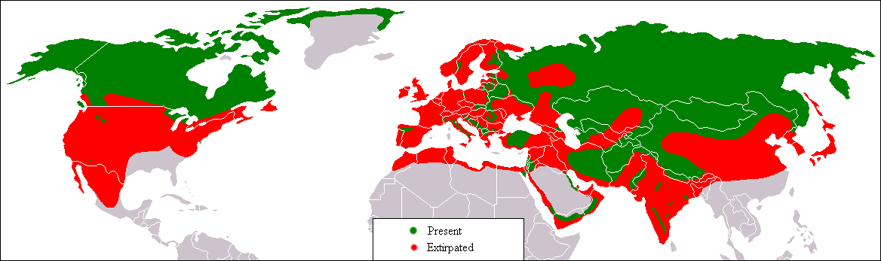

Picture1, A rough map showing the past (red) and current (green) distribution of the grey wolf. Note, how recently wolves have been discovered in places that have not had wolves in hundreds of years, and these locations are not marked on the map.

THE WOLVES AT THE UKWCT
The owner, Tsa Palmer has owned wolves with her late husband Rodger Palmer since the early 1970’s, though it was only in 1995 that they founded the trust and started to raise money for wolves worldwide. Both of them loved wolves with a passion, and are proud to say that they had the first European wolves born in England for 350 years (since they went extinct). In 2011, they got the first arctic wolves to ever be in the UK.
As of now, they have 10 grey wolves altogether, of which is three different subspecies (Northwestern, European and Arctic).
These wolves are separated into four different enclosures. Nine of them have been socialised, meaning they have been hand raised and their flight distance to humans reduced to a near zero, as they are considered working ambassador wolves for the trust. The trust has long realised that they can educate and get through to people better with socialised wolves, where people can actually see them up close for themselves and see what they’re really like, thus feeling more willing to help when they feel they have made a “connection” with the animal.
The UKWCT does not make a habit of just taking wolf cubs. All of their wolves have been rescued in some way or another and saved from being euthanized, either because of cubs having to be relocated or because of mothers abandoning their cubs due to e.g. den floods.
One notable case is the Arctics. Two males and a female were born in Quebec, Canada, at Parc Safari. They were having one of the worst snowstorms in about 30 years, and the wolves’ den had completely iced and snowed over. As an outcome, the mother abandoned the den and staff had to break it open to save the cubs. The situation was so bad that the two males had to be resuscitated, for they did not have a heartbeat. Due to the mother abandoning the cubs, they realised the cubs would have to be hand raised. Not having the experience or resources to do this themselves, they contacted various places, offering the Arctic cubs. The cub’s chances of survival was said to be incredibly low. Tsa had for some time been interested in Arctic wolves, and when she heard of the cubs, took the opportunity at once. Parc Safari were pleased to hear of the trusts experience of hand raising wolf cubs, and after examining the enclosures and conditions, were more than happy to give the Arctic cubs to the trust. The trust now has three big healthy Arctic wolves, a strong attraction to the public.
The wolves at the trust are fed once a day on raw meat, six out of seven days a week. We give them a starve day once a week to clear their digestive system and to relieve the stress of constant eating, as they would not eat every day in the wild, due to low success rates of hunts.
All the wolves are structurally slightly different, some longer legged, some with rounder ears, some with broader shoulders, and they all have their own different personalities. Some will be more dominant, some more submissive, while some are the mischievous ones, some the affectionate ones and some the loners.

TORAK, born in 2006, dominant male, half European and half Northwestern wolf, mate of Mosi.

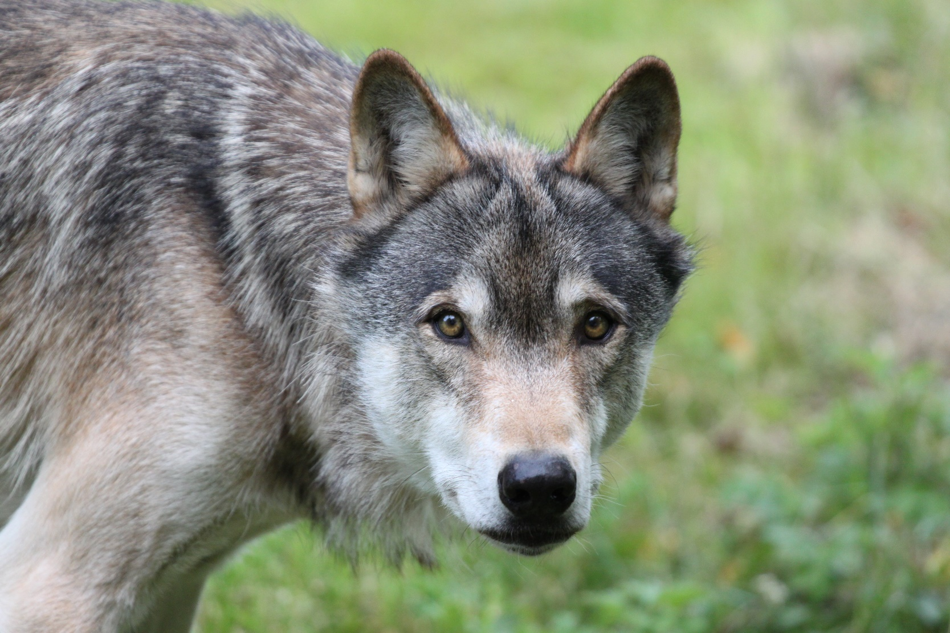

MOSI, born in 2006, dominant female, Northwestern wolf, mate of Torak, sister of Mai.

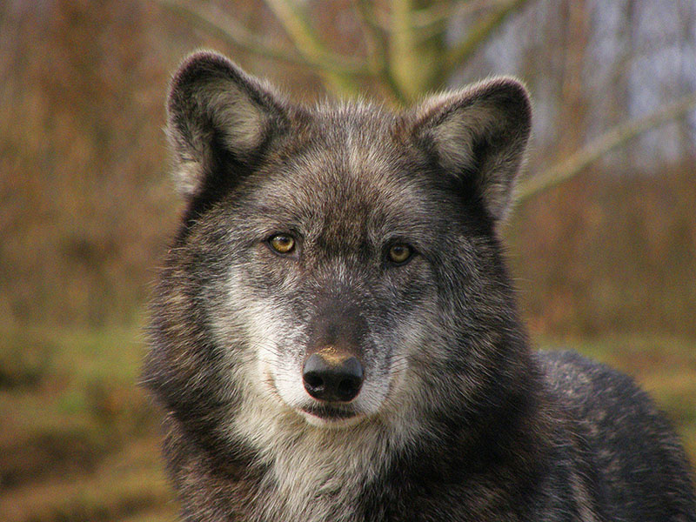

MAI, born in 2006, dominant female, Northwestern wolf, mate of Motomo, sister of Mosi.

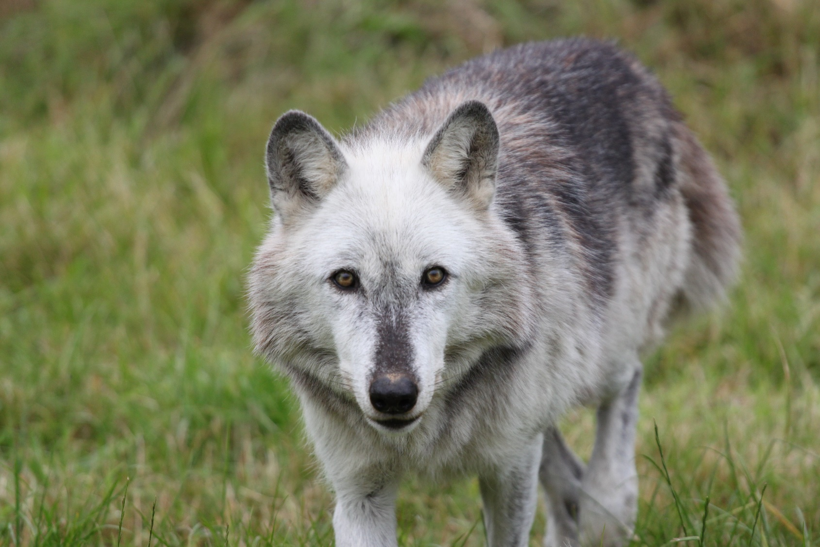

MOTOMO, born in 2008, dominant male, Northwestern wolf with some European, unsocialised, mate of Mai.

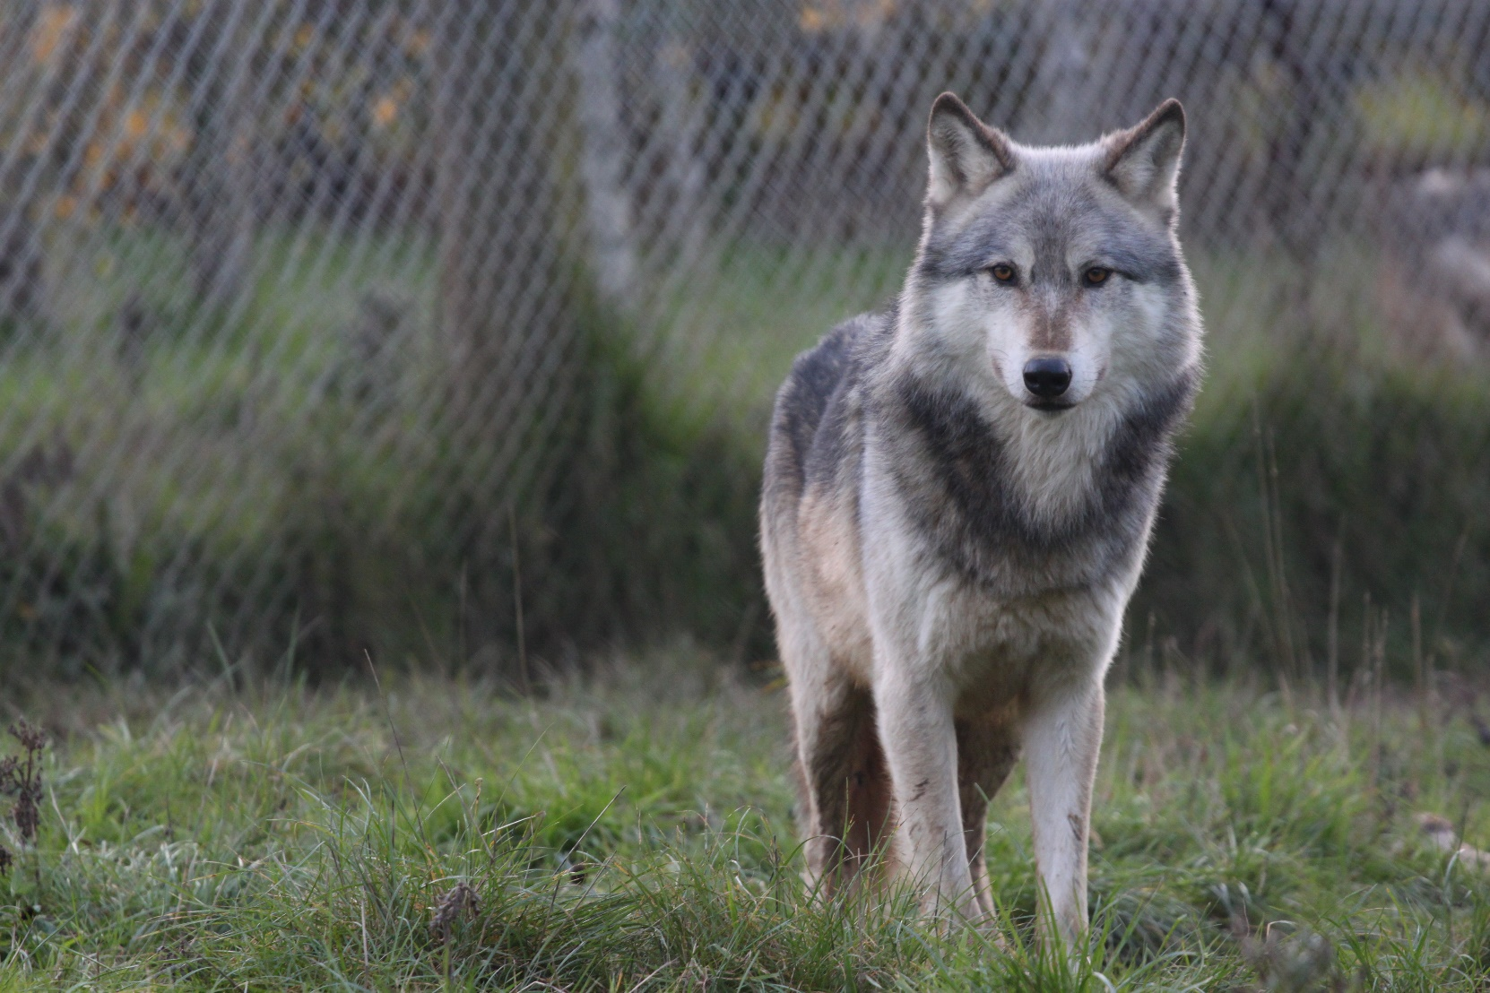

MASSAK, born in 2011, dominant male, Arctic wolf, brother of Sikko and Pukak.

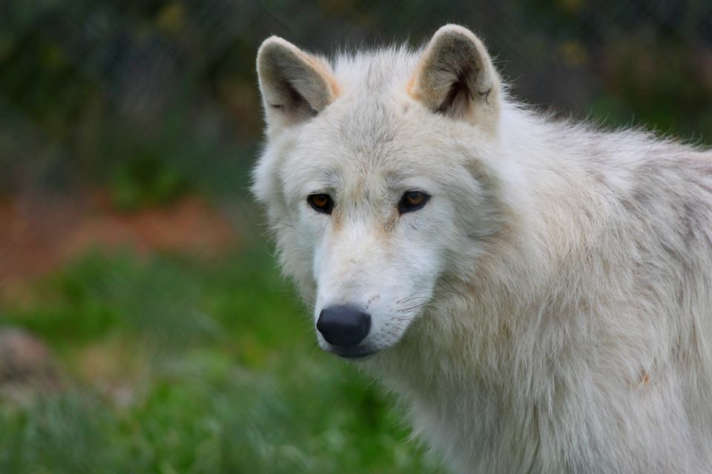

SIKKO, born in 2011, dominant female, Arctic wolf, sister of Massak and Pukak.

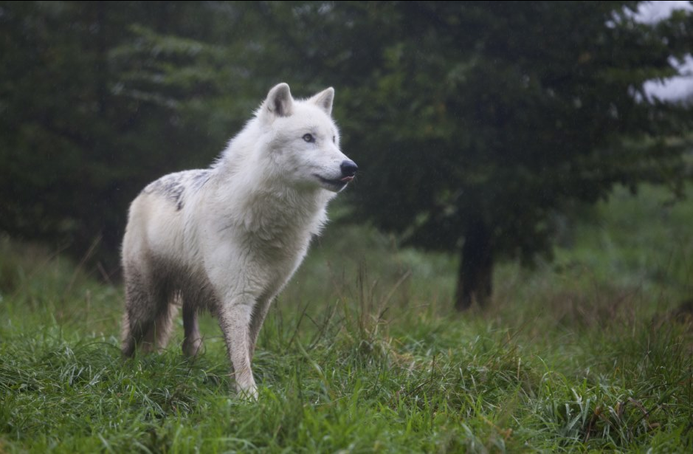

PUKAK, born in 2011, subordinate male, Arctic wolf, brother of Massak and Sikko.

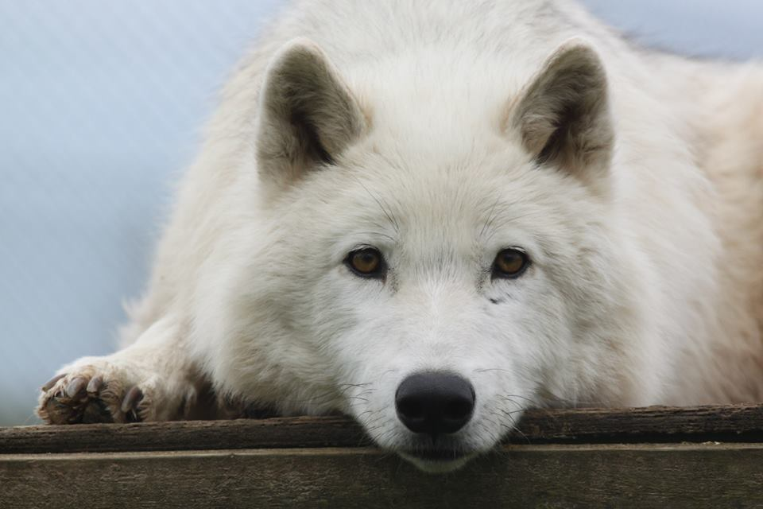

TUNDRA, born in 2011, dominant female, Northwestern wolf, sister of Nuka and Tala.

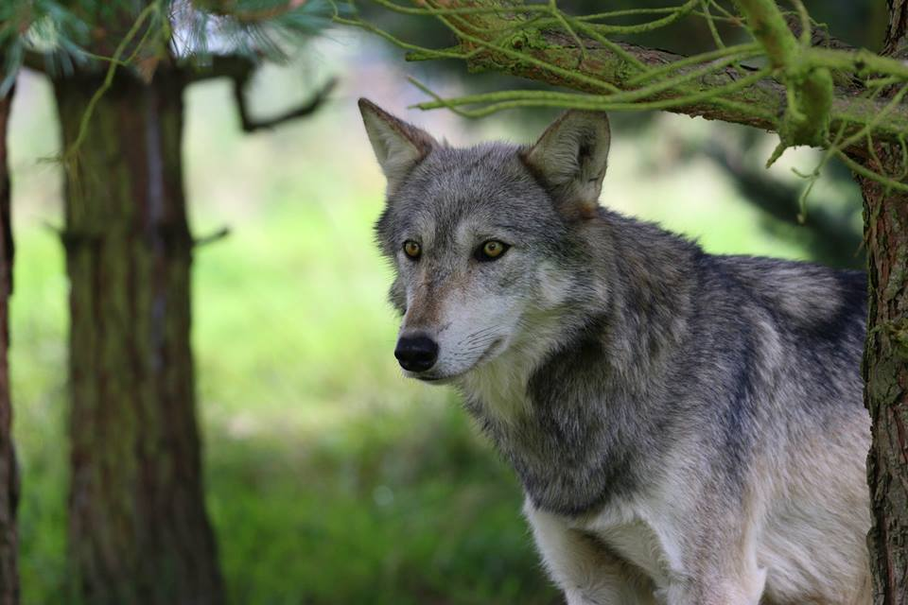

NUKA, born in 2011, dominant male, Northwestern wolf, brother of Tundra and Tala.

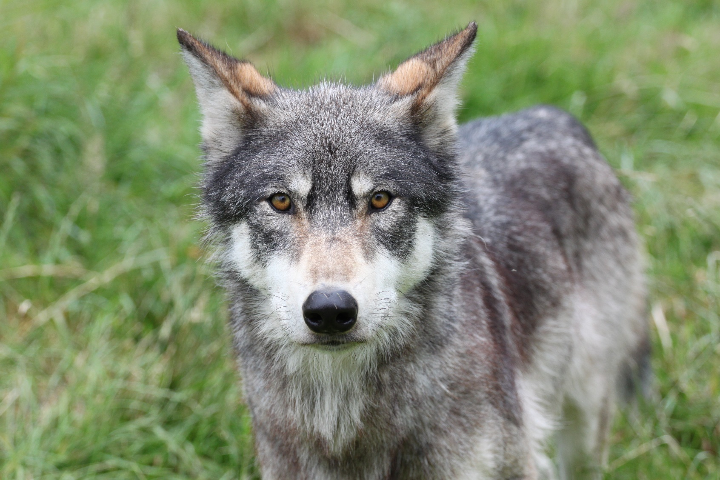

TALA, born in 2011, subordinate female, Northwestern wolf, sister of Tundra and Nuka.

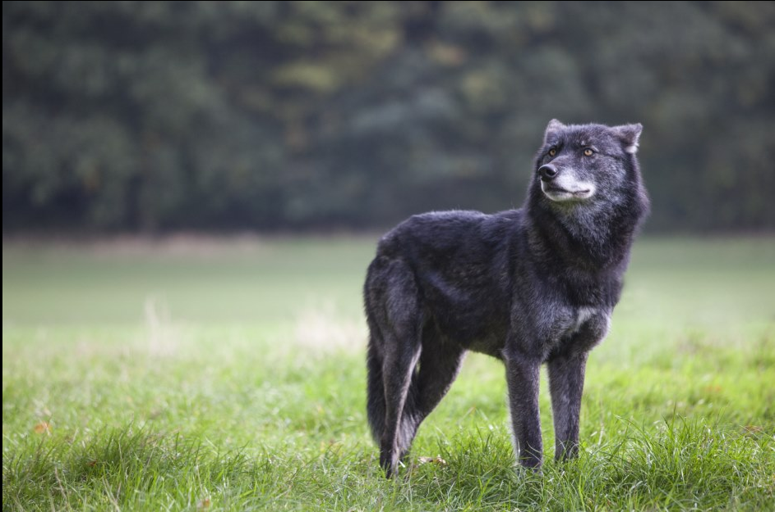

WHAT IS ENRICHMENT?
Enrichment is a term used to describe objects, situations or activities, created to encourage an animal to show a natural behaviour. These natural behaviours could be things such as problem solving, climbing or social interactions.
Enrichment is something that stimulates not only the body but also the mind. Enrichment can be anything, even things that are cheap and simple, to add to expansive habitats.

WHAT ARE A WOLF’S NATURAL BEHAVIOURS?

GENERAL TRAITS
A wolf has a wide expanse of behaviours and traits, and wouldn’t show these natural behaviours, through enrichment or otherwise, unless they were content in their surroundings and day to day experiences. These traits are both mental and physical.
We will start from the mind. Wolves are incredibly intelligent animals, considered to be as intelligent as a five-year-old human, and having the emotional capacity of a 3-year-old human. This intelligence is always there, and shows, whether they are in an enclosure in a captive situation or in the wild. In the wild, they rely on their intelligence to survive, using it to solve problems that could involve getting a decent feed or escaping a possible threat.
Wolves are highly untrainable. This is one of the main differences between a wolf and a domestic dog. Whereas a dog you can train and the dog will attempt to please you, you cannot train a wolf and it has no intentions to please you. The basic principles of training will of course work, just like with any animal, but the circumstances to accomplish this would have to be so extreme, that nowadays it would not be possible, due to laws and regulations, morals and the simple fact of safety. Therefore, in practise, you cannot train a wolf.
You could try training it, for example getting it to sit, using something positive it wants, for example a treat, and the wolf will most likely understand what to do. The wolf however does not want to do as it is asked, and will set its mind to figure out how to get what it wants (the treat) without having to do as it’s told (sit). This is one form of problem solving and forward thinking that dogs generally do not have (at least to the same extent), and is just a natural process they would use in the wild too, to think of how to obtain the most benefits by doing the least amount of work. In addition, wolves simply do not care all too much about humans.
Other forms of intelligence differing, or exceeding, from dogs include things such as intentionally trying to trick a human (succeeding more than half the time), being independent and thinking about “the next time”.
In the wild, they are constantly assessing situations and summing up whether it’s worth it or not. If they see a rabbit near them, they will most likely not go after it (whereas many dogs would), as it would not be worth all the energy wasted to try to catch it, to risk not catching it at all, only to then get a measly meal the size of a couple mouthfuls.
On the contrary, if you try training a wolf using negative reinforcement, the wolf, knowing it does not have to listen to you, will eventually turn to express its dislike, showing its dominance. Considering that grey wolves have the bite power about 2½ times that of a Mastiff or Rottweiler, this will not end very well for the human, even if the wolf gives no more than a warning. Overall, you cannot make a wolf do what it does not want to do.
Though wolves are the largest member of the family canidae, their physical traits are very expanse, and vary between each species and subspecies, generally following the Bergmann’s rule of increased body size from south to north, with the exception of some Arctic wolves decreasing in size as you go further north to the high Arctic. Wolves’ weights varies from 30-60 kilos, though an official record of a 79.4kg Arctic wolf in Canada and an 86kg wolf in Ukraine exists, both having been killed. Wolves can be up to 90cm at the shoulder in height, and up to 2 meters in length from nose to tail tip. Males are generally 15-20% larger than females.
In general, wolves are incredibly strong for their size, being about twice as strong as a dog of the same size. Their bodies are virtually pure muscle and don’t put on fat or anything else excessive, unlike for example dogs. Wolves have a very narrow and keel-like chest, with the forelimbs extremely close together and seemingly pressed into their chest, and with elbows turned inward and front paws turned outwards. Their back paws are also turned outwards, giving them slight cow hocks when looking from behind. Their legs are generally long in proportion to their body. This type of body and limb structure aids them when running and allows them to reach fast speeds and travel long distances, helping them push up and off more easily, especially through deep snow.
They have large paws in proportion to their body, with two protruding front toes, toes that can spread far out and semi-webbed feet, which help them balance and run on different terrains, on top of acting as a type of snowshoe on snow. Their long claws act as extra grip (also used for digging), with the Arctic wolves having the largest paws and longest claws of all grey wolf subspecies. A wolf’s front paws are larger than the back, with paw size being about 14cm long and 10,5cm wide (excluding fur).
A wolf’s fur has two layers, the undercoat and the guard hairs. The undercoat cannot be seen except when shedding during spring, and is always a shade of grey colour, hence the name grey wolf. It serves a bit like a fleece, and insulates heat. The guard hairs on the other hand, are the hairs we see, and can be a variety of colours. These can be very long, and each hair is hollow and waterproof, further helping in insulation and giving them a weatherproof coat, meaning wolves could be out in torrential rain and their skin still stay perfectly dry. Their fur is very thick in general, and most wolves can stand up to about -50C comfortably, with Arctic wolves having been recorded in temperatures down to -70C. Because of this undercoat, a wolf can lay in the snow, have snow falling on it and the snow will not melt but just slowly cover the wolf. (Many snowy mornings at the UKWCT, volunteers have arrived to find no wolves in an enclosure. Feeling slightly worried, they have then called for them, only to see big snowy mounds get up and shake all the snow off them.) The nose is the only place any body heat escapes, since even the paws are insulated by long thick fur. A wolf rests laying on its side and occasionally on its abdomen, though when sleeping they will lay curled up with their tail covering their nose to keep warm. During harsh cold weather, wolves may rest in this position too.
Wolves generally look a lot larger than they actually are, due to their thick coats. During winter when their coats are at their fullest, they can seem almost twice the size of what they actually are. Guard hairs are normally 6-10cm, but in certain areas, such as around the mane, (neck and over the shoulders) the guard hairs could be 15cm long. On top of this, each hair is attached to erectorpilli muscles, which allow the hairs to stand on end, making the wolf appear even bigger.
Wolves will vary in colour between each subspecies, with northern North American wolves varying from white to black and all shades in between with very slight colouring, southern North American and Mexican wolves varying from brown to red with slight blacks and greys, while European and Asian wolves will tend to be more blotchy and have more dark patches with more browns, fawns, sand and even red colours in them. This is due to blending into their environment, as northern North American wolves tend to live in the rockier and tundra type environments, as well as plains, with a less variety of plants, southern North American and Mexican wolves will live in more sandy but moist environment, with plains as well as desert like features, and plants varying less in colour variety, while European and Asian wolves will live in more of a mixed environment, with forests, sand type areas and low mountains, with plants varying much more in colour. Over the years, wolves’ coats will fade slightly, with their fur growing lighter each year. This is not so much to do with age, for wolves do not “go grey” as domestic dogs will, but to do with moulting. Each year they will shed their coat and each year it renews, every time being slightly lighter than the last.
A wolf’s coat colour is extremely well blended, whereas dogs often show high contrast and margins. It is suggested that the gene mutation for black wolves originates from domestic dogs, with black wolves appearing more consistently in continents and areas with high wolf populations and a strong presence of wolf-dog hybridisation. It is also suggested, however, that this gene mutation started from wolves, got passed on to dogs and died out in wolves, and now is being passed back to them. This is something extremely difficult to study and we may never know the answer.
A wolf starts growing its winter coat during late summer, and achieves its full look by late autumn. It is then during early-late spring that it sheds, with mature females being the last to lose it (in case of a cold weather spell and possible cubs to keep warm). Wolves, unlike dogs who shed hairs daily, will shed their fur all at once and not otherwise. It will start from the bottom and shed its way up, with the fur on their backs and neck being the last to drop. This is just in case the weather should suddenly take a turn; they still have some coverage to keep warm. Due to the undercoat falling out all at once, during spring, wolves can look quite scruffy and mangey, with fur poking out and falling off and patches of short fur showing. This is the reason most photos of wolves are of them in their winter coats.
Other physical differences between subspecies, is how European wolves will generally be larger, have shorter legs, much wider skulls, broader shoulders and slightly longer muzzles. This is all to help batter their way through the dense forests and undergrowth, whereas North Americans will generally be smaller, longer legged (apart from the notoriously short legged Northwestern wolves) and more streamlined, perfect for getting through vast open spaces. South Asian wolves, such as Indian wolves can be fairly small and streamlined. Arctic wolves tend to be the largest subspecies, with their brilliant white coats and smaller ears and shorter muzzles to help with thermoregulation. They are also the only subspecies to have developed vasoconstriction, further helping them with thermoregulation. This means the blood vessels constrict, restricting blood flow and allowing less blood to reach the surface of the skin, thus reducing the radiation of heat.
Wolves in general also have leg arteries and veins located close to each other. This means when the blood in the veins is cooled due to outside temperatures, it warms up again from neighbouring arteries, keeping the body warmer and at a more consistent temperature.
All wolves are generally excellent swimmers and enjoy the water, due to their semi-webbed feet. They will not hesitate to follow prey through icy rivers and often cool off in water during hot weather, and have been known to wash off mud from their coats in streams and rivers.

SENSES
Most behaviour is shown through senses, for a wolf’s world is ruled by smell. They can generally smell a scent more than 1.5km away, with 2.4km having been observed under favourable conditions. Their sense of smell is about 100x better than a human’s, though less than some scent hounds, with a wolf having about 200 million olfactory cells, while a human has about 2 million. The part receptive to smell in a wolf’s nose is about 14 times greater than that of a human’s, with about five times more surface area, partly due to an extended rostrum. Through this, they hunt and communicate, and it is mainly their great sense of smell that helps them be such remarkable hunters.
Not only this, but a wolf has the ability to analyse a smell, obtaining all the information it can from it. A great example to explain this with, is if someone were to smell a bottle of tomato ketchup, a human may think that it smells like tomatoes or maybe a bit like vinegar too. However, if you turn the bottle around, you will see a whole list of ingredients that we would have no idea are in there, were they not written for us to read. These are all the different things a wolf can single out and gather from a scent. A scent will tell them how recent or old that scent is, what type of animal it was from, whether that animal was old or young, sick or healthy, what hormonal stage the animal is in and even the smells that the animal has had on it. A wolf’s sense of smell has been compared to human health tests, with the amount and type of information a wolf can obtain being at the same level of information we obtain from a blood test or urine sample. After separation, pack members will have a good smell of each other to discover where they have been, what they have been up to and to investigate if the wolf had found anything interesting.
Scent marking and scent carrying is a big part of communicating. An example is leaving messages for other wolves by defecating or urinating in a specific spot. This could be, among other reasons, reinforcing boundaries, claiming something such as a bit of food, or simply letting other wolves/animals know who has been there. While urinating, the dominant female and male wolf will cock their leg, whereas the subordinate wolves won’t. The reason for leg cocking is to get the urine at a reasonable height (about 30cm off the ground), to significantly increase the chance of another wolf noticing it. This leg cocking behaviour has passed down into domestic dogs, generally only the male ones, whereas with female domestic dogs this behaviour has supressed. While defecating, the faeces will gain scents excreted from the wolf’s scent glands located around the anus, a scent as unique to each wolf as our fingerprints are to us. Usually, after scent marking, the wolf will then begin to scratch and scrape the ground, normally flinging up bits of earth and plants while doing so. This is because wolves also have scent glands on the bottom of their paws, and scraping the ground serves as a type of second message, leading to the first, just to make sure any other wolf passing by won’t miss it. In a way, it’s a bit like someone sending a message to a friend, to let them know they have sent them an email. This scratching behaviour has also passed down into domestic dogs, though nearly all dog breeds are now missing the glands on their paws, so in a sense it serves no purpose. Having scent glands on a wolf’s paws also aids them in tracking each other and finding their way back to a specific location. In addition, wolves do not sweat through their paws as dogs do, with a wolf’s nose being the only place they are able to sweat from.
Other forms of scent marking include lifting their tails high, to drag them along things such as undergrowth, the entrance of a den and even other wolves, for every wolf has a pre-caudal scent gland located about one third of the way down from the base of their tail, characterised by a few longer and stiffer hairs, tipped with black, giving the appearance of a black spot. Even black wolves will have this spot, despite being harder to see. This scent gland releases pheromones, and is at great debate whether domestic dogs have this or not, however, most agree that dogs have a supracaudal gland (also known as a violet gland), a remnant of the pre-caudal gland, which consists of lipid and protein secreting sweat glands and sebaceous glands, thus not functioning in quite the same way as a wolf’s pre-caudal gland. Many domestic dogs will also have the darker spot of fur on their tails.
When a wolf finds a distinct smell, it will often rub itself in it. It will start by rubbing its cheek into it, then carrying on until the side of its chest has passed through it, and either repeat while alternating sides, or carry on past the chest until the wolf has flipped right onto its side or back, rolling all over the smell. They will often try to tear up the surface that the scent is on with their teeth, such as a bit of ground, drawing out the scent and accessing it better.
The exact reason for rolling is still unknown, though there are a few theories as to why they do so. One theory is to camouflage its own scent. A wolf’s fur or skin does not smell of anything to humans, except what they have been around/rolled in (unlike dogs with their classic “wet dog smell”). Despite not having a scent to us, they do presumably have their own smells between themselves, and could also have traces of recently used scent glands or any other unusual smell obtained such as food, potentially picked up by other animals with a good sense of smell. By rolling in other strong or different smelling scents, a wolf is able to hide any other smell it may be carrying, which other animals would recognise. The biggest advantage to this is, of course, while hunting. Hiding a wolf’s smell will decrease the chance of a prey animal being alerted, thus increasing the chance of a hunt success.
Another theory is that it is bringing back a scent to the pack or den. Once finding a smell of say, potential prey such as deer faeces, it will roll in it to get the prey’s scent on it, then go back to the pack to show them what it has found. Often when coming across a carcass or bit of meat, a wolf will roll in it and then (after eating a sneaky bit to itself) go back to the pack to be able to lead them to it.
The third theory is, with smell being their most powerful scent, that wolves just simply love smells and enjoy having a good roll in them. It could very well be that all of these reasons hold true and correct, but whatever the reason, this is another behaviour passed on through generations to domestic dogs. Whether dogs know why they are doing it themselves, is a different matter.
The second most important and acute sense is hearing. A wolf will rely on their hearing, as well as their sense of smell, more than vision. A wolf’s range of hearing reaches about 80kHz, in the range where bats and porpoises will produce sounds, whereas a humans will only reach around 20kHz. It has been observed for a wolf to hear sounds up to 9,5km away in a forest, and 16km away in open areas, similar to how far their howling can travel.
Their large and wide ears will easily catch sounds, with lots of fur on the insides of their ears, thought to not only fight against the cold, but to help with receiving vibrations. Their ears will move and rotate to whichever direction the sound is coming from, helping them in situations such as locating rodents under thick snow.
A wolf’s vision is fairly comparable to that of a humans. Their sight-field is about 180 degrees, the same as a human’s, which allows them to focus on depth and judge distances accurately. However, a wolf’s eyes lack a foveal pit, which prevents them seeing sharp images at closer distances (closer than about 30-45m), however at further distances their vision is about 16x sharper than a humans. It is suggested that this is why a wolf’s fur and facial markings help to accent their facial markings, especially eyes and ears so greatly, for body language, including facial language is extremely important to a wolf.
A great difference between a wolf’s and a human’s eyesight is that a wolf’s is more greatly tuned into movement. If a human were to walk into a room, where people were sitting down in chairs, the first thing a human might notice are for example what people are wearing, in particular the colours of clothes and hair etc. If a wolf were to go into the same room, the first thing it would notice was everyone’s feet shuffling and fingers fidgeting. This gives them a great advantage while hunting, for example if a deer was to stand completely still in a forest, a wolf will find it hard to spot due to the deer camouflaging, but as soon as a fly or mosquito causes the involuntary ear flick movement in the deer, a wolf will spot it at even great distances away.
The other great difference is that a wolf’s eyesight will be less tuned into colour than a human’s will. Wolves have mainly rod cells (about 95%), which help them see excellently in the dark, far better than humans can. We have a great number of cone cells, which helps us see a large spectrum of colours. It is at great debate on whether wolves are colour-blind or not. It is thought that wolves can see colours, but only certain ones. Through studies, wolves have noticed reds and yellows while ignoring blues and greens. We don’t yet however know whether this is just because reds and yellows are associated with blood and urine, while blues and greens are not associated with anything particularly interesting. Some suggest the colours they cannot see appears as a shade of grey, while others think they appear as a strange absence, the appearance of nothingness, thus the reason some colours frighten or unsettle wolves. These colours have tended to be the ones they will not come across in the wild (such as a neon orange), and it is common for captive wolves to get extremely unsettled by these colours, either in objects or someone wearing them.
The lack of cone cells, the abundance of rod cells and the ability to catch onto tiny movements makes wolves exceedingly greater at hunting during the twilight hours, for they do not see as well during the bright day, thus making them crepuscular animals, meaning they are the most active during dawn and dusk.
A large part of wolf communication is body language. A wolf will show dominance, submission, affection, play and give messages and directions through body language. Especially the facial features are extremely important, thus the accentuated facial markings such as black lips and eye rims. A wolf’s hierarchy is already established as cubs, mainly through play. Body language is asserted and especially a wolf’s stance, tail, eyes, ears and muzzle play a huge part (pictures below). Dominance is getting a clear message across, but causing minimal damage to the wolf (for it would not benefit the pack to have an injured wolf), and can be asserted in numerous ways; even something simple such as a wolf resting its head on another wolf’s back. Submissive behaviours stem from cub behaviour, with active submission (crouching low, showing an appeasing smile, licking the muzzle of the dominant wolf) stemming from the begging behaviour of cubs licking the muzzle of the mother or adult wolf to stimulate food regurgitation. Passive submission (rolling over, exposing stomach, possibly urinating) stems from a cubs elimination position, when the mother licks the cubs bladder region to stimulate the passing of urine and faeces. A wolf’s hierarchy is a key to surviving, but once established, wolves generally live at peace. A pack is not built around aggression as previously thought, but cooperation, and this is what wolves strive to do. However, youngsters do sometimes need reminding and being told off (as do all youngsters), and this could be followed through by an endless amount of different (but normally harmless) ways.

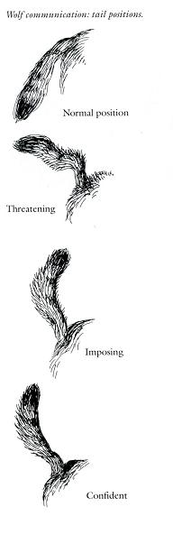

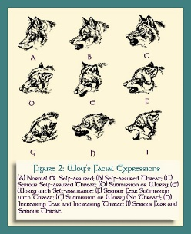

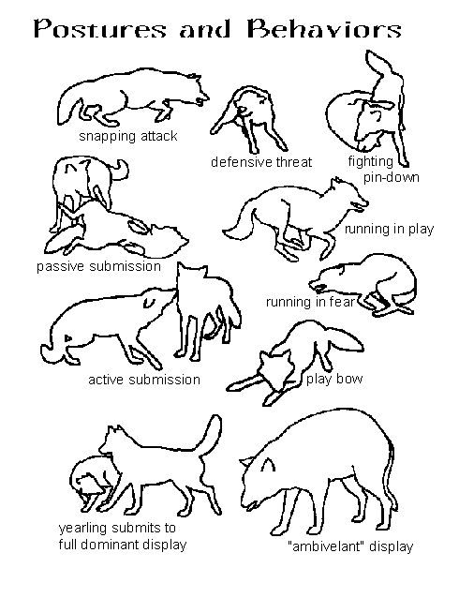
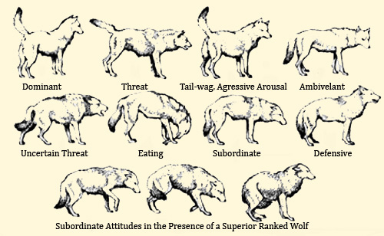

Wolves can be very vocal. They are able to produce a wide variety of sounds, including growling, whining, barking, squeaking, monkey chatter, the famous howling and even sounds such as humming and screaming. Howling is a form of long distance communication, when they cannot see one another. Howling can be done either standing up or (less frequently) laying down, and is produced by throwing back the heads to open up the vocal chords and windpipe, forming an oval with the mouth, curling the tongue and letting out a long howl. Their eyes normally shut or roll backwards and their ears will lay flat across their head, usually causing the wolf to be momentarily deaf. Wolves may also climb to a higher level, such as a hill, to howl.
Wolves will never howl on the same note, but will harmonise with each other to give the illusion of more wolves than there actually are. A howl will travel for about as far as a wolf can hear: about 9,5km in dense forests and up to 16km in vast open spaces and across the treeless tundra. There are many reasons for howling, with just some of the reasons being to assemble the pack before or after a hunt, locating other wolves over long distances, competing, alerting other wolves of something and “mourning” a dead pack member, which could last for weeks. Wolves may compete among each other or a pack may compete with another pack. Their adrenaline is worked up very high, and this is when they start rally-howling. A rally-howl is when they build up a lot of energy with their howls, and the howls themselves can be very raspy and be mixed with many groans and bark-type sounds. Rally howling is also the type of howling they usually do before a hunt, to bring the team together and cause an adrenaline rush. Wolves also generally enjoy howling and are easily set off, especially by any two-toned sounds such as alarms, bells and sirens. Howls will also vary among subspecies. Wolves than live in thinner and clearer spaces such as the wolves in North America tend to have a much higher howl, whereas wolves living in thicker undergrowth and forests, such as in Europe will have a much lower sound to them. The reason for this is when producing a lower sound, the sound waves are much bigger, thus being able to bend around trees easier and thus travel further through forests. On the other hand, producing a higher sound will allow the howl to travel further in open spaces, with arctic wolves commonly having the highest pitched howl.
Wolves will rarely bark and when they do, it is not like a dog’s. A wolf’s bark tends to be a very hushed, breathy, beginning of a bark, which could then possibly turn into a coarse rough howl. A bark serves as a warning, a quick, low and sudden sound that will quickly travel around to nearby wolves, warning them of possible danger or dislike, with the coarse howl that may follow being a distress howl. Barks are frequently used among cubs who will play and scuffle a lot amongst each other.
Whining is a wolf’s general form of short distance communication. It does not necessarily mean anything is wrong, and socialised wolves will use this type of communication on people too. Wolves whine at varied frequencies, going right up to squeaking, even sounding like a little bird, and could mean almost anything and be used in almost any situation. Growling and snarling are used to show their disapproval of something. It will involve a lot of facial language and body language too. It may be something very quick or may continue for some time.
Monkey chatter is the term used to describe the sounds wolves make when they crack their teeth together, normally as a sign of anxiety or as a threat, warning or apology, and is often accompanied by things such as whining and tail swishing. It is another sound/action used in diverse situations, used frequently for example when bickering.
A wolf’s sense of taste is hard to study, and we do not know much about it, except that they have the same four types of taste we do. Their sense of taste is thought to be fairly poor, and they certainly don’t stop to taste their food.
Instinct is not exactly a sense, though it will be added here anyway. Wolves have many skills that they do not need to be taught, but are simply born with. One of these instincts is having a natural fear of humans. Every single wolf will have this (to some extent) whether they have seen a human or not, and it is not learnt from other wolves. For this reason, before you could get close to a wolf in the wild, the wolf will usually be gone. Wolves will smell you and hear you long before you can get close to see them. There is no way of getting rid of this fear unless they are influenced when they are cubs, just before and as their eyes and ears open. This is called socialising. Every wolf has a natural flight distance from a human, when at which point it will run to try to escape. Socialising brings that flight distance down to zero. Even then, once a wolf is socialised, socialising will need to be consistent to uphold the wolf’s willingness to be around humans, and despite having a socialised wolf, a wolf will always be skittish and alert, ready for any danger.
Another instinct wolves have is hunting and howling. It is often wrongly thought that the adult wolves teach the youngsters how to hunt and howl, yet this is not true. More about this is written in the “Myths, misbeliefs and misconceptions” section.
Other instincts include establishing social structures, through dominance and submission and situations such as feeding and play amongst cubs, which will also strengthen their hunting skills.

THE LIFE CYCLE OF A WOLF PACK
Wolves mate for life and their social structures (packs) are based on families.
It consists of the monogamous breeding pair, a dominant male and female who will breed once a year. The rest of the pack is their offspring, resulting in a pack on average of about nine wolves, depending on prey abundance, size of prey, time of year (cub birth and dispersal rate) and threats in the area (a pack consisting of 36 members has existed in Yellowstone National Park). Wolves will reach sexual maturity at 18-30 months old (about three years old in captivity), after they will eventually become sexually frustrated from not being allowed to mate, leave the pack to find their own mate and territory, and start their own pack. It has been recorded, for a male to breed in the wild at 8 months old already.
We start the year coming up to the breeding season, which is January-February, possibly going into March. The mature male and female would have been engaging in courtship for a few days, possibly even to a few months before the breeding season, sniffing and nipping each other, head rubbing, muzzle grabbing, tail wagging and of course lots of play. The male’s testicles start to swell, as they are normally peanut sized, for a male is infertile until breeding season.
During the breeding season, the pair will become very restless, as their hormones raise high. They may be much more vocal, constantly patrol their territory and generally cannot stay in the same place. The male may pester after the female a lot and smell her genitalia, but the female will not like this until she feels it is the right moment. The female wolf enters an oestrus phase that lasts 5-7 days, when she will finally allow him to mount her in which copulating will take place. After copulation, they will often perform a behaviour called tying. This is the second part of reproduction, when the male’s bulbous base of the penis swells and locks into the female’s vaginal sphincter. The male turns around 180 degrees, with his backend to her backend, ejaculating into her and their tails possibly intertwined. This can last up to half an hour.
Later on as the female starts to expect cubs, she will dig at least one den, if not multiple, in case something should happen to the first (such as collapsing or being flooded). A den is often dug into the ground, but could also be a rock crevice, an overturned tree stump or any type of sheltered and peaceful setting. It is generally thought for it to only be the female who digs the den, but has recently been observed, in captive wolves, for the male to help dig it too. A mother’s gestation period will be for about 63 days and she will expect 4-6 cubs a year (the extremes being 1-14). However, by having 8 nipples they are potentially able to have up to 8 surviving cubs, for a wolf who does not get enough of its mother’s milk will develop problems such as brittle bones and cataracts, thus not surviving in the wild. Unfortunately, 40-60% of wolf cubs die soon after birth, so it is usual that the final number of cubs a year is about 2-4, leaving the mother with a smaller litter to care for.
The only time a wolf will live in a den is when it is about to have cubs, and for a few weeks after. Wolf cubs are born weighing around 450g. They are born with their eyes and ears shut, and are usually a shade of grey (another notion towards the name of the species) before gaining their colour traits. At this point, their world starts through their sense of smell. The mother will show her usual instinctive behaviour of licking the cubs clean, stimulating their breathing and other internal circulations, and keeping them warm for the cubs cannot warm themselves yet. The cubs will instinctively suckle. Their eyes and ears will open any time between 10-12 days (extremes 6-15 days), with their eyesight not fully developed yet and their eyes being a shade of blue. At this point, their instinctive fear of humans is set in stone.
An adult wolf’s eyes will always be a varying shade of amber, occasionally with some green thrown in too, but while they are cubs, their eyes will always be blue. This is because the colour pigments that give them their final amber colour need light to develop. Wolves, as do many other animals, have much more heavy-duty eyelids than for example humans, so, unlike for us, the light cannot get through when they are closed. This means that the colour pigments will not be able to develop fully until the eyes open. This happens in many other mammal’s cubs, such as lion cubs. An advantage of having underdeveloped eyes (thus not being able to let as much light in), is to not become instantly blind (or developed damaged eyesight) upon opening their eyes.
Between 2-3 weeks, the cubs will already be forming the howl shape with their mouths, despite not being able to produce the sound yet, and by 3 weeks their milk teeth should appear. They will stay in the den until about 3 weeks of age before emerging; suckling during these 3 weeks before being weaned onto solid food throughout a period of a few months. The mother will stimulate the cubs to help them pass urine and faeces by licking them on their lower stomach and between the back legs where the bladder is. The cub’s time in the den will be spent building up strength and developing further. By the time they have been move outside, they would be practising their hunting skills and forming their social hierarchy through forms of play, such as chasing, ambushing and mock fighting. Their hierarchy should be set by 30 days old. Ears should be fully standing by 3-3.5 weeks old.
While weaning onto solid food, all existing wolves will help to take part in feeding them. The adult wolves will eat their fill of food and then regurgitate it for the cub to eat, until the cub is able to eat solid food for itself. Cubs will beg and stimulate regurgitation by licking the muzzles of adults. The mother will stay near her young for the first 2 months, in which the other adult wolf/wolves will help feed her too. The claws of a cub will start out lightish in colour and gradually darken, as it grows older, with full colour achieved by 8-10 weeks of age.
In the meanwhile the adults will be getting up to their usual life, patrolling boundaries and hunting. A wolf’s territory can be anywhere between less than 200km2 to over 2500km2. Territory size completely depends on the global location of the pack, prey abundance, the nature of terrain, the climate and the presence of other threats such as other wolf packs, large predators and humans. Wolves living higher north in places such as Alaska and Canada could have a territory sizing between 750km2 to over 2500km2, whereas wolves living closer to humans and in smaller regions generally have from under 200km2 up to 700km2. Wolves like to get a better view of their surroundings by climbing higher, such as to the top of a hill, getting a better idea of what is going on in their territory. They will occasionally patrol their boundaries, making sure to scent mark it. Scent marks will usually be placed about 30cm from the ground and about 90m apart from each other, though this is not exact.
Being at the top of the food chain means wolves don’t exactly have predators, though rivals do exist, however most wolf packs and other carnivores avoid confrontation to avoid injury and wasting energy. Wolves are very territorial and are highly intolerable to other canids. Wolves attacking coyotes are common, often when coyotes attempt to feed on wolf kills and sometimes wolves may raid coyote dens and kill their cubs. Despite killing, they will rarely eat them. It is very similar with jackals, and in areas of high wolf population, the population of jackals will be minimal. Wolves are the main predators of raccoon dogs, killing large numbers, on top of various types of foxes. Cannibalism is not unheard of in wolves, with accounts of attacking weak or injured wolves being heard of, usually in times of hardship, such as harsh winters, and they may also eat the bodies of dead pack members. Other animals regarded as competition include bears, felines, hyenas, wolverines and tigers, mostly due to carcass disputes.
American black bear and wolf encounters are not frequent, due to different habitat preferences, though upon interaction black bears are frequently killed. Brown bear and wolf encounters are common, with rivalry being fairly equal. Brown bears typically dominate wolves in carcass disputes, though wolves will dominate brown bears when defending den sites, having killed even full sized brown bears. Both species have kill each other’s young. Polar bears are rarely encountered by wolves, though there are two recorded cases of polar bear cubs being killed, with wolves successfully managing to separate it from its mother in the second case.
Large wolf populations tend to limit the population of felines. Wolves and cougars tend to avoid encountering each other, though upon encounter, wolf packs usually dominate cougars, with reports of killing mothers and their cubs. Wolves may sometimes steal a cougar’s kill. Wolves sometimes hunt Steppe cats, and may also reduce populations of the Eurasian lynx, possibly running them down or killing them before they can escape into trees, with similar encounters having been documented between wolves and bobcats. Wolves possibly pose a threat to snow leopards.
Wolves sometimes encounter hyenas in central Asia through carcass disputes. Wolf packs can drive off single hyenas, but hyenas will dominate wolves in one-on-one encounters. Wolverines usually wait until wolves are done feeding to scavenge for leftovers, but have been known to drive wolves away from their kills; however confirmed reports of wolf packs killing wolverines exist.
Other than humans, tigers appear to be the sole serious predator of wolves. Wolf and tiger interactions are well documented in a mountain range in far-west Russia, where tigers deplete the wolf population, either to extinction or to such low numbers for wolves to be an insignificant component of the ecosystem.
Wolves can travel remarkable distances, either because of territory or because of prey, travelling anywhere between 30-200km in one day to locate food. Wolves will step in each other’s paw prints in addition to trotting to save energy. This trot allows them to travel a long time without tiring, with their speed being around 8km/h. While running to chase down prey, they reach speeds of about 60km/h (55-70km/h), keeping this up for at least 20 minutes, or over 5 kilometres.
Wolves primarily hunt herbivorous ungulates, which include various types of deer, moose, bison, reindeer, mouflon, wild goats and muskoxen. These types of animals give them everything they could need, and they do not benefit as much from eating any form of omnivore, resulting in less energy obtained. This is great for keeping the ungulate populations down. Other herbivorous animals they may eat are beavers, rabbits and hares, with Arctic wolves being observed to hunt lemmings, waterfowl and lagopodes. Seals in the Arctic and wild boar elsewhere are also common prey, despite being omnivores/carnivores. Only if herbivorous prey gets very scarce, they may sometimes eat smaller omnivores, such as musteloids, insectivores, rodents and sometimes jackals, foxes and eggs, while wolves in West Canada have been observed by biologist Bob Bromley to feed on salmon, catching five fish in fifteen minutes. Wolves will readily eat various berries to supplement their diet, being known to visit melon fields and also eat apples and pears.
Wolves are opportunists, meaning they will take any opportunity they can get. When food is scarce, they will prey on lizards, snakes, frogs and large insects. If they come across carrion, they will take the opportunity of a meal, for they do not know when they will next get one, which could be up to two weeks later. Wolves (on top of the many other scavengers) are a great help on clearing up any dead animals.
Wolves will always choose to hunt animals from the wild and from their own territory. It is only when humans start invading their territory, causing it to get so small, thus leaving natural prey scarce and forcing wolves to live near to humans, would they consider turning on domesticated animals. Unfortunately, once started, this behaviour can be hard to stop.
To hunt, wolves will scout around, trying to catch onto the scent of a prey animal. Wolves hunting alone often hunt animals such as hares and possibly rodents, by pouncing on them/surprising them and running after them until they are grabbed and caught. The larger animals such as deer, bison, elk, muskox and wild boar are usually hunted by groups of wolves. Saying that, single wolves are capable of catching adult ungulates alone, with a single wolf being observed in North America to take down a healthy adult bison unaided. Wolves will always aim to single out the weaker animals, usually ending up with the young, old, injured or sick; though will take down a healthy animal if necessary or given the opportunity. Once a larger prey animal has been spotted, the wolves will try to get up close without alerting the animal, and then chase it if it runs.
The prey animal running is the key for a wolf to bring it down. While a large prey animal is stationary, the wolves are vulnerable to potentially fatal kicks, whereas if it is concentrating on running, it is not able to defend itself as easily while the wolves bring it down. Animals such as bison and muskoxen therefore try to stand their ground to increase their chances of survival. If the animal does not run, the wolves will try intimidating it and frightening it into running, for until then the wolves cannot do much. Once the prey animal runs, it is necessary for the wolves to pursue without delay, for delayed reaction rapidly decreases hunt success.
With an animal running, the wolves will run after it in a general race of endurance. Their goal is to wound and tire the animal into collapsing as quickly as possible, for wolves cannot run too far at high speeds, thus they will nip and bite at the animals front half, avoiding its back legs, to get it bleeding, making it weaker. The more it bleeds the sooner it will collapse. If it is a smaller animal, such as a small deer, they may aim for the back half as well. Eventually when the prey animal is slow and weak enough, one of the wolves (usually one of the most experienced) will latch onto it until it stumbles and falls, thus needing a lot of jaw power to hold on. Once the animal is down the wolf will bite at the jugular vein to kill it. The wolves will then either lead the rest of the pack to the kill, or attempt to take the kill back to the pack.
Success rates of hunts vary from 10% to 56%, with an average being 25%. Low success rates of hunting are not exactly down to a wolf being a bad hunter, with most unsuccessful hunts being down to two reasons. The first being wolves realising their hunt is going to cost more in energy than their prey is worth, and the second being wolves backing off from prey in situations considered too dangerous to proceed. However, new studies on reintroduced wolves that are in large packs, in areas such as Yellowstone, are showing signs of wolves becoming “more intelligent” by evolving more successful strategies for difficult hunts. This can involve the pack splitting up into two groups, either attacking the prey animal simultaneously from different sides, or with one group pursuing the animal and the other group lying in wait, cutting off the animal’s escape. Other behaviours such as driving a prey animal into denser forests have been observed, presumably to force the prey animal to a slower speed or providing fewer clear escape routes.
It is a wolf’s bite power that allows it to hunt large animals and survive. This is understandable as a wolf has no other means of fighting (for example usable claws or a large size), and considering they hunt animals weighing up to around 1000kg, such as bison, they need this power to be able to bring them down quickly. One kick from their prey will result in serious injury, if not death.
Bite power is something extremely hard to study, and causes a lot of confliction in the canine world. It all depends on how much of the jaw is being tested, what part of the jaw is tested, how wide open the jaw is, how big of an area it is biting down on, the method of carrying the tests out and the unit of measurement. Either way, no true answers have ever been found. Generally, it is believed that out of the domestic dog breeds, the Rottweiler or Mastiff have the highest bite pressure. Numbers will vary from source to source since, as said before, it depends on so many things. One of the most common findings is that a Rottweiler or Mastiff will have a bite power of around 500-700 pounds per square inch. To put it in perspective, humans have a measly 130-150 psi, while grey wolves have about 1500 psi (just over 100kg/cm2). Other notable animals are alligator snapping turtles with about 2000 psi, hyenas with just over 2000 psi, jaguars (notorious for killing by biting through skulls to get to the brain, and biting through turtle and tortoise shells) with about 2,350 psi, hippos with just under 3000 psi, crocodiles with almost 5000 psi and the Tasmanian devil with just over 6000 psi.
One of the main differences between a wolf and domestic dog, resulting in such a different bite power is the amount of muscle. Wolves are pure muscle and, especially around the skull, have extremely strong muscles. In particular, the zygomatic arch is more spacious and angled, thus having more room for muscles, and the mandibular and masseter muscles are much larger and stronger than in domestic dogs. When watching a wolf eat, you can see their eyes bulge out of their head each time they chew, due to all the muscles around their face.
Another reason is the size of its skull being much larger and wider in proportion to its body, thus being able to produce a much bigger bite, and the orbital angle of a wolf’s skull being smaller than that of a domestic dog, again relating to the cheekbones (picture2 and picture3). This shows in wolves by their almost inexistent stop, whereas a domestic dog’s stop is more pronounced. On top of everything else, a wolf’s sagittal crest protrudes much more than a domestic dogs, thus providing more muscle attachment area.
With hunts frequently being unsuccessful, all of the carcass will often be consumed apart from the guts, from which the wolves do not gain anything and could potentially get sick from. Other parts left may include the skull, other large bones and some of the hide. Feathers, fur and bones keep teeth clean, and fur is usually consumed with meat, wrapping around food in the stomach and protecting the guts and other organs from sharp splinters of bone. It is thought that the fur also serves to rid the stomach of any parasites, scouring it and flushing them through.
A carcass will easily last a full sized pack a couple of days, or a very small pack up to a week. After eating their food, any food they have left over will be cached. Wolves will generally cache their food by digging a hole and burying it. This helps preserve it and protect it from scavengers. A wolf generally needs about a kilo of food a day to survive, but needs about 3kg a day to reproduce successfully. Adults can go weeks without food, though cubs will need regular nourishment to be able to travel and hunt with the adults by the autumn. A wolf can eat up to 10kg of meat in one sitting (roughly equivalent to a human eating 100 hamburgers in one sitting), and will generally eat as much as they can, for it could be a long wait until their next meal. Despite this, many wolves don’t actually stuff themselves completely full (unlike many dogs), but until they are content or comfortably full, their stomachs just being able to handle that amount of food.
Wolves are great at knowing exactly what type of nutrition they need that day. Although they can’t always pick and choose in the wild, upon having a carcass, they may eat specific parts out of it, depending on what they need that day. This ability shows especially in captive wolves. When given a choice of for example bones (calcium), muscle meat (protein) or flesh containing good fatty acids, the wolves will usually pick what they need, and will not eat any more.
A wolf will not really chew their food, but slice it into manageable chunks to swallow whole. The bigger bones will be ground up, but the smaller bones will only be chewed a few times, as if to squash them smaller, and then swallowed whole. This ability to open the throat and allow extremely large pieces to slide down seems to be lost in domestic dogs.
A wolf’s dental structure is like a penknife, consisting of everything it may possibly need. It has the bite power to bring down prey and not let go, with specialised teeth for different situations. A wolf has 42 teeth. We start with the incisors (12), used for scraping meat off bones and nipping their prey. Then we have the canines (4), up to 5.5cm long, which are the teeth used to dig into their prey and hold on, serving as an anchor. Next, are the premolars (16), specially designed for cutting through meat, and last of all are the molars (10), used for grinding down bone to eat.
Wolves have one pair of carnassial teeth, as all canines do, and many carnivorans. This pair is the upper fourth premolar and the lower first molar. The edges of these teeth are razor sharp and shear past each other as the jaw closes, similar to that of scissors. This allows them to slice through even the toughest meat and tendons effortlessly. The rear portion of the lower first molar also dips down, to create a kind of basin, called the talonid shelf (picture4). This, with the aid of the upper first molar serves as a kind of nutcracker, cracking even a bison’s femur in just a few bites.
Wolves lose a lot of their food to ravens. Wolves and ravens have been observed to have a very complex and meaningful, social and symbiotic relationship. Each is fully aware of the other’s capabilities and is rewarded in some way by the presence of the other. The ravens often lead wolves to either prey animals or carcasses, and serve as extra eyes and ears, for they are more suspicious and alert than wolves during feeding. In return, the ravens get a meal, for they cannot break through the tough hides of animals themselves, needing a carnivore to do it for them. Unfortunately, ravens will continue to carry off food to cache, being able to eat and carry away up to 1.8kg of food in a day, thus wolves missing out on a lot of their meat.
A recent study suggests ravens being a major factor for wolves hunting in packs. Because a single wolf is able to take down an adult ungulate on its own, pack hunting has frequently been questioned. Research from a study calculates wolves would be best hunting in pairs, in terms of energy burned and meat gained, however, a pair of wolves lose an estimated 37% of a moose carcass to ravens, while a pack of six lose just 17%. Ravens have been considered another reason wolves often kill more than they can eat in one go, for up to one third can be lost to ravens, yet with more wolves in a pack, the more they can quickly consume themselves, leaving less for the birds. Ravens are often present within 60 seconds, and can appear up to their hundreds, normally waiting until the wolves have moved aside to rest after eating to then take over the carcass, thus a wolf pack is also able to drive them away more easily than just a pair of wolves.
Ravens are shown to be initially cautious at carcasses with wolves absent, waiting for other ravens to feed first, though are present at every wolf kill, feeding immediately after the wolves, and occasionally even alongside them. Ravens have also learnt to follow migrating herds in wait of wolf kills and tend to be attracted to wolf howls, due to wolves often howling before a hunt. Wolves, on the other hand, have learnt to recognise a raven’s alarm call and certain vocalisations and behaviour indicating prey. Wolves and ravens have been observed playing together, with ravens diving and pecking or pulling on wolf tails, and in particular wolf cubs chasing after teasing ravens.
By about 6 months old, wolf cubs will be almost their full size, equipped with adult teeth. Some cubs may have possibly died along the way, either due to lack of food or possible illness. Carrying on through their lives, wolves will come across many threats, or potential threats. These could be almost anything, for wolves are very sceptical animals and tend to be suspicious and wary if there is even the slightest reason to be (one reason for their fear of humans).
The dominant pair will naturally be more reserved than the others, for they know should anything happen to them, the whole pack will be wiped out, whereas should something happen to their offspring, they can always make new cubs next year. Because of this, if there is any sense of danger or mystery, such as investigating something new, they will always send in the young ones to assess the situation and discover what it is. If it is something negative and something possibly happens to them, they know to escape and have new cubs next year. On the contrary, if it is something positive, they will normally go and take it off the young ones, having it for themselves.
A wolf’s life will initially revolve around finding food and avoiding threats. A wolf’s life is threatened by possible cub mortality, starvation, injuries from prey animals or other carnivores and disease such as sarcoptic mange, canine distemper, canine parvovirus and rabies. Lyme disease also affects wolves, and heartworm can reduce a wolf’s endurance by restricting blood flow to the lungs. Birds of prey are a big threat to young wolf cubs, being able to snatch them up as prey, causing many wolves to have an instinctive habit of looking up above them. Death through humans is a major threat, such as legal or illegal hunting, trapping and poisoning. Wolves will sometimes be hit by cars, though this is uncommon and tends to happen in areas vastly fragmented by roads.
A good average life span for a wolf in the wild is about 4-8 years, depending on the area, though wolves living to about 13 years are not unheard of. The average life span for an area like Yellowstone is a mere 4 years. Many cubs don’t survive through their first winter, though those that make it past two years have a high chance of surviving a few more, providing they get enough to eat and avoid fatal injury. Captive wolves on the other hand will easily live to around 16 years of age, with some wolves recorded to live until 18-20 years of age. The reason for living longer is simply that they do not have all the risks that they face in the wild. They will always be fed enough and have veterinary checks. Once a wolf reaches old age, the most common reason for passing away is cancer. On top of this, they will develop problems such as arthritis and organ failure.
Not only a parent’s cubs may die, but a cub’s parents may die. When cubs become orphaned, there is usually one of four situations. If the cubs are not old enough, the cubs will die too, due to not being able to survive on their own yet. If the cubs are old enough to survive, but haven’t sexually matured yet, they will most likely stick together with their own hierarchy coming into play, hunting their way through life until they sexually mature and disperse, that is, if all works out well. If the “cubs” have sexually matured already, then they will simply disperse to find a mate and start their own pack.
The fourth situation is when a very young cub is orphaned and another pack comes across it. An adult wolf will never hurt a cub, even if it is not its own or from a familiar wolf, nor will it leave it to die. Wolf packs have taken on orphaned cubs plenty of times, raised it with the others and treated it as one of their own. Although it is another mouth to feed, it is also a greater chance for their pack to survive.
All wolves, including the parents, will engage in a lot of play. Play is not only for entertainment, but is a vital part of keeping the pack together, for a pack is not only about being tough and making decisions. To prevent subordinate wolves getting frustrated, wolves will frequently engage in play where each wolf will vary their roles. This gives the chance for subordinate wolves to have their turn at being dominant, and for dominant wolves to be submissive. It breaks tension and strengthens bonds; in turn making sure the out-of-play hierarchy stays the same for the good of the pack.
As the months pass, the parent’s cubs will be reaching the end of their first year, fully joining in on hunts now. The parents will reach breeding season again, with the mother coming into season about two weeks before her female offspring. On top of occasionally nipping her offspring’s genitalia, coming into season earlier ensures that the younger females will not breed, and so the cycle continues. The mother may use the same den as last year, have new cubs, perhaps come across an orphaned one and a few of hers may die. The yearlings are good hunters but still lack the experience of the adult wolves, who will help refine their skills. More wolves joining in on hunts means larger prey animals taken down, in turn, meaning more food for a longer period. There will be more wolves feeding at the carcasses now.
During a carcass feed, the dominant couple will get to choose the best part to eat, while the rest will settle for the other parts. The breeding pair will also bring their youngest cubs to eat with them, getting the best bits, before about 3 months when they will then be pushed to the bottom of the pack and have to settle for poorer meat. Each wolf will get his or her own shoulder width share of the food, and each wolf is entitled to it, meaning the moment another wolf pokes its nose onto the wrong side; they are entitled to challenge that wolf to protect it, even if it is the dominant male or female. All the wolves will know this “rule” and respect it, for they know that each wolf needs to eat for the pack to stay strong, though occasionally you may get a cheeky wolf testing its luck.
Eventually, their first litter will be reaching full sexual maturity. They will want to breed, but with the parents not letting them, they will grow slowly and steadily more sexually frustrated. A factor for not letting other wolves breed is to avoid interbreeding and to encourage the spreading their genes as much as possible. Another is usually that there simply is not enough prey for more than one pair to reproduce. The dominant female will come into season about a week or two before the other females, which prevent males wanting to breed with them; however, in some cases such as in Yellowstone, prey abundance is so high that other females are allowed to breed too. Otherwise, in regular packs, one year the youngsters will become too sexually frustrated and will set off, leaving the pack to find his/her own mate and find their own territory.
A dispersed wolf is called a lone wolf. A lone wolf’s goal is to find a mate, and could travel great distances to find one, such as the famous radio collared Northwestern wolf OR-7 who travelled more than 1,600km to find a mate, or the European wolf Slavc, who travelled about 2000km until finding a mate and breeding (link 3 & 4). Currently (7.11.2014), a European wolf has travelled almost 2000km from the south of Norway, through Sweden to Lapland, and is still travelling, heading towards Russia.
While a lone wolf, the wolf will generally keep a low profile to avoid any conflict, and for example will very rarely howl, if even howl at all. Lone wolves will not show acts of dominance either, such as cocking their legs while urinating.
Since wolves will disperse at similar times, coming across another lone wolf is not unlikely, though in (fairly rare) situations where, for example, a male wolf cannot find a mate, they may mate with subordinate females of another pack whose subordinate females are allowed to mate. However, they will not bond with them. Such is the story of the wolf Casanova from Yellowstone National Park, who ended up spending his whole life reproducing this way, and fathered more cubs than any other wolf in Yellowstone.
Wolves are classed as monogamous, though many argue that they are not strictly monogamous. The theory of this is that it is really down to prey abundance as to whether they are monogamous or not. If food is so scarce to even support one pack, wolves will not form one. If food is plentiful, there will be no need to restrict their breeding to just one male/female, for there will be enough food to comfortably support more than one wolf pair’s litters, sometimes causing wolves to mate with multiple partners and avoid bonding, thus spreading their genes even more. Some argue that the reason wolves are classed as monogamous, and why most wild wolf packs show monogamous behaviour, is that prey abundance is usually at just that right level to keep them monogamous. The most famous place for having wolves who do not bond is, again, Yellowstone, and the wolf pack that Casanova eventually joined reproduced like this.
Normally though, upon finding a mate, the two wolves will bond and go in search of their own territory and breed at the next breeding season to produce cubs of their own, thus the beginning of a new wolf pack.

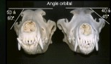

Picture2 and picture3, orbital angle.
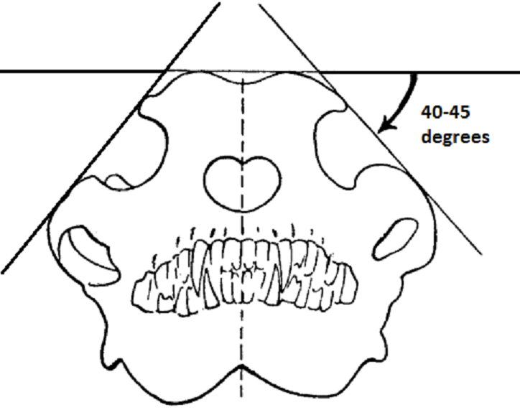

The orbital angle of a wolf will be
40-45 degrees, whereas the orbital
angle of a domestic dog is always
53 degrees or more. This is because
of the wolf’s larger zygomatic arches,
providing more space for muscles.
Also related to a domestic dog’s stop.

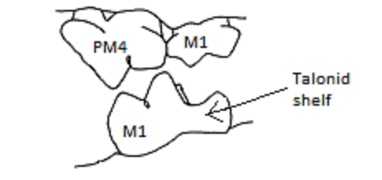

Picture4, Carnassial pair of a wolf.

PM4 = fourth premolar, M1= first molar. Note the rear of the lower first molar and its basin-like form.

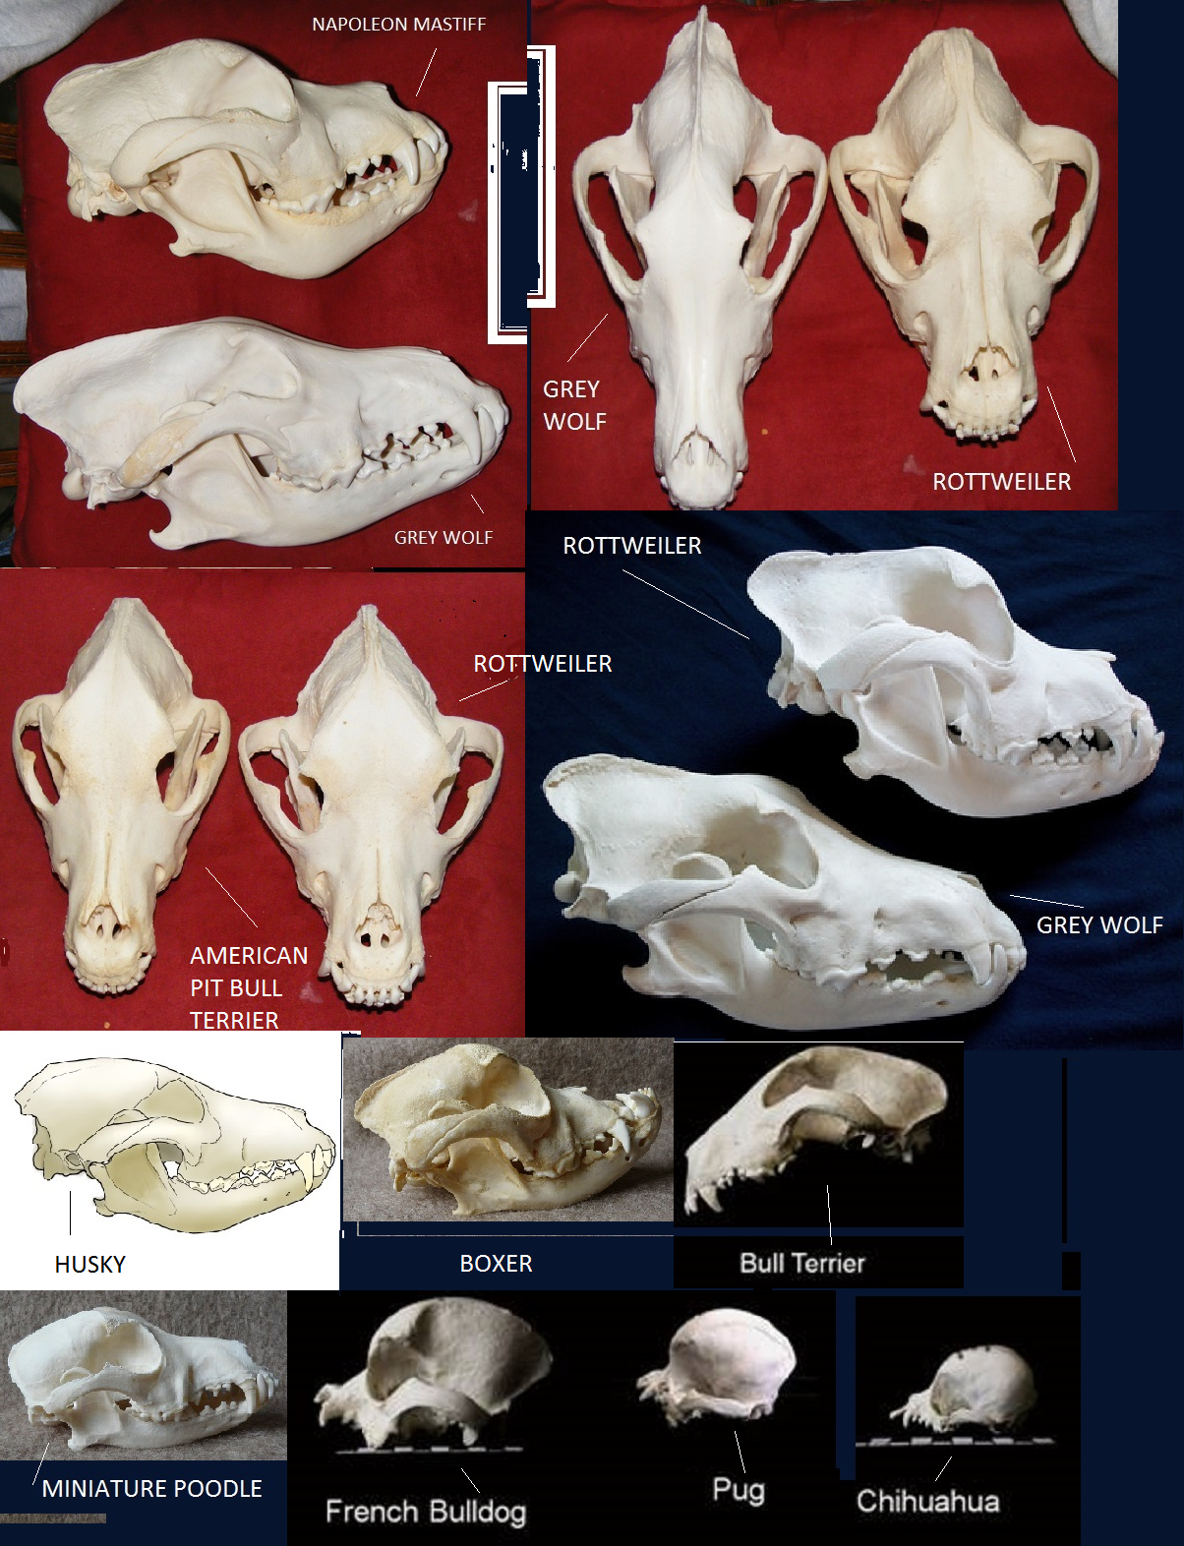

Picture5, Rough skull comparison.

From left to right, first row: Napoleon mastiff skull & Grey wolf skull (side view), Grey wolf skull & Rottweiler skull (front view)
Second row: American pit bull terrier & Rottweiler skull (front view), Rottweiler skull & Grey wolf skull (side view).
Third row: Husky skull (side view), Boxer skull (side view), Bull terrier skull (side view)
Fourth row: Miniature poodle skull (side view), French bulldog skull (side view), Pug skull (side view), Chihuahua skull (side view)

MYTHS, MISBELIEFS AND MISCONCEPTIONS
Wolf studies are a recent thing, thus more and more new information is being discovered about them every day. In fact, we have learnt more about wolves in the past 40 years, than in the rest of history. Most information we know now goes completely against the “correct” information of years ago. This is mainly because information from years ago has been based on human experiences, anecdotes, assumptions, captive wolf experiments and comparisons to other animals. Here are a few misconceptions, some older and some newer, plus the most likely origins behind them. As of early 2014, all this information stands correct, until some new information comes along and proves us wrong (which it will).

- Wolves howl at the moon
Wolves will howl for many different reasons. One of the reason for howling is not because it is a full moon. If fact, wolves will howl at many things, but you can be sure the moon is not one of them. Wolves could howl every single day at any given moment.
Howling is a form of long distance communication, a lot like how one person may make a phone call to another. All sorts of messages can be told through howling. Howling is also contagious. Much like how one dog barking sets other dogs off barking, a wolf howling can set other wolves off howling. Not only this, but similar types of sounds can get a wolf going. These types of sounds tend to mainly be the two-toned sounds, such as sirens, church bells, ice cream vans and alarms.
The reason for thinking wolves howl at the moon comes from way back before electricity, when the human population was small enough for wolves to still live around and nearby. On full moon nights or nights that the moon shone clearly, when things would be calm and “eerie”, a wolf’s howl would carry further than it normally would. People being outside in the dark, especially with no lights for vision, naturally got afraid. People either did not know what creature was out there, or just didn’t understand the reason for the noise, with howling often adding to the eerie feel. People could have understood it as many different things, for example a cry for an attack or future death. Through these howls, wolves also began to be associated with devils and witches, thus also the moon. In addition, werewolf-type stories have been around for centuries, and these have also strengthened the link between wolves and moons.

- Wolves have blue eyes
When a wolf cub’s eyes open, they will always be blue, however, this trait always disappears. A wolf cub’s blue eyes will lighten and fade, having changed into their amber colour by about 10 weeks old. An adult wolf’s eye colour will always be any shade of amber, yellow or gold but also come in hues of grey, green and brown.
Often, light greys or pale greens appear to have a slight blue appearance in certain lights or angles. For an adult wolf to have actual blue eyes, it would have to be for a specific reason. The main reason why a wolf may have bluish eyes is that it has cataracts. In this case, it is not the eye itself, which is blue, but the cataracts causing the appearance of blue. Wolves that develop cataracts in the wild will usually die out and are rarely seen.
Another reason is that the wolf is not a wolf, but a form of wolf dog hybrid. The blue eye trait in dogs is purely from domestication. For a dog to have blue eyes, it would have obtained them through one of four ways. The first way is a side effect of the merle gene. The merle gene will dilute pigment, including pigment in the nose and eyes. The merle appearance is purely from domestication, and wolves have no merle possibility.
The second way is having blue eyes associated with deafness. Blue eyes results from an absence of pigment in the iris, which is common with pigment-associated deafness. As with the merle gene, this is a side effect of lacking pigment, however one is associated with merle and the other with white. Again, this is a gene mutation developed through domestication, and does not exist in the wolf world. The third way is associated with albinism. True albinism causes pink eyes, though faint strains of it can result in blue eyes. Albinism can occur in wolves, as it can in nearly all animals, though it is extremely rare since wolves just simply do not have much albinism in their gene pool. On top of this, wild wolves who do have albinism would not live past their juvenile stage, due to having disadvantages in the tough struggle of life. There have been a few accounts of albino wolves in the wild, though these have mainly turned out to be Arctic wolves, or white wolves with a very pale eye colour.
Lastly, the fourth way to obtain blue eyes is to inherit them as a completely separate gene, unaffected by coat colour. However, this also is a gene mutation developed along the domestication line, and is what gives Siberian huskies their blue eyes.
The origin for thinking wolves have blue eyes in unclear, but could be reinforced by numerous reasons, such as seeing adult wolves with normal but pale eye colours, thinking wolf cub’s will grow up to have blue eyes, thinking a domestic dog’s blue eye strain stems from wild wolves and mistaking blue-eyed dogs/wolf dogs for wolves. Not only this, but also a lot of media, including novels and films, display wolves with blue eyes, on top of a lot of wolf images being Photoshopped to have blue eyes.

- Wolves eat humans, including babies
This is not true, but not exactly false either. Wolves will always primarily hunt herbivorous ungulates, as they do not benefit as much from eating any form of omnivore, thus humans are not prey. Only if herbivorous prey gets very scarce, they may sometimes eat smaller omnivores, such as wild boar, musteloids, rodents and small canids. Due to instinct and a wolf’s extremely wary and shy nature, wolves will always aim to avoid humans.
There are situations, though, when things change, with most consequences being due to a fault of the humans. At the same time as being wary, a wolf is extremely curious. Many times an exceptionally brave and curious wolf, perhaps a juvenile, has got close enough to humans for them to notice. Sometimes humans may try to approach the wolf, or start tempting it by leaving food etc. When wolves start to adapt to humans, thus being less wary of them, they become more dangerous. Humans may also attempt to push their luck, stepping out of line in one way or another, with the wolf then expressing its dislike. Other scenarios of wolf attacks are for example wolf dogs and sick wolves, such as a wolf with rabies.
The whole idea of wolves eating people has been around longer than we can ever know, and most likely stems from numerous attacks on people throughout history. Often these attacks are wolves trying to express something, but not actually aiming to kill. When being aggressive or violent, wolves will treat people as they would each other, for they do not realise humans are more fragile. With our body withstanding less than a wolf’s can, wolves easily end up killing us. Wolves usually would not eat humans, as we are far from their idea of prey, with human meat being far too salty for most animals to enjoy. The other account though, is wolves being opportunists, and especially during hard times, if there is a dead body around, they may take the opportunity for a good meal. However, it is interesting to note that Germans have eaten more humans in the last 50 years, than wolves have in the last 100 years.
Wolf attacks and human deaths and consumption were far more common hundreds of years ago, than the times of today. The reason for this is unclear, though it is thought that around the time humans started living next to wolves, and have overlapping territories, many wolves weren’t familiar with humans before, thus being less afraid. A wolf’s fear of humans has developed over the years due to humans killing them, and by now is embedded strongly into their genes, viewing humans as predators as opposed to prey. However, it must be mentioned that in some areas where wolves have had little human contact, such as the high Arctic, wolves are much less afraid, with it mainly being their wariness to unfamiliar things that keeps them at a distance.
In the end, most wolf attacks are by sick wolves or wolf dog hybrids (wolves hybridising and obtaining rabies became much more frequent when humans and their domestic dogs moved in closer). All these accounts, mixed with human hysteria, has formed the image that wolves hunt humans and will eat them as prey, being reinforced by humans’ attitudes and passing these “facts” down through generations. Again, the media plays a big role, with stories such as “Little Red Riding Hood”, and anecdotes making the papers easily, blaming situations on wolves that, in reality, had nothing to do with wolves, encouraging hatred on these animals. It is common to, for example, exaggerate a story, i.e. a wolf attacked a human’s dog, when in reality it was a fox running by that simply startled the dog.

- Wolves are bloodthirsty
This is a spin off from the misconception of wolves eating people. The word bloodthirsty implies that the animal is eager for blood, and kills for its own amusement. A wolf is and does none of these things. A wolf does not care much for blood, unless it tells the wolf of an injured prey animal. Again, humans are not prey and wolves do not hunt humans. A wolf will not be triggered by either the scent, taste or sight of blood. For example, a human with socialised wolves, who goes regularly in with them, could hurt themselves to the point they are bleeding, and the wolves will not pay attention to it. At most, they may have a good sniff at the wound and perhaps a lick, but this is simply investigating something new that they realised is not usually there, and they will quickly become uninterested. As for killing for fun, this is a highly complicated concept.
All animals will kill for some reason or another, some for more understandable reasons relating to survival, some for less understandable reasons. Most wild animals will kill because it gives them an advantage in living. Some wild animals have been observed to kill for reasons we do not yet know. Wolves, however, are not one of them, killing for clear reasons of survival.
The origin of killing for fun most likely stems from a wolf’s habit of surplus killing, by killing more than it immediately consumes. A wolf will often bring down a large animal that it cannot consume in one go. This is why they normally leave or bury the remains, but will come back to them next time they need a meal. Other reasons for thinking wolves kill for pleasure is observing how a wolf goes after wounded prey, or how wolves are easily scared off from their meal by something, usually humans themselves, thus abandoning the food. Wolf attacks again reinforce this, with wolves sometimes killing humans when not actually intending to, and diseased wolves seemingly killing for fun. Media plays a big part once again, with their idea of wolves being bloodthirsty stemming from the same reasons, and include influences from folklore such as werewolves.

- A pack consists of individual wolves that have ganged together
This is old information that has long been disproven, due to proper scientific wild wolf observations. This theory most likely originates, since most carnivorans are solitary animals and do not stay in families, and from observing stray dogs gathering into groups. Up until the true definition of a wolf pack was discovered, wolves in captivity were kept in “packs” that consisted of random unrelated wolves placed together, and most wolf observations were made on these captive wolf packs.

- A pack is led by an alpha/alpha pair
Probably the most common “fact” we still run into today. Back during the 1930’s and 40’s Rudolph Schenkel, an animal behaviourist, underwent the first close observational studies on two wolf packs to try to understand more about this little-known animal. He then released a ground-breaking paper in 1947, identifying two primary wolves in the packs, a male and female, whom he described as “first in the pack group”, and how “both of these ‘A animals’ defend their social position”. It is from this that the “alpha” concept was born.
The issue with this is that the two wolf packs were captive wolf packs, and consisted of unrelated wolves thrown in with each other. His studies remained the primary resource on wolf behaviour for decades, with researchers later performing their own studies on captive wolves, publishing similar findings of dominance and leader-follower relationships among captive wolf pack. The concept of alpha wolf was reinforced by famous wildlife biologist L. David Mech’s book in 1970, bringing the term to fame around the world.
Since then, animal behaviourists including Mech have spent more and more time studying wolves in the wild, opposed to captivity, with behaviours previously observed in the captive wolves being almost opposite to the wolves of the wild. In 1999, Mech released a paper stating how the concept of alpha “is particularly misleading”, and how the “alphas” are simply what we would call in any other group “parents”. This paper is considered the turning point in understanding the structure of wolf packs. “Alpha” implies the highest ranking position, won through some form of competition, usually through fighting or aggression. However, wild wolves do not do this, and neither do correctly established captive wolf packs, with the highest ranking position simply being obtained by reproducing, and the other wolves being the parents’ offspring. Younger wolves do not attempt to overthrow the “alpha” to become leader of the pack. As Mech himself states, “such an approach is analogous to trying to draw inferences about human family dynamics by studying humans in refugee camps”.
This does not mean that wolves do not display forms of social dominance, however, but simply packs are formed and kept alive through co-operation rather than aggression, submission rather than dominance.
Despite scientists, including the very man giving the concept “alpha” its popularity, expressing how wrong this term is, the easy notion of “alpha” persists, giving the media industry great stories for entertainment. In addition, the outdated idea of “alpha” still holds valuable meaning in an area of the real world: dog training. (For Mech’s statement on the alpha concept, see link 5)

- Wolves are aggressive amongst each other and fight a lot
This misconception has also stemmed from the famous observation studies on the packs of captive, unrelated wolves, with Rudolph Schenkel noting violent rivalries between individual members of the packs. At this time, it was not known that wolf packs were families, and most captive wolves were placed together at random. This led to horrendous fights among the wolves, many leading to deaths, with the behaviour being considered normal at the time. This idea has also most likely formed from observations of grouped stray dogs, which can at times fight a lot. Schenkel frequently drew parallels and conclusions between wolves and domestic dog behaviour.
- Wolves hunt like lions
This idea most likely stems from the time knowledge on wolves was very restricted. Trying to understand more of their nature, they were compared to other carnivores that lived in groups. Perhaps a lion pride resembled a wolf pack best, more so than for example hyenas, thus possibly coming to the assumption that the wolves must hunt similarly, creating the idea that each wolf has a different role in the hunt. However, as disappointing as it may be, wolves generally all do the same thing during a hunt, with the exception of one wolf finishing the hunt.
Wolves will start off by tracking and detecting their prey, when they will then try to creep in undetected, getting as close as possible. However, wolves are no felines, and they will not succeed in creeping too close. Once detected, the prey animal will either stand its ground or run. Wolves require the chase to bring an animal down and get a meal. While an animal stands its ground, wolves will generally give up or try to intimidate it into running. Smaller animals such as deer or wild sheep will most likely run, for it is more instinctual for them, as wolves have a better chance at bringing a smaller prey animal down even when standing still, thus the prey animal relying on speed to escape. Once the prey animal starts running, the wolves must immediately take pursuit, for if their pursuit is delayed, they will most likely not get a meal. Once chasing the animal, all wolves will run after it and all wolves will take turn in nipping at it, getting it to bleed and thus become weaker more quickly. Once their prey animal is weak enough and near exhaustion, one wolf will latch on with its jaw, causing the animal to collapse, in which the wolf will then bite into the jugular vein to kill its prey.
Hunting methods will vary, depending on prey animals and environment type, however this hunting method is nearly always used, and even in other types of hunting methods, wolves have never have individual roles.

- Wolves need to be taught how to hunt
Ever since birth, wolves have the instinct to hunt. Even captive wolves who have grown up uninfluenced by older wolves will all learn how to hunt for themselves. In the wild, their already existing skills start to strengthen through play amongst siblings. This could be chasing, ambushing, mock fighting or simply playing with a swishing tail, for a wolf is triggered by movement. As they grow older they will take more interest into moving animals, such as insects, fish, amphibians, reptiles and small mammals and birds, before moving on to larger animals. Despite having the skills to hunt, a wolf pack will refine those skills, with younger wolves learning tricks off the older ones, therefore reinforcing something that is already there. Many captive raised wolves will learn how to hunt on their own in their own enclosures despite never having been taught, though their skills may not be as great as an older, pack-influenced wolf’s.
The origins of this misconception is unclear, though nowadays people tend to obtain this idea from the likes of people on TV, who claim to live with wolves, teaching them how to hunt and howl. Why these people claim this is also unknown, for every human who has raised wolves has seen for themselves how they need to be taught nothing, but considering everything, it’s most likely to be for these TV people’s own egos.

- Wolves need to be taught how to howl
Similarly to teaching wolves how to hunt, this is not true. Wolf cubs, from a very young age of just a couple weeks old, are already throwing back their heads and producing the shape of a howl, despite not being able to produce the sounds yet. Again, every captive wolf has learnt how to howl, even if not “taught” and not influenced by other older wolves. The reason for this misconception is most likely the same as for the “wolves need to be taught how to hunt” myth.

- Wolves are a big problem with livestock
This is not entirely a misconception, though it is highly exaggerated. Wolves will always hunt animals from the wild and only if their natural prey is so scarce, would they consider turning on domesticated animals. In today’s world, much of a wolf’s previous habitat had been taken over, and over 50% of wolves have reduced natural prey. Another factor in livestock predation is whether a mother is using a den nearby, making food sought primarily from the area.
Livestock could be killed also through circumstance. A wolf could be in pursuit of prey, in which the prey animal heads towards a habituated area and jumps over a fence, in which a wolf may not hesitate to follow. Upon realising there are much easier and defenceless prey surrounding the wolf, it will attack them instead.
All this means livestock predation does happen, however, it is not as frequent as humans make out to be. More livestock is claimed by animals such as domestic dogs than wolves, and although it is true that we have far more domestic dogs than we have wolves, this does not change the fact that most livestock claimed is by domestic dogs and not wolves.
Livestock predation by wolves is fairly easily discouraged, thanks to the wolf’s wary and energy-saving nature. Installing solid and high enough fences or keeping animals such as domestic dogs or llamas will discourage most wild wolves from predation. Mothers will move themselves and their cubs to a new location if noisily rousted from their dens. Wolves are wary animals who like to stick to routine and like things to be the same, for they shy away from anything different and strange, making such things as even scarecrows or big hats on fences scary enough to discourage a wolf.
The ideas of wolves being a big problem with livestock most likely originates from before wolves were so afraid of people, with these stories passing down through generations. On top of this, there are the real livestock predations made from wolves due to things such as low prey abundance and livestock roaming free in nature (a wolf will not know the difference between a wild prey animal and a farmed animal allowed to roam free). Many humans who own livestock, such as farmers and shepherds, also tend to be people with extreme hatred for wolves, thus when an incident happens it is made sure to be published and possibly exaggerated, or the blame is shifted onto a wolf when it was indeed another animal. Again, sometimes these animals could be people’s wolf dogs let loose, and mistaken for a wolf. It is also highly possible that other animals that sometimes kill livestock, such as bears, will leave some remains. It is natural then for wolves (being opportunists) to come and eat whatever remains are left, sometimes being caught in the act, and thus getting the blame. Some wolves however, do learn the source of easy prey, after discovering it once. In these cases, the wolf may return time and time again, in which case eradication is needed.

- Wolves stalk people
This is a definite misconception, due to misinterpreting the behaviour of wolves. If a human has truly been stalked by a wolf, they most likely would not be alive to tell the tale. Wolves can be incredibly territorial and like to monitor what is going on in their territory. Upon smelling/hearing humans approaching, they will move to the opposite end of their territory to avoid them, but will still keep an eye on them. The reason for this is simply that wolves are extremely unsettled by humans and like to make sure they are gone from their territory/area. Usually, it is one of the younger ones sent to do this. It is not uncommon for humans to spot a wolf, for example on the other side of a valley. Sometimes humans may notice that the wolf is “watching them”. Hiking onwards, the humans may again spot a wolf watching/following them, thus thinking they are being stalked. In reality, the wolf is just staying alert for possible danger, and is waiting for when the humans leave its territory. Once the humans have crossed the boundary, the wolf will go back to join its pack.

- Wolves are nocturnal animals
This is a common misconception, and although they may be very busy at night, wolves are actually crepuscular animals. In addition to seeing best at these times of the day, wolves are at their most active during dawn and dusk, for these circumstances suit them best. Captive wolves are commonly found dozing during both the day and night, though perhaps more so during the day. In the end, wolves are opportunists, thus using every opportunity they can, which will mean going about their ways at night too, though this applies to the daytime too. However, there is no doubting that they are most active in every way during dawn and dusk, thus when it comes to classifying them, they are certainly crepuscular. Thinking they are nocturnal animals perhaps comes from wolves being more active at night (compared to daytime) in areas with humans around, with wolves having learnt that there is less human interference and threat at night.

- German shepherds or Siberian huskies are one of the closest living dog breeds to a wolf
The genetic difference between specific dog breeds and wolves is constantly argued about, with many different answers found, for example on the internet. In the end, there is an extremely small genetic difference between any dog, wolf, coyote, dingo etc.
Despite most separate animal species not being able to breed or produce viable offspring, many canines can. It is so little, that most genetic tests cannot tell how much wolf is in a wolf dog, or whether the red wolf is really and truly its own species. Scientists agree though, that there is at most a 0.2% genetic coding difference between grey wolves and dogs, though many people tend to get this figure mixed up with 2%. Nowadays, the ability to find out which breed is the closest to a wolf is impossible, unless every single dog individual from every single breed was genetically tested, and even then, it would most likely not be clear. We do know as a fact, however, that every single domestic dog derives from the grey wolf, contrary to beliefs such as Chihuahuas deriving from fennec foxes. Most scientists don’t like to think of one domesticated dog breed being closer to a wolf than another, for they are all Canis Lupus Familiaris, and all have the same amount of wolf DNA in them as each other. However, if having to answer that question, the most they can do is give an educated guess, with most concluding it most likely to be an ancient breed from areas such as the Middle East, or ancient Chinese fighting dogs, however, not breeds such as the Siberian husky or German shepherd (relatively recent breeds).
Despite dogs and wolves being genetically so similar, all scientists and animal behaviourists will agree that they are far from being physically or mentally similar, with wolves representing one extreme of the spectrum and domestic dogs the other. They have in fact become so different, that many would like to class them as their own species (Canis Familiaris), though due to genetics, they are normally classed as a subspecies of the grey wolf (Canis Lupus Familiaris).
The reason many people think breeds such as Siberian huskies or German shepherds would be closest to a wolf, is most likely partly to do with people wanting to feel special with their dog, or more commonly due to how similar they can look to wolves, and maybe how “wild” huskies can be. However, as many educated people know, the phenotype does not express every aspect of the genotype, with convergent evolution being a good example, such as sugar gliders & flying squirrels, porcupines & hedgehogs, legless lizards & snakes, swifts & swallows, and old world vultures & new world vultures. None of these animals are closely related. Another example is how closely related animals can look completely different, such as tigers and snow leopards being sister species (whereas snow leopards and leopards are not as closely related).

- Wolves (and wolf dogs) make great pets
Mixing wolf and dog is a common thought most people think of, when wanting something wolf-like, but still manageable. However, most animal behaviourists, experienced wolf and wolf dog owners will agree it is the complete opposite. Generally, by mixing dog and wolf, you get the equivalent of a bipolar/schizophrenic animal (similar to breeding horse and donkey together, and how most male mules must be castrated to be manageable). Studies performed have concluded wolf dogs to be 11 times more likely to attack a human than the most aggressive dogs. However, if they are kept outside in large, safe enclosures, treated as a wild animal and looked after by a knowledgeable person, they can be very manageable.
How manageable a wolf dog is, is greatly affected by how many wolf traits the wolf dog has inherited. Many sellers of wolf dogs will lie or create false records on how much wolf is in the animal. They may either claim there is less than what there truly is, to avoid laws and regulations, or, more commonly, claim there is more than what there truly is, appealing to customers more, earning more money or because of their own ignorance. Some will even go to the point of claiming its wolf heritage, when there is, in fact, none in the dog at all. About 75-95% of all wolf dogs worldwide are claimed to have a higher wolf percentage than in reality. Many breeders will think it’s a simple calculation in knowing how much wolf is in a wolf dog (much like they do with breeds), however when you are breeding a subspecies (or species) to a different subspecies (or species), it is never that simple. Wolf percentage greatly depends on, for example, the sex of the wolf dog, chromosomes and what traits are inherited from which side. In the end, a wolf dog’s wolf percentage is impossible to know, unless a thorough, professional and reliable DNA test is performed, and these normally cost thousands of pounds. Unexperienced wolf dog owners, not knowing what to look for in a wolf dog, will often believe a falsely claimed percentage and, upon finding their wolf dog easy to manage, will falsely form the opinion that wolf dogs are easy to handle, when in reality it is usually down to having an extremely low wolf percentage (if any at all). Dogs and wolves are so behaviourally different, with a wolf’s behaviour embedded so deeply within it, that it is generally pretty safe to assume that a wolf dog has not got much wolf in it if it is living in a human home, laying on the couch with the family, walking on a lead and generally being “good as gold”. However, as previously mentioned, the phenotype does not express every aspect of the genotype and genetics are a very complicated matter, so of course there are always exceptions.
Wolves themselves can hardly be called pets and will not ever satisfy a human if looking for a companion to bond with, an animal to obey or an animal good with families and/or other pets. Despite being genetically so similar to domestic dogs, they are near opposites of each other. They will not be trained (especially house trained), they’ll be destructive, try to escape, eat the neighbour’s cat, dominate the kids in the house etc (the list goes on). As the saying goes, you can take an animal out of the wild, but you cannot take the wild out of an animal. It is necessary that reliable information is obtained on both wolves and wolf dogs, and preferably studied a long time before obtaining either. However, it cannot be strained enough, that with the right people and the right environment and conditions, a wolf or a wolf dog can be a very safe and rewarding experience. In the end, there is nothing usually wrong with the animals, but the people who own them, with many wolves and wolf dogs ending up in zoos or shelters, put down or turned loose into nature, due to humans not realising what they are in for, or with the wolves/ wolf dogs turning out unmanageable, aggressive or simply just “too wolfy”.

- Being “top dog” is the key to training your dog.
The dominance theory in domestic dogs stems from the “alpha” concept. During Rudolph Schenkel’s captive wolf pack studies, he applied his findings on domestic dogs. In his 1947 paper, he came to many conclusions by drawing similarities between the captive wolves and anecdotes of domestic dogs. He implied how wolves live in packs in which individual members compete for dominance, and so fore, dogs must be very similar. Later on, famous wildlife biologist and animal behaviourist David Mech reinforced the alpha concept, making it popular worldwide, thus many carried the idea of “alpha wolf” over to domestic dogs. Just as human parents hold dominance over their children and wolf parents hold dominance over their cubs, dog owners hold dominance over their dogs. However, the idea of pack rank is often taken too far, with humans having rules to “maintain alpha status” in all aspects of the relationship, such as not letting a dog walk through the door before humans, not letting the dog win a game of tug and not letting the dog eat before humans do. Even certain famous trainers will teach this, on top of encouraging acts of physical dominance that could be potentially dangerous and harming to the dog, but more than anything, just unnecessary.
Most of this is a legacy to the old wolf studies, suggesting we are in constant competition with our dogs for the “pack leader” position, and although some might think domestic dogs behave similarly to wolves in captivity, even hand-reared wolves are behaviourally distinct from domestic dogs, especially when it comes to human beings. Basing our understanding of dog behaviour on wolf behaviour, is essentially the same as trying to understand human behaviour by studying chimps. Wolves, in any situation, do not look to humans for help. They are problem solvers and pack animals, turning to their own species than to any other, for they are specially suited to cooperate and communicate with other wolves to perform a task, especially group exercises, where a packs of wolves have even outperformed groups of chimps. Never do they at any point consider humans (a different species) as part of their pack, just as they don’t consider ravens part of their pack. Dogs however tend to look to humans. Years of selectively breeding, that turned that cooperative tendency from inter-species to intra-species, has caused them to be cooperative with humans and to be more socially intelligent than wolves when it comes to human interaction. This is also how you get domestic dogs “best friends” with other species such as elephants or donkeys. In other words, “dominating” dogs is unnecessary, for besides the obvious reasons of us having the credit card and having control over everything the dog wants, dogs are already pre-programmed to want to work with us. The exact same behavioural results can be accomplished via for example positive reinforcement, and this is psychologically much healthier for the dog. On top of everything else, domestic dogs have evolved as scavengers. They are not pack animals as such anymore, but solitary animals, who sometimes live in loose groups and may sometimes engage in cooperative hunting, but usually not. Most feral dogs tend to hang around humans to obtain their food that way, instead of actively going out hunting their own food. Even in stray dog packs, the dog with the most “friendships” tends to be the leader rather than the most dominant, and animals will randomly and frequently join and leave. Wolves on the other hand are apex hunters and predators, though are able to scavenge when needed/when the opportunity arises, and have close relationships and tight pack dynamics.
Despite the very same people responsible for the dominance theory stating it to be false and unnecessary and potentially damaging, many people still believe in and defend the theory, thus it being very controversial with many different opinions. However, most scientists and officials specialising in biology, animal behaviour and canine ethology discourage this type of training, with the American Veterinary Society of Animal Behaviour releasing a policy statement, deeming the dominance-based alpha dog theory wrong and not being a basis for domestic dog interaction, with a wide variety of dog training organisations in the UK agreeing.

WHY ENRICHMENT?
Enrichment is a huge part in keeping any animal in captivity, and is crucial to keeping animals content in a captive situation and for the animal to show the same natural behaviours in a captive environment, as it would in the wild.
Enrichment is the sole factor in preventing stereotypical behaviours, and must be varied enough to remain effective for any given length of time. If the same enrichment is used often, or there is too much routine, the animal will soon start showing expecting behaviours, resulting in a stereotypical behaviour.

WHAT IS A STEROTYPICAL BEHAVIOUR?
A stereotypical behaviour is a built-in behaviour associated with stress in a captive environment, and tends to be repetitive. These behaviours are caused by artificial environments that do not allow animals to satisfy their normal behavioural needs, and are generally carried out to relieve anxiety. Natural behaviours that show low variation can also be considered a stereotypical behaviour.
A behaviour is statistically “abnormal” when the occurrence, frequency or intensity of the behaviour varies significantly, either more or less, from the normal value. Saying this, it has often been thought that these behaviours are not “abnormal behaviours”, but rather a “behavioural indicative of an abnormal environment”.
Stereotypical behaviours can be due to things such as inadequate mental stimulation or confinement. Examples of stereotypical behaviours in animals are sows biting at their stall bars/tails or constant chewing without anything in their mouth, excessive grooming or sleeping in lab rodents, or management issues in stabled horses, such as chewing or kicking facilities and repetitive motions such as chewing or pacing.
Stereotypical behaviours are also common in zoo animals. 40-54% of all elephants in zoos display stereotypical behaviours such as rocking and trunk swinging. Excessive sucking or tongue use on inanimate objects is also common, especially with giraffes, due to most of them being hand reared and the need to suckle remaining, for less time is spent suckling while being human-raised, than mother-raised.
Other stereotypical behaviours are reduced reproducing success, self-injury, fur pulling, feather plucking, cannibalism, masturbation, depression, aggression, mouthing, pawing, vocalising, tail chasing, eating soil/sand/faeces, and herbivory behaviours in carnivores.
Once a stereotypical behaviour is established, it is often impossible to eliminate due to alterations in the brain.
A stereotypical behaviour is a type of fixed action pattern, induced by a specific stimulus. Fixed action patterns are produced by a neural network, of a hardwired releasing mechanism system. Once started, it can occur without the stimulus needed, thus the importance of preventing these behaviours.

STEREOTYPICAL BEHAVIOURS IN WOLVES
The main stereotypical behaviour in wolves is pacing, due to both confinement and boredom. Pacing is very different to patrolling territory, as pacing is across a very small distance and is much more repetitive, with the animal not seemingly aware of what it is doing, whereas patrolling is across the whole enclosure, whilst possibly cutting across different parts, with the animal obviously aware of its intentions. Patrolling is also neither constant, nor repetitive, though during the breeding season it may be common for wolves to patrol constantly, as their hormone levels rise and stress levels naturally become higher.
Other stereotypical behaviours in wolves are excessive sleeping, fur pulling, aggression, depression and suppressed appetite.

ENRICHMENT TYPES
Enrichment comes in many different forms, all of which are usually grouped into seven different categories. These categories are sensory, environmental, feeding, social, training, manipulation and problem solving. Despite these categories, most enrichment activities include elements of more than one type, thus being able to place them into more than one category.

SENSORY ENRICHMENT
Sensory enrichment specifically targets the senses, which are visual, olfactory, auditory, tactile and taste. Sensory enrichment helps keep senses sharp and are generally very pleasant to animals, often engaging them for hours.

ENVIRONMENTAL ENRICHMENT
Environmental enrichment is the process of tailoring an animal’s captive enclosure, to target its natural behaviour and allow them to show these behaviours such as climbing or swimming. It enhances the animal’s captive habitat, giving opportunities that change or add complexity to the environment.

FEEDING ENRICHMENT
Feeding enrichments are different methods of food presentation to make feeding more challenging, encouraging the animal to investigate, manipulate and work for their food, as they would in a non-captive environment.

SOCIAL ENRICHMENT
Social enrichment provides the opportunity to interact with other animals, which could be either the same species or a different species. Many animals are social animals, meaning that inadequate social interaction could lead to things such as depression and boredom.

TRAINING ENRICHMENT
Training enrichment is training an animal with positive reinforcement or habituation. This has both its benefits on the animal and the humans. It can be positive for the animal, as it may be one-on-one time with the human, get lots of attention, the animal may find it fun, feel good about itself, feel like it’s accomplished something or may take it as great social enrichment. The positives for humans could simply be that trained animals are easier to manage than completely wild animals. This can make things like transportation, getting into close proximity for observation or vets visits much simpler.
Conditioning fits into this category. Conditioning is where an animal is not trained to perform something, but taught to adapt to a certain process or environment, such as a moving trailer.

MANIPULATION ENRICHMENT
Manipulation enrichment is providing items that can be manipulated with paws, feet, tail, teeth, horns, head etc. This promotes investigatory behaviour and exploratory play.

PROBLEM SOLVING ENRICHMENT
This is the kind of enrichment that can keep an animal busy for hours on end. Problem solving enrichment is requiring an animal to solve simple problems to access things such as food or other rewards. It encourages the animal to think for itself and practise getting around things. It is great for stimulating the animals mind and raising its confidence through accomplishment.

POSITIVE AND NEGATIVE ENRICHMENT
Most enrichment is considered positive, though some enrichment can be classed as negative. An example of negative enrichment is recording bird of prey noises to play near the predators natural prey animals. The benefit of this is that it keeps the prey animal’s natural behaviour going, but can also induce stress. Many people are against this sort of stress, despite the stress of e.g. an animal facing a predator/prey situation enhancing their natural behaviours and fine-tuning their senses. Meerkats are a good example. They have a very complex social structure, and relying on others to be lookouts strengthens bonds between individuals.
On top of this, some enrichment considered a negative one, can actually be successful, such as a bad smell.
In the end, enrichment must not cause any harm or unnaturally high stress to the animal to be considered successful.

SUCCESSFUL ENRICHMENT
Successful enrichment prevents stereotypical behaviours and keeps an animal engaged and mentally stimulated.
Telling if enrichment has been successful or not is done by completing ethograms, carrying out observational studies on the state of the animal, such as the state of its coat, stress hormone levels and heart rate, and working for responsive actions, for example observing how the animal reacts to stimuli such as the presence of food. Another indicator of sufficient enrichment is the success rates of breeding.
If a stereotypical behaviour has already occurred, such as pacing, giving enrichment and then conducting ethograms to see if pacing occurs less frequently is the most common way to see enrichment success.

ENRICHMENT IN PRACTISE AT THE UKWCT
At the UK Wolf Conservation Trust, we try to target all of the enrichment types. Below are examples listed of each enrichment type carried out at the Trust, though manipulation enrichment has been left out, since most objects cannot be placed into wolf enclosures, due to their destructive nature. Those objects that are put in for enrichment fit better into another category.

SENSORY ENRICHMENT
At the UKWCT we often target the wolves’ sense of smell, as this is the sense that wolves rely on the most. To stimulate this, we often use hessian sacks, which we then fill with straw, either from another pack’s kennel beds or from the barn our two pygmy goats sleep in. This alone would be enough, but occasionally we like to add other strong scents such as old perfumes, essential oils, citric juices, vinegar, scat from other animals, ash, coffee, tea or brine from hot dogs or fish, and sometimes even blood from their own food. We then throw this sack over into the enclosure (picture6-8).
It does not always have to be hessian sacks. For example, occasionally we have thrown in teabags, either used or unused, which is essentially its own tiny hessian sack. We have sometimes observed wolves sucking and chewing these up, even days later.
In the autumn when all the leaves have dried up and fallen to the ground, we rake them up and make a great big pile in the enclosure. We then place some strong scents under, on top or inside the leaf pile (picture9). In winter, if there is a sufficient amount of snow, we like to make giant icy snowballs or snowmen, with a scent or treat hidden in the middle. Scents on trees and rocks work well too (picture10).
These enrichments will usually also encourage social interaction, as they squabble over who gets what, or discover new things together, encouraging investigation at the same time.
The wolves get tactile enrichment mainly through humans. As our wolves are socialised, they will sometimes come over to ask for a scratch and could sometimes spend hours staying still and letting you scratch them, if only you would let them.
When a wolf returns from a walk with new smells on it, the other wolves in the pack will run over, touch, and smell the walked wolf all over, encouraging discovery too. This separation and re-immersion is another form of tactile enrichment. Enclosures provide different tactile enrichment, for example different terrains and water.
The wolves get plenty of auditory enrichment through hearing things such as the village’s church bells or ice cream van, all of which usually set the wolves off howling. Hearing another pack howl is also auditory enrichment and usually once one pack howls, the rest will follow. This storm of howls also encourages a lot of social enrichment. Occasionally we have played back different sounds including other howls to them.
To target sight, we have experimented with things such as bubbles, something the wolves have probably never seen before in their life, animals made out of sticks that are then placed into their enclosures (possibly adding a scent or food to them), and even “strange” and different clothes work as enrichment. In general, we try not to create too strange things for them to see, for they can stress easily from things that appear scary or unnatural to them. Natural wildlife serves as additional visual enrichment, including birds of prey, which serves as a type of negative enrichment, for some of our wolves are very wary of them and may constantly look up in situations such as feeding time. Our pygmy goats who often run free on site will act as visual enrichment (as well as auditory and scent enrichment), as the wolves love seeing and following these goats along the fence (picture 11). We frequently spot the goats teasing the wolves, rubbing themselves against the barrier fence directly in front of them, while the wolves are trying to get them to play, or sometimes even stalking them. Once the wolves get close enough, the goats will often turn around and butt the fence, making the wolves jump back very quickly!

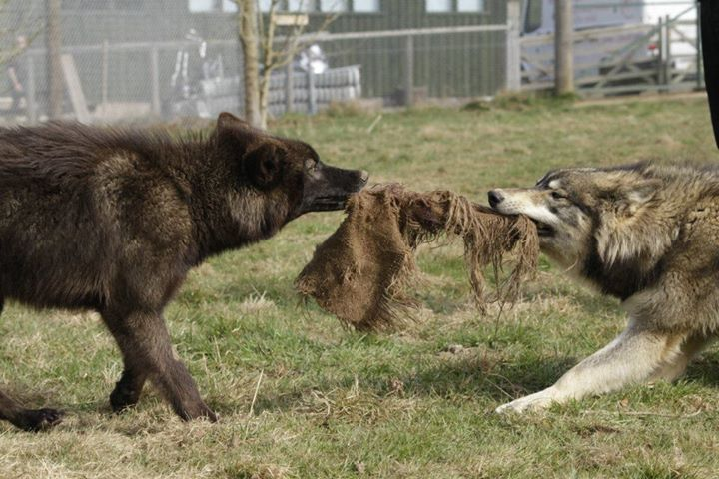

Picture6, Tala and Nuka tugging on a hessian sack.

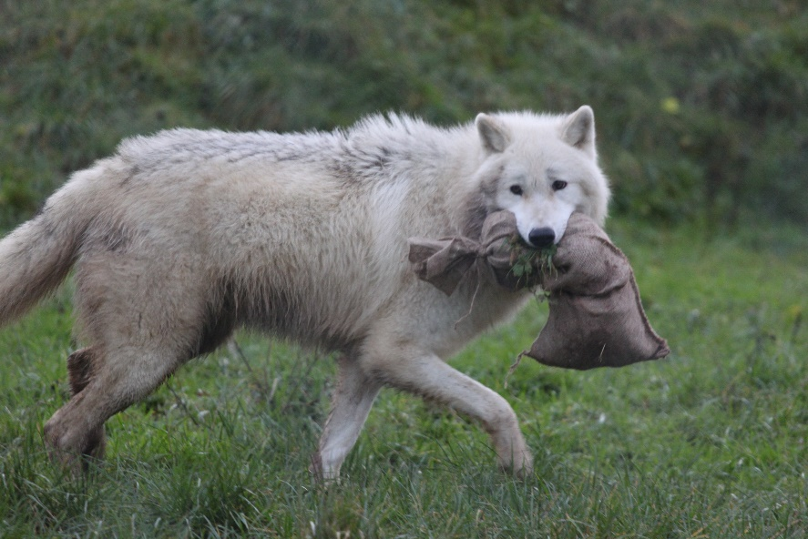

Picture7, Massak running away with a hessian sack
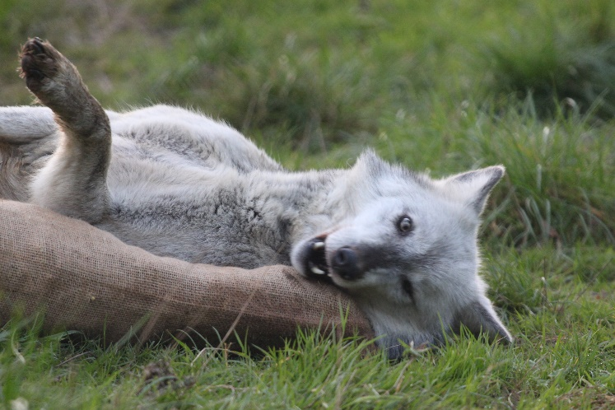

Picture8, Mai rolling on a hessian sack.
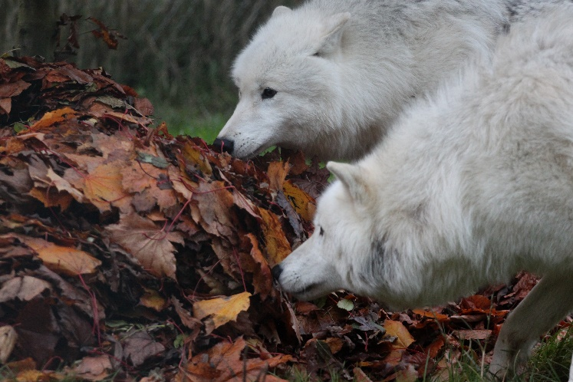

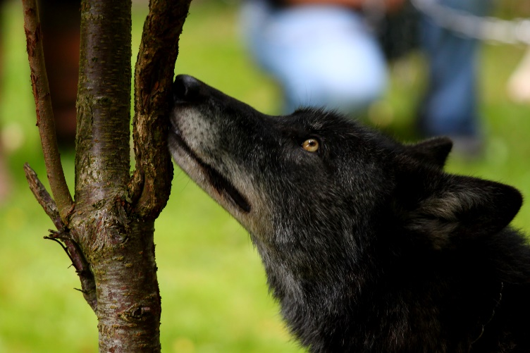
Picture9, Massak and Pukak investigating some scented leaves.

Picture10, Tala smelling a scented tree.
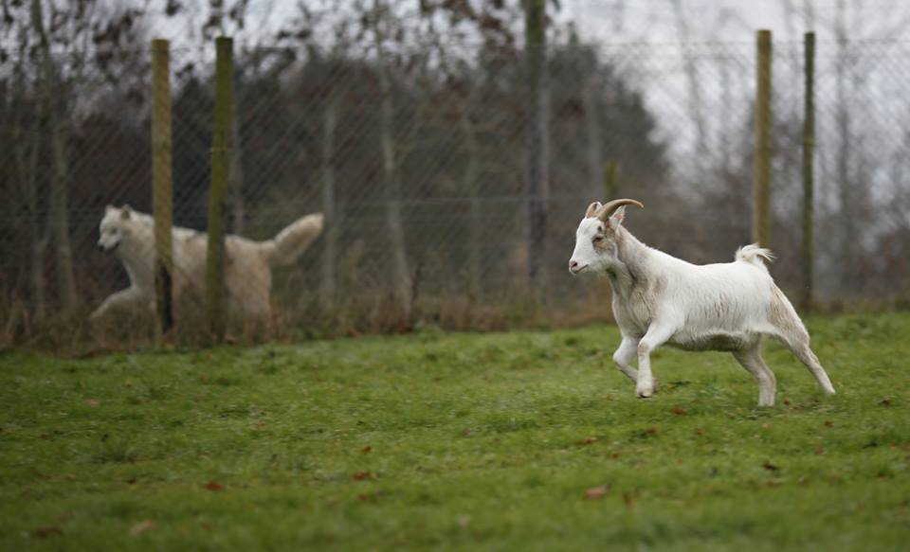

Picture11, Massak follow a running pygmy goat.

ENVIRONMENTAL ENRICHMENT
At the UKWCT, we took careful consideration and planning when creating enclosures, and included everything a wolf may want or need in a natural territory (attachment 1-3.). We made sure they have plenty of space, our enclosures being 1.5-3 acres big, being able to play, socially interact, and show the same natural behaviours recorded in the wild. These behaviours include, among others, climbing high to see around their territory and digging dens during breeding season.
The enclosures have hill top vantage points (picture13), tree cover, various types of undergrowth and overgrowth (picture14), water sources and ponds (picture15), ready-made denning sites, platforms at various heights, rocks, fallen over tree trunks, sand and various fruit trees.
The wolves will also get environmental enrichment through our maintenance we do in the enclosures. This maintenance always alters the environment in some form, such as strimming long grass and weeds down, cleaning water troughs and filling in holes. Usually, after strimming we will see the wolves smelling every clump of cut grass and then rolling in it all, urinating in and mucking about in clean troughs to make them dirty again, and digging up filled in holes to see if we happened to bury anything!

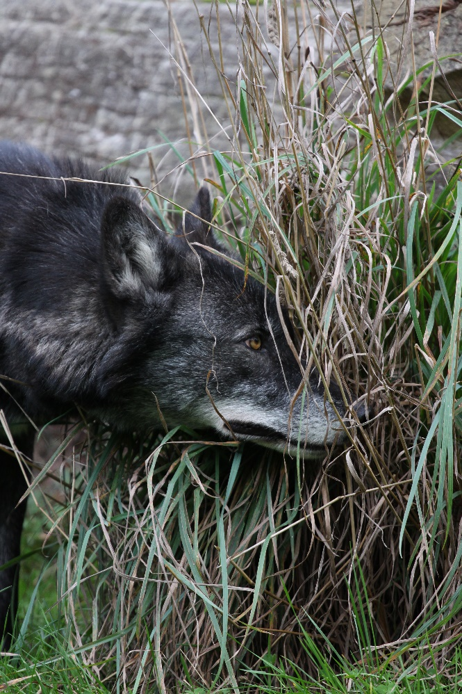

Picture12, Tala peering through long grass next to a tree trunk.

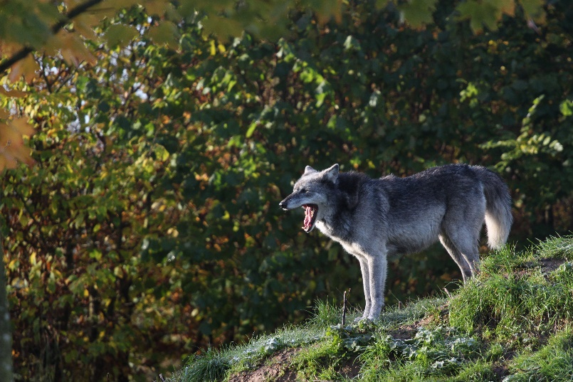

Picture13, Mosi mounted on a hilltop.
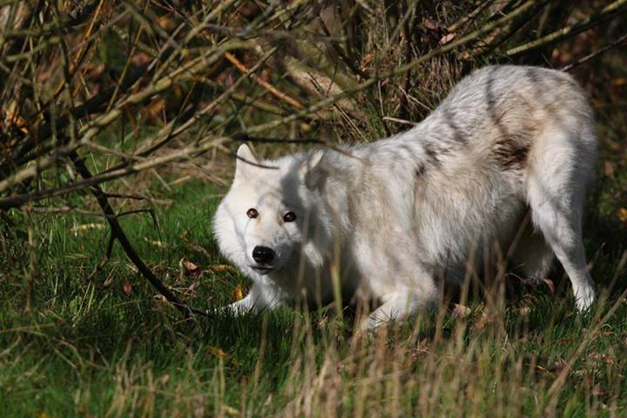

Picture14, Massak hiding under thin overgrowth.
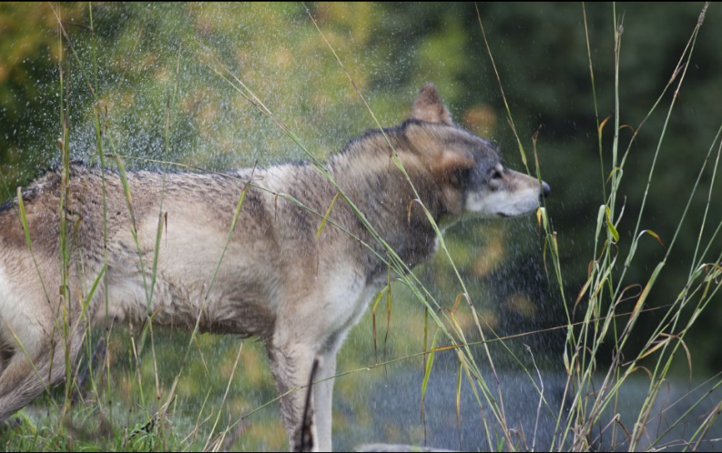

Picture15, Torak shaking water off at a pond.

FEEDING ENRICHMENT
Wolves love to eat, eating extremely fast (hence the saying “wolfing it down”). Because of this, this is a favourite type of enrichment to target. We try to vary their diet as much as possible, some days giving something of this and other days something of that. The types of meat we give them is beef, chicken carcasses, paunch (the unprocessed stomach lining of a sheep), rabbit, hare, various deer, bison bones, pork and lamb scraps, liver, heart and the occasional pheasant, and any other little bits usable for enrichment or children’s events, such as hot dogs, tinned fish, cheese, dog and cat food, black pudding, blood jellies and pâté.
To vary feeding enrichment even more, we feed the wolves in different ways. Nine of our 10 wolves are socialised, meaning they will happily take food through the fence (picture16). This hand feeding also has the added advantage of being able to slip any necessary medication into their food, such as worming tablets or sedatives, and making sure it is eaten by the right wolf, avoiding the risks of dart guns. Occasionally we may create a carcass feed, where we place a whole carcass of a deer into an enclosure (picture17), forcing the wolves to work for their food and promoting lots of social interaction. Other forms of feeding is creating food trails, where we drag their food around the enclosure, eventually hiding it, possibly up a tree or down a hole, ready for them to smell it out and find it. This is another form of sensory enrichment. Food may be tied to trees with natural rope to make it more challenging.
Other feeding enrichment created is placing or hiding skulls, melons or pumpkins, carved out and filled with food into the enclosure. This will also encourage them to use all of their paws, teeth and intellect, also a form of problem solving enrichment.
In the summer time, when the days are hot, we give the wolves ice-lollies. These could be a mixture of fruit and juices, or blood drained from their meat and tit bits, frozen and put into the enclosure ready for the wolves to lick down to nothing.
Despite wolves being mainly carnivorous, they get some amount of fruit too. They have various fruit trees such as apple, pear and hazelnut trees, and we sometimes place whole fruits such as different types of melons into their enclosures (picture18).

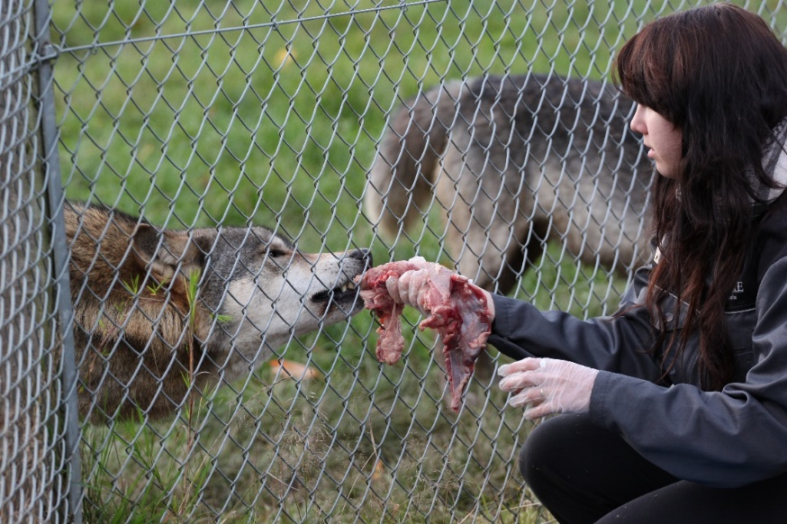

Picture16, Hand feeding Torak.

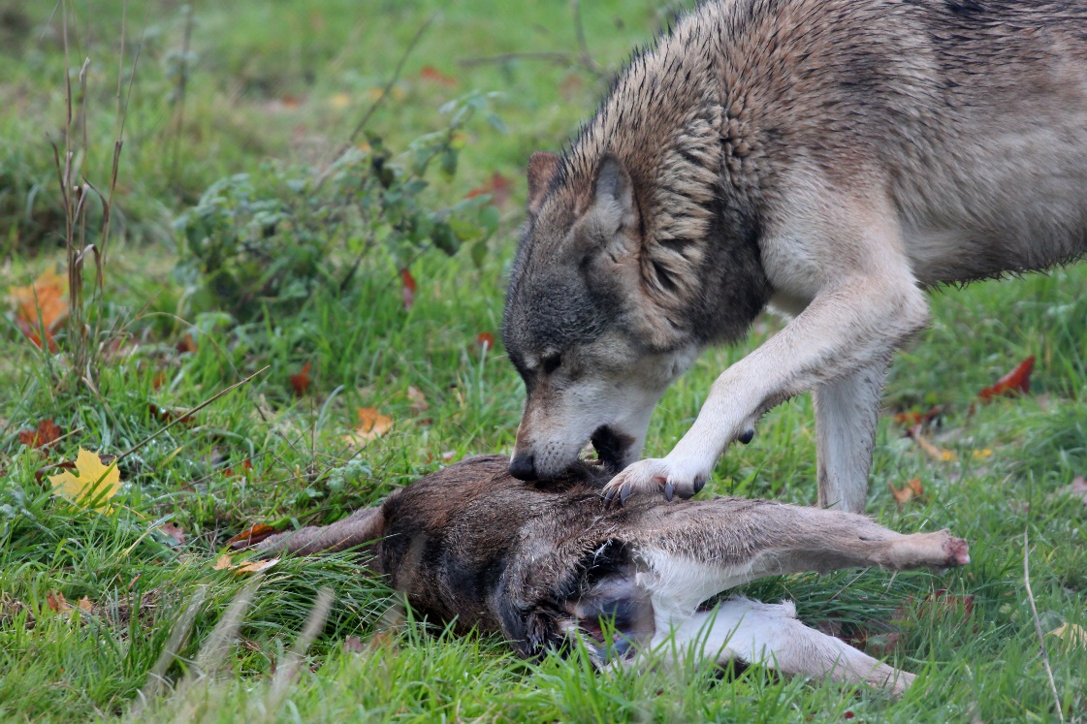

Picture17, Torak starting on a deer carcass.
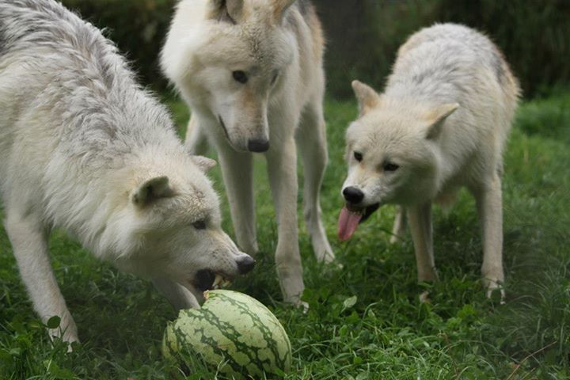

Picture18, The Arctics socially interacting over a watermelon.

SOCIAL ENRICHMENT
At the UKWCT, we understand that wolves never do well on their own. This is why in each enclosure, we always have at least two wolves, making sure we provide for them the company that they would naturally have in the wild. That way they get a lot of social enrichment from each other and strengthen bonds through play, attempted breeding (for our wolves are either spayed or neutered), dominance and submission.
Every so often, about once a year, we switch our wolves around between enclosures. This gives them new neighbours and promotes not only social enrichment by increasing social interaction between groups of wolves, but also sensory enrichment, as they explore and discover the scents that the previous group had left behind, also giving them the mission of scent marking to make the territory their own.
Social enrichment is carried out through people too. Nearly all our wolves are socialised meaning they’ve been hand reared since about 6-10 days old, taking the wolves flight distance of humans down to about zero. This means we can touch them, walk them, check their paws and teeth, and the vet can perform things like injections on them without them having to be sedated. To uphold this, we socialise with the wolves about once a week, some more and some less. This simply means going into the enclosure and keeping them company, giving them scratches if they want, practising general health check-ups and just letting them carry on being used to our presence. Wolf interaction is always done on the wolf’s terms, though if we would not keep this up, the wolves would start to become more wary and intolerant of people. On top of this we greet them at least once a day through the fence, again, giving them scratches if they ask for them.
Once a week, on Wednesdays, the Trust is open to the public. This means that anywhere between 5 or 500 visitors could come in one day to look at and learn about the wolves. This in turn gives the wolves a type of social enrichment too, as well as visual, auditory and olfactory. We will always have wolves that are less keen on big crowds, which is another reason the enclosures are big enough and with enough hiding places, for the wolves to go away from the crowd or hide if they want to.

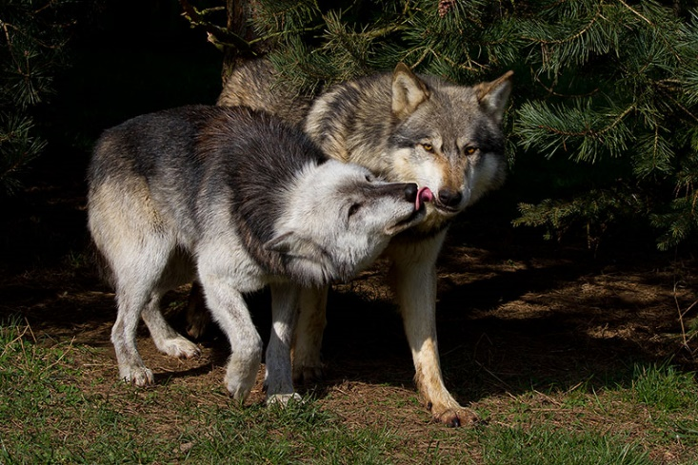

Picture19, Motomo and Mai showing social behaviour.
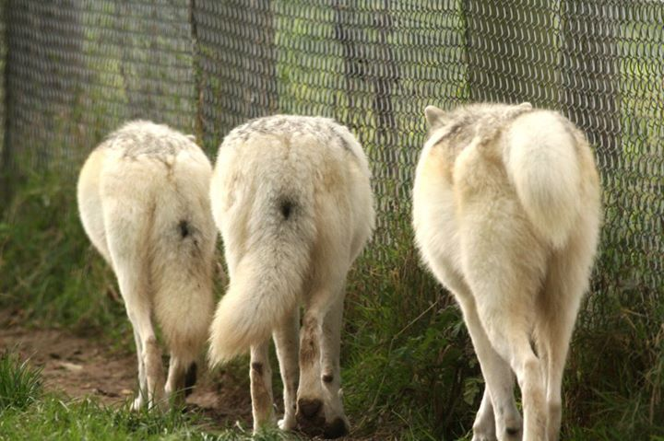

Picture20, The Arctics patrolling together.

TRAINING ENRICHMENT
At the Trust, we haven’t trained our wolves to react to any stimuli, such as clicker trainers, as we like our wolves to act as naturally as possible. However, the wolves are conditioned to certain things, the main thing being a collar and lead. This has let us introduce walks to the wolves, not for exercise, but for sensory enrichment (picture21). Through these walks around fields, the wolves get to experience new sights, sounds, smells and wildlife, and get a lot of social interaction once they get back, if any wolves have been left behind!
As well as walks, some of the wolves have been conditioned to transporting devices, such as trailers or crates, as in the past they were occasionally taken to different places for programmes, films or happenings to educate about them. Nowadays, however, the wolves are no longer taken, due to different rules and regulations, the age and temperament of the wolves and stress.

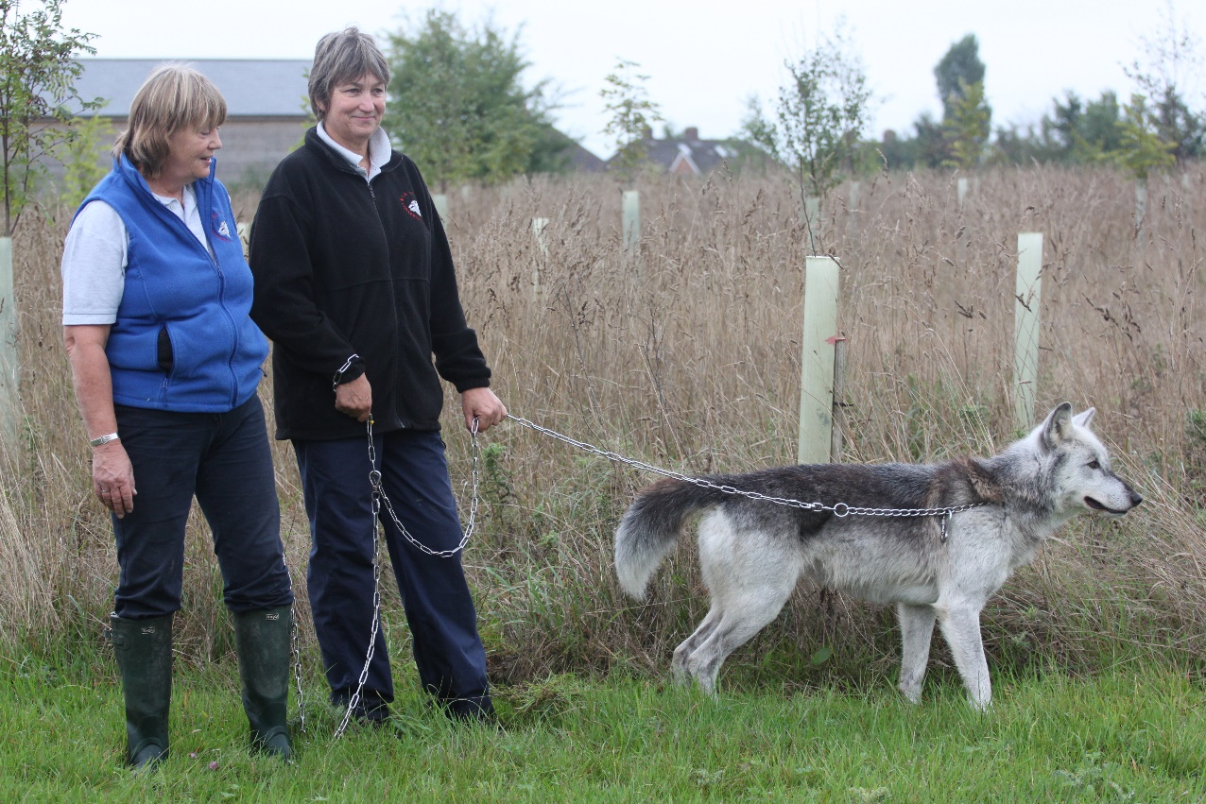

Picture21, Mai on a walk with owner Tsa (left) and a former wolf handler.

PROBLEM SOLVING ENRICHMENT
Our problem solving enrichment mainly comes in the form of hiding food in an edible container. An example of this is how we recently drilled holes into coconuts, draining out the liquid and then stuffing them with treats. This encouraged the wolves to work out where the food is and how to get into it (picture22). It was great watching them try different methods, how some sat with the coconut between their paws, trying to lick all the contents out, some tried to roll treats out of the hole, while others succeeded in biting and cracking the coconuts open after impatiently deciding nothing else was going to work.
Other containers include tree trunks with holes in, balls made of woven branches and concrete slabs with holes passing through them, which support the natural wear down of their claws, as they sometimes scratch at these containers in different attempts for the food.
Some enclosure maintenance, such as filling in holes, involves putting an object, such as a slab of concrete, into the hole to try to discourage their digging in that particular spot. Whether we like it or not, this acts as problem solving enrichment for the wolves too, as they try to find out what exactly we buried and then try to remove the item (also acting as manipulative enrichment).

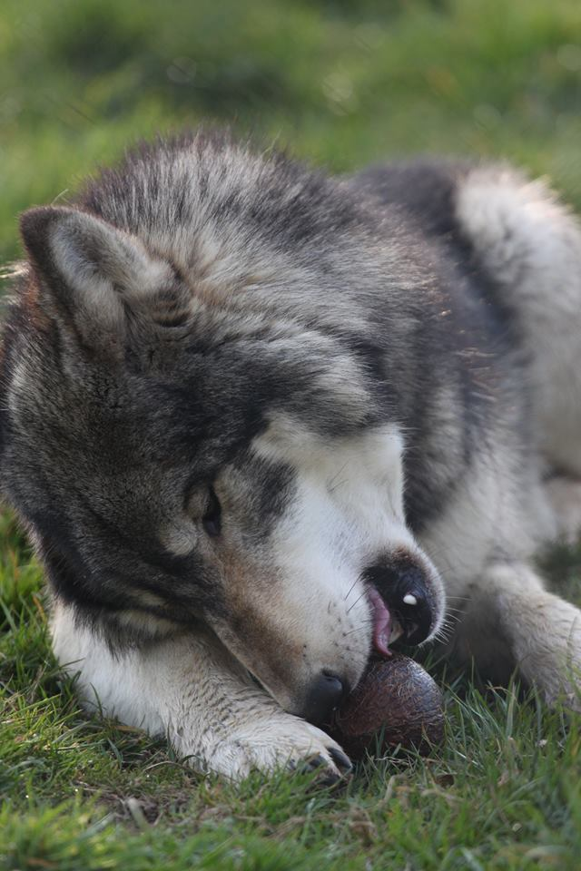

Picture22, Nuka trying to solve the coconut puzzle.

CELEBRATIONS
The trust often tailors enrichment for children and adults to take part in various celebrations, letting them see the wolves with their enrichment and possibly be in the Wolf Print magazine too.
At Christmas time, we make wolf-safe Christmas cakes, letting children and adults take part in decorating the cake with cream cheese and edibles, prior to being able to place the cakes themselves into the enclosures. A couple weeks before hand, we also put up a Christmas tree in each enclosure, where at the same Christmas event, children can hang treats as edible Christmas tree decorations for the wolves. Another common enrichment is making mince pies with real mincemeat, and wrapping up treats in Christmas paper, giving the wolves their very own Christmas presents (picture23).
At Easter time, we let children and parents decorate various eggs for the wolves. These range from goose eggs to rhea eggs to ostrich eggs (picture24). The guests decorate them with edible decorations and then place them in the enclosures themselves. On top of this, we have cardboard Easter eggs that the children fill with wolf treats and also put in the enclosures.
All wolves are born in the spring, which means we have many birthdays to celebrate! We make one birthday cake per wolf and then again, let children and adults decorate them and place them in enclosures (picture25).
Last comes Halloween, where the public take part in carving out pumpkins, filling them with treats to give to the wolves (picture26).

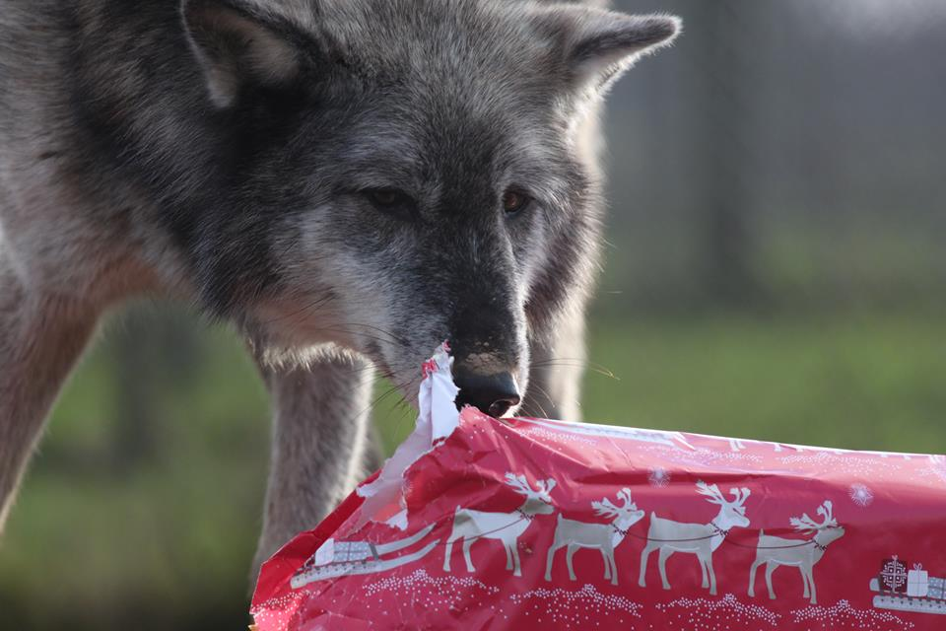

Picture23, Mosi opening a Christmas present.
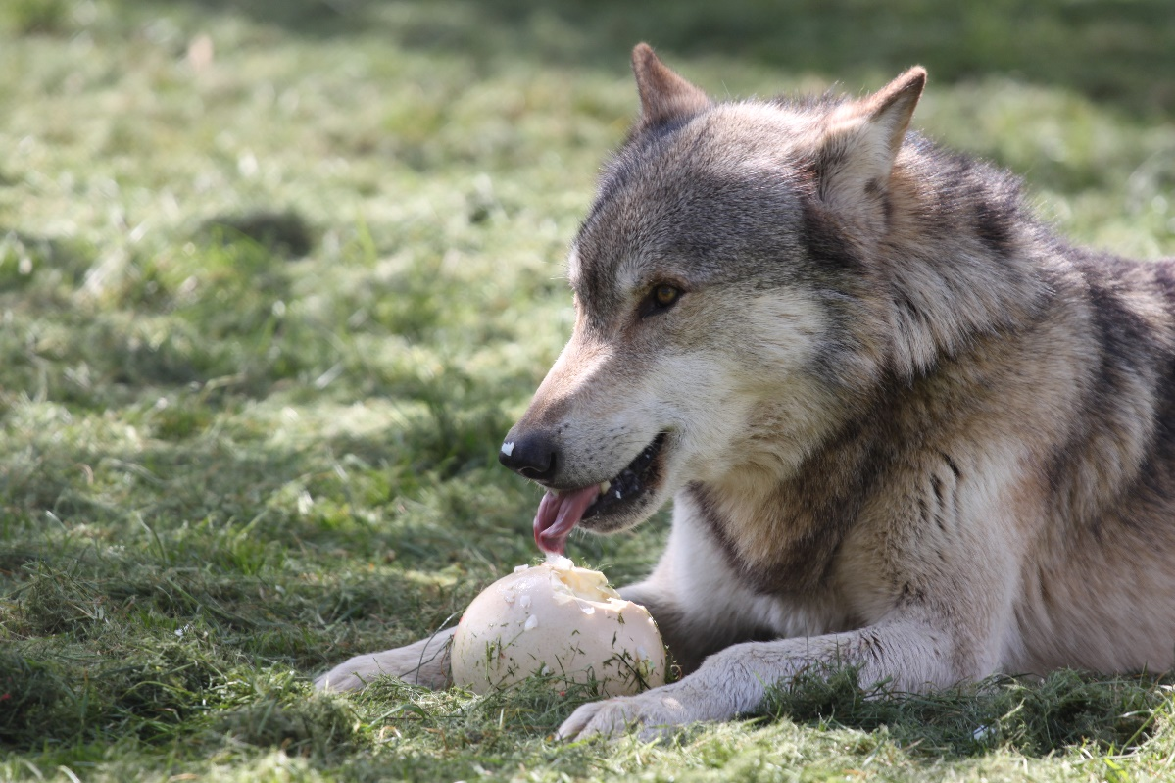

Picture24, Torak enjoying his Easter ostrich egg.
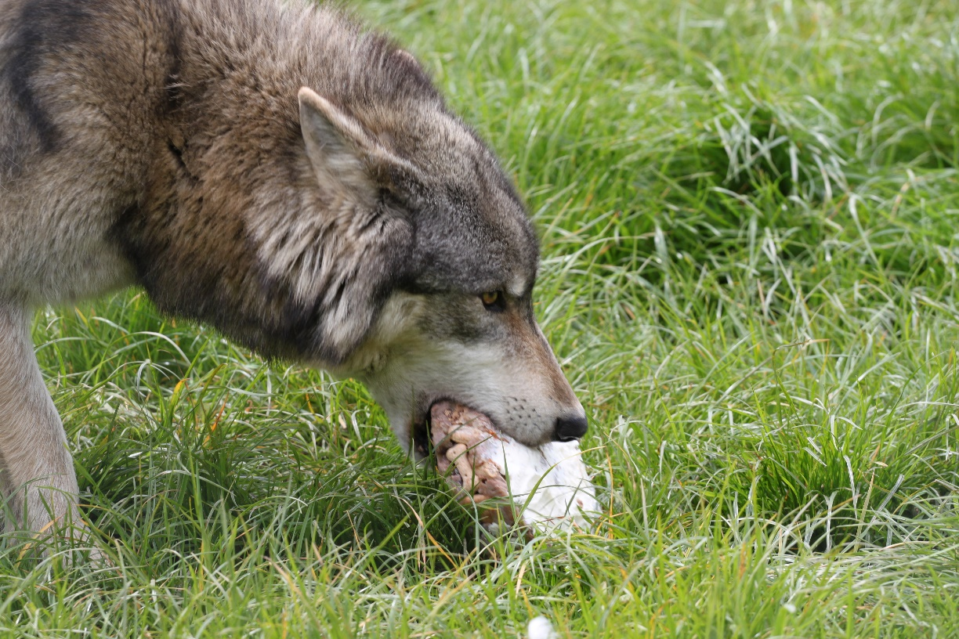

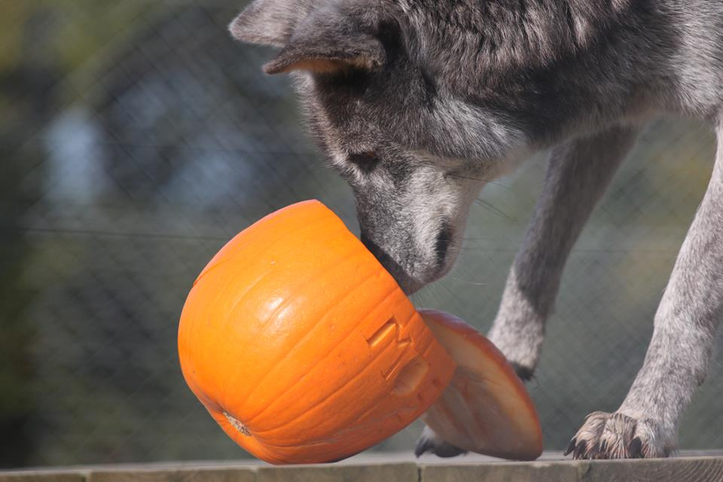
Picture25, Nuka, about to carry off his Birthday cake.

Picture26, Mosi investigating a stuffed Halloween pumpkin.

WORKING TOGETHER
The UKWCT knows how crucial enrichment is, and thus tries to get everyone involved in enrichment to make it as successful as possible, and constantly look for new ideas.

STUDENTS
At the Trust, we try to encourage all students working on work experience to take part in inventing new enrichment and to get creative. They can come up with anything they like and simply run the idea by us to find out if it will work out or not. We have had some brilliant ideas before, bubbles being one of them (picture27).

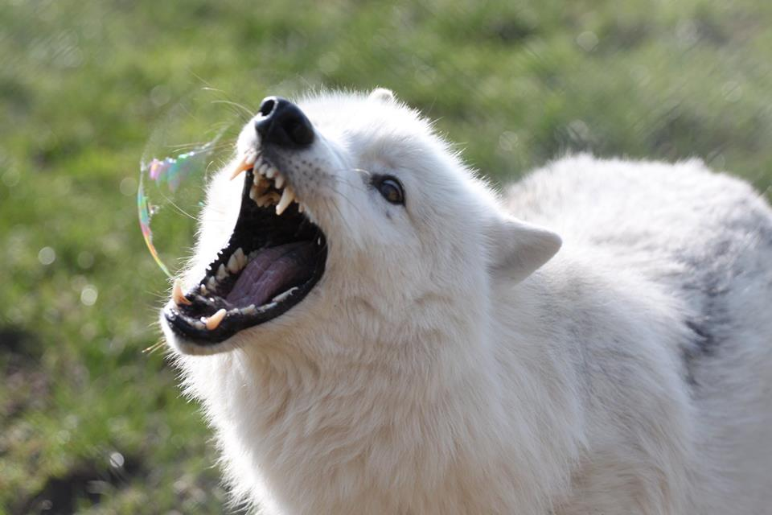

Picture27, Pukak eating a bubble.

OTHER ANIMAL COLLECTIONS
Enrichment is implemented by all good animal collections, including the UKWCT. We actively contact other animal collections to discuss and work together, to create new enrichment ideas. We like to discuss and see in practise how our enrichment differs, and also collect scat and fur from these new and “strange” packs (or any other animal) to use on our wolves. One of our plans for the future is to create a type of Skype call, where our wolves will hear the howls of other packs elsewhere and hopefully howl back to them!

CONCLUSION
In my opinion, enrichment is something that all animal collections should take time out and resources for. It is a priority and to me and nothing else matters if the enrichment, and thus animal welfare, is not right.
It is something that can be modified and applied to literally every animal. During my time on work experience, I took it in myself to create enrichment for the two pygmy goats, and surprised myself with just how much could be created for the animals, whose enrichment I thought would mainly be just eating.
I have noticed how nowadays I automatically observe animals’ behaviours more, and observe their enrichment possibilities. I understand a lot more about enrichment and natural behaviour, and have learnt an incredible amount of wolf behaviour.
Unfortunately, during my visits and work experience at various zoos in Finland, I have noticed how incredibly out of date their information on wolves is, and how lots of keepers’ conceptions of wolves are still false.
To sum this up, I am proud to say I am now an official volunteer at the UKWCT, and have been since March. While in England, I volunteer every weekday and find the work extremely rewarding, getting to walk and socialise with the wolves. I encourage anyone in the area to visit and learn about these misunderstood animals, and to spread the knowledge when and where they can.

SUVI HALL S12LMAAEB 2014

LINKS AND ATTACHMENTS

Link 1.
http://ukwct.org.uk/

Link 2.
http://newswatch.nationalgeographic.com/2014/02/16/this-will-shatter-your-view-of-apex-predators-how-wolves-change-rivers/

Link 3.
http://www.theguardian.com/science/animal-magic/2014/aug/08/slavc-wolf-migration-europe

Link 4.
http://www.theguardian.com/science/animal-magic/2014/aug/25/wolves-slavc-giulietta-litter-seven-italy

Link 5.
http://www.davemech.org/news.html

Attachment 1.

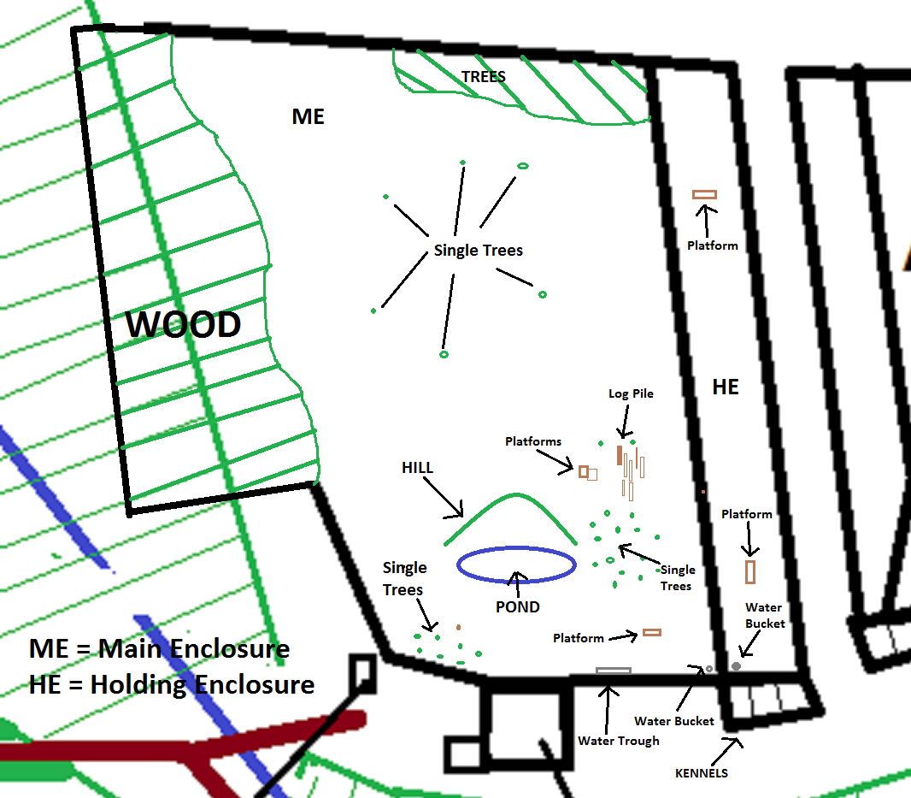

The first enclosure where, for now, Torak and Mosi live.
The kennels are made of concrete and are closed during the day. The pond has a running waterfall. The holding enclosure is for temporary use only, when the wolves are needed out of the main enclosure.

Attachment 2.

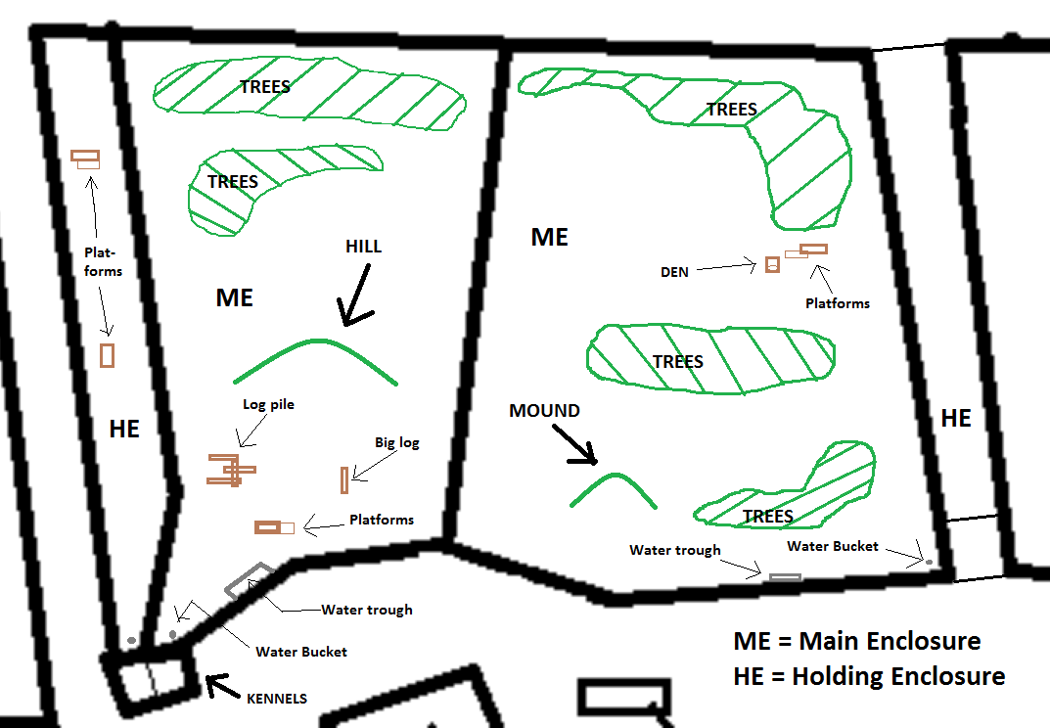

On the left is the second enclosure where, for now, the Arctics live.
The kennels are made of concrete and are shut during the day. The holding enclosure is for temporary use only, when the wolves are needed out of the main enclosure.

On the right is the third enclosure where, for now, Mai and Motomo live.
They do not have kennels to go into for the night, but do have manmade dens available.

Attachment 3.

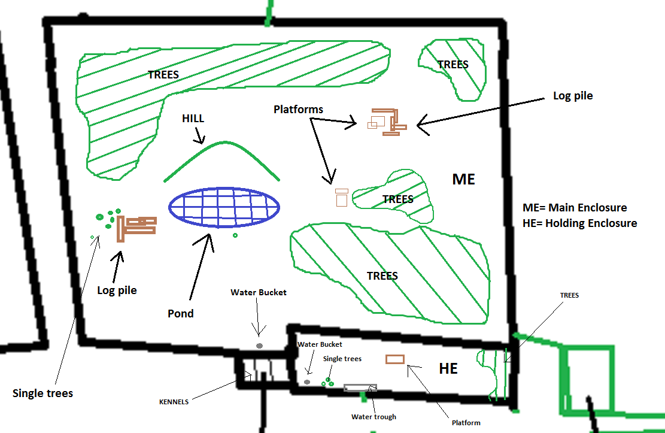

The fourth enclosure where, for now, Tundra, Nuka and Tala live.
The pond has a running waterfall. The kennels are made of concrete and are closed during the day. The holding enclosure is for temporary use only, when the wolves are needed out of the main enclosure.

