**Perusraportti**

**Old music notation course feedback by students**

Vastaajien kokonaismäärä: 20

**1. My knowledge of the old music notation before the course was**

Vastaajien määrä: 20

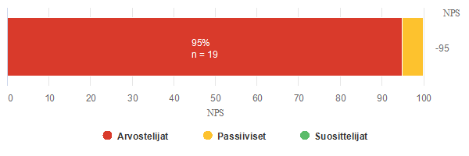

|  |  |  |  |  |  |  |  |  |  |  |
| --- | --- | --- | --- | --- | --- | --- | --- | --- | --- | --- |
| Arvostelijat | | | | | | | Passiiviset | | Suosittelijat | |
| 0 | 1 | 2 | 3 | 4 | 5 | 6 | 7 | 8 | 9 | 10 |
| n = 19 | | | | | | | n = 1 | | n = 0 | |
| 95,0% | | | | | | | 5,0% | | 0,0% | |
| 5 | 6 | 4 | 3 | 1 | 0 | 0 | 1 | 0 | 0 | 0 |
| 25,0% | 30,0% | 20,0% | 15,0% | 5,0% | 0,0% | 0,0% | 5,0% | 0,0% | 0,0% | 0,0% |

|  |  |  |
| --- | --- | --- |
| **Yhteensä** | | |
| **Vastauksia** | **NPS** | **Keskiarvo** |
| 20 | -95 | 1,7 |

**2. My knowledge of the old music notation after the course now after the course, but before the Belgian mobility is**

Vastaajien määrä: 20

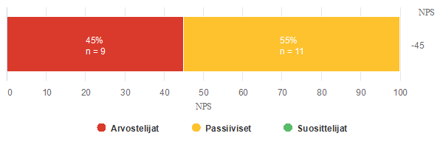

|  |  |  |  |  |  |  |  |  |  |  |
| --- | --- | --- | --- | --- | --- | --- | --- | --- | --- | --- |
| Arvostelijat | | | | | | | Passiiviset | | Suosittelijat | |
| 0 | 1 | 2 | 3 | 4 | 5 | 6 | 7 | 8 | 9 | 10 |
| n = 9 | | | | | | | n = 11 | | n = 0 | |
| 45,0% | | | | | | | 55,0% | | 0,0% | |
| 0 | 0 | 0 | 0 | 4 | 2 | 3 | 7 | 4 | 0 | 0 |
| 0,0% | 0,0% | 0,0% | 0,0% | 20,0% | 10,0% | 15,0% | 35,0% | 20,0% | 0,0% | 0,0% |

|  |  |  |
| --- | --- | --- |
| **Yhteensä** | | |
| **Vastauksia** | **NPS** | **Keskiarvo** |
| 20 | -45 | 6,3 |

**3. I took part in the course because (many answers are possible):**

Vastaajien määrä: 20, valittujen vastausten lukumäärä: 58

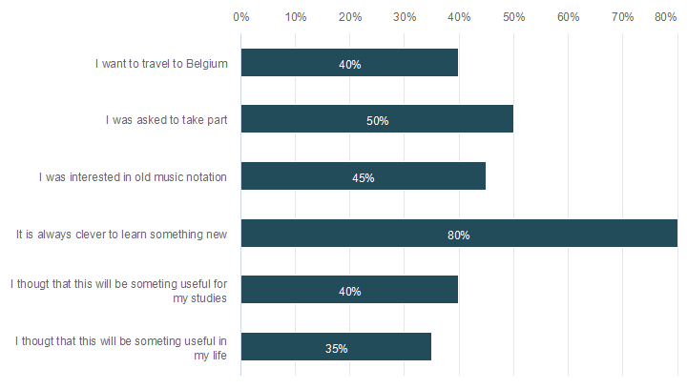

|  |  |  |
| --- | --- | --- |
|  | **n** | **Prosentti** |
| I want to travel to Belgium | 8 | 40,0% |
| I was asked to take part | 10 | 50,0% |
| I was interested in old music notation | 9 | 45,0% |
| It is always clever to learn something new | 16 | 80,0% |
| I thougt that this will be someting useful for my studies | 8 | 40,0% |
| I thougt that this will be someting useful in my life | 7 | 35,0% |

**4. I rank the old music notation course in my music school**

Vastaajien määrä: 20

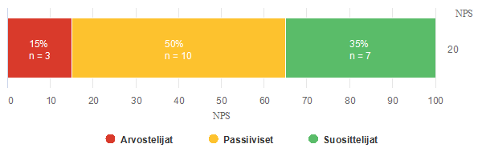

|  |  |  |  |  |  |  |  |  |  |  |
| --- | --- | --- | --- | --- | --- | --- | --- | --- | --- | --- |
| Arvostelijat | | | | | | | Passiiviset | | Suosittelijat | |
| 0 | 1 | 2 | 3 | 4 | 5 | 6 | 7 | 8 | 9 | 10 |
| n = 3 | | | | | | | n = 10 | | n = 7 | |
| 15,0% | | | | | | | 50,0% | | 35,0% | |
| 0 | 0 | 1 | 0 | 0 | 1 | 1 | 5 | 5 | 5 | 2 |
| 0,0% | 0,0% | 5,0% | 0,0% | 0,0% | 5,0% | 5,0% | 25,0% | 25,0% | 25,0% | 10,0% |

|  |  |  |
| --- | --- | --- |
| **Yhteensä** | | |
| **Vastauksia** | **NPS** | **Keskiarvo** |
| 20 | 20 | 7,7 |

**5. I found the course**

Vastaajien määrä: 20

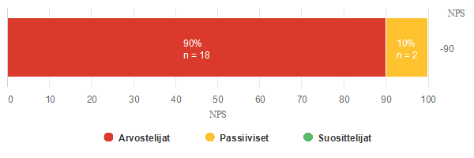

|  |  |  |  |  |  |  |  |  |  |  |
| --- | --- | --- | --- | --- | --- | --- | --- | --- | --- | --- |
| Arvostelijat | | | | | | | Passiiviset | | Suosittelijat | |
| 0 | 1 | 2 | 3 | 4 | 5 | 6 | 7 | 8 | 9 | 10 |
| n = 18 | | | | | | | n = 2 | | n = 0 | |
| 90,0% | | | | | | | 10,0% | | 0,0% | |
| 0 | 1 | 0 | 2 | 5 | 5 | 5 | 1 | 1 | 0 | 0 |
| 0,0% | 5,0% | 0,0% | 10,0% | 25,0% | 25,0% | 25,0% | 5,0% | 5,0% | 0,0% | 0,0% |

|  |  |  |
| --- | --- | --- |
| **Yhteensä** | | |
| **Vastauksia** | **NPS** | **Keskiarvo** |
| 20 | -90 | 4,9 |

**6. My positive remarks and comments about the course:**

Vastaajien määrä: 12

|  |
| --- |
| **Vastaukset** |
| This course was so interesting. At school we didn’t learn anything about old music, and at music school we didn’t learn it either. So I loved to get to know more about it, because I believe it contributes to a broader on the world of music. |
| It was interesting but difficult |
| These were some really interesting lessons and I enjoyed them. |
| It was fun |
| It sure was fun! |
| I think that the material given by the teachers is easy to understand and, With all the explanations, i think that it is affordable to learn this new musical language. |
| I think it's a great opportunity to increase my knowledge about notation and also a good chance to meet students of my age and how music schools in other countries work. |
| It was very interesting because my teachers give us all the information to understand how they sing in the past and how to sing as they. |
| I liked how the teacher kept his patience even though I was most of the time the reason we had to repeat a section or he had to help me personally. This became better over time and I am very grateful. |
| Very interesting and know I learn so much about this old music and how to sing it and with so many voices is beautiful |
| It has been very fun to study new things about old music. Especially singing has been very fun. |
| I learned a lot of new things, and it was very nice to play with other students. |

**7. What could have been done differently on the course?**

Vastaajien määrä: 10

|  |
| --- |
| **Vastaukset** |
| More lessons |
| More lesons |
| / |
| Maybe practice more with sheet music that have this notation and put more examples interactively |
| I know it's pretty early, but I would like to take part into another meeting online, so I can know better the other students and do more interactive activities |
| Nothing, it was really good |
| I don't think there is a lot that could have been changed. |
| Lessons would have been in different day |
| I would like more lessons in this course. |
| I felt like everything was good. |

**8. What else I would like to say:**

Vastaajien määrä: 7

|  |
| --- |
| **Vastaukset** |
| It was new for me but very interesting |
| I cent wait to go on the trim and learn |
| It really wasn't an easy course, but I learned a lot! It was nice to see everyone online, although it would have been amazing to meet in Belgium. |
| We are waiting very excited for the trip and the experience, we will give everything to sing! |
| I’m looking forward to starting with the project and I wish we'll be able to travel without any covid issues! |
| / |
| Teach these things to other people as well |