
Finnish plant microbiome
Instructions for sampling

Sampling equipment Packed -check the box!

1 L bags for samples 16 pcs( 4 x pine, 4x spruce, 4 x bilberry , 4 lingonberry □
extra: 16 bags for tissue print (epiphyte plating) and microscope samples □
marker for bags (and plates) □
gloves and scissors (4 kpl) for sampling □
wipes for the scissors □
compass □
thermometer □
temperature loggers x2 (August) □
light meter □
instructions, forms, pencils □
cooler □
cold blocks (frozen) □
Ice cube bags (filled, frozen) □
marking tape (August) □
marking sticks for bilberry and lingonberry (min 30 cm) □
garden shovel, soil sample bags x4 □
snow shovel, measuring tape (In February, for measuring snow depth) □
camera/phone camera(s) □

Optional - for preparing leaf prints in the field or at the school:
agar plates plates (min 24x)
clean (printer) paper for sample preparation
parafilm or tape for sealing the plates

Sampling site(s)

Easily accessible site near the school. Forest with pine, spruce, bilberry, lingonberry. Choose the sites within the forest (avoid impact of neighboring biotopes, if possible)

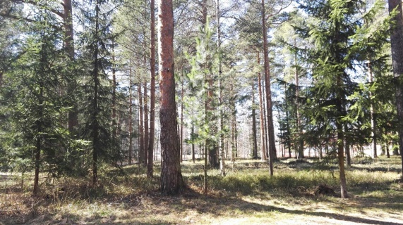

Task 1
Sampling the plants
PINE, Pinus sylvestris
Pick 4 youngish pine trees - make sure you can sample at the height of 1,5 meters

Pick a healthy branch at southern side of the tree, at 1,5 m height, mark it with red marking ribbon near the tree trunk.

Prelabel the sampling bags:
Location, date, pine 1
Location, date, pine 2
Location, date, pine 3
Location, date, pine 4

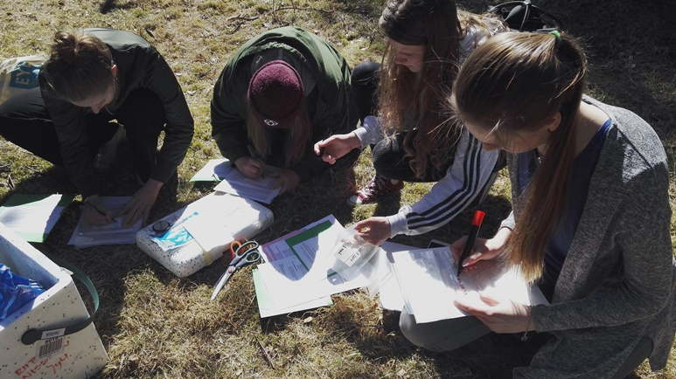

Sampling: PUT ON YOUR GLOVES!
- cut the branch so that you get at least 2 summer’s growth
(can be more)
- put the sample in the labelled bag with your hand (glove on!)
- close the bag, take to the cooler

Wipe the scissors between different samples with alcohol wipe
Keep the scissors on top of clean tissue/paper
(Your nose or ear will likely start itching when you put on your clean gloves , but remember NOT to scratch with your glove hand, ask a friend to help instead!)

Optional: cut a neighborging branch for leaf tissue print sample (epiphyte bacterial culturing) and microscope observations, put into a separate bag

Remember to document sampling, and upload the photos (with captions) onto project’s Facebook page - after asking permission from everyone in the photos!

THANK YOU!
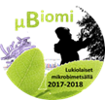
Task 2
Plant sampling
SPRUCE, Picea abies

Pick a healthy branch at southern side of the tree, at 1,5 m height, mark it with red marking ribbon near the tree trunk.

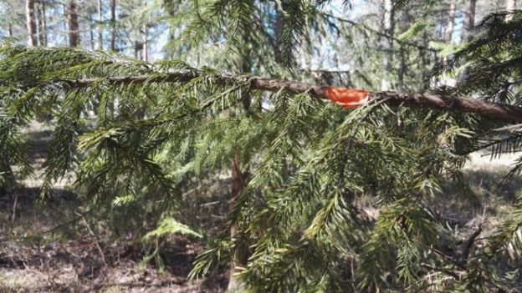

Prelabel the sampling bags:
Location, date, spruce 1
Location, date, spruce 2
Location, date, spruce 3
Location, date, spruce 4

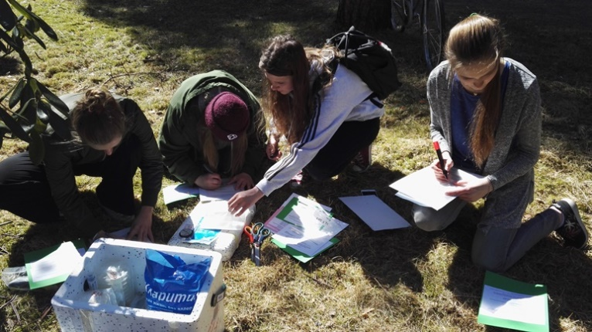

Sampling: PUT ON YOUR GLOVES!
- cut the branch so that you get at least 2 summer’s growth (can be also more)
- put the sample in the labelled bag with your hand (glove on!)
- close the bag, take to the cooler

Wipe the scissors between different samples with alcohol wipe
Keep the scissors on top of clean tissue/paper
(Your nose or ear will likely start itching when you put on your clean gloves , but remember NOT to scratch with your glove hand, ask a friend to help instead!)

Optional: cut a neighborging branch for leaf tissue print sample (epiphyte bacterial culturing) and microscope observations, put into a separate bag

Remember to document sampling, and upload the photos (with captions) onto project’s Facebook page - after asking permission from everyone in the photos!

THANK YOU!
.
Task 3
Plant sampling
LINGONBERRY, Vaccinium vitis-idea

Pick 4 plants ~30 cm apart, mark them with red ribbon. Place the ribbon close to ground level. Avoid touching the upper branches.
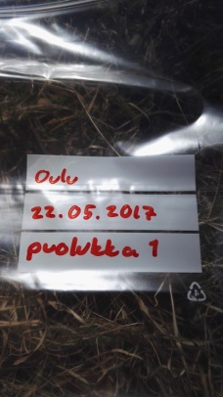
Prelabel 4 sample bags:

Location, date, lingonberry 1 Location, date, lingonberry 2
Location, date, lingonberry 3
Location, date, lingonberry 4

Mark the location with a marking pole (stick) that is higher than estimated snow depth in February.

Samping: PUT YOUR GLOVES ON
- cut off a branch so that you get at least 2 summer’s growth (can be also more) with clean scissors
- place the sample into prelabelled bag with your glove hand
- seal the bag, place in the cooler

- Wipe the scissors between different samples with alcohol wipe
- Keep the scissors on top of clean tissue/paper

Optional: cut a neighborging branch for leaf tissue print sample (epiphyte bacterial culturing) and microscope observations, put into a separate bag

(Your nose or ear will likely start itching when you put on your clean gloves , but remember NOT to scratch with your glove hand, ask a friend to help instead!)

Remember to document sampling, and upload the photos (with captions) onto project’s Facebook page - after asking permission from everyone in the photos!

THANK YOU!

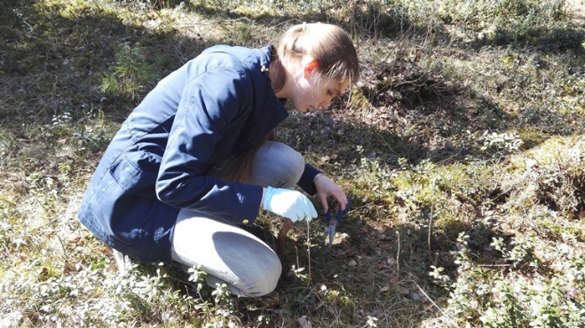
Task 4
Plant sampling
BILBERRY, Vaccinium myrtillus

Pick 4 plants ~30 cm apart, mark them with red ribbon. Place the ribbon close to ground level. Avoid touching the upper branches.
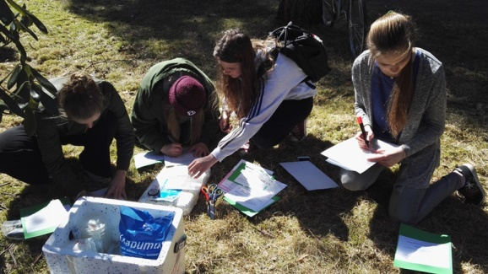
Prelabel 4 sample bags:

Location, date, bilberry 1
Location, date, bilberry 2
Location, date, bilberry 3
Location, date, bilberry 4

Mark the location with a marking pole (stick) that is higher than estimated snow depth in February.

Samping: PUT YOUR GLOVES ON
- cut off a branch so that you get at least 2 summer’s growth (can be also more) with clean scissors
- place the sample into prelabelled bag with your glove hand
- seal the bag, place in the cooler

- Wipe the scissors between different samples with alcohol wipe
- Keep the scissors on top of clean tissue/paper

(Your nose or ear will likely start itching when you put on your clean gloves , but remember NOT to scratch with your glove hand, ask a friend to help instead!)

Optional: cut a neighborging branch for leaf tissue print sample (epiphyte bacterial culturing) and microscope observations, put into a separate bag

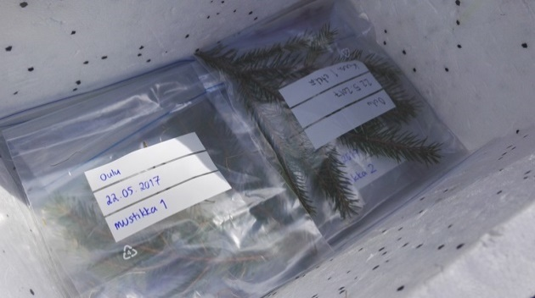

Remember to document sampling, and upload the photos (with captions) onto project’s Facebook page - after asking permission from everyone in the photos!

THANK YOU!
Task 5

- Sampling site metadata

Photograph the site. Make sure the site location is saved (GPS, coordinates)
Note down any possible animal sightings, tracks or droppings.
August: list the major plant species (and fungi, if any) at the site
February: measure the snow depth at the site of bilberry and lingonberry samples and ~1 m away from pines and spruces

At the school: Mark the location (coordinates) of the site on the map (later on PaikkaOppi-application), upload photos

- Temperature measurements

Record temperatures (in shadow) at three different heights
August: ground level, at 30 cm and 1,5 m above ground
February: beneath the snow at ground level (push the meter into the snow pack from the shoveled pit with a help of a stick), at snow surface level and ~ 0,5 m above snow surface. Mark the temperatures on the form.

- Light measurements

Record the light levels the sampling site (branch) for all sampled plants (16 measurements). Mark down the measurements on the form.

Take pictures and document different tasks and steps of the tasks. Upload the photos with captions on the project’s Facebook page - after asking permission from everyone in the photos!

Optional: observe and photograph the leaf surfaces of the sampled plants (and other interesting things!) in the field or at the school

THANK YOU!

Task 6
Soil sampling

Prelabel 4 sampling bags

Location, date, pine
Location, date, spruce
Location, date, bilberry
Location, date, lingonberry

Take the samples ~1 m from one of the sampled plants/species, on the south side of the spruce and pine.
Remove surface vegetation with shovel from ~10x10 cm area (as intact as possible).
Take a ~1 dl soil sample at the organic soil layer with the shovel into the bag.
Return the removed vegetation on the site
Close the bag carefully, place in the cooler

No need to wear gloves
No need to wash the shovel between samplings

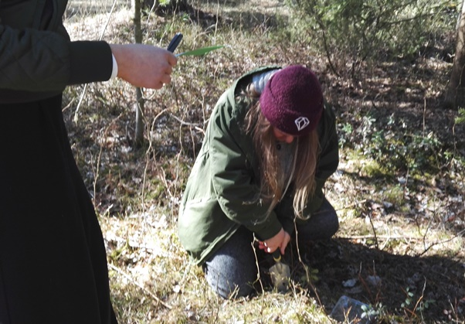

Remember to document sampling, and upload the photos (with captions) onto project’s Facebook page - after asking permission from everyone in the photos!

THANK YOU!

