**Spanish folk song “Boleras Sevillianas”**

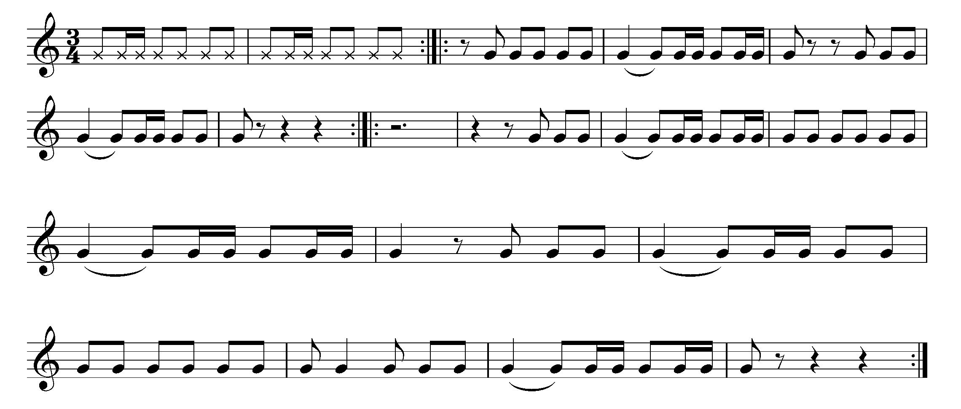

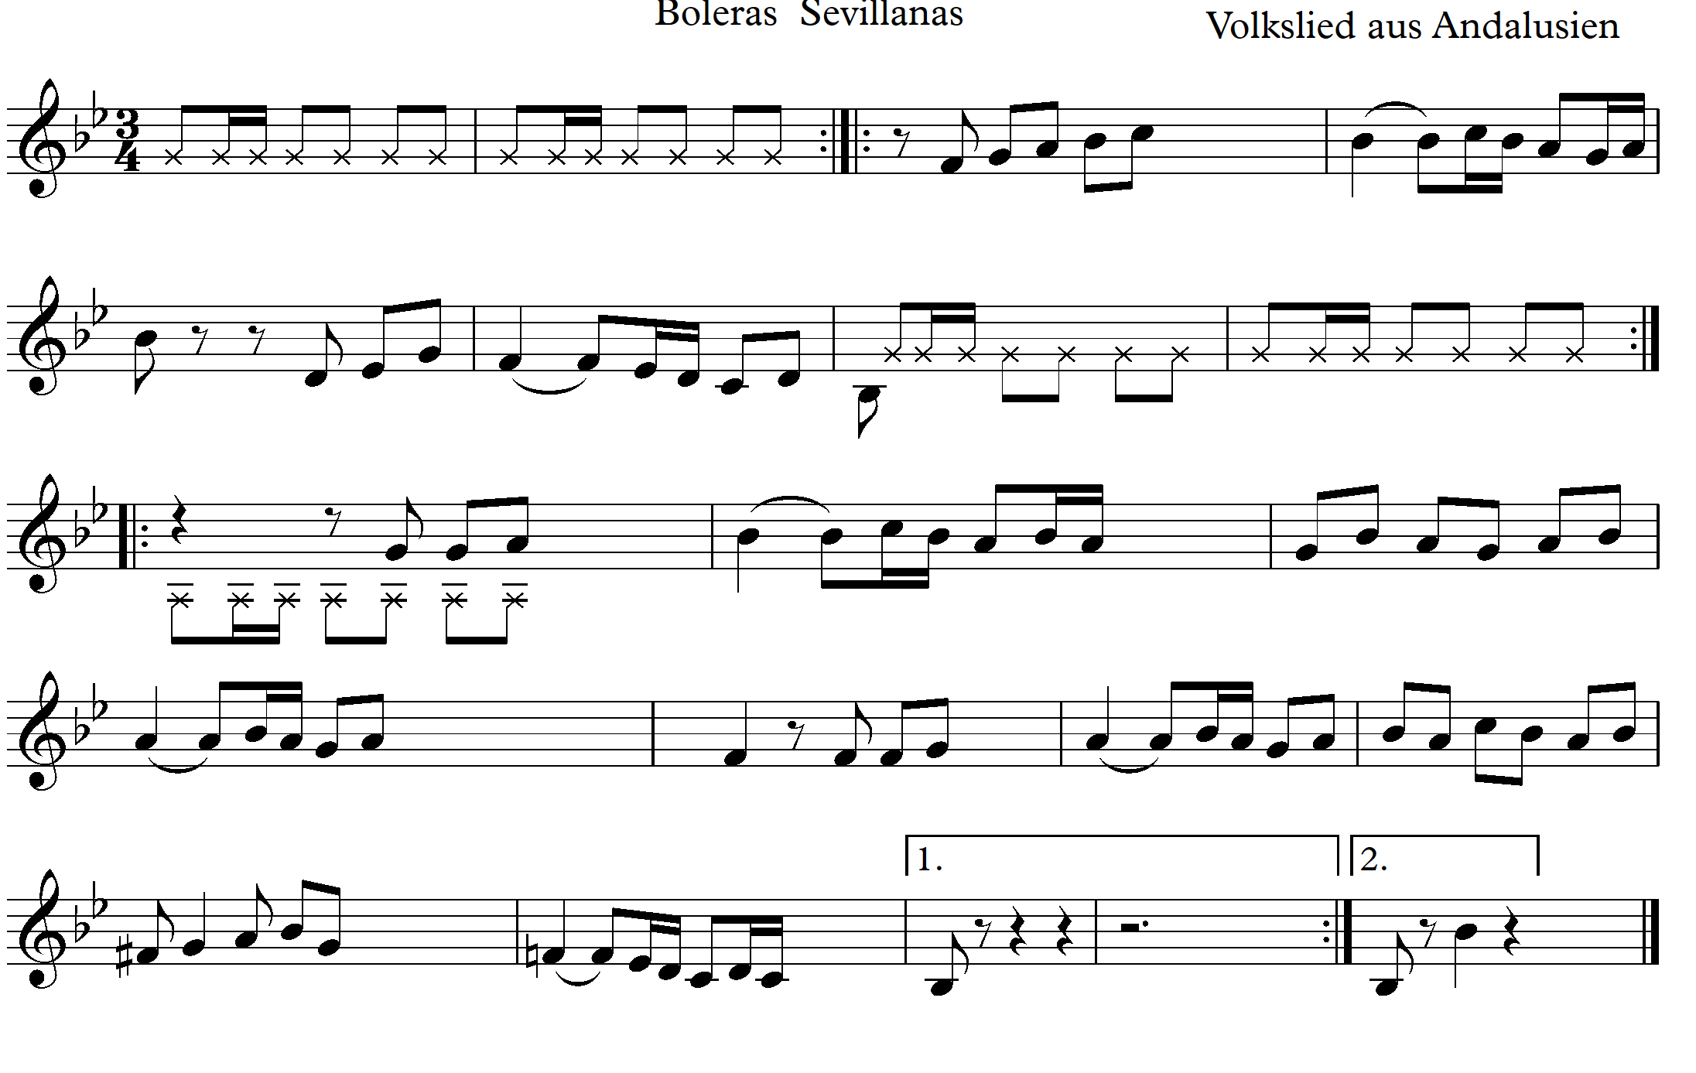

Motive for a sequence.

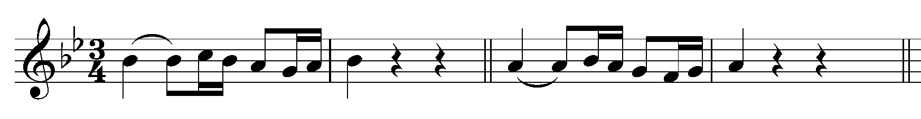

**Lesson 2**

1. The acquired rhythm.

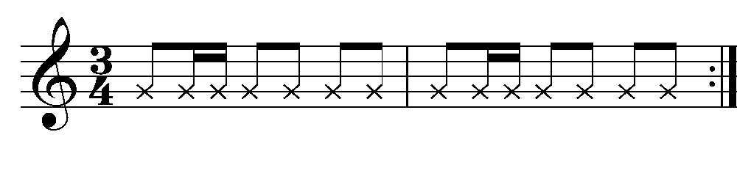

2. The acquired sequence.



3. B-flat (Ti[Flat.svg](https://lv.wikipedia.org/wiki/Att%C4%93ls:Flat.svg)) major scale (B dur)

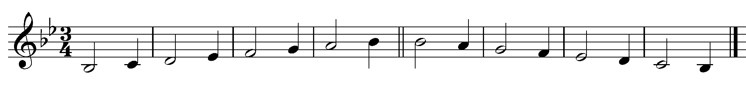

4. B-flat (Ti[Flat.svg](https://lv.wikipedia.org/wiki/Att%C4%93ls:Flat.svg)) major (B dur) scale with a rhythmic accompaniment.



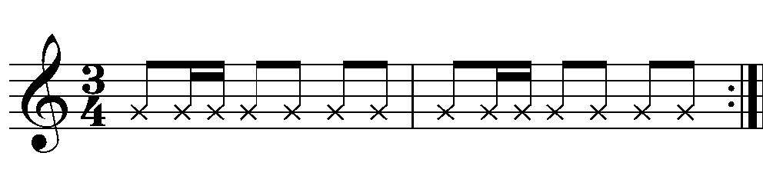

5. Harmonic G minor scale (g moll) with a rhythmic accompaniment.

**Spanish folk song “Boleras Sevillianas”**

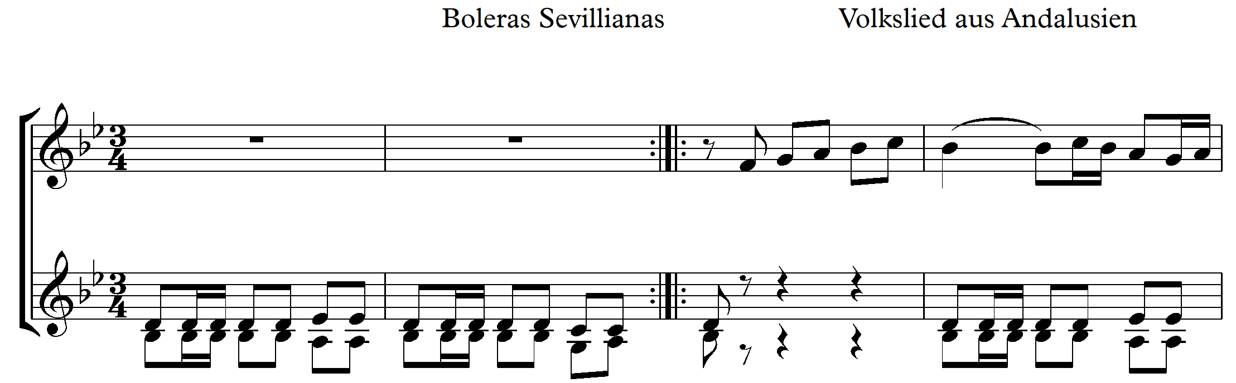

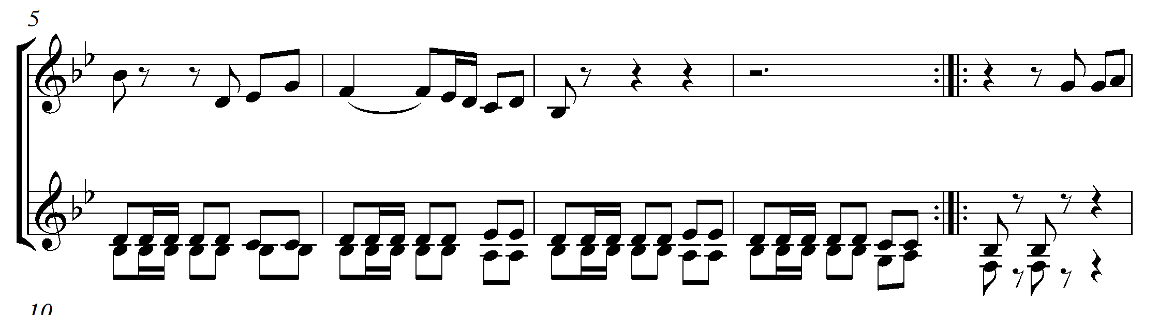

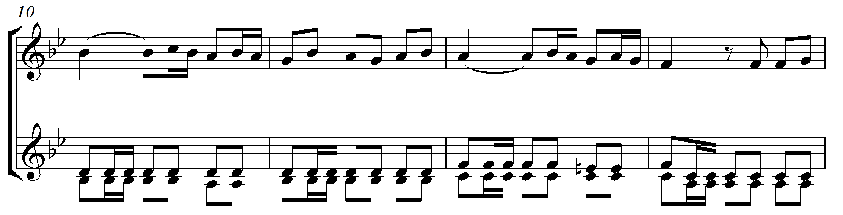

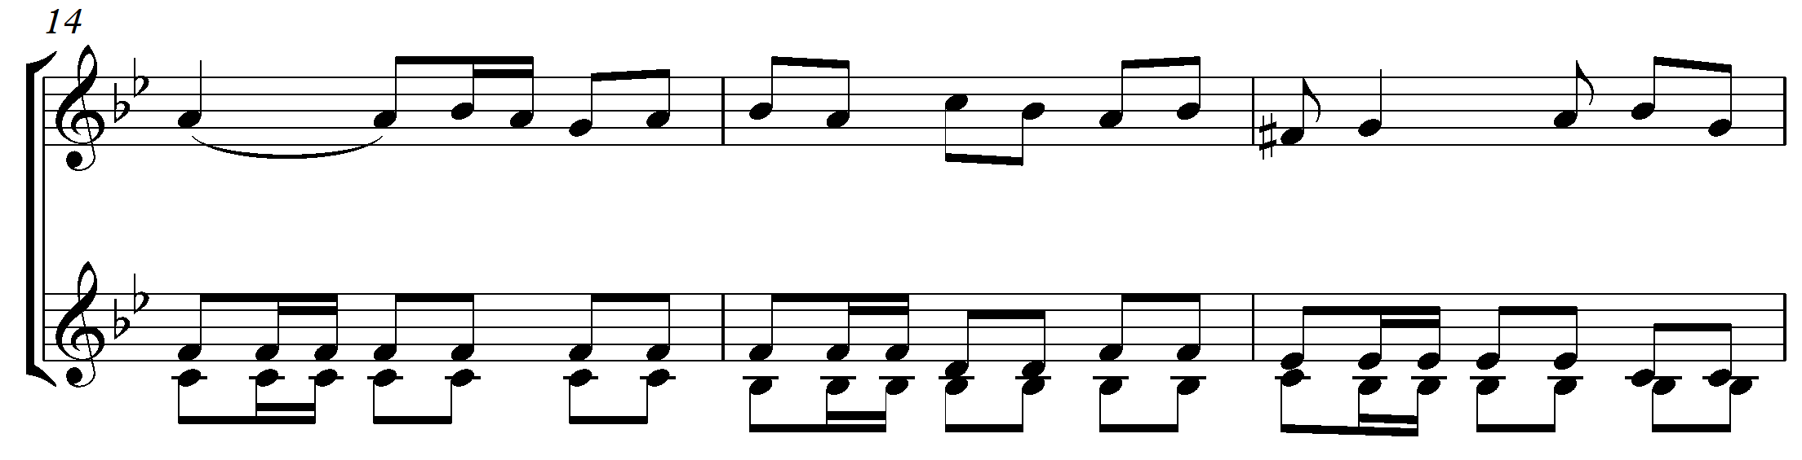

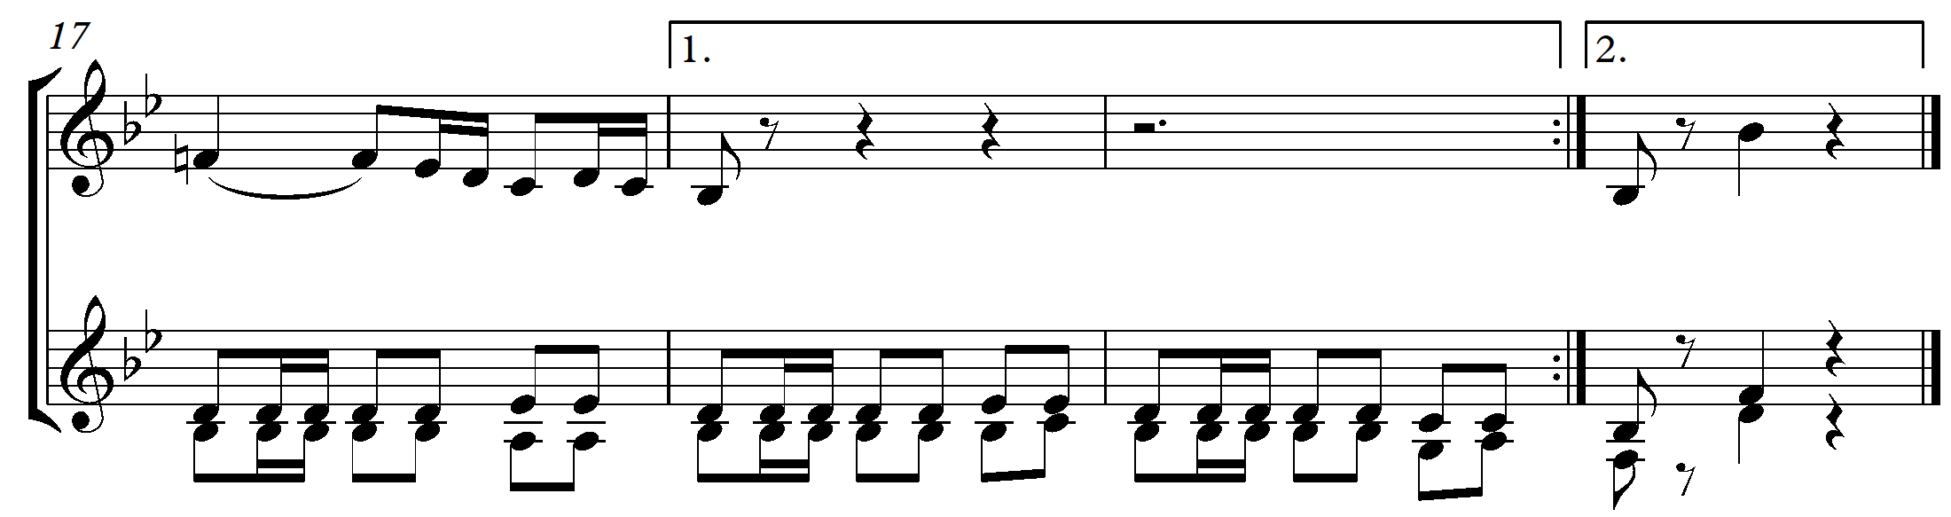

Good luck!