I recommend you this book
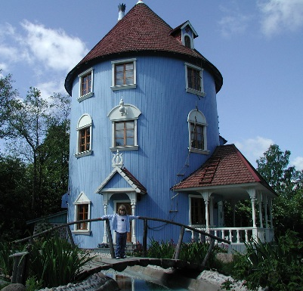
Title:
Comet in Moominland

Writer:
Tove jansson

Setting:
Moominvalley and Lonely Mountains

Characters:
Moomintroll, sniff, Snorkmaiden, snufkin

The book is about: First there is peaceful in Moominvalley. Then the
storm comes. Comet threats the Moominvalley.
It is very exciting story. Find out.

This book is good because: It is a little bit scary but, still it ends happily.

