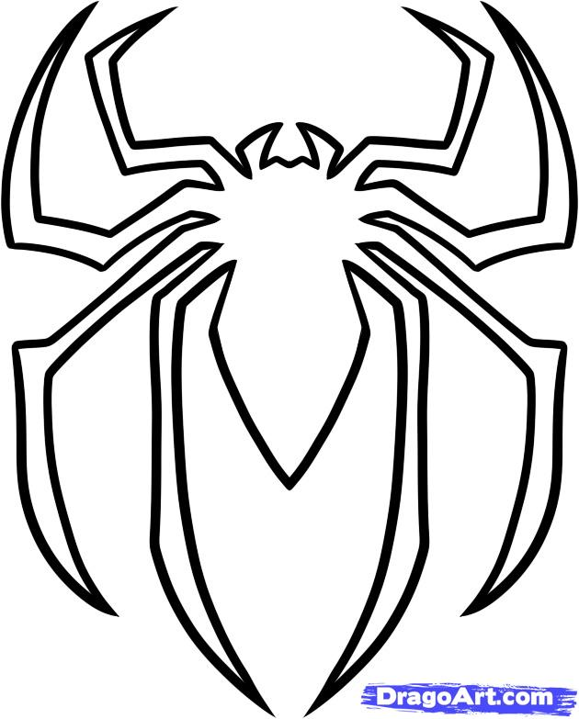
___________ LIKES DOGS

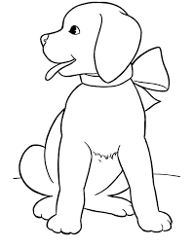

___________ LIKES SPIDERS

___________ LIKES CATS

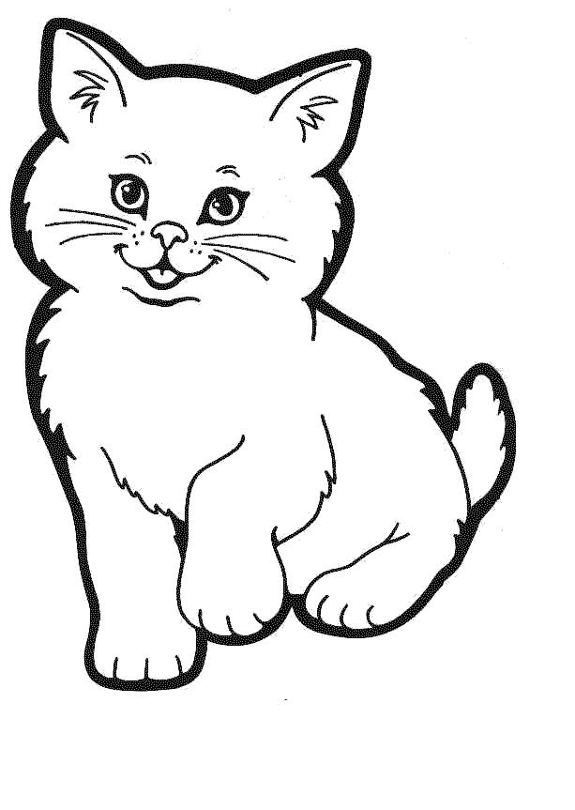

___________ LIKES LIZARDS
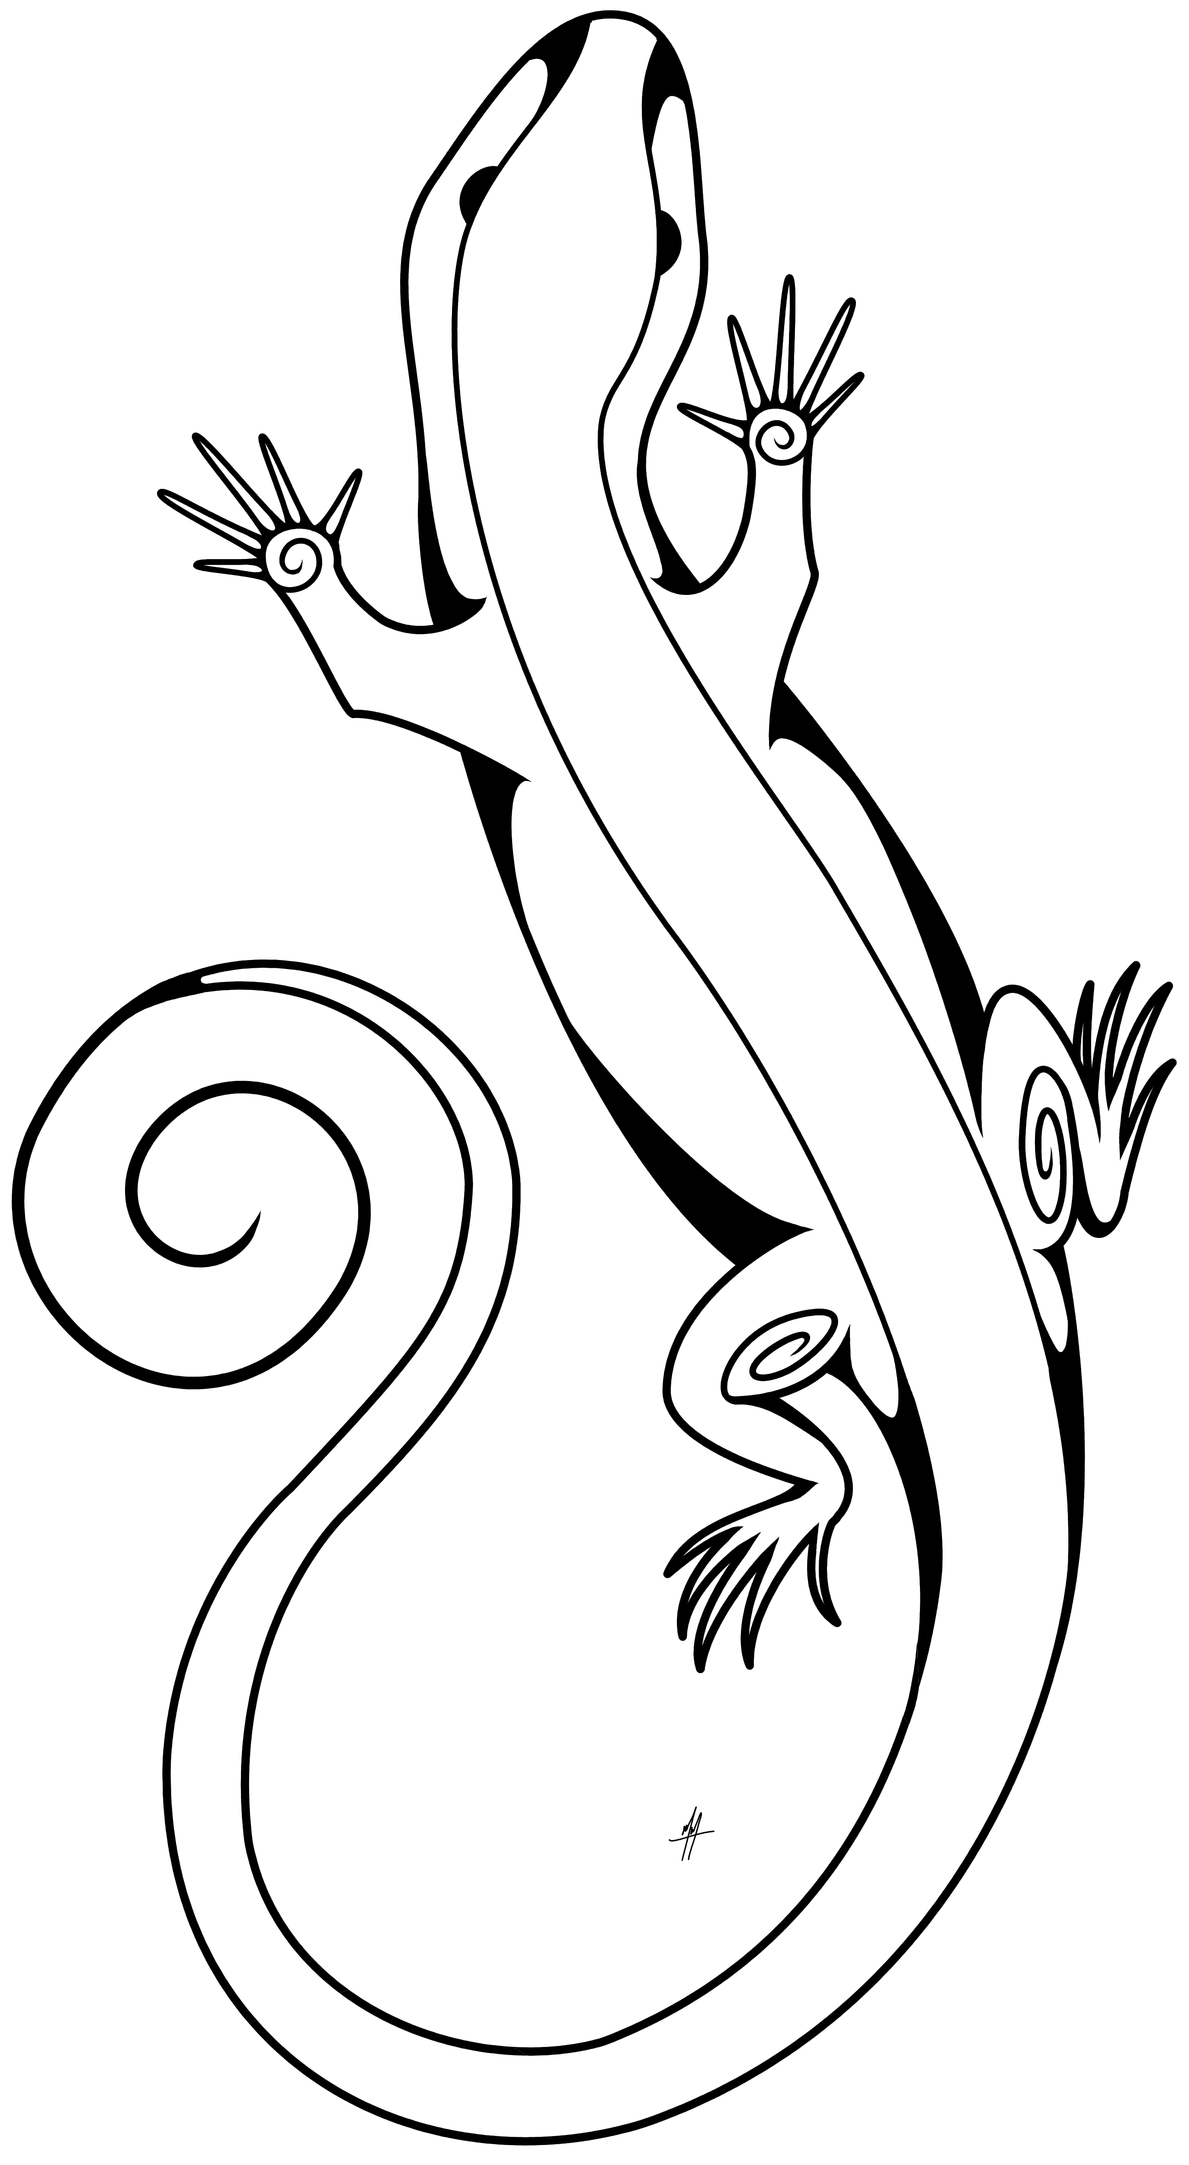
___________ LIKES CATS

___________ LIKES HORSES
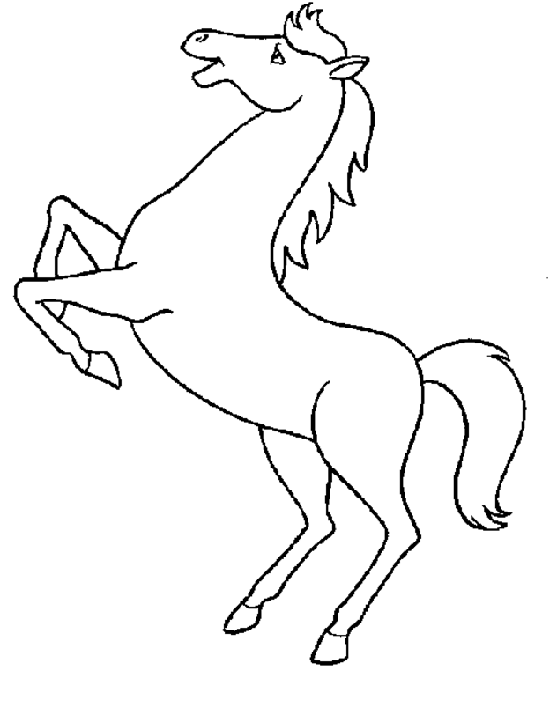

___________ LIKES HORSES

___________ LIKES HORSES

___________ LIKES CATS
___________ LIKES DOGS

