Mobility Finland

We are all very excited!

We, Emma, Wiebe, Elly and Sietse are going to Finland with our two teachers.

In our preparations we had contact with our host families.

From the first until the seventh of October we have visited Finland.

We made reports of our journey.

Day 3

Today was our first real schoolday in Pori. First we have a drawing lesson, then we went to the 3th and 4th grade. We did some maths and after that we made figures and flags of iron beads. Inbetween we had a lunch. We also had an English lesson. In the afternoon we went to climb in a climbing park. That was really fun! When we were home, we’ve been in the sauna.

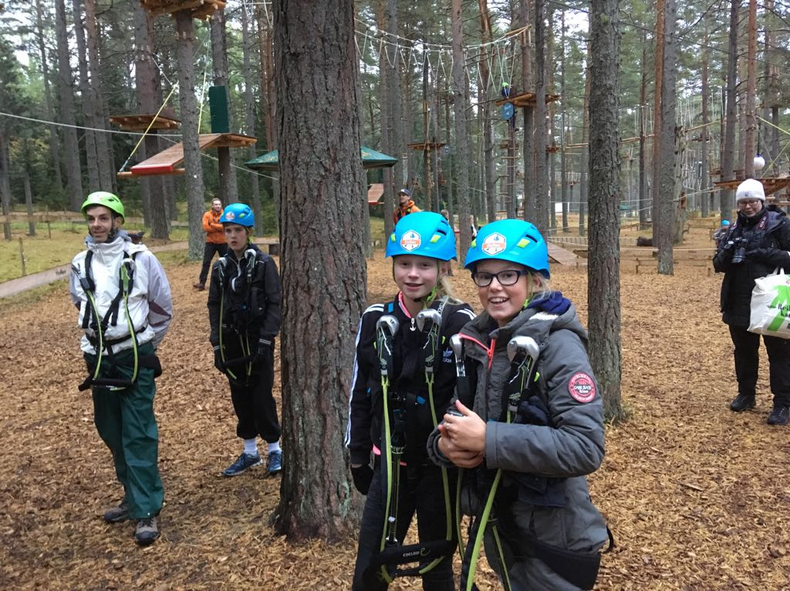

Day 4

We went to school, our first lesson was an English lesson. After that we did some crafts. We had a lunch at school. After the unch we continued with our crafts lesson. In the evening we went to see an ice hockey match. Everybody of the project was there. Our team lost with 3-2.

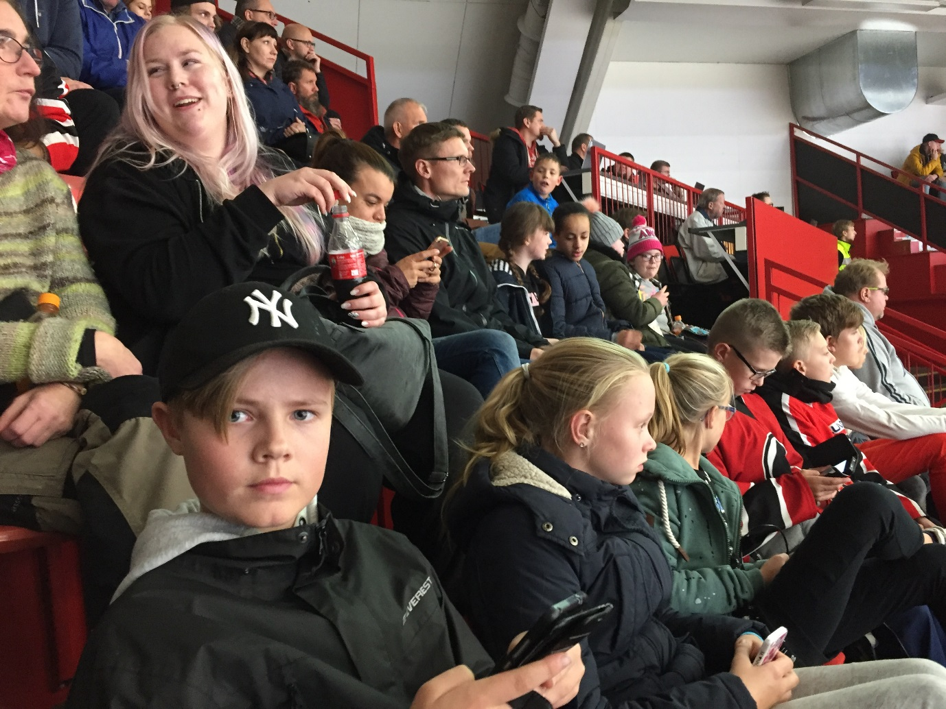

Day 5

This morning we went to school again. In the morning we followed the lessons. After the lunch we went to the park for a survivors programme. That was very nice. In the evening the host family took us to the Hesburger for dinner.

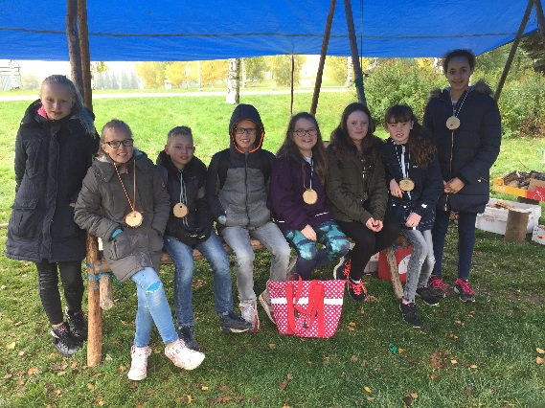

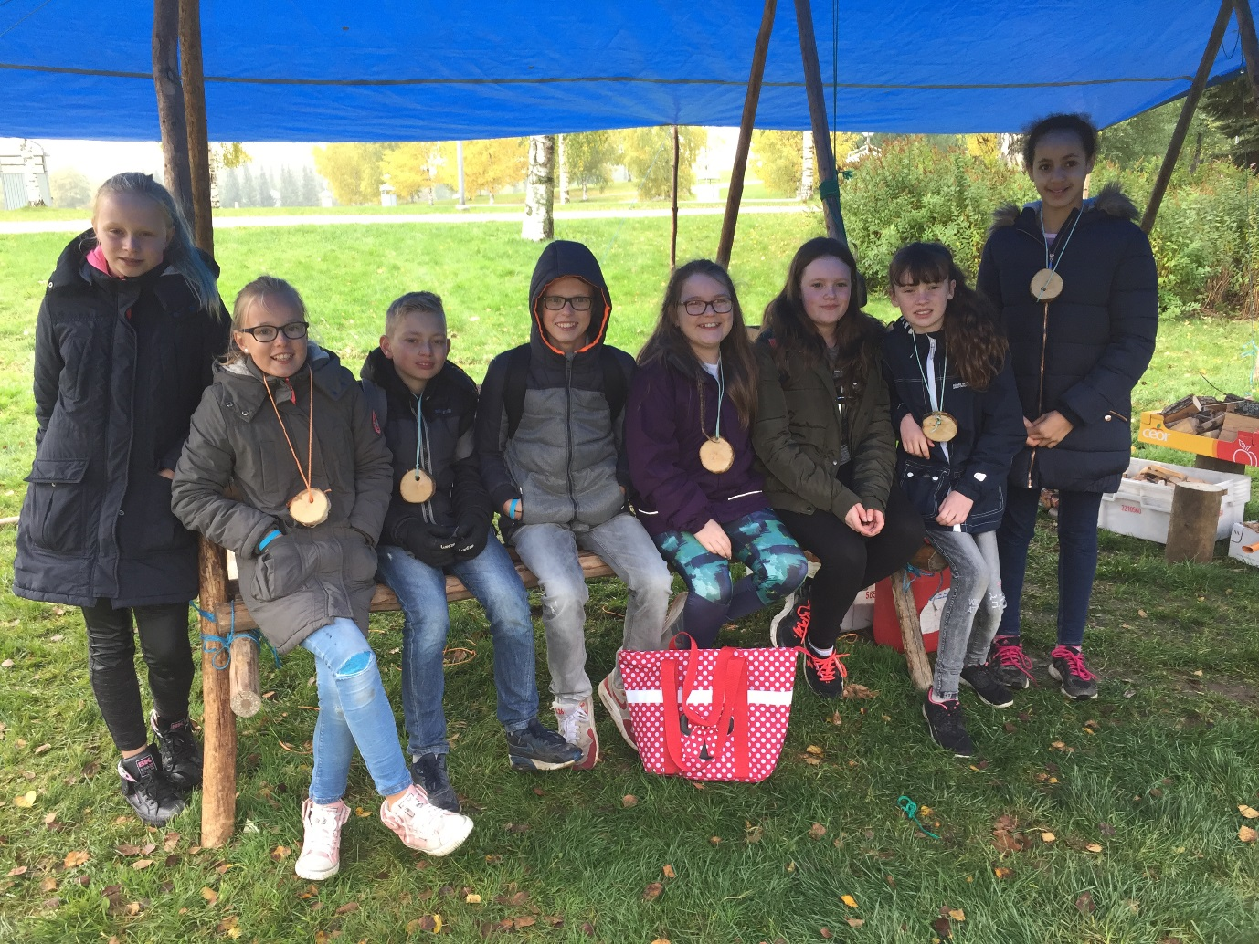

Day 4

We went to school, our first lesson was an English lesson. After that we did some crafts. We had a lunch at school. After the unch we continued with our crafts lesson. In the evening we went to see an ice hockey match. Everybody of the project was there. Our team lost with 3-2.

Day 5

This morning we went to school again. In the morning we followed the lessons. After the lunch we went to the park for a survivors programme. That was very nice. In the evening the host family took us to the Hesburger for dinner.

The report of Emma and Elly:

Day 1

The first day we all gathered at school. When everybody was there, we left to the airport in Amsterdam. When we arrived there we had to say goodbye. Then we checked in and we flew to Helsinki. When we arrived there, we had to wait for the other countries. When everybody had landed we went to Pori by bus. On our way we had a stop halfway. When we arrived in Pori our host family was waiting for us, we went home with them.

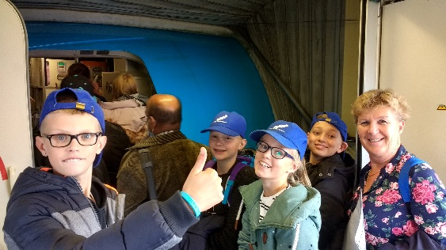

Day 2

We started this day with the opening ceremony. We had a lunch and after that we went to see the school for the first time. After school we went tot the shopping centre and after that we went for a city walk. This afternoon we were goin to the swimming pool with our hos family. There were diving boards and a sauna. We went into the sauna with Satu.

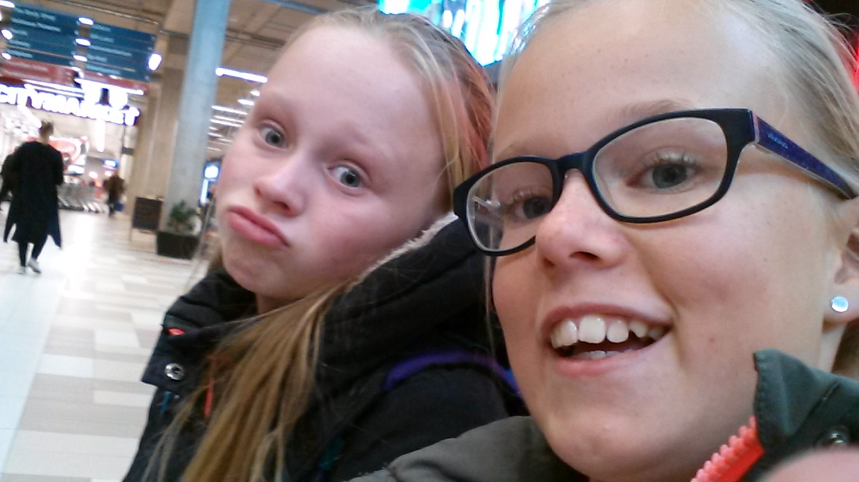
Day 6

We said goodbye to our host family and gave them a present. We went to the busstation in Pori, we took the bus to Helsinki. In Helsinki we have visited the cathedral and we went to the market to buy some souvenirs. We spend the night in a hotel with our teacher.

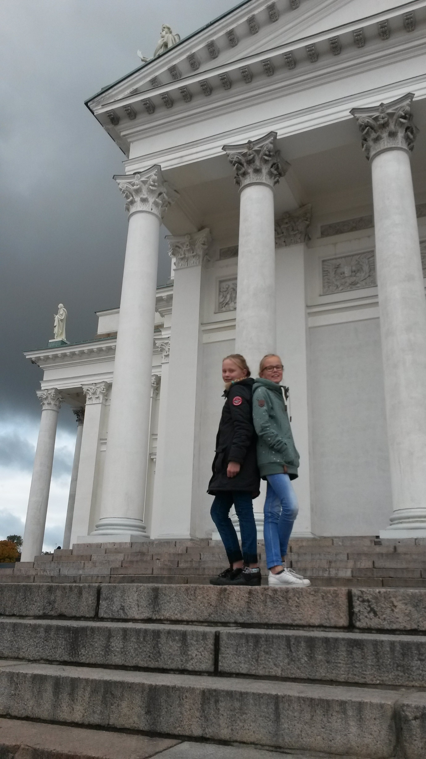

Day 7

Our last day in Finland. After breakfast we went to the Sibelius moment by tram. We walked the way back to the hotel. We went to the airport where we had something to eat. When we found our places in the airplane, we flew back to Holland. We were very glad to see our families again!

We enjoyed Finland very much!!

Best wishes Elly en Emma.

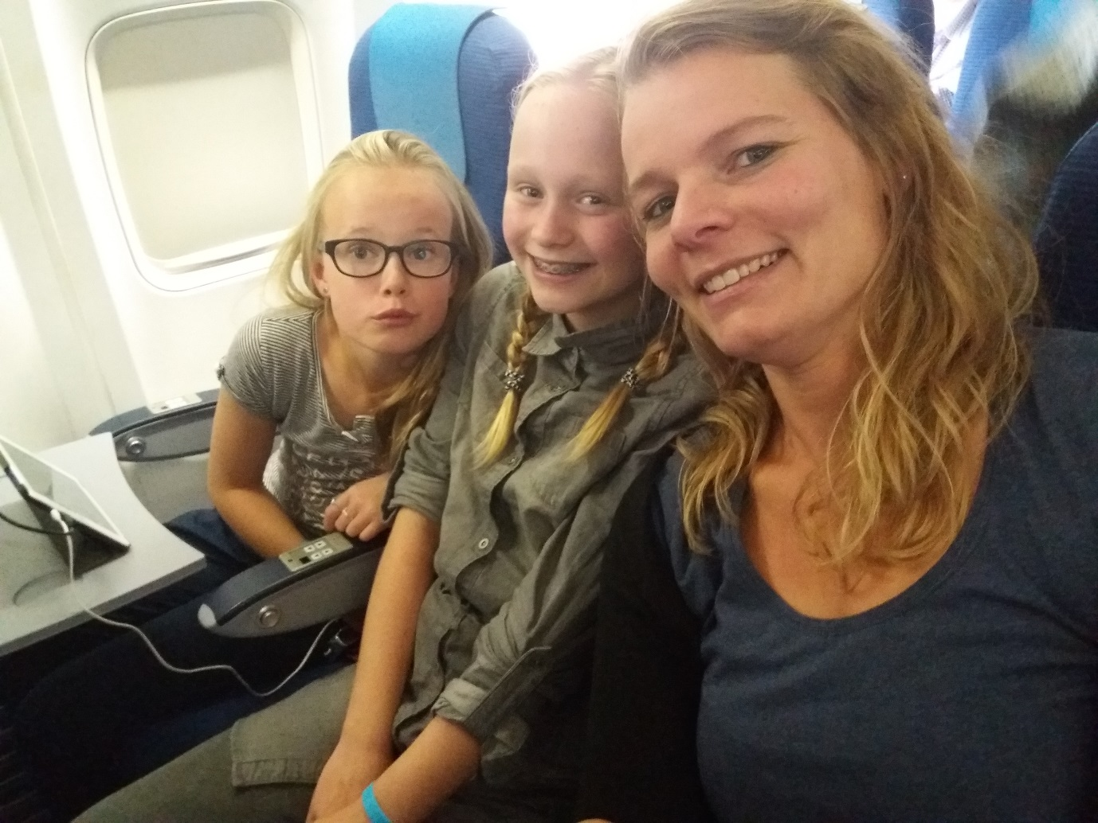

Souvenirs from Finland

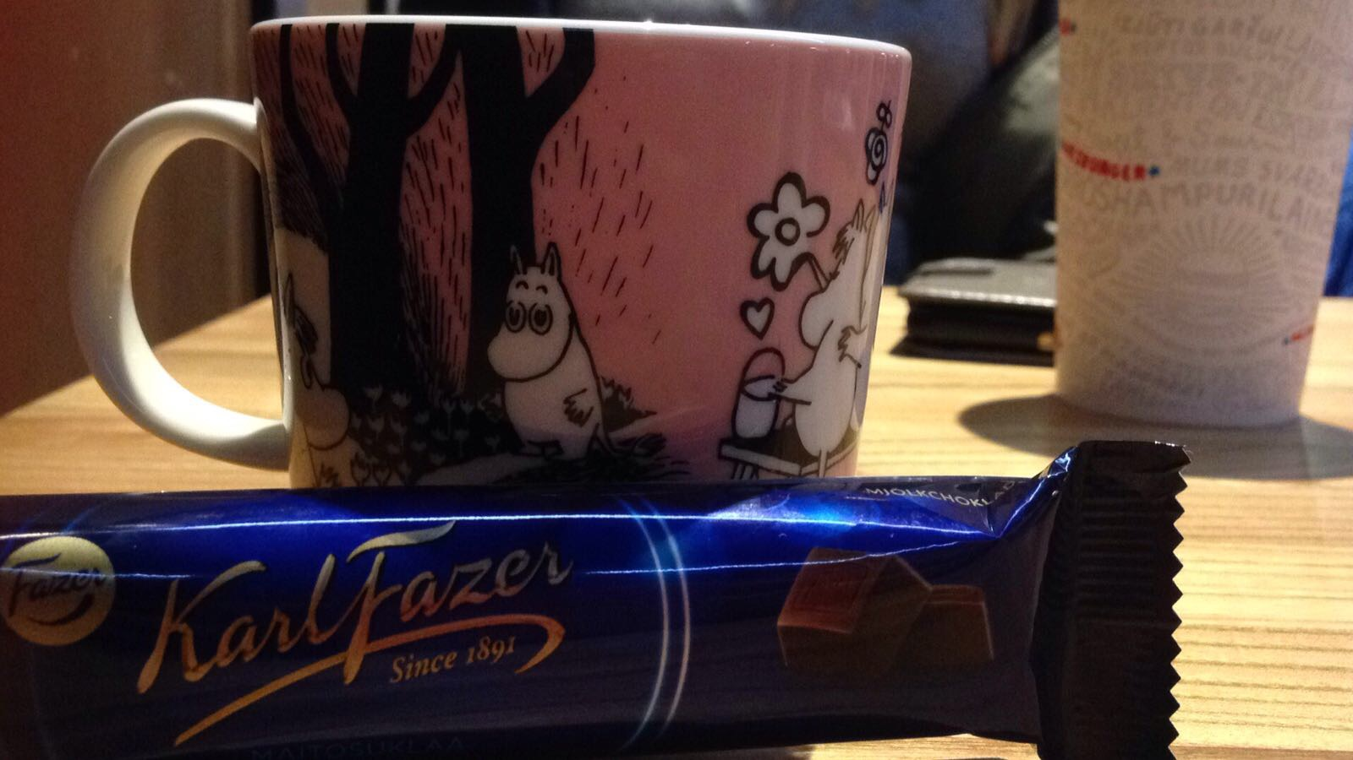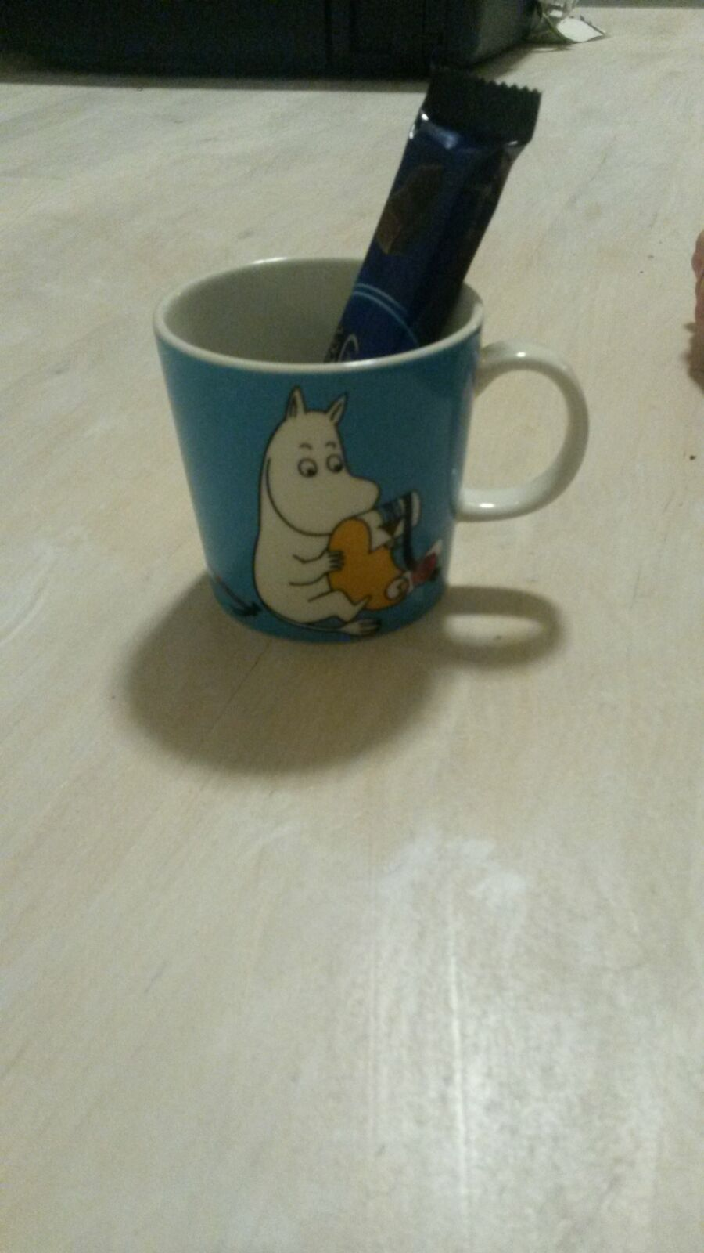
We were in the local
newspaper of Pori
The report of Sietse and Wiebe:

Our time in Finland

1 – 7 october 2017

We went out of bed around half past five. Yes, today we’re travelling to Finland!! We left at half past six from school, our airplane left at 10 o’clock from the airport. We had some time on the airport to look around. When we finally found our places in the airplane, it was really exciting. The take off was great. In the airplane we got some food and drinks. After two and a half hour we arrived in Helsinki. We had to take the bus to Pori. That was a very long trip. When we arrived in Pori, the host families were waiting for us. Our host family had three boys with the ages of 10, 12 and 14. Their names are Walter, Oliver and Wender. Oliver is a very good ice hockey player. We also went to see an ice hockey match in Finland, that was so much fun! We also went to a climbing park.

We had a very nice time in Finland!

Sietse and Wiebe

