Report from our visit to Lycée Saint Joseph, Lambelle, France.
Jonathan Young – West Kirby Grammar School
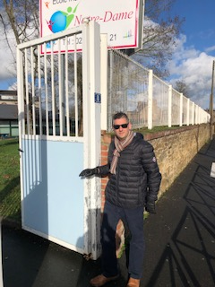
My name is Jonathan Young. I am a Design and Technology teacher at West Kirby Grammar School. I teach all year groups and have worked in the school for 19 years. My subject area is a STEM subject and very popular at West Kirby Grammar School. Many of my students continue to study engineering, architecture, construction or a design based discipline.
I was very fortunate to visit Lambelle with my colleague who is Head of Mathematics and like myself works hard to make links to the real world of work. We both found this experience, worthwhile, enriching and positive for making changes in our classrooms and teaching styles.

Gillian and I have gained many valuable experiences whilst in France. Both of us have never visited France apart from Paris city breaks. This was a real experience in a beautiful and charming town. We have been made very welcome by all of the staff, students and local community. We made many friends and we both commented about how the school, teachers and support staff are valued within the local community. We felt the community vibe of the school was very strong, the leadership was forward thinking, positive and very keen for the learners and staff to enrich their lives through educational visits and connections beyond the beautiful town of Lambelle. During the experience, we visited 13 lessons, visited a primary and took part in careers fair. We also eat some exceptional food in the schools onsite restaurant.
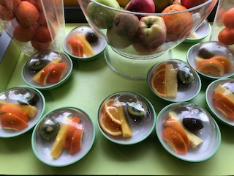
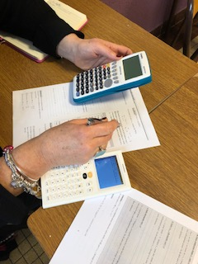
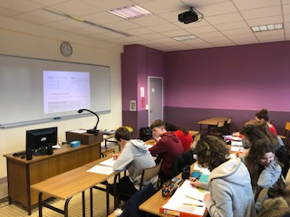

My objective was look at how work based learning and vocational studies influenced and supported learners for their career pathways. I am a Design and Technology teacher (STEM) and often try to make links to industry, careers and manufacturing. My own lessons often reflect the whole business from raw materials to final product.
Our school offers health and social care but only from theory aspect with little or no real practical experiences. I was very interested in how the lessons focused around the room being a health or preschool environment rather than a standard classroom. This was a very powerful and engaging experience. Visual wall materials and equipment was simper to professional care equipment. Medical dolls, elderly and paediatric where treated with respect and not as a toy and valued as powerful tools rather than amusement activity.
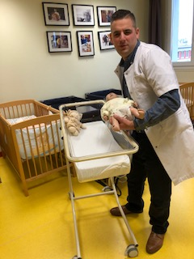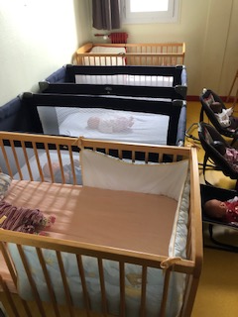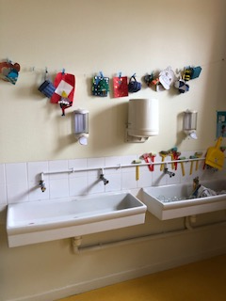
UK outcome for change: We have now started to collaborate more with local industry to enable learners to make positive links and solve real design problems. Lesson content refers more to industrial contexts, using additional technical vocabulary with younger learners. Encouraging more females into STEM (MINT) related career pathways. We now track our learners and use their stories of education and careers with STEM to encourage and call upon to provide talks, advice and assistance with university applications.
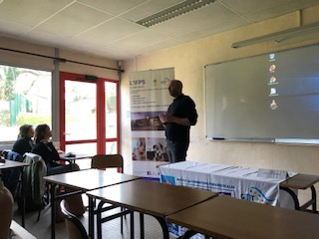
From personal perspective, I was very interested in attending the careers fair afternoon that had a strong focus upon health and social care. At West Kirby Grammar School, we offer a very similar experience. Learners rotated between rooms to listen to talks lead by local and national health organisations, further education and universities. The focus was health and social care industries and career. The presentations took the format of presenter, PowerPoint and question and answer sessions. Unlike our own schools, experiences parents and carers had no input. Not all learners engaged and minor disruption was evident, creating an uncomfortable situation for the presenters. There was little or no written documentation for the learners to take away, but it was clear that places were high in demand and often course where oversubscribed.
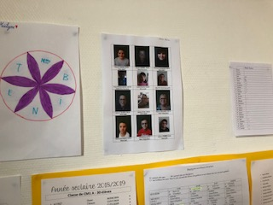
The most interesting part of the experience beyond the school observations was the afternoon spent in the feeder primary school. We moved between three classes and enjoyed entertaining the younger learners (aged 6/7) whilst on break time duty. The most noticeable feature of the learning environment was the learners progress and special educational requirements where displayed on the wall in the class, with clear ability structure in the room. We observed the use of teaching assistants to help with less able learners. As teachers from the UK, we felt uneasy with public display of abilities and SEND registers for all to view.
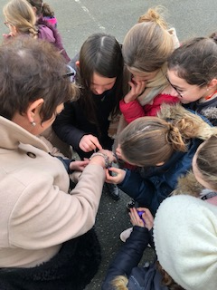
We stayed after school to discuss with the teacher, how in the UK this type of information is very sensitive and kept away from the eyes of other learners and visitors. The outcome enables us to appreciate that the learners would know and identify with their peers abilities or weaknesses and then help or learn from them, which on reflection is a positive point and eliminates and stigma attached to SEND as learners progress through school. The afternoon helped us gather information about how Lycée Saint Joseph provide transition programmes, it was very clear that the two head teachers collaborate on a frequent basis.

