Let's help the pollinators!

The number of pollinating insects in the world has declined threateningly. Regionally, more than 40 percent of pollinating insects are threatened with extinction. Even in Finland, almost one in five of the most important pollinators, ie bees, bumblebees and butterflies, is endangered.
The disappearance of pollinators is a disaster not only for nature but also for humans, as 75 percent of crops need insect pollination. The shortage of pollinators also threatens non-food crops, which can jeopardize the food supply of wildlife. For example, the number of eaves has collapsed by more than 90 percent in four decades. The reason is suspected to be a reduction in suitable insect food. The number of some pests can also explode in the hands if the insects that eat them disappear.
The cause of the loss is the loss of insect habitats, insecticides (=chemicals), alien species and climate change. Meadows and fields are among the most endangered habitats in Finland and would be a typical habitat for insects.
The problem is already real in countries where intensive farming is common. In Germany and the United Kingdom, there is already talk of a direct loss of pollinators. China has even resorted to pollinating the flowers of fruit trees by manpower.
Without suitable pollinators, the number of plants that clean the air and prevent erosion will also be reduced.
In January 2020, a team of more than 70 international scientists once again put the plight of pollinating insects in the headlines. The demand from researchers is clear: action must be taken now to protect pollinators, or the consequences can be unpredictable and devastating.

Building instructions below:

A very simple beehouse – all materials are recycled!

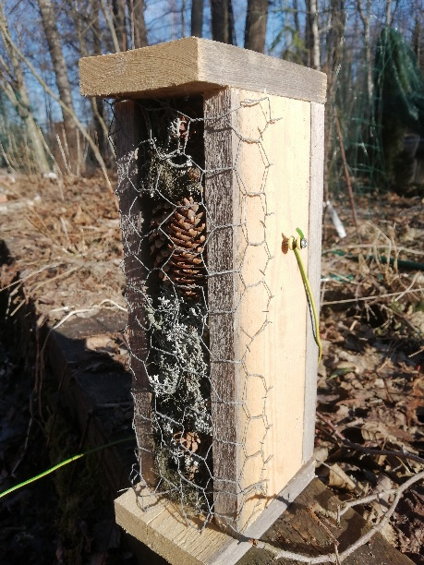 Picture 1

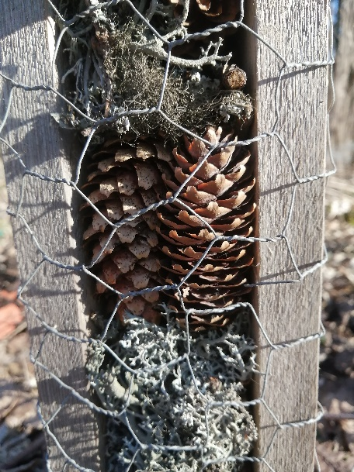 Picture 2

How to do:

- You have a piece of wood (120 cm)
- Use the meter and pen: mark to the piece of wood the measures needed (below)
- Use the saw: you need 3 x 30 cm high pieces of wood and 2 x 15 cm high pieces
- Use the hammer: nail pieces together to make a box = hotel (picture 1)
- Fill the hotel with all kind of dry material: spruce and pine cones, lichens, twigs, dry leaves, dry hay etc. Pack them tightly! (Picture 2)
- Use the staple: staple net tighly to the both hotel sites.
- Use the screwdriver: screw one screw on each side of the hotel
- A wire is placed on the screws to hang it on the wood.
- Put the name= colour of your group to the back. Hang it!

