http://www.funbrain.com/numbers.html

Number Games Online for Kids
• Soccer Shootout
Have fun with fractions and win the soccer game.
• One False Move
Step into the wrong room and you'll be doomed.
• MathCar Racing
Gear up your math skills and win the race.
• Tic Tac Toe Squares
Get three in a row to prove all you know.
• What's the Point?
Keep track of your coordinates on the graph
• Operation Order
Use algebra to build a pyramid
• Measure It!
Find the length in centimeters or inches.
• Cookie Dough
Write numbers and make a cookie fortune.
• Number Cracker
Get the secret code or get soaked.
• Math Baseball
Score runs with your math skills.
• Guess the Number Plus
Hey, who turned on the lights?
• Power Football
Kicking field goals requires brains.
• Shape Surveyor
Train to be an archaeologist.
• Line Jumper
Jump on the right number.
• Change Maker
Never get short-changed.
• Fresh Baked Fractions
Fraction Jackson is hungry for pi.
• Guess the Number
Are you feeling clucky?
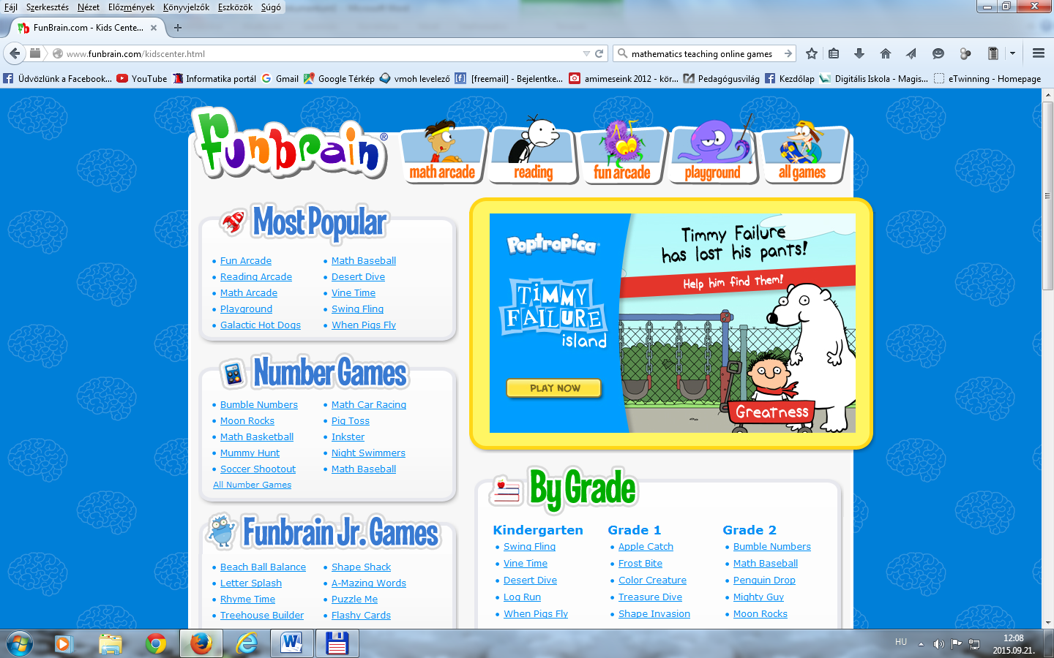

(One False Move)
http://www.education.com/games/math/kindergarten/

http://www.adaptedmind.com/landing-responsivev13jsfix.php?utm_expid=33853517-85.aV3h48VGQfCtLLYyE2CVew.2&gclid=CNzLwfbyh8gCFUe3Gwod1

usCKg&utm_referrer=http%3A%2F%2Ftpc.googlesyndication.com%2Fsafeframe%2F1-0-2%2Fhtml%2Fcontainer.html

Each lesson has 500 problems, explanations, and an instructional video.
http://www.topmarks.co.uk/maths-games/5-7-years/counting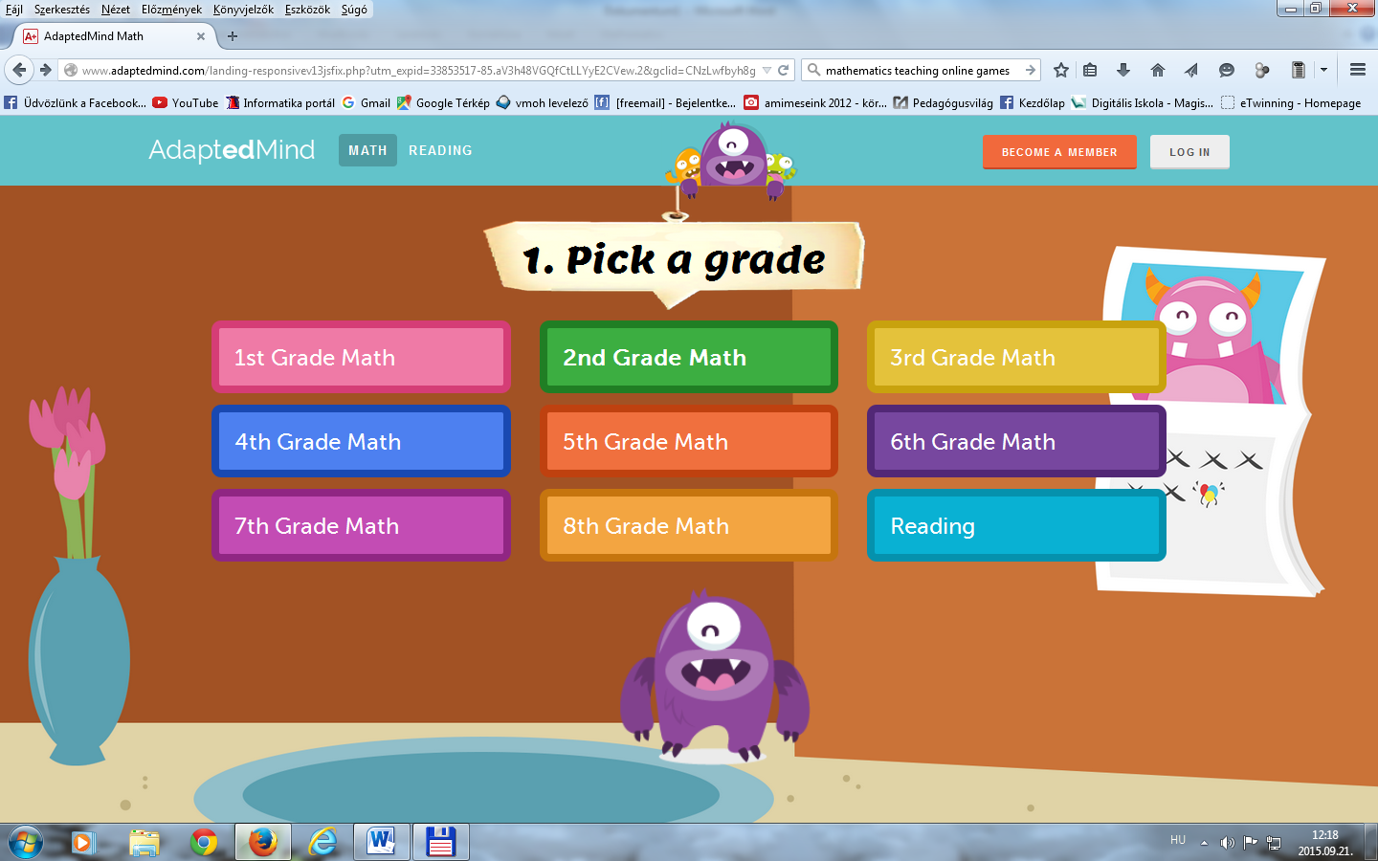
Tablet friendly online games:
http://www.topmarks.co.uk/maths-games/5-7-years/counting

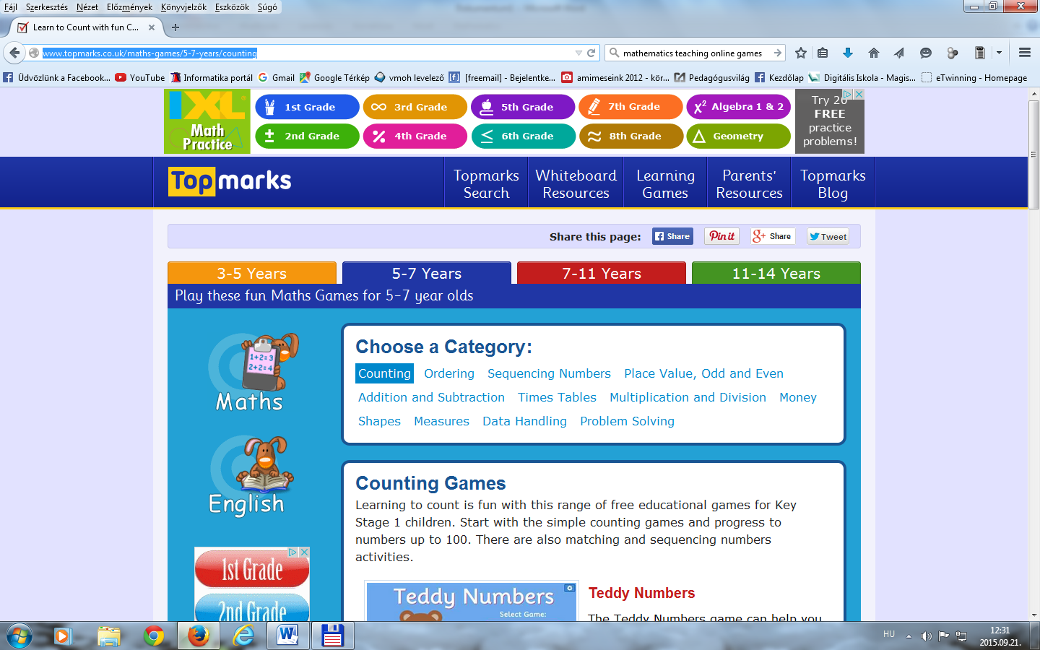
http://nrich.maths.org/public/leg.php?code=5039&cl=1&cldcmpid=5651
https://www.geogebra.org/

http://www.kidsmathgamesonline.com/



Logic Puzzles Money Addition Subtraction Multiplication Division Counting Problem Solving Sudoku Board Games Memory Fractions Probability



Welcome to Kids Math Games Online! Enjoy a wide range of free math games, interactive learning activities and fun educational resources that will engage students while they learn mathematics.
Find cool math games, interesting facts, printable worksheets, quizzes, videos and so much more!

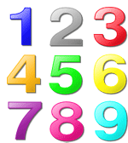
Learn about numbers with these fun interactive games and activities. Complete challenges related to number patterns, fractions, decimals, place values, graphs, probability, codes, data, mean, median & mode, calculators and more.
- Fun fraction game
- Decimals activity for kids
- Learn about probability
- Percentage game for kids

  
  Check out these educational geometry games for kids and have fun improving your geometry skills. Learn about shapes, grids, weights, building blocks, angles, measurements, reflection, rotation, transformations and more.
  - Fun shape game for kids
  - Measuring length & weight
  - Angle game for kids
  - Learn about grids & coordinates
  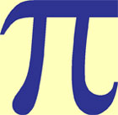
  Enjoy our interesting math facts, trivia and information related to the world of mathematics. Learn about numbers, read famous quotes and learn about shapes such as circles, squares, triangles, spheres and cubes.
  - Interesting number facts
  - Fun geometry facts for kids
  - The history of mathematics
  - Famous mathematicians
  
  Watch these great math videos for kids and have fun learning online with educational clips that will teach you the order of operations, how to add and subtract fractions and many more handy math tips.
  - How to add & subtract fractions
  - Multiply & divide fractions
  - Applying order of operations
  - Basic shapes video for kids
  
  Find a range of printable math worksheets for kids and enjoy a range of free activities that parents and teachers can use to help students practice their subtraction, division, basic algebra and other math skills.
  - Addition worksheet for kids
  - Multiplication worksheet for kids
  - Fractions worksheet for kids
  - Number coloring pages
  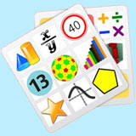
  Enjoy our wide range of free math pictures, photos, images and diagrams. Find pictures of math symbols, spirals, numbers, clip art, geometric patterns and more that you can use as you please.
  - Shapes pictures and images
  - Pictures of famous mathematicians
  - Cool optical illusions
  - Pictures of numbers
  
  Challenge your math skills with our printable math quizzes for kids. Answer questions that cover a range of math topics including addition, subtraction, division, decimals, money, shapes, basic algebra and more.
  - Fractions quiz for kids
  - Geometry quiz for kids
  - Multiplication quiz for kids
  - General math quiz for kids
  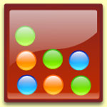
  Enjoy our range of awesome logic games. Test your logical thinking with brain benders, interactive activities and classic games such as mastermind, tic tac toe, the Towers of Hanoi and rock paper scissors.
  - Mastermind logic game
  - Tic tac toe
  - 3D puzzle cube
  - Rock paper scissors
  
  Take time out to relax and enjoy some funny jokes, brain teasers, amazing numbers, easy classroom activities and cool riddles with our fun math stuff for kids that focuses on the lighter side of mathematics.
  - Funny math jokes for kids
  - Fun brain teasers
  - Big, large, HUGE numbers!
  - Fun numbers and cool equations
  
  If you like puzzles then you'll love these fun puzzle games. Find the solutions to tricky number problems, match colors, shift blocks, complete jigsaws and enjoy a wide range of online challenges.
  - Matching colors puzzle
  - Numbers puzzle game
  - Sliding blocks puzzle
  - Color puzzle game
  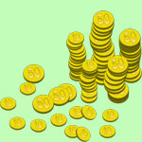
  Learn about money with these cool games for kids. Open your own coffee shop or lemonade stand, go shopping, check bus money, run a farm, count coins and enjoy other fun activities related to money.
  - Shopping game for kids
  - Lemonade stand game
  - Money counting game
  - Coffee shop game
  
  Learn how to add with these excellent addition games. Teachers and parents can use these interactive activities to help teach their students and children valuable skills related to addition and math.
  - Fun addition game for kids
  - Interactive addition challenge
  - Easy addition game
  - Plupon addition game
  
  Enjoy these free multiplication games that are great for students looking for a fun way to study their times tables. Finish arithmetic problems, solve number puzzles, play logic games and more.
  - Fun multiplication game
  - Interactive multiplication activity
  - Educational multiplication game
  - Multiply numbers game for kids
  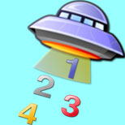
  Young children and kids in the early grades of school will love these fun counting games. Enjoy interactive activities such as counting blocks, chasing numbers, protecting towers and solving puzzles.
  - Interactive counting game
  - Tower defense game
  - Kindergarten counting game
  - Block counting game
  
  Put your problem solving skills to the test with these brain bending activities for kids. Help people across a bridge, measure water the hard way, choose the right path for a jumping frog and more.
  - Bridge crossing game
  - Hourglass time problem
  - Frog jump game
  - Wolf and sheep problem
  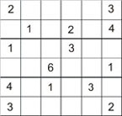
  Enjoy our free sudoku puzzles. Beginners can learn how to play on practice boards, experts can challenge themselves to brain bending puzzles of extreme difficulty while teachers can find a range of printable sudoku worksheets.
  - Free sudoku game
  - Easy sudoku for kids
  - Sudoku countdown
  - Free sudoku generator
  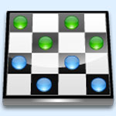
  Check out these free board games and have fun playing online. Enjoy classics such as chess, checkers, yahtzee, backgammon and dominoes or try something different like mahjong solitaire and dice wars.
  - Checkers game for kids
  - Free yahtzee game
  - Play mahjong solitaire
  - Online chess game
  
  Challenge your knowledge with these math quizzes and tests. Enjoy fun practice problems, brain training exercises, time challenges, arithmetic equations, geometry challenges and a free IQ test.
  - Brain training exercises
  - Visual geometry test
  - Free online IQ test
  - SpongeBob math quiz
  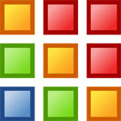
  Play these cool memory games and have fun training your short term memory. Match pictures, remember sound and light sequences, find numbers, be a detective and enjoy all kinds of memory activities for kids.
  - Play simon online
  - Food memory game
  - Picture matching game
  - Detective game

Kids Math Games Online © | Home | Contact | Numbers | Geometry | Facts | Worksheets | Videos | Quizzes | Pictures | Fun Stuff | Privacy | Sitemap

http://nrich.maths.org/public/leg.php?code=5039&cl=1&cldcmpid=5651

