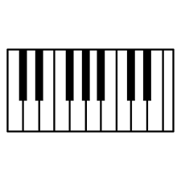
E
D
A
E
G
D#
Eb

C#
Db

A#
Bb

G#
Ab

D#
Eb

F#
Gb
C#
Db

PIANON KOSKETTIMIEN NIMET
F
C
B
(H)
F
D
C

