**Source A:** Lenin and Stalin in Lenin’s dacha in Gorki on 2 September 1922. (The picture has been taken by Lenin’s sister Maria Uljanov.)

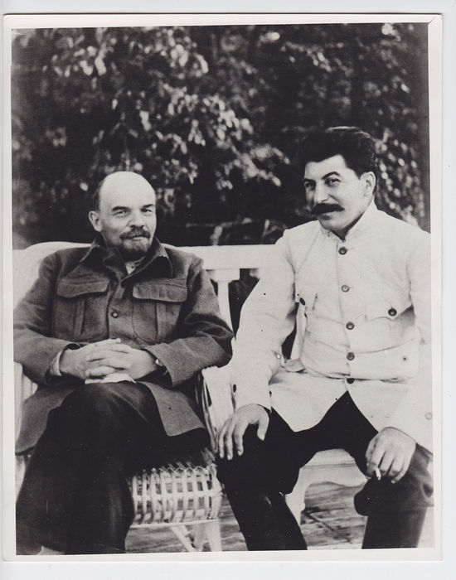

**Source B:** J.V. Stalin, *Trotskyism or Leninism?* A speech delivered at the Party meeting on 19 November 1924; Published in ‘*Pravda*’ a week later:

*‘-- I am far from denying Trotsky's undoubtedly important role in the uprising. I must say, however, that Trotsky did not play any special role in the October [1917] uprising, nor could he do so; being chairman of the Petrograd Soviet, he merely carried out the will of the appropriate Party bodies, which directed every step that Trotsky took. -- Whoever is familiar with the mechanics of Bolshevik Party leadership will have no difficulty in understanding that it could not be otherwise: it would have been enough for Trotsky to have gone against the will of the Central Committee to have been deprived of influence on the course of events. This talk about Trotsky's special role is a legend that is being spread by obliging "Party" gossips. This, of course, does not mean that the October uprising did not have its inspirer. It did have its inspirer and leader, but this was Lenin, and none other than Lenin, that same Lenin whose resolutions the Central Committee adopted when deciding the question of the uprising, that same Lenin who, in spite of what Trotsky says, was not prevented by being in hiding from being the actual inspirer of the uprising. It is foolish and ridiculous to attempt now, by gossip about Lenin having been in hiding, to obscure the indubitable fact that the inspirer of the uprising was the leader of the Party, V. I. Lenin.’*

**Source C:** Dmitri Volkogonov, Stalin: Triumph and tragedy, (Transl. H. Shukman) Forum 1996:

*'By the mid-1920's, Stalin's main opponents would come to realize that this 'outstanding mediocrity' was an exceptional politician, cunning, crafty and wilful. Soon, any party and state leaders who had anything to do with him would also realize it. In examining this period of history, one inevitably feels that the great issues surrounding the historic choice were frequently put into second place by the personal ambitions of the leaders, and the struggle how to build a socialism was severely affected by personal rivalry. The chief contenders were Stalin, Trotsky and Zinoviev. Behind their contest lay concrete issues of politics and economics, attitudes to the peasantry, the way to industrialize, the theory and practise of the international Communist movement. On occasion, the differences over these issues were infact of secondary importance and agreement could have been based on their common denominator. But personal ambition, rivalry and militant irreconcilability, particularly between Stalin and Trotsky, gave the struggle a dramatic quality which meant that any ideas that differed from his own were regarded by Stalin solely as class-hostile, capitulationist, revisionist, traitorous, and so on.'*

**Source D:** Michael Lynch, *Stalin and Khrushchev: The USSR 1924-64,* Hodder Arnold H&S 1990:

*’What these posts [general secretary of the Communist Party and chair of its Control Commission] gave him was the power of patronage, the right to appoint individuals to official positions in the party and government. he used this power to place his own supporters in key positions. Since they then owed their place to him (he fired as well as hired), Stalin could count on their support in the voting of various committees… Whatever ability of individuals who opposed him or the strengths of their arguments, he could always out-vote them. Stalin’s advantages over his rivals had been increased… by ‘Lenin’s Enrolment’ [an expansion of party membership]. The new members were poorly educated and politically unsophisticated but they understood that the privileges that came with party membership depended on their being loyal to those who admitted them. They provided the general secretary with reliable body of votes in the various party committees at local and central level.’*

1. (a) What according to source B was Stalin’s opinion about the role of Lev Trotsky as a revolutionary leader. (3)

(b) How could source A have been utilized after Lenin’s death? (2)

1. With reference to its origin, purpose and content, analyse the value and limitations of source B for an historian studying the Stalin’s rise to power. (4)
2. Compare and contrast what sources C and D reveal about the methods used and the conditions which helped in Stalin’s rise to power. (6)
3. Using the sources and your own knowledge, assess the reasons why Stalin rather than Trotsky had become leader of the Soviet Union by 1929. (9)