I recommend you this book
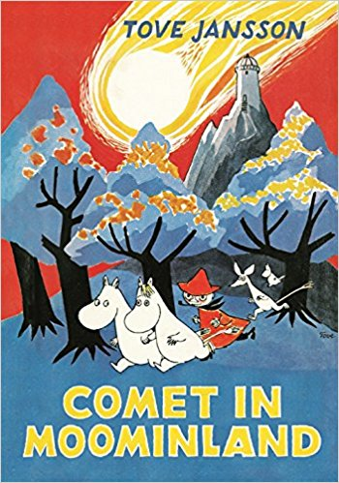
Title:
Comet in Moominland

Writer:
Tove Jansson

Setting:
Moominland, Moomins house, Force and New Bridge

Characters:
Moomimtroll, Sniff, Moominpappa
Moominmamma, Hemulens, snufkin,
Little My, Mymble, Too-Ticky, Fillyjonk,
Hattifatters, Thingumy, Bob, Groke,
Stinky and The Muddler

The book is about: First Moomintroll, Little My and Sniff go in the star tower and they hear in Moominland come the comet. I don’t wont spoil no more.

This book is good because: Because this book is interesting and exiting.

