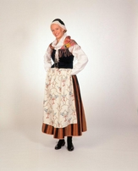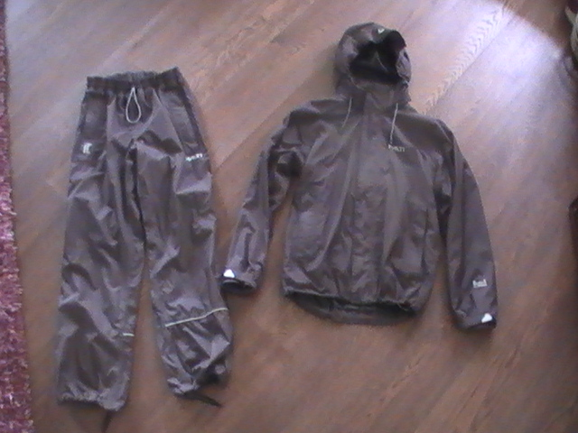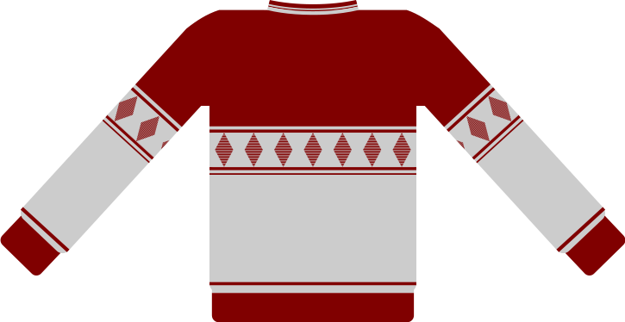
Women’s traditional national costume in Central Finland
Nowadays someone uses these in familyparties.
Photo: Kari-kuva
Original wind suit made in Finland. Finnish people wear this outdoors.
Jussishirt is a sweater from Pohjanmaa
Jussishirt ”Jussipaita”

