STUDY PACK SPAIN – BAND – MARGOT
LESSON 1
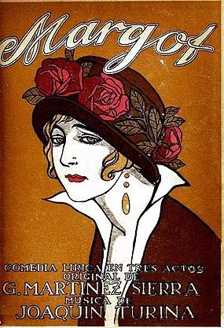
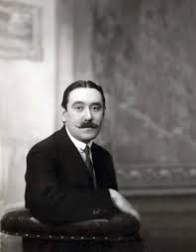
This work is framed within Spanish musical nationalism, an artistic and cultural movement that arose at the end of the 19th century and early 20th century in Spain. Its followers sought to create music that reflected the traditions and culture of Spain, in opposition to music imported from other countries.
Joaquín Turina (1882-1949) was a composer and pianist born in Seville who studied in Madrid before moving to Paris to train with composers like Paul Dukas and Vincent d'Indy. During his stay in Paris, Turina became interested in Spanish folk music and began to incorporate elements of this music in his compositions. In 1909 he returned to Spain and began working as a piano teacher at the Conservatory of Madrid, of which he was director from 1920. Turina died in Madrid on January 14, 1949. His musical legacy is considered one of the most important pieces of Spanish music of the 20th century.

Margot is an opera in three acts (later reduced to two) composed by Joaquín Turina to a Spanish-language libretto by María Martínez Sierra. It premiered at the Teatro de la Zarzuela in Madrid on 10 October 1914. Set in Paris and Seville, the opera's story involves a love triangle between José Manuel, a young Spaniard; Margot, a Parisian courtesan with whom he has an affair; and Amparo, José Manuel's sweetheart in Andalucía.
It is a story that tells of a love triangle that highlights the dilemma between a comfortable love or a passionate outburst. In this situation is José Manuel, a young man from a good family in Seville. On a trip to Paris, he meets Margot, a beautiful and famous cabaret dancer at a Parisian club. They fall in love, here we can also see a reflection of the attraction for the Spanish by the French at that time, with many shades of picturesqueness. José Manuel returns to Seville, where Amparo, his lifelong girlfriend, is waiting for him. It is on the night of Maundy Thursday, when a Sevillian square witnesses the reunion between José Manuel and Margot, who has traveled from France to find him. José Manuel, before the meeting takes place, has premonitions, notes a thickening in the atmosphere that makes him be alert, prepared for something special. This is enhanced by the expectancy of the people as the procession approaches: the incense, the drums, the penitents and the entourage are getting closer to the square, forming an atmosphere that sharpens the sensitivity. When he sees Margot, he feels the effervescence of passion again, he surrenders to her arms as if he finds a balm that cures all ills. But then a saeta is heard, a saeta sung by his girlfriend Amparo (Saeta is a traditional song primarily performed in the Holy Week processions in Spain). It is at this moment that the greatest struggle of conflicting feelings is unleashed, and José Manuel runs away, leaving behind his lover, runs to solitude because he doesn't feel comfortable going to Amparo.
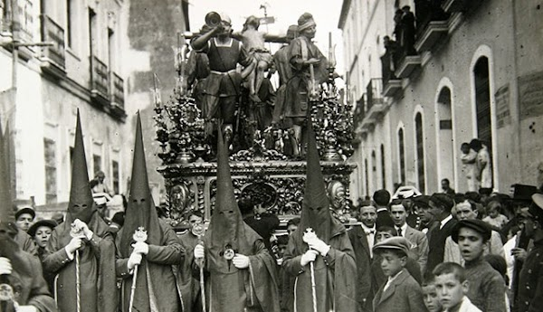
Margot was the second of Turina's three operas, and the first to be staged. He began its composition on 24 June 1914 and finished the orchestration on 27 September, less than three weeks before the opera's premiere. We can find different transcriptions and arrangements from different parts of the Opera and we’re working with this one for wind band.

Adaptation to the procession march: There are several adaptations of the work to a procession march. The march oscillates between two main themes, one in minor mode and the other in major mode. The theme in minor mode in the original work is the one that accompanies the reunion between José Manuel and Margot; it is a theme that plays with descending melodic lines. Passionate, melancholic, it is like a sadness that continues without being able to stop it. It always appears in the woodwinds, with different interventions from the brass, sometimes coloring some motif and other times giving it a rhythmic accompaniment that intensifies the drama. The other theme is in major mode, although the melody has hints of the Phrygian mode, a sample of the attachment to Andalusian culture. This theme is a saeta, the saeta sung by Amparo that makes José Manuel doubt. It appears first in a soft form in the saxophones and oboes, with sensual harmonies, and towards the end of the march is presented by the brass in a decisive way. It is the apotheosis ending that reflects the character's internal struggle.

Activities for this Lesson

- Here you have some versions of the same piece, listen and note the differences between them.
-LINK 1 → https://www.youtube.com/watch?v=iAH2-0pDlbc (The piece played in procession with percussion)
-LINK 2 → https://www.youtube.com/watch?v=UO6dtVzvLKg (Recording)

- Listen to link 2 again and take note of when the melody of the “saeta” appears.

LESSON 2

RHYTHM
Activities for this Lesson
1. Listen to the song performed by a band:
https://www.youtube.com/watch?v=UO6dtVzvLKg
2. Learn how to do the solfege of these 2 rhythms patterns inspired by the different themes of the piece.

Rhythm pattern nº1

Rhythm pattern nº2

3. Learn how to play in your instrument the rhythms of the piece. You can play the same note for all, or you can play 2 differents notes (one in each barr)

4. Now, along with your teacher or another student, you can play the rhythm pattern nº 1 and nº 2 together:
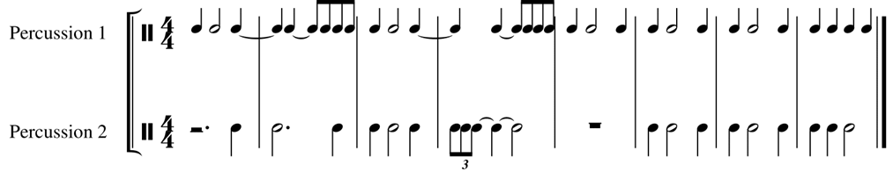

MELODY
The piece is in B flat Major/minor, but there are “cadencias” based in the F Phrygian mode. The most interesting melody in the piece is the “saeta”, a song to lament for the death of Christ. We can find this melody for the 1st time in bar 76.

1. Sing that melody in C major:
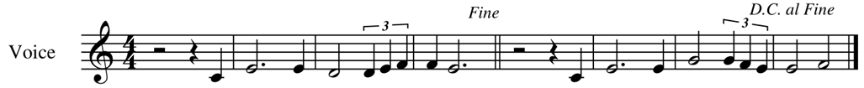
2. Sing that melody in B-flat major (original key):
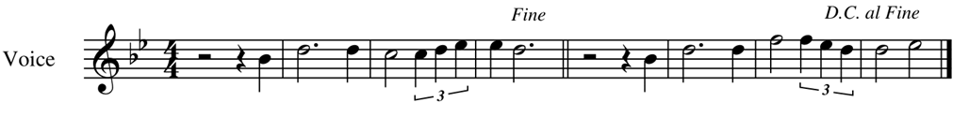
3. Play the last melody in your instrument.

LESSON 3

MAIN IDEAS FOR INTERPRETATION
- TEMPO: Tempo in four beats, 4/4, it should be played as the recording tempo.
- INSTRUMENTATION: Principal melodies are played by clarinets, flutes, saxophones and trumpets. Brass section usually plays bass line and counterpoint.
- MUSICAL VALUES: Not too difficult. Importance of percussion to play outside.
- CHARACTER: Funeral or religious. Importance of dynamics changes.

