[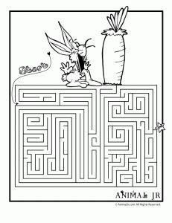](https://www.google.fi/url?sa=i&rct=j&q=&esrc=s&source=images&cd=&cad=rja&uact=8&ved=0CAcQjRxqFQoTCPOYpY-HnckCFQmdcgod8DwIPQ&url=https://www.pinterest.com/theappyladies/easter-worksheetsprintables/&psig=AFQjCNHZxQTPgV8fvY5rbx-di5I7lchW3g&ust=1448041985215267) [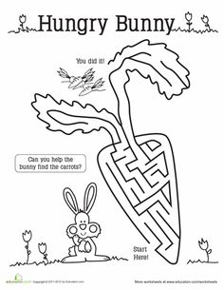](https://www.google.fi/url?sa=i&rct=j&q=&esrc=s&source=images&cd=&cad=rja&uact=8&ved=0CAcQjRxqFQoTCNfNlteHnckCFUUycgodQPIKiQ&url=https://www.pinterest.com/theappyladies/easter-worksheetsprintables/&psig=AFQjCNFaSyoh0uzzIlPA2ewdXr2APYxGZA&ust=1448042172182827)

[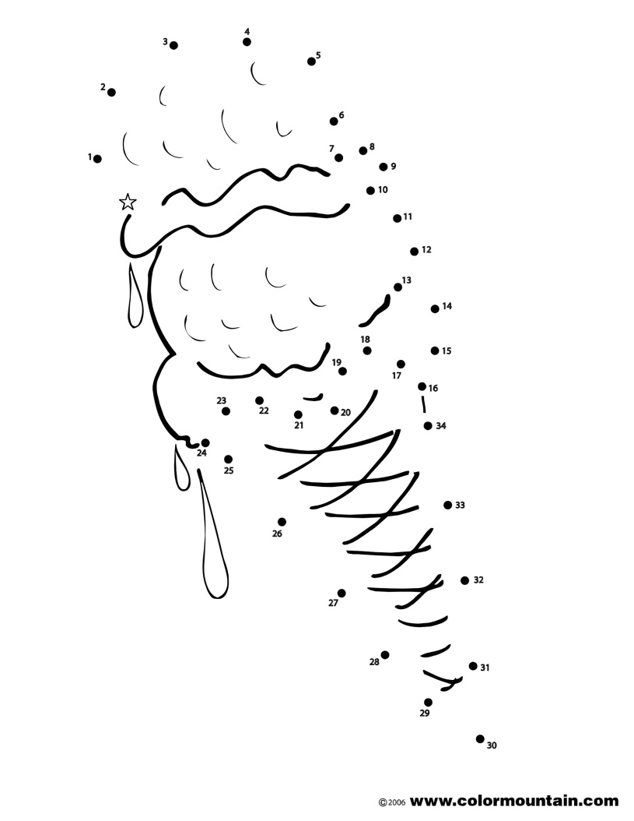](http://www.google.fi/url?sa=i&rct=j&q=&esrc=s&source=images&cd=&cad=rja&uact=8&ved=0CAcQjRxqFQoTCP2Fy7OHnckCFcKDcgodQ0kDlQ&url=http://www.colormountain.com/print/index.php?id%3D522&psig=AFQjCNE2Gtz-6ogVzHmv0CAUTXkfHxsAHQ&ust=1448042088136557)[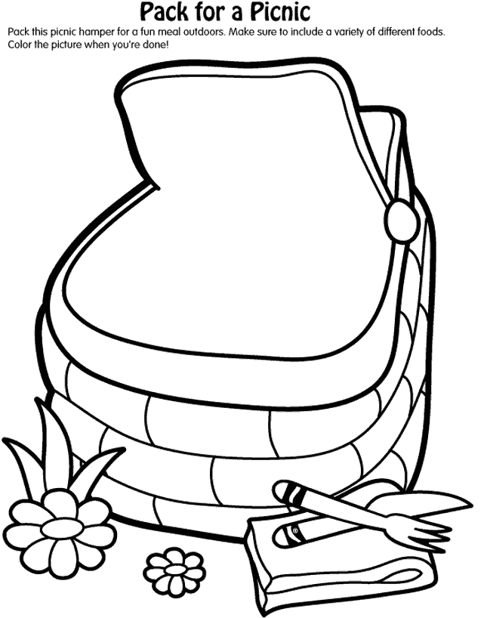](https://www.google.fi/url?sa=i&rct=j&q=&esrc=s&source=images&cd=&cad=rja&uact=8&ved=0CAcQjRxqFQoTCPH5l6OJnckCFcezcgoda3UIbw&url=https://www.pinterest.com/pin/179018153913452790/&psig=AFQjCNFvc9TQoULcv1__q1SRYRHIpjj6Rw&ust=1448042605069490)