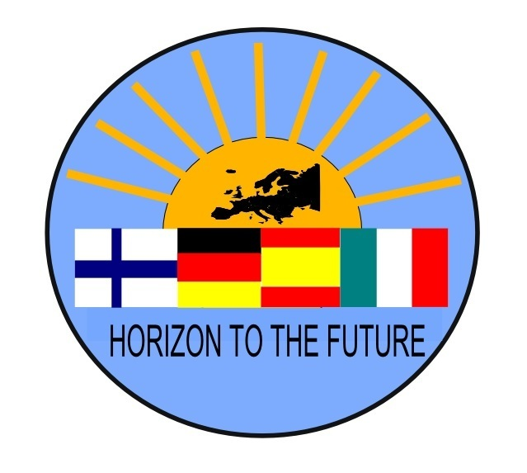
Horizon to the Future –project
Final meeting 10.-12.4.2018 in Joutsa

MEM0 of the FINAL MEETING
Participants:
Joutsa: Sanna, Eeva, Katariina, Sirpa, Mika, Mikko, Markus, Lisa
Bitterfeld: Sven, Frauke, Jakob, Kerstin, Carolin, Bärbel
Montmelo: Marta and Javi
Cambre: Olga and Bea
Civitavecchia: Donato, Luca, Mauro, Stefania, Deborah

We begun with the welcome dinner in Kellari restaurant at 18.00.
ISSUES:
Tuesday 10th of April,
-8.15-9.00 Tour around the school: by tutor students (Riikka, Sara, Sanni, Jani and Merja)
-9.00-9.45 Italian team presented their thought of TN, WS and seminar in Civitavecchia in Autumn 2017. The Italy WS´s feedbacks are to be collected by each team themselves, because the Italian team´s too busy timetable.
-10.00-11.00 Meeting with the major Harri Nissinen in the town hall. We discussed about differences between our school systems and teachers training.
-Lunch at school at 11.30
-12.00-14.30 “Walking and reflecting” –mindfulness session in Leivonmäki National park. Our guides were 8th grade pupils Netta, Ruusa and Runo. Pupils presented our school´s Green Flag activity during the bus drive, they had made a leaflet and a task for us all. There was a lot of snow still in the route!
-14.40-16.00 Visit to artesan companies: Karoliinan Keskikievari –café and Jukolan Juusto the local cheese factory. We heard about these companies establishing ideas, values, marketing etc.
-18.00-21.00 “MasterChef Joutsa” in the school´s kitchen, that meat that we made together our own dinner. We had for example salmon and lanttu done in the owen and pulla of course.
Wednesday 11th of April,
-8.30-11.30 Writing the final report in mixed groups (group leaders were: Frauke, Olga, Bea and Marta) in Google Drive. In ict-classroom. Evaluating the project. Jakob presented the eGuide. Checking the Mobility Tool with contact persons: we decided that each team writes in paste tense their presentation of their WS. This way others can copy those in Mobility Tool. Sanna will write a summary of the project and every team will use the same one in their reports.
Lunch at school 11.30.
-12.00 by bus to Jyväskylä, on the way we were planning eGuide´s content and outlook. Little stop in Sanna´s home to see an example of a Finnish home, collecting all ideas together. We had to leave the sights away our program in order to be able to continue with the actual issues. About 16-17.30 free time in the centre of Jyväskylä. At 18.00-21.45 spending the evening and dinner in Sirpa´s home.

Thursday 12th of April,
-8.30-11.30 Writing the final report in mixed groups (group leaders were: Frauke, Olga, Bea and Marta) in Google Drive. In ict-classroom. We continued with the writing. Olga and Bea presented their conclusion of all Quality plans. We decided that each team check their Quality plan one more time. Jakob asked more details for eGuide, which we can give to him also after this meeting. We printed out the certificates from Civitavecchia TN, Italian team gave us the Europasses from their WS.
Luch at school at 11.30. After that working continued..
-13.00-15.00 Final Celebration of the ending of the project, in auditorio. All high school students, pupils from grades 7.-9., teachers, journalist and our guest of honour from the municipality, Lea-Elina Nikkilä, were present. Principal Mika Sirkka held a speech, 2 high school´s bands performed, 2 of our final grade´s high school students held a speech too. Also each partner school´s both students and teachers had prepared a video greeting, which gave an excellent and positive feedback from the participants. The celebration was livestreamed through Joutsa High school´s Facebook site. The celebration ended with coffee and cakes.
-18.00-22.30 Sauna evening in Lamminmäet, with a little cross country skiing, Frisbee golf and walking in the snow too. In the end of the last evening we enjoyed a nice Finnish dinner.

in Joutsa 13th of April 2018,

Sanna Pienmäki

Annex 1.
What you have to do next
- Quality plan
-check again your quality plan, make corrections and/or addings.
-send it by email to Olga and Sanna
-deadline 4.5.2018.

- eGuide
-you can add issues to FAQ, if you like.
-you can give ideas to “General Outcomes” chapter, Finnish team will look the right comments from the final report for this.

- Mobility Tool
-write activity chapters in Mobility Tool in “past tense”, that mean what has happened.
-you can also mention the TN-meeting you have held before the workshop: were there some activities or “bridges” between the TN and WS..?! (We have had learning activities for teachers also during the TN-meetings, I think this is important to mention)
-copy that text to a doc. format and send it to Sanna. Deadline 4.5.2018.

- Feedback from Italy
-ask your students to freely comment and write their thoughts about the workshop in Italy
-feedback from the teachers too, both from the TN-meeting and Workshop
-send this feedback to Sanna by email. Deadline 4.5.2018.

- Final Report
-you can add your ideas to the final report, which we already has started (it is in Drive)
-Finnish team will start to work with it at 27th of April, and after that we do not accepted any new ideas to it.
-of course we will share the report with you before the end of May for a short-time commenting.
-Sanna will write the summary for the Final report, every team can use the same one.

Thank you for your excellent work during the Final meeting

