TEST & TRAIN 2025

Part 2

The human world

Part 2 contains eight sections with reading comprehensions, listening comprehensions and vocabulary exercises related to the human world. Keys to exercises can be found in a separate document.


Image from Pixabay

1) Having fun
Exercise 1A
Combine the words with the correct pictures. There is one extra word.

arcade games ferris wheel rollercoaster
bumper cars merry-go-round water ride
dunk tank pendulum ride whac-a-mole
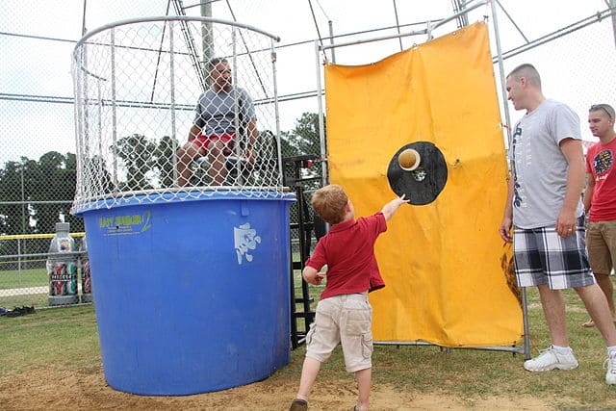  1) ________________________________ | 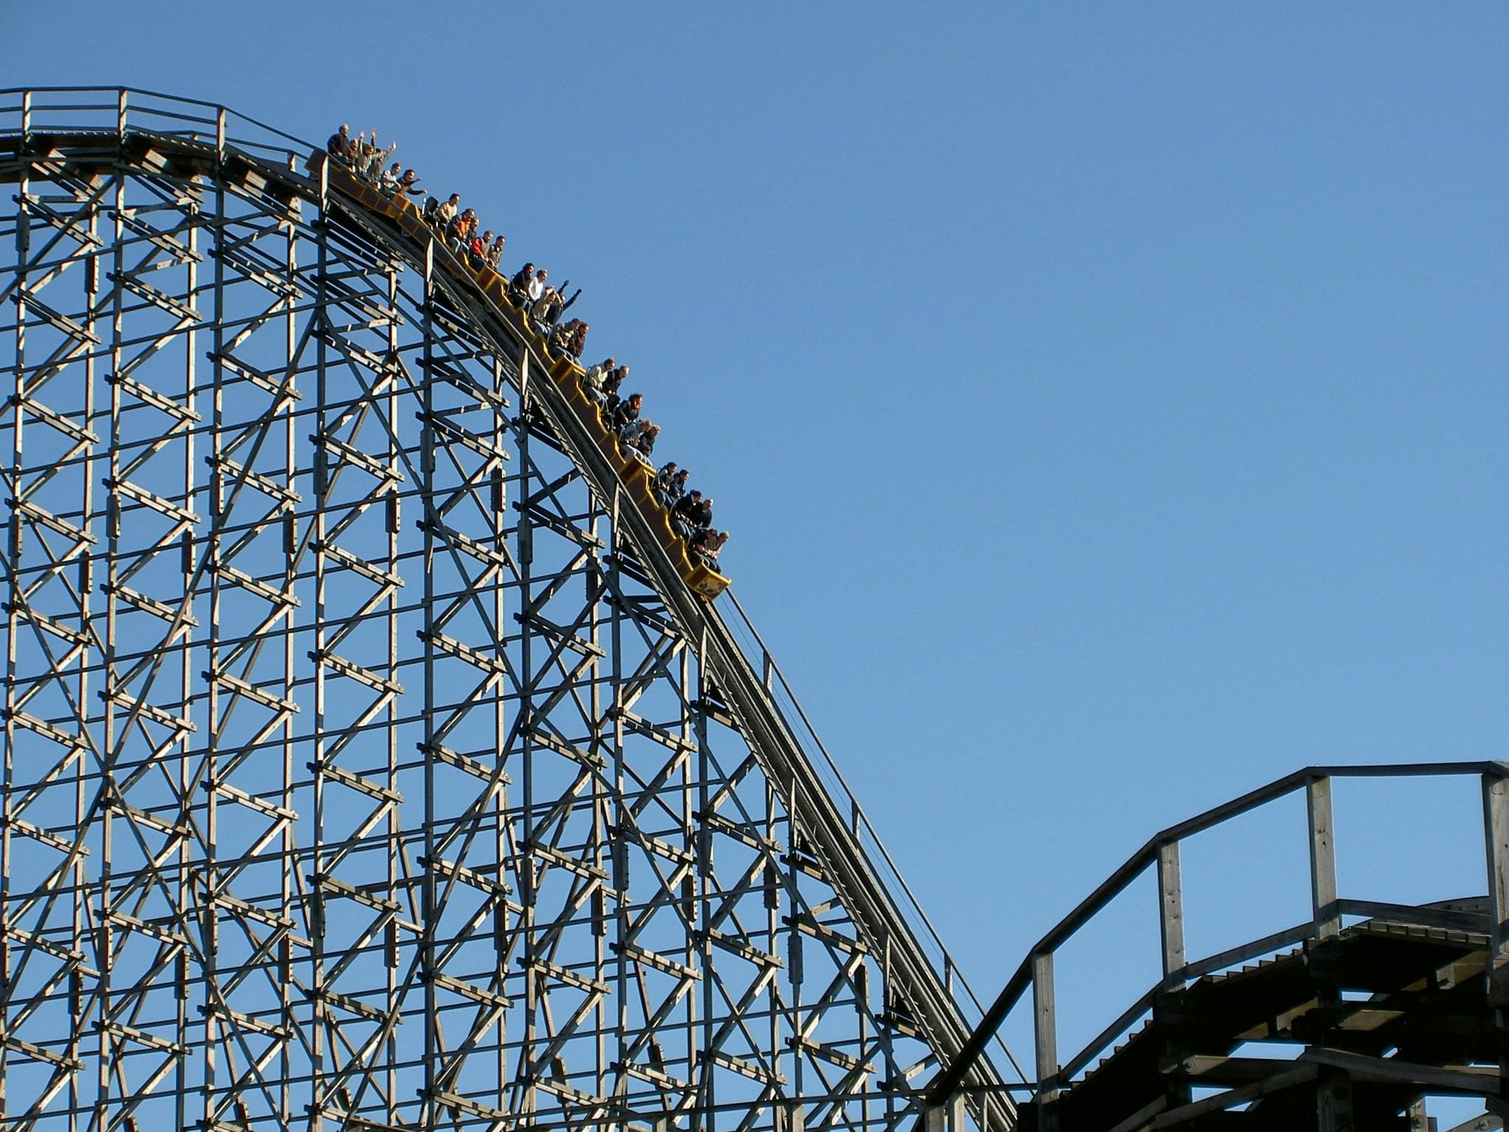  2) ________________________________
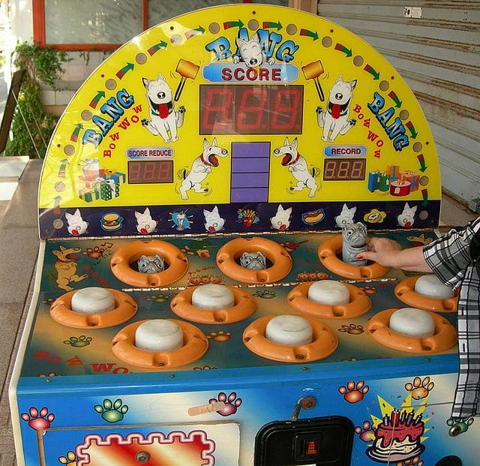  3) ________________________________ |   4) ________________________________
  5) ________________________________ | 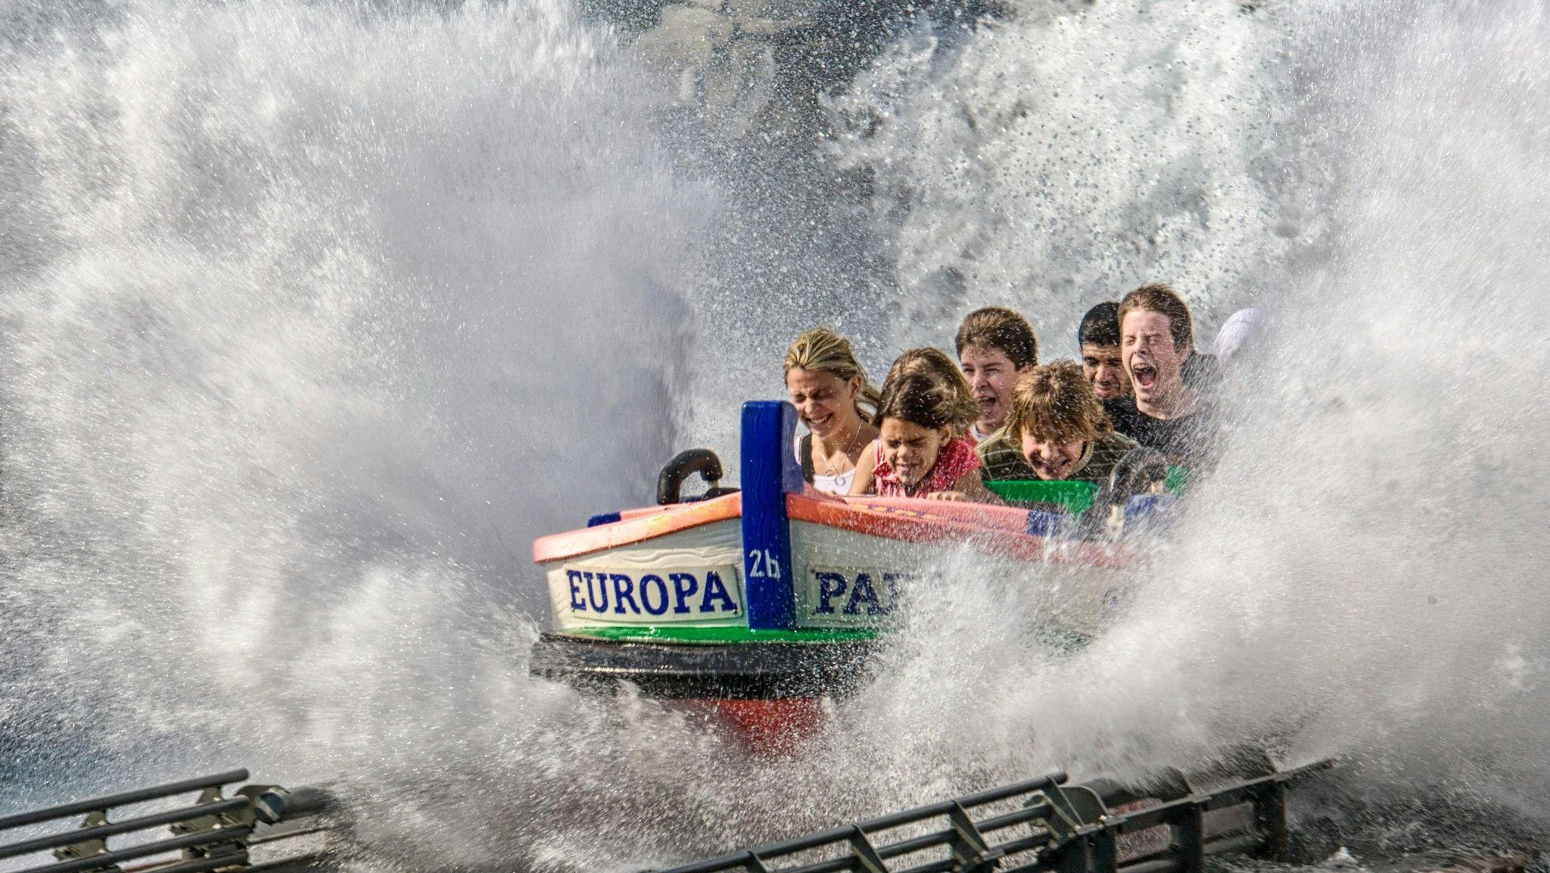  6) ________________________________

  7) ________________________________ |   8) ________________________________

Images 1 and 3 from Wikimedia Commons
Images 2 and 4-8 from Pexels

Exercise 1B
Combine the words with the correct pictures. There is one extra word.

caramel apple funnel cake snow cone
corn dog hot dog soft serve
cotton candy slushie

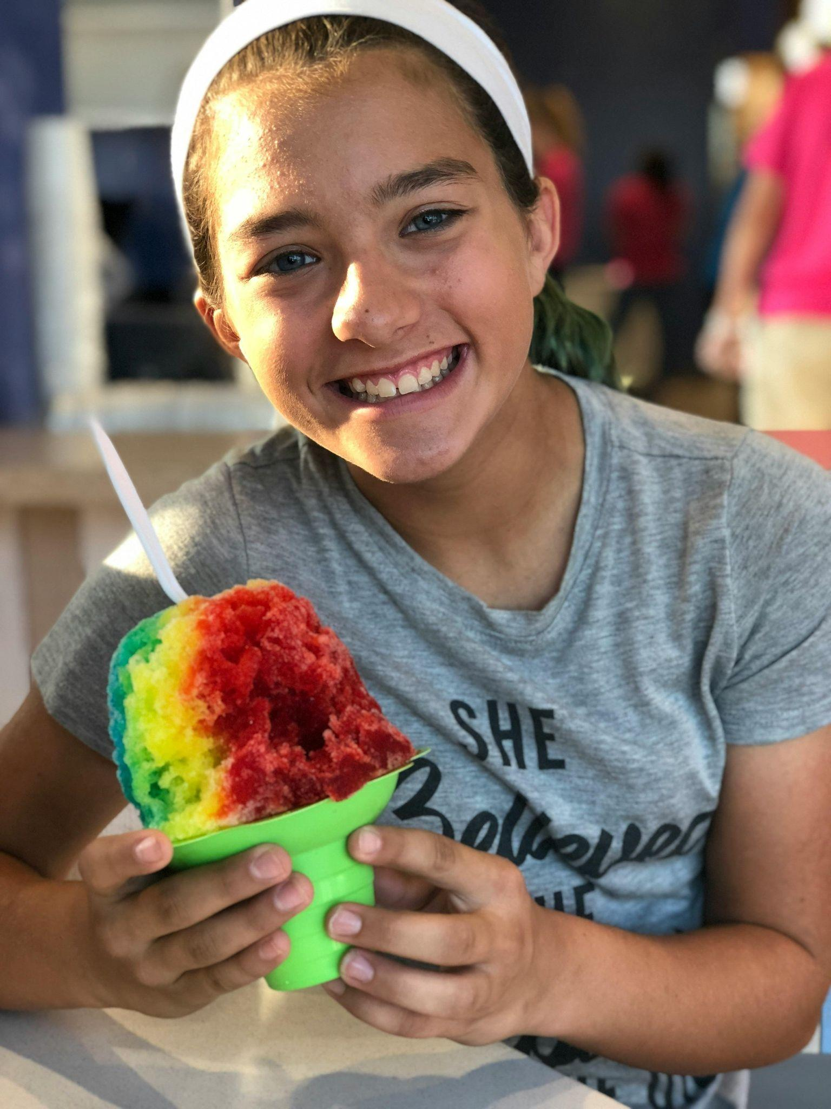  1) ________________________________ |   2) ________________________________

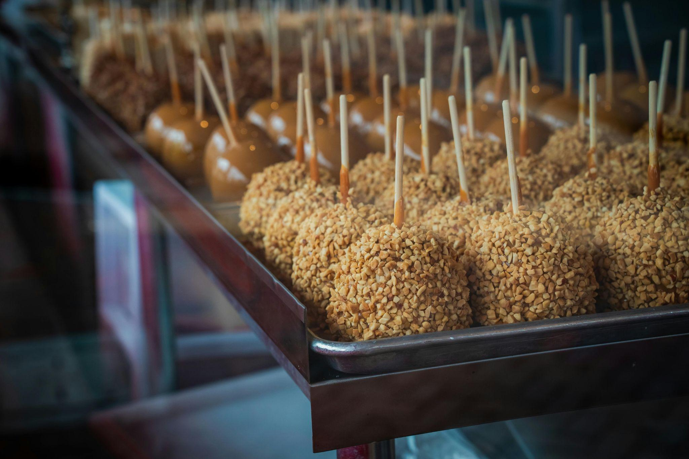  3) ________________________________ | 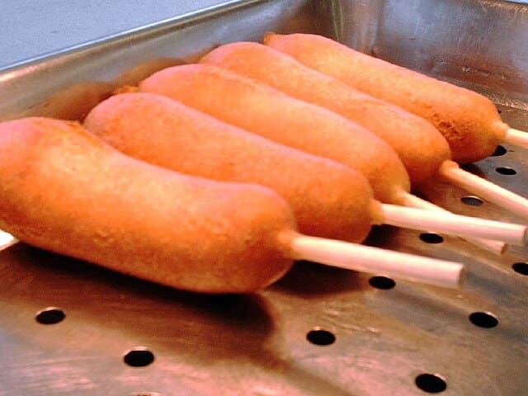  4) ________________________________
  5) ________________________________ | 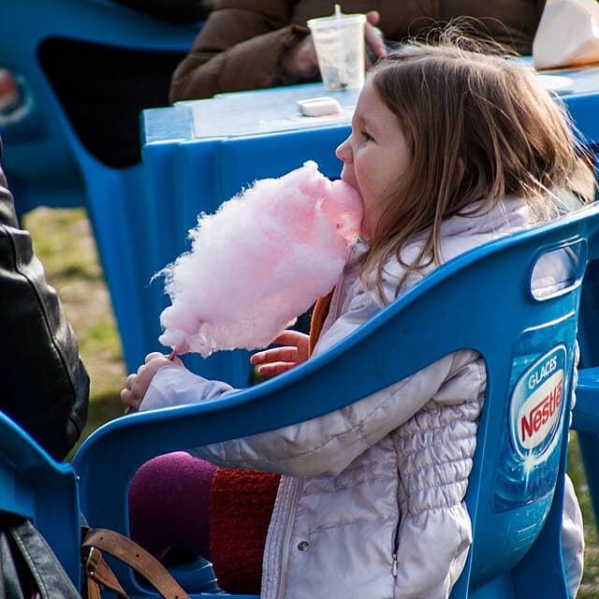  6) ________________________________
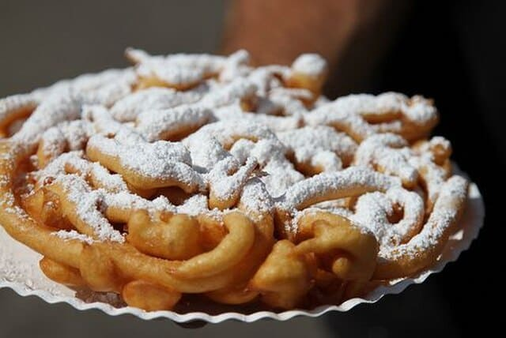

7) ________________________________

Images 1-5 from Pexels
Images 6-7 from Wikimedia Commons
Exercise 2
Choose the correct alternative.

Wonderland Amusement Park opened (1) on / in May 27, 1905, in Minneapolis.
(2) During / Under the first few seasons, it looked as if the park would be a success. Visitors regularly filled the park and enjoyed (3) its / it’s amusements. At Wonderland, visitors rode the "scenic railway," which was a roller coaster that reached speeds of forty-five miles
(4) a / an hour. They would also "Shoot the Chutes" by taking a boat that was drawn up a large hill and then sped down a large ramp (5) into / in a constructed lagoon. Children could travel on a miniature railroad or visit a petting zoo.

At the center of the park was a 120-foot lighted Beacon Tower that people could climb. According to (6) the / - contemporary reports, the tower was lit by more than five
(7) thousand / thousands bulbs, which was a tremendous extravagance at the time. It was reputed to be visible from miles away.

One key attraction was the place known as the Infant Incubator Institute or Infantorium, where, for a small (8) fee / fare, the public could see premature babies in incubators. At the time, incubators (9) were / where a new technology and (10) most / the most premature babies died within a few days of birth. The exhibit worked both to promote incubator technology and save lives. The price of admission paid for the staff, and parents
(11) owed / owned the park nothing for the care of their baby. The incubators kept the babies warm, and nurses made sure that the newborns received regular feedings from wet nurses. While such displays would seem strange today, at the time, incubator displays had been a part of the recent World's Fair in Paris in 1900 and at (12) Coney Island / Coney island.

(13) Despite / Although its early success, Wonderland would remain open for only seven seasons. In 1910, the summer was colder and wetter than (14) usual / usually in Minnesota, and another cold summer in 1911 caused the park to (15) lose / loose $10,000. Some of the rides, notably the shoot-the-chute and scenic railway, needed extensive repairs. Just as importantly, the area around the park had continued to be developed and the land on which the park sat had quadrupled in value since it opened. With all of (16) these / this factors in mind, the owner decided to close the park after the 1911 season.
Text from: https://www.mnopedia.org/place/wonderland-amusement-park

Exercise 3
Idioms with fun and games: Pair the idiom with the correct definition. Then make a sentence where you use the idiom.

Example:
Party animal = someone who loves to party and is always enthusiastic about it
Alex and Max are real party animals; they are always the ones to get the party started on the dance floor.

Idioms
blow away the cobwebs live it up
blow off some steam make waves
go bananas monkey around
have a ball paint the town red
let your hair down raise the roof

1. ________________________________________________
= to have a lot of fun doing something

2. ________________________________________________
= to relax and enjoy yourself informally with more freedom than you usually do

3. ________________________________________________
= to have a very good time by doing exciting or enjoyable things, or by spending lots of money

4. ________________________________________________
= to go out and have a great time, usually in a city at night with dancing and drinking in bars and clubs

5. ________________________________________________
= to spend time fooling around and having fun while not being productive or useful at all

6. ________________________________________________
= to get very excited or lose control in a fun, wild way

7. ________________________________________________
= to do something that gives you some fresh air and enjoyment, and clears your head

8. ________________________________________________
= to release pent-up energy or frustration by going out and having fun

9. ________________________________________________
= to make a lot of noise and have a great time, especially at a party

10. ________________________________________________
= to create a lot of excitement, controversy, or attention in a fun way



Image from Wikimedia Commons

2) Consumption

Exercise 1
Read the text. Choose the best alternative or answer the questions in Finnish.

The new reality of chocolate and coffee
Due to extreme weather events caused by climate change, both cocoa and coffee beans were in short supply during 2024. Trading prices soared, and analysts predict that the market for both commodities will remain tight in 2025.

In response to this volatility, companies and farmers have taken different approaches to adapt to the changing market conditions.

In Côte d’Ivoire and Ghana—the world’s biggest cocoa-producing countries—farmers are paid fixed rates for their beans by their governments. As a result, they are unable to benefit from the recent price spikes and some cocoa farmers are throwing in the towel.
Meanwhile, major corporations are investing in long-term solutions. Starbucks, for example, has responded to the challenges in the coffee supply chain by investing in research and development to breed more resilient coffee plants. In addition to climate adaptation, the company is also pursuing sustainability goals, aiming to achieve “carbon neutral green coffee” by 2030.

Other companies are exploring alternative ingredients altogether. While coffee substitutes like soluble barley have been available for years, cocoa-free chocolate is a newer innovation. The familiar flavour of chocolate typically comes from the fermentation and roasting of cocoa beans, but similar flavour notes can be achieved by roasting cereals such as barley.

Vallée Torréfaction, based in French Brittany, has begun producing chocolate using roasted malted barley powder. Although the taste differs slightly from traditional chocolate, the product costs half as much. This makes it especially appealing for large-scale manufacturing of, for example, brownies and other chocolate-based products.

In addition to natural substitutes, the coffee industry is also exploring lab-grown alternatives. Investors are backing the development of synthetic coffee grown from cultured coffee cells in a laboratory setting. The aim is to produce a 100% coffee product, yielding a powder that can be roasted and brewed like traditional coffee, with the same taste, texture, and aroma as its farm-grown counterpart.

Given that the impact of climate change is expected to persist in key producing regions, chocolate and coffee may soon become luxury items. For those unable to afford them regularly, substitutes and synthetic alternatives could increasingly become part of everyday consumption.

Text adapted from:

https://www.thedailyupside.com/industries/consumer/coffee-and-chocolate-are-the-reigning-commodity-kings/

https://www.euractiv.com/section/agriculture-food/news/rising-coffee-and-chocolate-prices-drive-substitutes-industry-growth-in-europe/

https://www.researchgate.net/publication/382225234_Analytical_Platform_to_Determine_Similarities_and_Dissimilarities_between_Cell-Cultured_Coffee_and_Farm-Grown_Coffee



1. Millä tavalla ilmastonmuutos vaikutti kaakao- ja kahvipapujen viljelyyn vuonna 2024? Vastaa suomeksi. Vastauksen pituus on enintään 50 merkkiä.

_________________________________________________________________________

2. Miten osa kaakaoviljelijöistä reagoi Norsunluurannikolla ja Ghanassa? Vastaa suomeksi. Vastauksen pituus on enintään 50 merkkiä.

_________________________________________________________________________

3. To mitigate the effects of extreme weather events, Starbucks is…
- focusing on reducing its carbon and water footprints
- looking for hardier coffee plants
- collaborating with other corporations

4. Why are cereals mentioned?
- They are a well-known substitute for coffee
- In soluble form, their flavour is very similar to coffee
- They have recently replaced cocoa in mass-produced chocolate

5. Mitä kahvituotanto laboratoriossa edellyttää? Vastaa suomeksi. Vastauksen pituus on enintään 50 merkkiä.

_________________________________________________________________________

6. Which of the following best corresponds to the writer’s predictions?
- Production of chocolate and coffee will persist despite climate change
- Indulging in chocolate or coffee products will become less common
- Substitute products will entirely replace traditional chocolate and coffee products

Exercise 2
Complete the definitions by selecting suitable words from the box. Please note that you may need to conjugate verbs and use plural forms of nouns to fit the context.

allocate demand good raw
commodity fluctuation purchase trade

- A price spike is a rapid and significant increase in the price of a good or service, usually driven by sudden changes in supply or _____________________.

- Consumption can be defined as the act of using or ___________________________ goods and services by individuals, households, or society as a whole.

- A fixed rate is a set price paid for a product or service that does not change in response to market ___________________________.

- Scarcity refers to a situation where the supply of a ___________________________ or resource is limited in relation to demand.

- Investment can be described as the ___________________________ of resources into projects, research, or assets with the expectation of future returns.
- A supply chain refers to the system of people, companies, and activities involved in producing a product and delivering it to the customer, from ___________________________ materials to the final sale.

- Volatility is the extent to which prices or values of ___________________________ fluctuate over time, often due to unpredictable factors.
- A tariff is a tax or duty that a government places on goods imported (or sometimes exported) to control ___________________________ and protect local industries.

Exercise 3
Suggest synonyms for the words in bold. Consider if or how the synonyms change the meaning. Does it mean the prices and exports rose a little / a lot / drastically etc.? Also consider if the synonyms are formal or informal.

A. Coffee prices increased after the drought.

___________________________________________________________________________________________________________________________________________________________________________________________________________________________

B. Cocoa exports decreased due to bad weather.

___________________________________________________________________________________________________________________________________________________________________________________________________________________________

Exercise 4
Complete the sentences with an appropriate pronoun by translating the clue in brackets/parentheses into English.

- Luxury brands often market _________________________ products as symbols of success and status. (heidän)
- These shoes are very expensive. Are they _________________________ ? (sinun)
- The company, _________________________ profits soared last quarter, specialises in luxury electric vehicles. (jonka)
- The investors analysed the market data by _________________________ before making a decision. (itse)
- They didn’t understand _________________________ made the handbag so expensive. (mikä)
- I looked at several luxury watches, but _________________________ were within my budget. (mikään)
- I prefer products _________________________ are made from sustainable materials. (jotka)
- She met a designer _________________________ collection focuses on ethical consumption and minimal waste. (kenen)
- We challenged _________________________ to go a whole week without buying anything unnecessary. (itsemme)
- _________________________ invest wisely in renewable energy stocks often see better long-term returns. (He jotka)
- _________________________ of the two phones had the features I needed for managing my finances. (Kumpikaan)
- _________________________ decided to track our spending for a month to see how much we spend on non-essential items. (Minä ja ystäväni)
- _________________________ of the twins prefers saving money and investing, while _________________________ enjoys spending on luxury fashion.
(Yksi - toinen)
- That gold bracelet looks just like _________________________. (minun)
- The new smart wallet, _________________________has a built-in tracker, is very popular among young consumers. (jolla)
- _________________________ customer received a personalised recommendation based on their spending habits. (Jokainen)
- You can choose _________________________ the leather wallet or the eco-friendly one—they’re both great quality. (joko)
- After browsing the store for an hour, I bought _________________________ . (mitään)
- He bought the expensive watch as a gift to _________________________ after getting a promotion. (itselleen)
- After returning the faulty headphones, she decided to order _________________________ pair from a different brand. (toiset)

3) Social media

Image: Social Sharing - Author: Seobility - License: CC BY-SA 4.0

Exercise 1
Read the text and choose the best alternative.
Meta, the company behind Facebook and other social media platforms, has replaced traditional fact-checking with a system of community notes, similar to the one used by X (formerly Twitter). Instead of relying on independent fact-checkers, this model allows users to add corrections to false or misleading posts. Elon Musk has called this approach “citizen journalism”, describing it as a system where information comes directly “by the people, for the people.”
For this method to be effective, both those adding corrections and those reading them must value accuracy, accountability, and good-faith discussion. However, research suggests that social media users may not be the best group to rely on for these qualities.
Sociologist Zeynep Tufekci argues that social media is more about bonding with like-minded people and mocking opponents than engaging in meaningful discussions. She explains, “belonging is stronger than facts”, meaning that people tend to support views that align with their social groups rather than seek the truth. Anyone who has tried to debate politics online has likely experienced this firsthand.
Social media platforms are not designed to support democracy. Their business model encourages users to act as brands competing for attention, rather than as citizens engaging in informed discussions. This environment does not promote responsible fact-checking, nor does it encourage users to care about it.
Platforms prefer to distance themselves from fact-checking because it is politically sensitive. They claim to support the free flow of information, but they still control what users see through their algorithms. These systems determine which posts appear in our feeds and which do not. It is misleading for social media companies to claim they have no responsibility for content, especially when their platforms have contributed to an increasingly polarized and misinformed digital landscape.

Text adapted from:
https://theconversation.com/dont-rely-on-social-media-users-for-fact-checking-many-dont-care-much-about-the-common-good-246977
https://www.aljazeera.com/news/2025/1/10/meta-facebook-to-drop-fact-checkers-what-does-this-mean-for-social-media

1. What has happened?
- Meta’s content moderation policies have changed
- Meta has replaced the social media platform X
- Meta has started relying on a new type of information source
2. What is said about social media users?
- They are generally adept at verifying facts
- They often engage in online political debates
- They rather ridicule others than have thoughtful conversations
3. Because of the algorithms, social media platforms
- can avoid fact-checking the content
- are accountable for the content
- may include misleading content
Exercise 2
Complete the sentences by selecting suitable words from the box.
content creator engagement go viral privacy settings
cyberbullying fact-checking polarisation profile
echo chamber feed post unfollow

- If someone is posting rude comments about you online, it might be __________________________________________ .
- My __________________________________________ is set to private, so only friends can see my posts.
- I saw your holiday pictures on my ________________________________________ this morning.
- You should always check your __________________________________________ so strangers can't contact you.
- Her __________________________________________ about the football game had high __________________________________________ – over 200 likes and 40 comments!
- The funny cat video started to __________________________________________ and was shared by millions of people in a few hours.
- A good __________________________________________ doesn’t just post photos – they plan, film, and edit their work.
- Social media can become an __________________________________________ if you only follow people who agree with you.
- I decided to __________________________________________ the account because it was posting too many negative comments.
- Before you believe something you read online, it’s a good idea to do some __________________________________________ .
- __________________________________________ on social media means that people’s opinions become more extreme and divided because they mostly see posts that support their own views.

Exercise 3
Study the idioms and use them in the sentences below.

- Speak your mind = say exactly what you think
- Air your views = share your opinions publicly
- Sit on the fence = avoid giving an opinion or taking sides
- A difference of opinion = a disagreement
- Put in your two cents (US) / Put in your penny’s worth (UK) = add your opinion to a discussion
- I’m sitting _______________________________________ about which university to choose because both have good programs.
- If I can put _______________________________________ , I think we should wait until next week to launch the product.
- Don’t be afraid to speak _______________________________________ during the meeting — your ideas are important.
- During the conference, the professor aired _______________________________________ on the impact of social media on young people.
- There was a difference _______________________________________ between the managers about how to handle the customer complaint.

4) Nationality words and foreign-language influences

Exercise 1
Complete the text by translating the given words into English.

Visiting Germany
Germany has many arresting and curious (1) ______________________________ for the visitor. There truly is something for everyone. (2) ______________________________ as we take off (3) ______________________________ some of the famous places!

Let’s first make our way to Cologne, home to the Kölnerdom, which was built in the
(4) ______________________________ . What a majestic sight this must have been to the (5-6) ________________________________________________________ .

In the Bavarian city of (7) ______________________________, you will be able to shop Christmas decorations all year long. And how about pretzels and a
(8) ______________________________ for breakfast?

Getting off the Autobahn, we take the scenic route with castles and
(9) ______________________________ along winding rivers.

Finally, in Berlin, we will visit the (10) ______________________________ Reichstag building, a monument to (11-12) ______________________________________________ .


1. matkakohteita
2. Tule mukaan
3. tutkimaan
4. 1200-luvulla
5-6. keskiajan ihmiselle
7. München
8. vehnäolut
9. viinitarhoja
10. jälleenrakennettu
11-12. saksalainen demokratia

Exercise 2
Complete the table with the missing nationality words. Pay attention to capitalisation!

Country | A person from that country | The language spoken in that country
 | an Argentinian
Belgium
China
 | a Croatian
 |  | Danish
England | an English/British person | English
 |  | French
Germany
Greece
Iceland
 |  | Latvian
 |  | Dutch
The Philippines
Portugal
 | a Swiss
 |  | Thai



Exercise 3
Study the list of foreign words and expressions and do the exercise.
- ad hoc (Latin) = created or done for a particular purpose as necessary; not planned in advance
- coup d'état (French) = the sudden and illegal removal of a government, usually by a small group or the military, often using force
- cul-de-sac (French) = a dead-end street; a street closed at one end
- déjà vu (French) = the feeling that you have already experienced something that is actually happening for the first time
- faux pas (French) = a social mistake or embarrassing action that is considered improper or awkward
- gazebo (from Latin/Portuguese via English) = a small, open-sided structure, usually in a garden or park, used for relaxing or enjoying the view
- hors d'oeuvres (French) = small savoury dishes served before the main meal, often as appetisers at parties or formal events
- laissez-faire (French) = an attitude of not interfering or controlling, allowing people or businesses to act freely
- modus operandi (MO) (Latin) = a particular method or way of doing something, especially one that is typical for a person or organisation
- pro bono (Latin) = work done for free, especially legal or professional work done as a public service
- rendezvous (French) = a planned meeting or appointment, often in a specific place; to meet at an agreed time or place
- status quo (Latin) = the existing state of affairs or current situation
- There was a beautiful wooden _________________________________________ in the centre of the village where tourists could sit and enjoy the scenery.
- Walking through the narrow streets of the old town, we suddenly found ourselves at a _________________________________________ and had to turn back.
- During the conference, an unexpected problem arose, so the organisers formed a(n) _________________________________________ committee to solve it quickly.
- As a guest in Japan, it’s important to understand local customs so you don’t commit a cultural _________________________________________ by accident.
- Before dinner was served, the guests enjoyed some delicious _________________________________________ and drinks.
- The local guide’s _________________________________________ was always the same: arrive early, avoid crowds, and give us plenty of free time to explore.
- While visiting the historic market, I suddenly had a feeling of _________________________________________ ; it seemed like I had been there before, even though it was my first visit.
- The volunteer lawyer offered his services___________________________________ to help the travellers who had legal issues abroad.
- The city’s government takes a ___________________________________ approach to street artists, allowing them to perform freely without strict regulations.
- The tour guide explained that after the ____________________________________, the country experienced years of political instability.
- The two travel groups agreed to _________________________________________ at the museum entrance before starting the tour together.
- Despite growing tourism, the locals prefer to maintain the _________________________________________ and protect their traditional way of life.
5) Sports and injuries

Exercise 1
Watch the video “How to avoid running injuries”. Read the questions carefully and choose the best answer.

1. According to the speaker, his video is topical because
- many people start training at the beginning of a new year
- running has recently become a popular pastime
- many runners get injured during the London Marathon

2. If you plan to participate in a running event, you should
- buy a training plan designed specifically for that event
- start with a short distance and gradually increase the effort
- stick to a sensible running plan before the event

3. The speaker mentions football and tennis because
- many football and tennis players also take part in running events
- running training is similar to football and tennis training
- football and tennis players also have a high injury rate

4. While training, you should remember to
- recharge your batteries from time to time
- hit the ground running right from the start
- power through and not give up when you feel tired

5. A training schedule should be varied because it
- helps prevent fatigue
- helps runners set priorities
- leads to better results

6. Who may find the speaker’s website or company useful?
- Those who are interested in sports
- Someone recovering from an injury
- Anyone who loves talking about running

Exercise 2
Complete the text with the correct form of the verbs given below. You may need to add auxiliaries and the “to” particle before the verb.

Many people enjoy (1) ___________________________ sports such as running, football, tennis, or working out at the gym. While physical activity is important for staying healthy, it can also lead to injuries if people are not careful. One of the most common problems for runners 2) ___________________________ knee pain, often 3) ______________________ by overtraining or using the wrong type of shoes. Football players often
4) ___________________________ from ankle sprains or muscle strains because of the fast movements and sudden changes of direction. People who frequently
5) ___________________________ to the gym may experience back pain or pulled muscles if they use incorrect techniques or lift too much weight.
6) ___________________________ these injuries, it is important to follow a proper training plan. Warming up before exercise and cooling down afterwards can help
7) ___________________________ the muscles and avoid strain. In addition, listening to your body and 8)___________________________ rest days when necessary can prevent overuse injuries. 9) ___________________________ the right equipment, such as good running shoes or proper gym machines, also plays an important role in injury prevention. With the right approach, most sports-related injuries can 10) _________________________, allowing people to enjoy their favourite activities safely.

- do
- be
- cause
- suffer
- go
- prevent
- prepare
- take
- use
- avoid

Exercise 3
Complete the sentences with the correct idiom from the box. You may need to change the form to fit the context.
go out on a limb – cold feet – keep an eye on – pull someone’s leg – a pain in the neck – cost an arm and a leg – break a leg – put your foot down – have a sweet tooth – get something off your chest

- Before the big race, my coach told me: “__________________________________!”
- I was going to sign up for the marathon, but at the last moment I got _____________________________________.
- Can you _____________________________________my bag while I go to the restroom?
- After keeping it to myself for so long, it felt really good to finally tell someone and _____________________________________.
- She has a _____________________________________and can’t resist eating chocolate after every meal.
- That gym membership _____________________________________, but it’s worth it for the excellent equipment.
- My friend is always late; honestly, he’s _____________________________________ sometimes.
- I didn’t believe him at first — I thought he was _____________________________________.
- She decided to _____________________________________and invest in the new fitness business, even though it was risky.
- The manager had to _____________________________________when people kept skipping practice.
Exercise 4
Complete the text by translating the given words into English. The exercise continues on the next page.

Run It Straight, 1) ___________________________________ was created in Australia, is a new, ultra-violent combat sport. Across a 20x4 metre grassed “battlefield,” players charge at full speed toward 2) ___________________________________ .
Alternating between carrying the ball (ball runner) and defending (tackler), victory is awarded via knockout (a competitor cannot continue), or a 3) ________________________________ decision based on an athlete’s dominance during the collisions.

4) ___________________________________ neuroscientists issuing grave warnings about the risks of this brutal sport, the viral popularity of Run It Straight, including endorsement among high profile athletes, 5) ___________________________________ .

Drawing hundreds of spectators and 6) ___________________________________ online views, the full-speed collision challenge is already turning 7) _________________________ violence and social media footprint into commercial success abroad, securing interest in the United States.

In 8) ___________________________________ times, symbolic cultural displays of power and physical dominance featured in combat sports such as wrestling, boxing, pankration (a mixed martial art combining boxing and wrestling) and even armoured foot races. This brutal entertainment is reflected in 9) ___________________________________ collision sports such as the National Rugby League (NRL) and Australian Football League (AFL).

1. joka
2. toisiaan
3. tuomarin
4. Huolimatta
5. lisääntyy
6. miljoonia
7. sen
8. antiikin
9. nykyaikainen / tämän päiväisissä

In recent decades, however, the danger of concussion has resulted in
10) ___________________________________ contact sports changing rules and regulations to protect athletes from head injuries. Various measures have been implemented to mitigate, eliminate and 11) ___________________________________ head trauma. The
12) ___________________________________ government is exerting influence and committing material resources to support athletes living with brain issues such as chronic traumatic encephalopathy (CTE).

Text adapted from
https://theconversation.com/head-knocks-and-ultra-violence-viral-games-run-it-straight-and-power-slap-put-sports-safety-back-centuries-256473
10. suurin osa
11. hoitaa
12. Australian

Exercise 5
What do you call the following track and field events in English?

- kiekonheitto ________________________________
- kilpakävely ________________________________
- estejuoksu ________________________________
- aitajuoksu ________________________________
- korkeushyppy ________________________________
- kuulantyöntö ________________________________
- pituushyppy ________________________________
- pikajuoksu ________________________________
- seitsenottelu ________________________________
- moukarinheitto ________________________________
- keihäänheitto ________________________________
- viestijuoksu ________________________________
- seiväshyppy ________________________________
- kymmenottelu ________________________________
- kolmiloikka ________________________________

6) Reading habits, literature and fashion
Exercise 1
Listen to the audio “Wish you read more books?”. Read the questions carefully and choose the best answer.
1. What proportion of Australians who have engaged with a book in the last year admitted to reading less than they aspired to?
- 49.8 %
- 54.9 %
- 62.5 %

2. What behavioural science approach is emphasised to overcome barriers to reading?
- Identifying obstacles and applying tailored strategies
- Focusing solely on motivation to read
- Eliminating distractions entirely

3. Which of the following is NOT identified as a frequent obstacle preventing Australians from indulging in reading?
- Locating books they desire to read
- Feeling incentivised to read
- Scarcity of library access

4. Which reading mediums are recommended to seamlessly integrate reading into one’s daily routine?
- Periodicals and journals
- Audiobooks and digital books
- Physical books exclusively

5. What is one strategy proposed to diminish the perceived exertion associated with reading?
- Establishing a habitual reading schedule
- Immersing oneself in lengthy novels
- Exploring concise works or varied genres
Exercise 2
Complete the text by translating the given words into English. Pay special attention to the genitive forms.
1) _____________________________ novels have captivated
2) ____________________________________________________ for centuries.
3) _____________________________ authors often explore the same themes in their writing. The 4) _____________________________ struggles in novels like Pride and Prejudice resonate with modern 5) _____________________________ . Many contemporary 6) _____________________________ books explore
7) _____________________________ norms, much like Jane Austen did.
8) _____________________ exploration of 9) _____________________________ roles in society remains relevant. The literary 10) _____________________________ evolution owes much to the groundbreaking and eternal
11) ______________________________________________________ .

1. Jane Austenin 7. yhteiskunnan
2 lukijoiden sydämet 8. Hänen
3. Nykyajan 9. naisten
4. (pää)henkilöiden 10. maailman
5. lukija 11. Jane Austenin teoksia
6. kirjailijoiden

Exercise 3A
Combine the literary terms from the box with the correct definitions.

blurb hardback novel setting
cover heroine pocketbook short story
fiction narrator plot villain
genre non-fiction protagonist

1. ____________________________________________________________________
= a long fictional story, typically with complex characters and a developed plot

2. ____________________________________________________________________
= a brief fictional narrative, usually focused on a single event or character

3. ____________________________________________________________________
= the main character around whom the story revolves, often the “hero” of the tale

4. ____________________________________________________________________
= the sequence of events that make up the story

5. ____________________________________________________________________
= the time and place in which the story takes place

6. ____________________________________________________________________
= a short summary or promotional description of a book, usually found on the back cover

7. ____________________________________________________________________
= a small, portable paperback edition of a book

8. ____________________________________________________________________
= a book bound with rigid protective covers

9. ____________________________________________________________________
= the person or voice telling the story

10. ___________________________________________________________________
= a female character who is the hero or central figure in a story

11. ______________________________________________________________________
= the character who opposes the protagonist; often the antagonist or “bad guy”

12. ______________________________________________________________________
= writing that comes from the imagination and is not based entirely on fact
13. ______________________________________________________________________
= factual writing based on real events, people, and information

14. ______________________________________________________________________
= a category or type of literature characterised by a particular style, form, or content

15. ______________________________________________________________________
= the outer design of a book, including the front, spine, and back

Exercise 3B
Make at least five sentences where you use as many of the literary terms as possible
to explain a series of books that you are familiar with, for example, Tove Jansson’s
Moomin Family, Astrid Lindgren’s Pippi Longstocking or J.K. Rowling’s Harry Potter.

Example: The setting for most of the novels in the Harry Potter series is Hogwarts
School for Witchcraft and Wizardry.

Exercise 4
Read the text and study the images below. Explain to a partner in your own words
why and how women’s dresses changed dramatically in only a few decades.

Women’s fashion during the life of Jane Austen
Women’s fashion underwent a dramatic transformation from the late 18th century to the early 19th century, particularly in the realm of dresses. The shift reflected broader cultural, political and philosophical changes, including the Enlightenment, the French Revolution and the rise of Neoclassicism. In the late 18th century (circa 1770 – 1790) the silhouette was dominated by corseted waists and wide skirts. Opulent and expensive fabrics like brocade, silk and lace were widely used. By the early 19th century and the era of Jane Austen (circa 1795 – 1817) the style of women’s dresses had changed completely. The Empire style had a narrow and columnar skirt with a high waistline under the bust. The favoured materials were now lightweight cotton muslins. From having displayed aristocratic wealth and excess, the dresses became simplistic with a minimal structure.

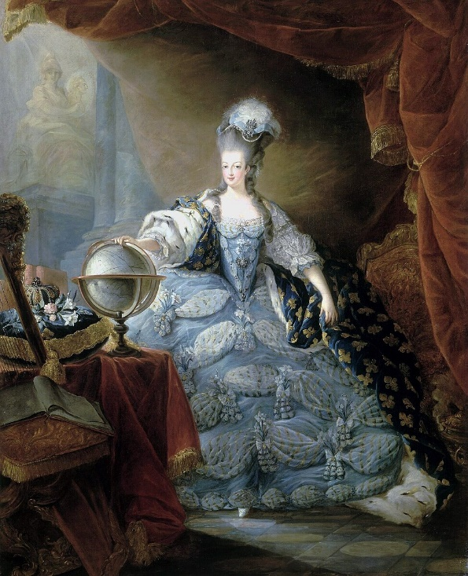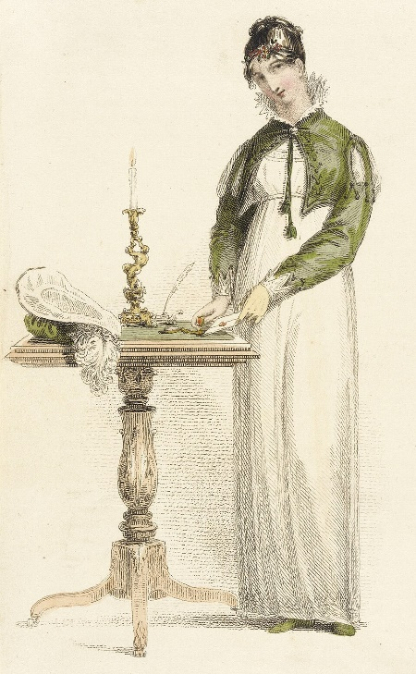
Images from Wikimedia Commons

Exercise 5
Complete the sentences with the given verb in the correct form, the progressive or
simple tense with or without “to” (doing / do / to do).

- I stopped ____________________________________ fast fashion after I learned how harmful it is to the environment. (buy)
- I look forward to ____________________________________ the designer’s newest collection. (see)
- It’s no use ____________________________________ . The stain will come out with the right detergent. (panic)
- I’m not used to ____________________________________ formal outfits. It feels strange. (wear)
- I couldn’t help ____________________________________. The accessories looked like something from a costume party. (laugh)
- She warned us ____________________________________ the dress code, or we wouldn’t be allowed into the event. (not break)
- There’s nothing like ____________________________________ in bed in your favourite pyjamas on a rainy morning. (lie)
- Ever since he visited Paris Fashion Week, he's done nothing but ____________________________________ about the latest fashion trends. (talk)
- I regret ____________________________________ you that your vintage dress was sold to someone else by mistake. (tell)
- It’s not worth ____________________________________ that brand just because it’s popular. You should focus on comfort too. (buy)

7) Grades, studying and learning

Exercise 1
Read the text and choose the best alternative.

Grading based on excellence or effort?
Not all children are equal. They learn in different ways. They think differently. Their skills and talents vary. So, should they all be graded on the same scale? What kind of scale? And what is fair? These are all questions one must consider when comparing the benefits and drawbacks of grading on excellence versus effort.
Children have varying degrees of intelligence and skills. Some are brilliant, others are just average. As teachers, it is our job to try our hardest to never classify students based on intelligence, or any other stereotypical characteristic. But we see it. We see the students who struggle to keep up, and the students who barely try and still succeed with flying colors. And it's not fair.
Therefore, some people believe that students should be graded on effort alone. Not on the quality of their work, but on the effort they put into it. Others believe that a certain percentage of the grade should be effort-based. A prime example of an effort-based grading scale is the scale used at the predominantly African American Benedict College of South Carolina. According to the Office of Academic Affairs at Benedict College, the grading scale for freshmen is 60 percent effort, and 40 percent knowledge. Sophomores have a 60 percent knowledge and 40 percent effort (Swinton, D., 2004). The idea of the college policy, called Success Equals Effort (SEE), is to "provide our students with a strong and immediate incentive to adopt the behaviors and habits that are most likely to bring academic success" (Swinton, D., 2004). They believe that in their unique setting, students can receive more feedback than they would in a traditional college setting, and therefore have more room to improve their skills (Swinton, D., 2004).
In response to an increased amount of negative press, Benedict College has been forced to defend what some consider questionable practices. With so much opposition to one college, whose grading scale is not based on effort alone, it is easy to see why many public schools might fear a change. Most would not even think of challenging the grading system that has been in practice for so many years. However, many others believe that an effort-based grading scale would be very beneficial for all students.
Fairness and equality for all sound nice, but is it a realistic goal? Many believe that it is not. Michael Covington, a professor at the University of Georgia, strongly believes in assigning a fair letter grading scale. He reasons that the main function of grades is to act as a system of communication between the teacher and the student and between different teachers and educational institutions (Covington, 2004). The teacher assigns the students a grade that they earned, based on their performance. Everything is clear-cut and straightforward. He believes that students should understand the grading scale, know what is expected of them, and work to achieve that goal to the best of their abilities.
His second principle is very simple: "Grades measure results, not effort" (Covington, 2004). While this may sound harsh, he maintains that in many instances, we do not know how hard our students work. Observing classwork is one thing, but knowing whether students worked hard outside the classroom is impossible. Furthermore, he adds that "grading on effort can conceal incompetence or, at best, send students into advanced courses for which they are not prepared" (Covington, 2004). Moreover, students are given degrees based on talent, not on hard work. He reminds us that we would not want a surgeon operating on us who tried their best in college and was graded "on effort" (Covington, 2004).
Walter Williams, a well-known writer with a doctorate in economics from the University of California at Los Angeles, shares a similar view. He provides his opinion regarding the unique grading scale of Benedict College in Columbia, S.C. He reminds us that "60 percent of a freshman's grade is based on effort and the rest on academic performance" (Williams, 2004). This means that a student could receive an A grade in effort, and an F in knowledge and still pass the class with a C. The reason for this is the SEE policy advocated by the college. In fact, the school takes this policy so seriously that teachers who fail to comply with it can be fired (Williams, 2004).
Williams believes that a student without the necessary talent who is graded on effort will "fall further and further behind because he hasn't grasped the material from the earlier courses. He'll graduate only if the fraudulent grading continues" (Williams, 2004). Basically what Williams is trying to say is that grading students on effort, especially at a college level, is completely unrealistic. It does not prepare students for the real world, where knowledge reigns supreme. He believes that students attending this college will be in for a rude awakening when they graduate from college and get a real job. Furthermore, Williams believes that degrees from Benedict College may become obsolete, as employers discover the means by which their employees earned their degrees (Williams, 2004).

Text adapted from
https://socialsci.libretexts.org/Bookshelves/Education_and_Professional_Development/Foundations_of_Education_and_Instructional_Assessment_(Kidd_et_al.)/15%3A_Instructional_Assessment-Grading/15.04%3A_Should_students_be_graded_on_effort

1. Benedict College advocates effort-based grading because
- they have seen that it results in better study methods
- they think this grading scale is more fair
- they want to encourage students to develop their skills

2. Benedict College has
- explained their grading policy in the press
- received negative attention
- decided to change their policy
3. According to Michael Covington,
- students and teachers should together determine the grading scale
- grading on effort leaves students unprepared for real-world challenges
- grades should inform parents about what their children have learned
4. Walter Williams
- concurs with Covington
- refutes Covington’s opinions
- acknowledges Convington’s views

5. According to Williams, students from Benedict College
- will not be able to graduate
- will have worthless degrees
- will have an unrealistic view of their abilities

Exercise 2
Which words could replace the underlined words in the text? Choose the alternative that best fits the context and conveys a similar meaning.

1. A prime example of an effort-based grading scale is the scale used at the predominantly African American Benedict College of South Carolina.
- chief
- crucial
- flagrant
2. However, many others believe that an effort-based grading scale would be very beneficial for all students.
- malevolent
- advantageous
- onerous
3. While this may sound harsh, he maintains that in many instances, we do not know how hard our students work.
- grim
- futile
- fictitious
4. In fact, the school takes this policy so seriously that teachers who fail to comply with it can be fired.
- deviate from
- consent to
- adhere to
5. He'll graduate only if the fraudulent grading continues.
- unfair
- blatant
- deceitful

Exercise 3
Complete the text by translating the given words into English.

My language profile
My name is Sofia, and I’m 16 years old. I grew up speaking Spanish at home, but I started learning English at school as a 1) _____________________________________. Now I feel quite comfortable using 2) _____________________________________.
At home, I mostly speak 3) _____________________________________ with my family, but with some friends and online, I often switch to English. I also know a little bit of French, which I started learning 4) _____________________________________.
In Spanish, I use a more formal register when talking to teachers or
5) _____________________________________, but when I’m with my friends, I speak very informally, sometimes even using local slang from my region. In English, I
6) _____________________________________ use informal language when chatting online or watching YouTube videos, but I try to be more
7) _____________________________________ and formal in class or when writing essays.
I enjoy 8) _____________________________________ languages because they help me connect with people from different cultures.

1. kuusivuotiaana
2. molempia kieliä
3. espanjaa
4. kaksi vuotta sitten
5. vanhemmille ihmisille
6. useimmiten
7. huolellinen / tarkka
8. oppia

Exercise 4
The sentences below contain idioms connected to learning, studying and academic performance. Complete the idioms by filling in the missing words. The first letter has been given.
- Even though Camilla didn’t get a high grade on her essay, the teacher gave her an A for e_______________________because she worked hard on it.
- With exams coming up, Mathias had to burn the midnight o_______________________ every night just to catch up on his reading list.
- As soon as the weekend started, I hit the b_______________________ to prepare for the history test.
- Jukka always goes the extra m_______________________ by doing extra research and helping his classmates review the material.
- To impress his professor, Alex pulled out all the s_______________________ on his final presentation, including interviews, visuals, and a detailed handout.
- Thanks to her hard work and consistent study habits, Sara passed with flying c_______________________ on all her final exams.
- When the professor asked about the main cause of the financial crisis, Leo hit the nail on the h_______________________ with his well-reasoned answer.
- During the oral exam, I completely drew a b_______________________ when the teacher asked me about the theory we covered last week.
- As a first-year student, Minna soaks up knowledge like a s_______________________—she’s always curious and eager to learn more.
- The first semester was challenging, but once I learned the r_______________________, I felt much more confident managing my workload.

Exercise 5
Complete the sentences by translating the given words into English.
- I hadn’t learned how to read and write before _____________________________ (peruskoulun alakoulua / ala-astetta)
- Sanna and I were best friends in ____________________________ .
(peruskoulun yläkoulussa/yläasteella)
- In many countries, students take a ____________________________ at the end of ____________________________ to qualify for university. (ylioppilaskoe - lukio)
- If I fail, will I be able to ____________________________ again? (kirjoittaa/suorittaa kokeen)
- A bachelor’s ____________________________ usually takes three years to complete. (tutkinto)
- The academic year is divided into two parts, and each ____________________________ lasts around four months. (lukukausi)
- She earned a high ____________________________ in math, so her parents were very proud. (arvosana)
- The teacher handed out the ____________________________ today, so we could see our progress in each subject. (todistus)
- My ____________________________ for this semester is 8.5, which is the highest I’ve ever had! (keskiarvo)
- My sister didn’t go to university; she studied mechanics at a ____________________________ instead. (ammattikoulu)

8) News items
Listen to three separate news items. Read the questions carefully. Choose the best alternative or write an answer in Finnish.

News item 1

1. Which of the following statements is true?

- The Nobel Prize winners in physics utilised AI in their research
- The award-winning research was a result of interdisciplinary collaboration
- AI functions on principles established in the research by the Nobel Prize winners

News item 2

2. What is said about this work of art?

- Performance art is rather rare in Finland
- The piece encourages the audience to participate
- The art was selected by both students and staff

3. Mitä vaikutuksia taiteella voi olla yleisöön? Vastaa suomeksi. Vastauksen pituus on enintään 80 merkkiä.

_________________________________________________________________________

News item 3

4. What did the report show?

- SUVs pose a significant risk to pedestrians
- The size of SUVs has steadily increased
- SUVs frequently cause traffic accidents

