I recommend you this book
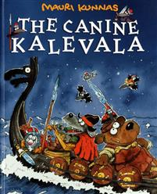
Title:
The Canine Kalevala

Writer:
Mauri Kunnas

Setting:
Kalevala village and Pohjola village.

Characters: Lemminkäinen’s mother, Ahti Lemminkäinen, Väinämöinen, Ilmarinen, Annikki, The maid of the north, Ahti lord of the billows, Iku-turso, The swan of tuonela, Monstrous pike.

The book is about: The book is old finnish myths for example how the world was born.

This book is good because: It’s suitable for everyone. It is exciting.

