Keeping Healthy

The Netherlands

With the students of the 3, 4, 5 and 6th grade we start our researches about the theme keeping healthy with a word web. What do we think of when we talk about keeping healthy. The students came with a lot of words and ideas.
The students had to decide about which subject they want to know more. Do they want to know more about sports, calories, fruit, vegetables, sugar, salt, how do you stay healthy? etc.
Then they divided themselves in groups of 4, 5 or 6 students and started their research.
The role of the teacher is a coach. We stimulate the students to discover things by themselves.
In this e-magazine you can read the reports of the different groups.

Compare sports

Our research was about the comparison moving the Netherlands and Finland. There is not such a big difference between the Netherlands and Finland, football is also a little bit famous in Finland. We have been working on the presentation during the past few weeks.
We have worked with Jelmer Elly, Sytske and Berber.
We made a poster and made a tennis / football pitch.
We have asked questions to Finland, sport questions.
We had an answer within 2 days.
Jelmer and Berber have done the tinkering the football field and tennis court.
Elly and Sytske have done the poster.
The information we had found on Google, we have put it in our own words.
We have learned that sport fishing is in the top 3 of the Netherlands' most famous sports.
The presentation went very well we thought, just a pity that Berber was not there.
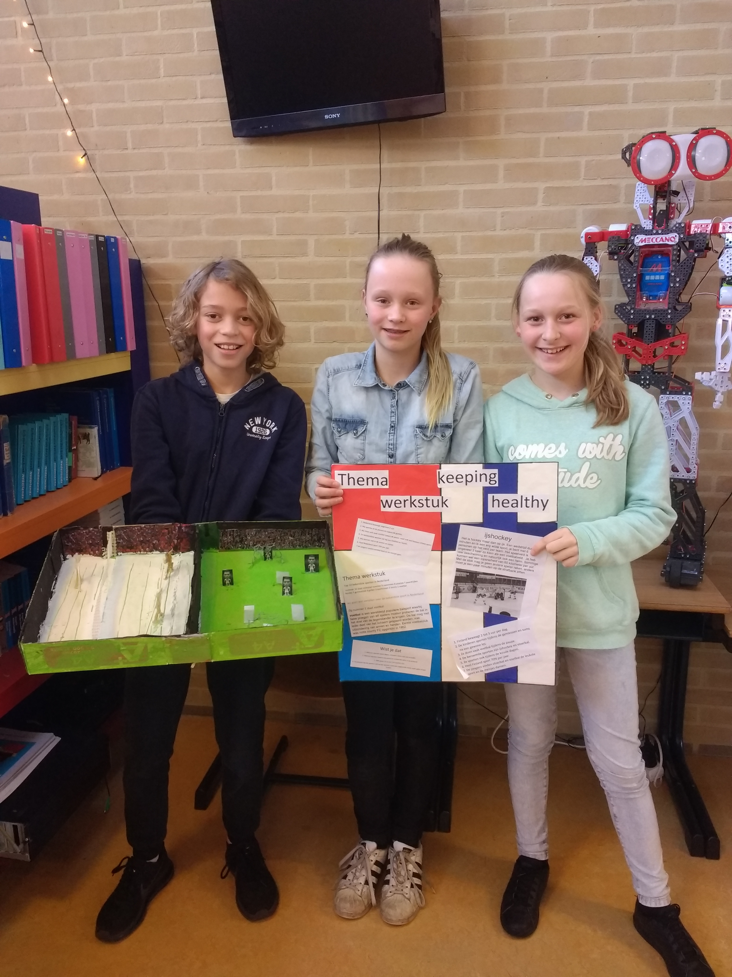

Sugar

Hello, we have done a research about sugar. We have learned how sugar is originated and for what it is used. And we researched the difference between the sugar in fruit and vegetables. We have made a quiz where we asked questions. And we have made a powerpoint presentation with information about sugar. We had a good cooperation.
Marike, Amber, Laura, Ricardo and Thijmen

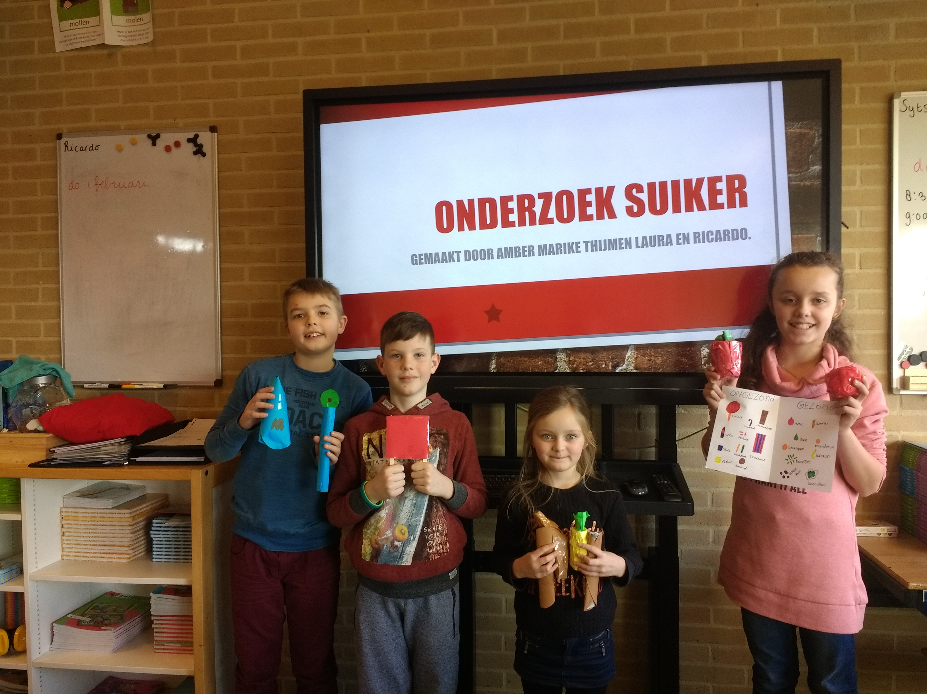

Energy and calories

Hello everyone we are Jeroen, Weit, Marije, Myrthe and Demy. We had to create a presentation for Keeping Healthy. Our theme was Energy and Calories. We came up with the idea to make a poster. For example, we have learned what calories are. And what food you get a lot energy of. It went pretty good with a good result. We got a more than sufficient for our presentation and that was of course more than enough. It was great fun to do this.

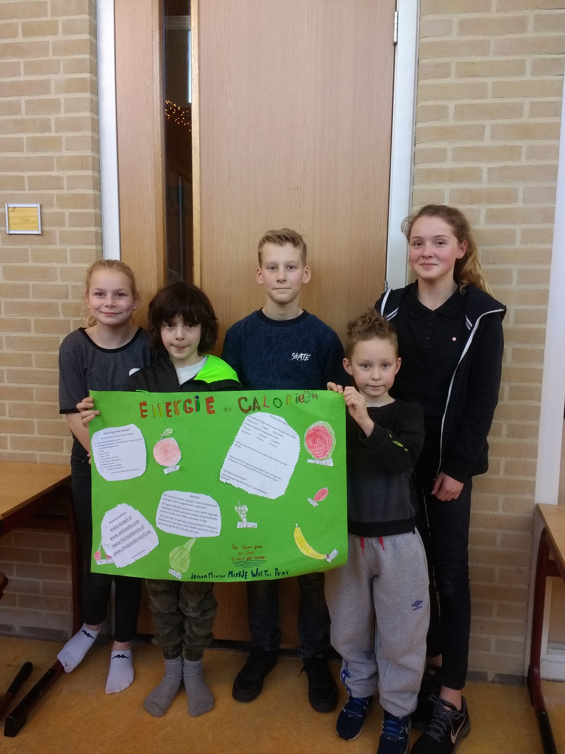

Board game

We made a board game (Xander, Jordy, Niek, Huub). How it works is simple: you pick up a question card and if the question is right you can roll dice, if you are wrong, you cannot throw dice. The name is, Sport Quiz. What we have learned is what the biggest football stadion is and the English word offside for football.
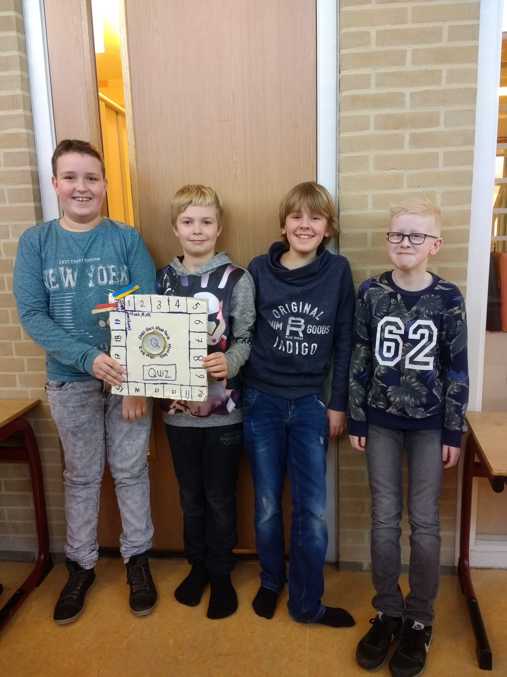

Sports

Our research was about sport. We looked up questions and wrote down the answer and we included that in a play, but that did not work as well because we could not practice for so long, so we just did a sport in the background. And that has become hockey.
We have made a list of questions.
We have learned about burning calories and how much energy is situated in certain food and how much do you have to sport to burn calories.
Rients, Damien, Jarno and Tjitte

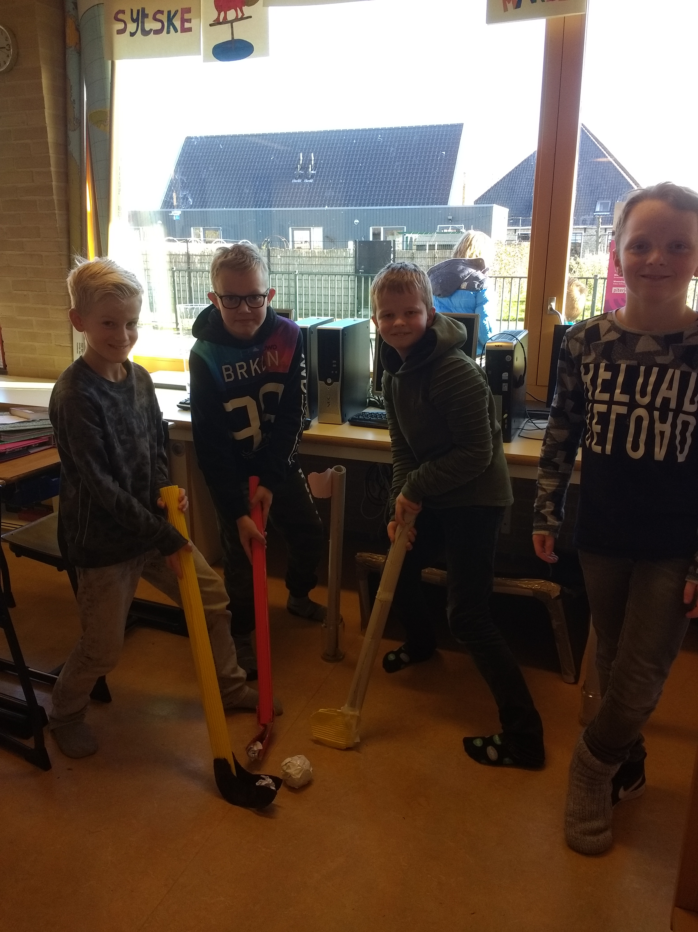

Sport

We have learned when sport originated, what sports does with your heart and your body. What is the most popular sport in the Netherlands is the answer is football
We have looked when the first World Cup has started from football. Here are the answers 1 sports reduces your heart 2 rate sports reduces stroke
Sport originated between 1800 and 1900.
We have made a journal with the ipad, we have come to this subject so that one of us wanted to make a book and the others a play we have learned many new things
This was what we made with kind regards
Sietse Ywan Thijs Jochem Sem

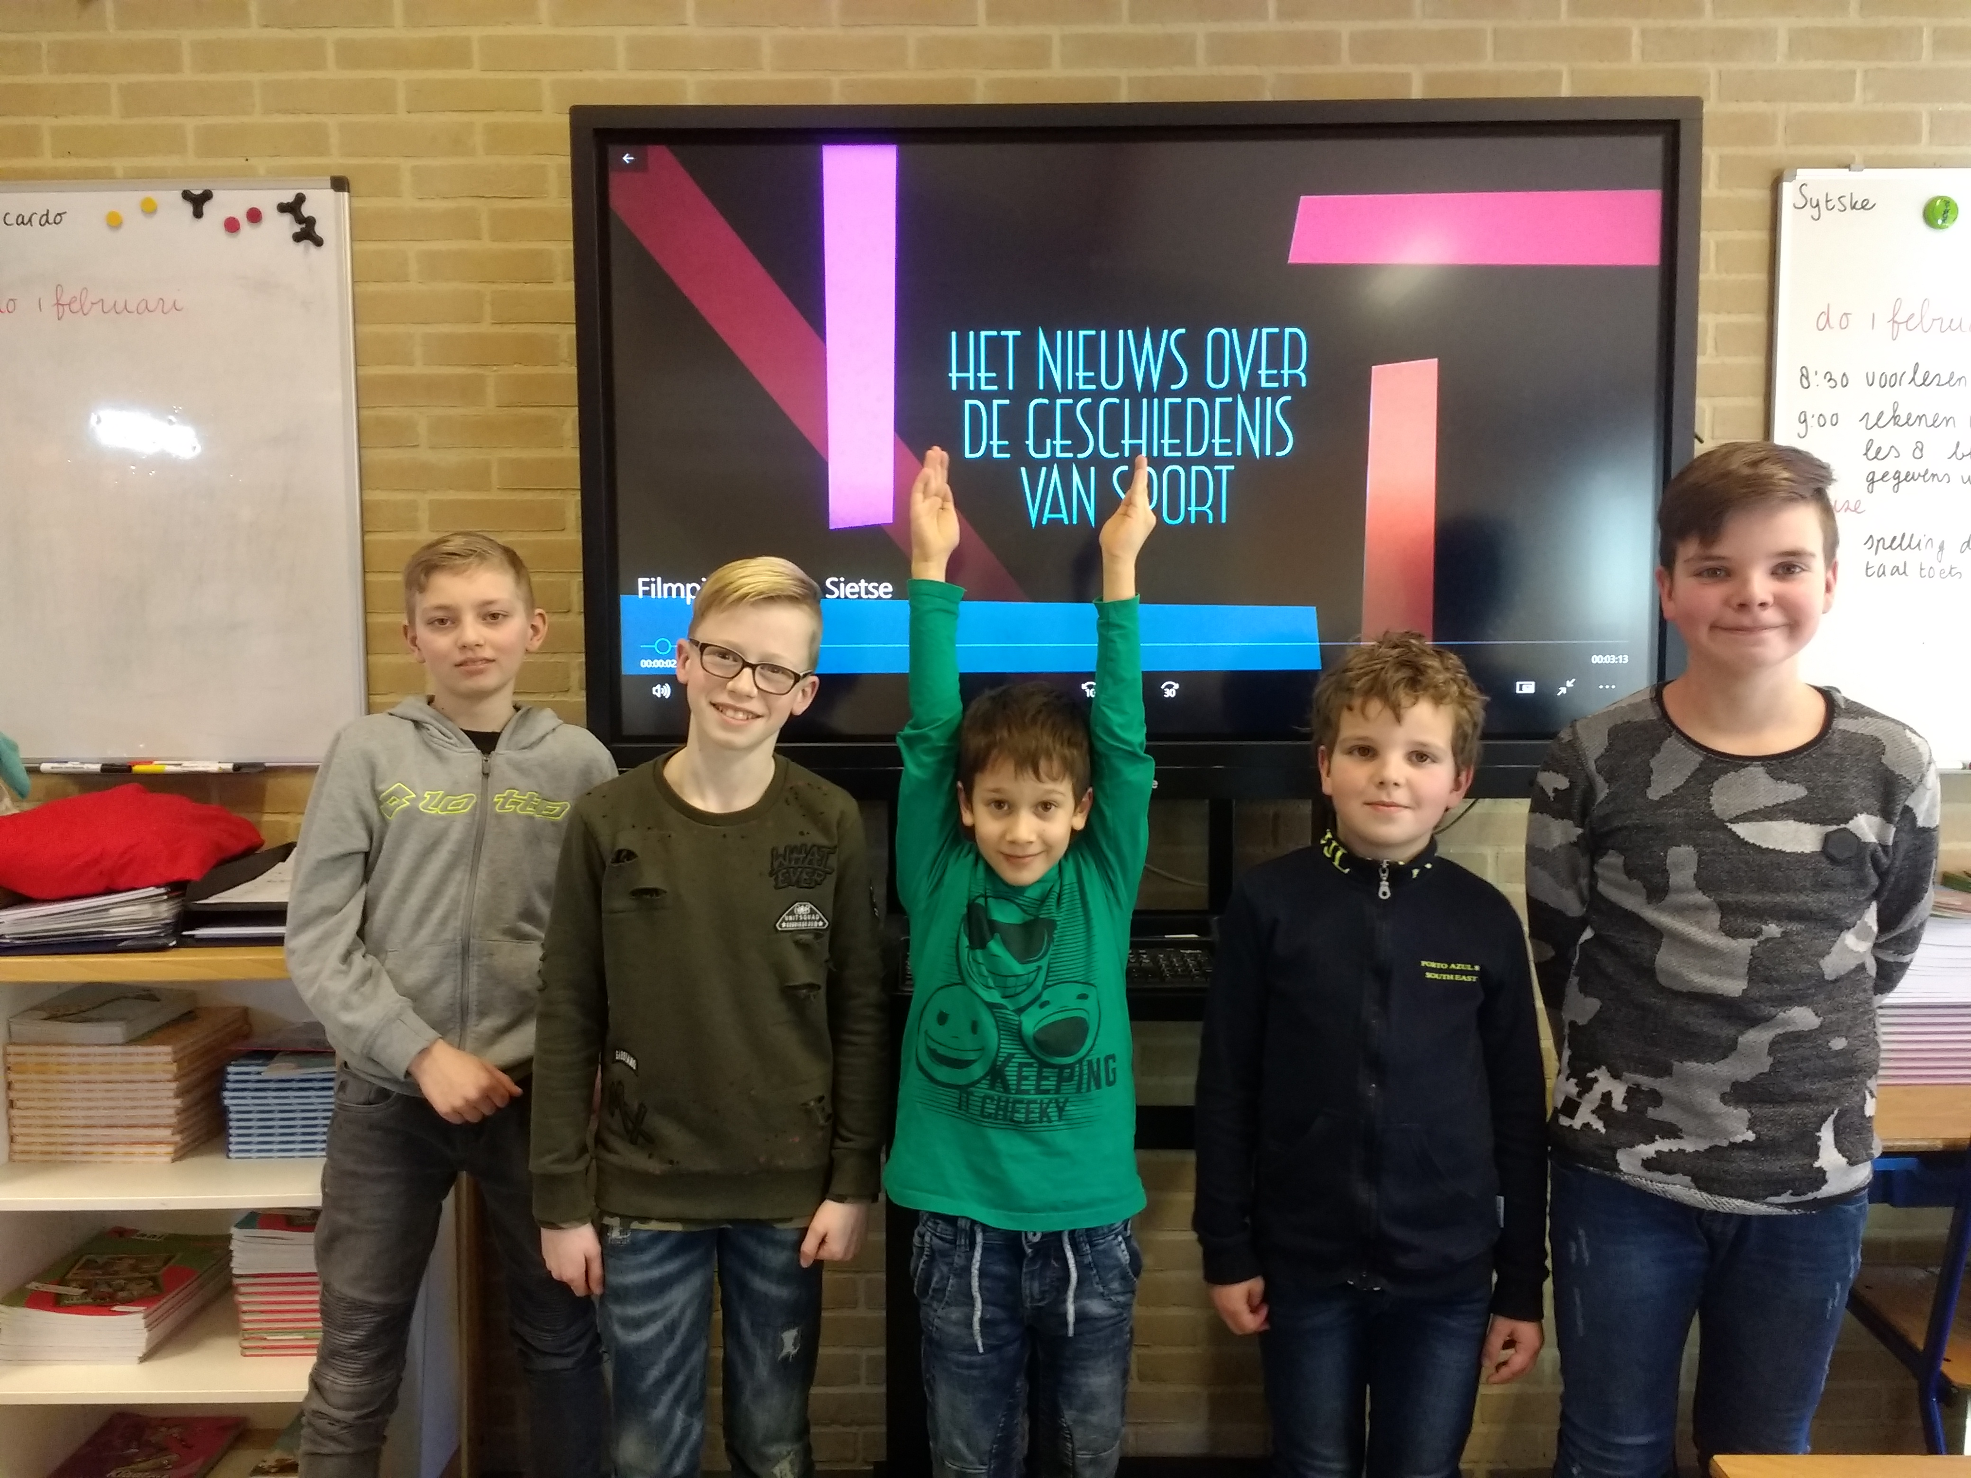

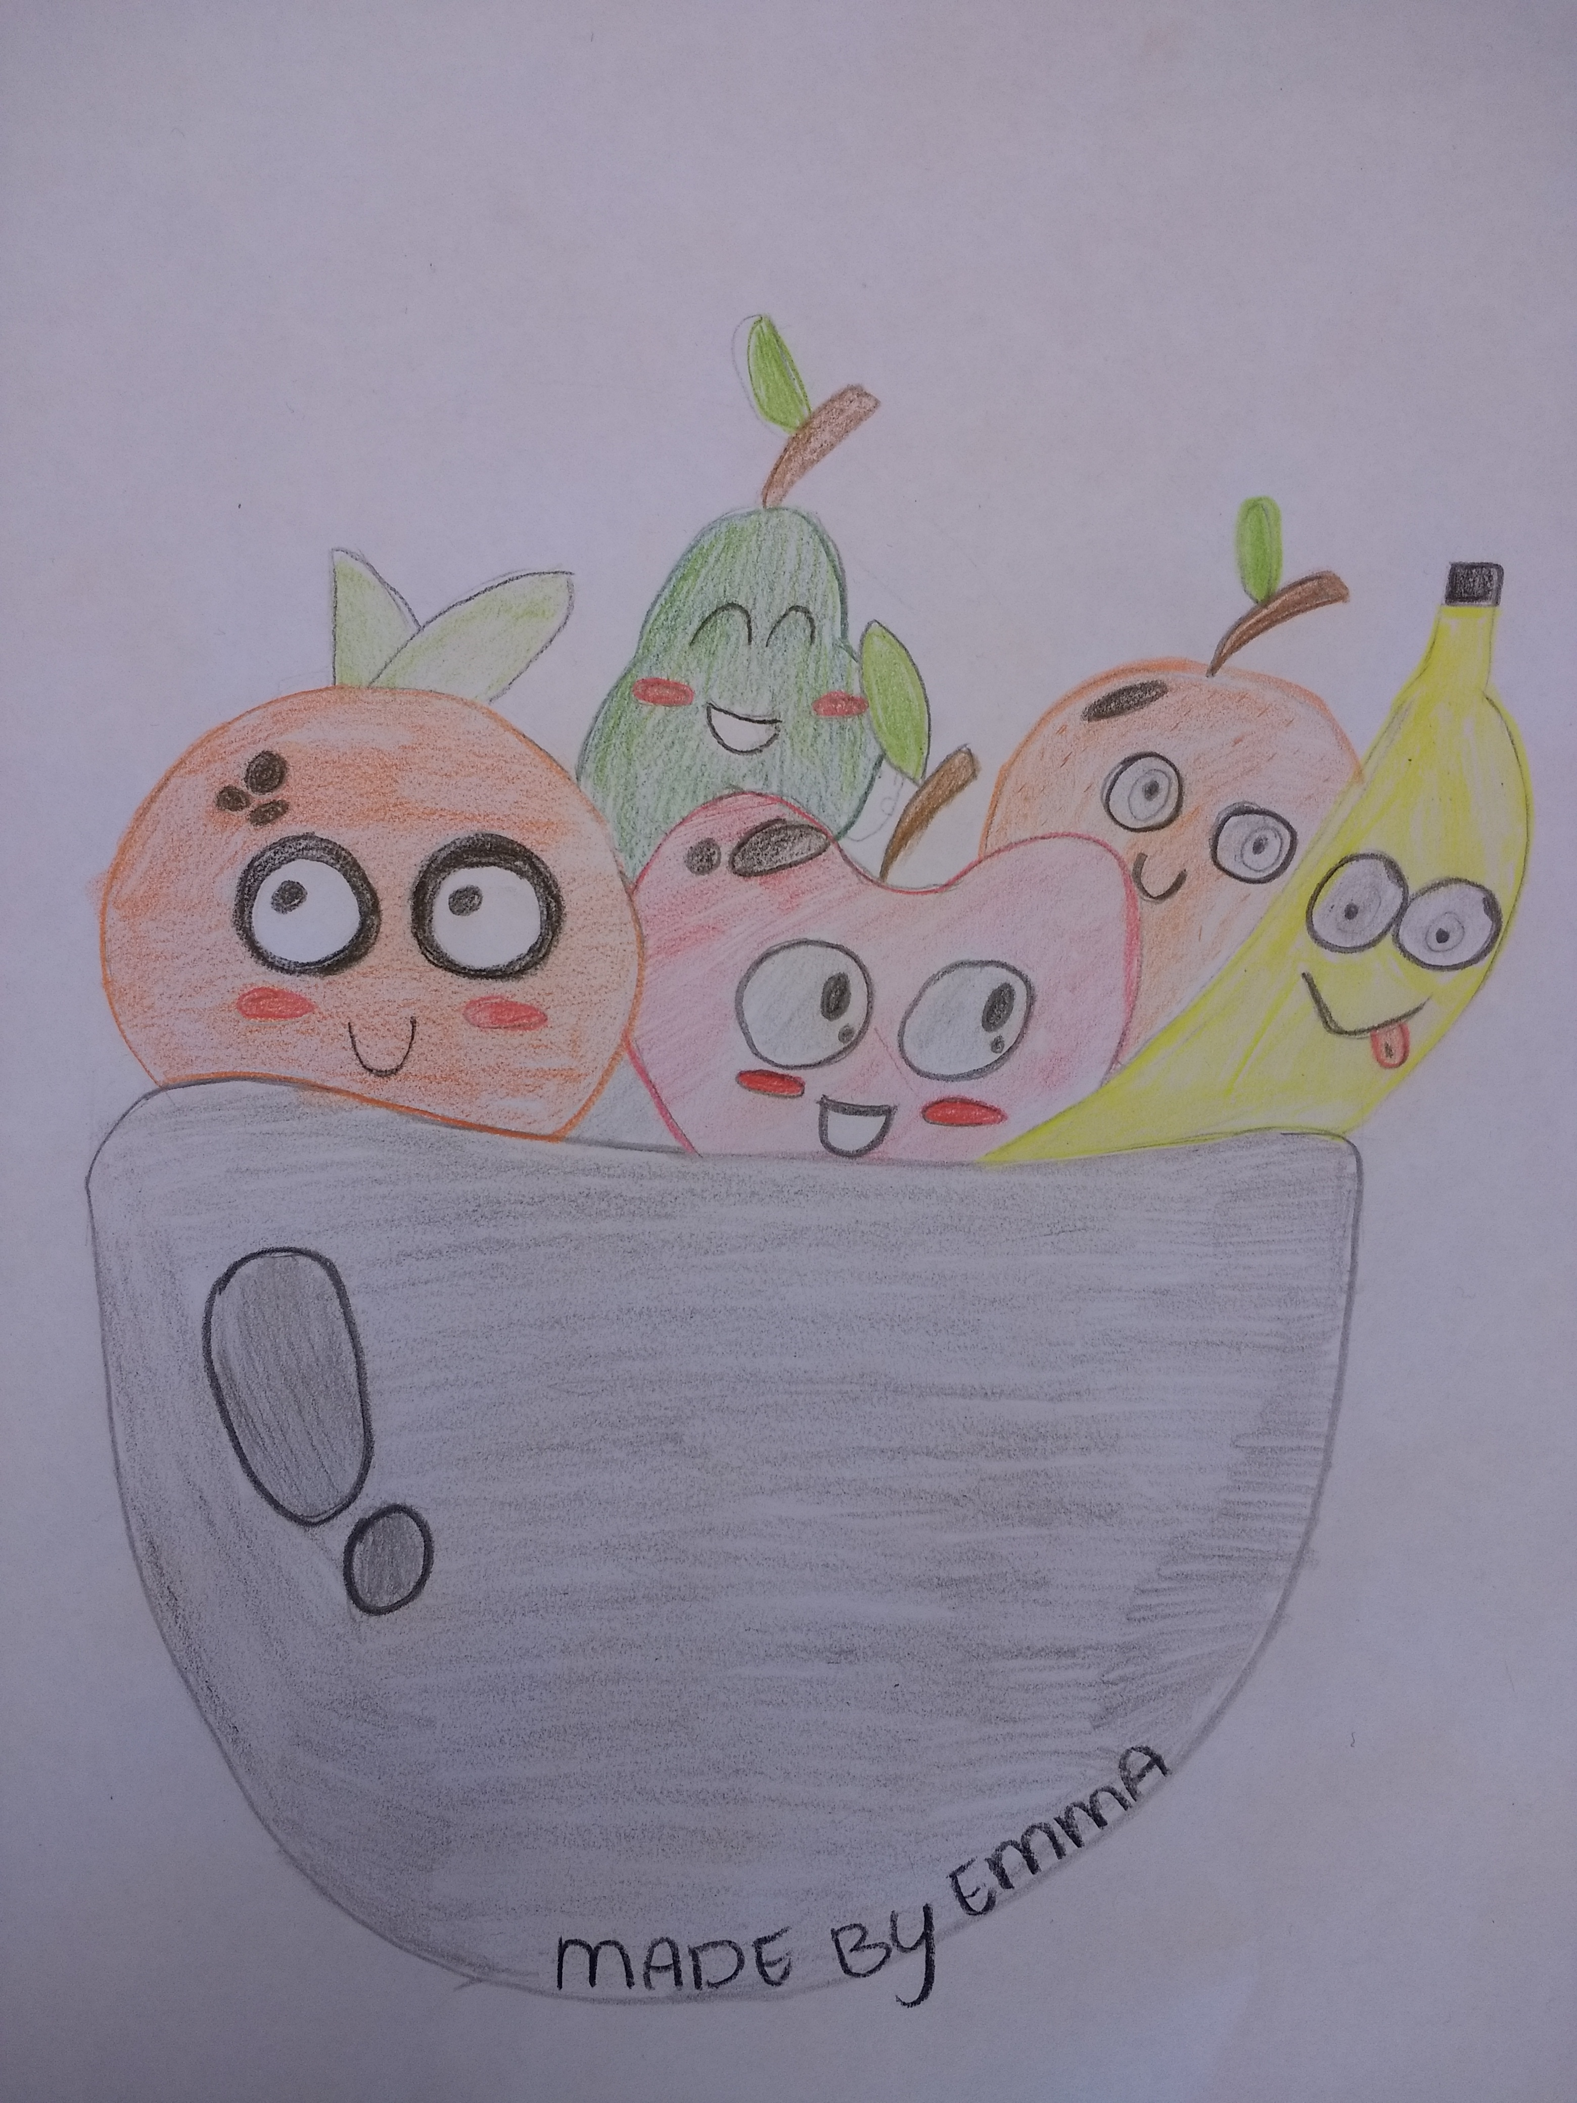

FRUIT
We have chosen the theme fruit. We have a fruit bowl made with 2 games figured out facts what to do with the theme fruit. We have discovered that there are 500 fruit pieces in the world, that some fruit pieces are healthy and unhealthy and that most vitamins are in an Apple.
The first game works like this: you pick up a question and then find the right answer.
The second game works like this: you grabber a ticket out of the box where some information gets up, and then you have some information! And the tidbits scrambling you just a high out of the box.
The cooperation went well. And we think it was a super nice theme and we have learned a lot.
Created by Wiebe and Sido, Manon, Amarins, Emma and Lynn

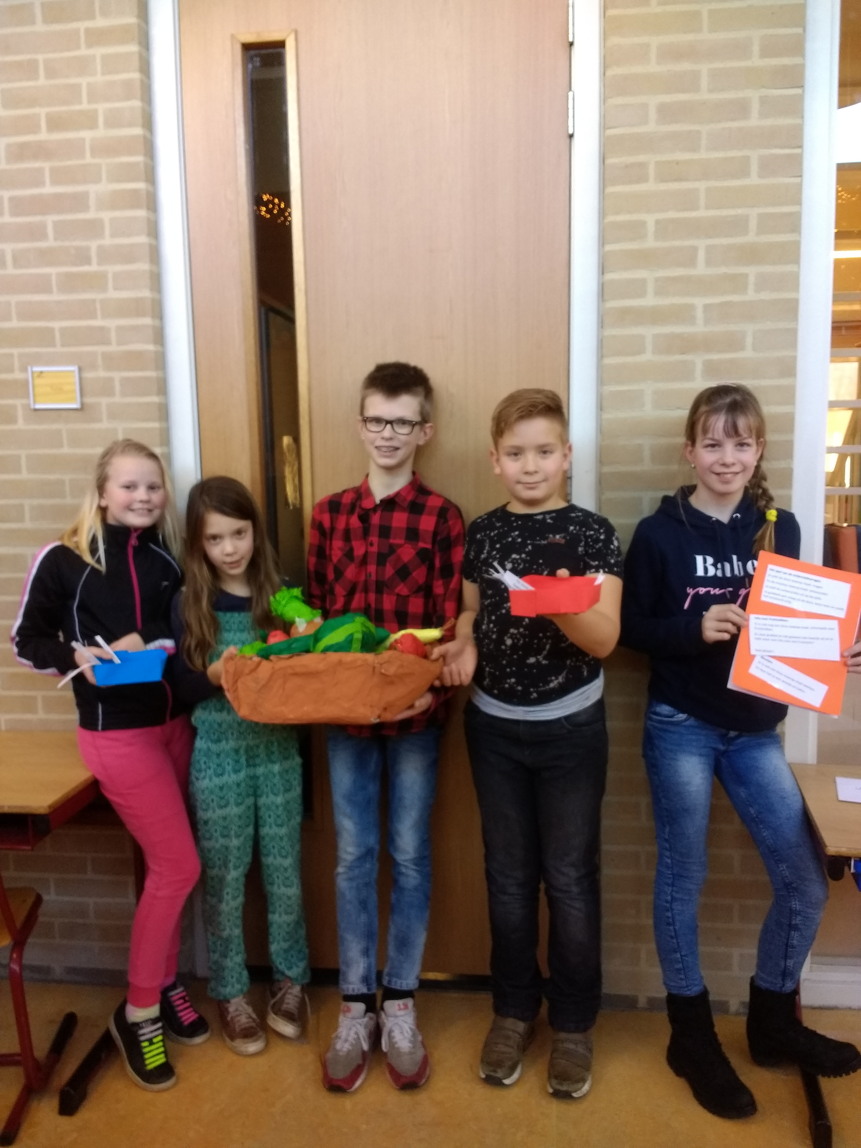

Puppet show

Hi we have a puppet show created about the ‘schijf van vijf’.
The ’schijf van 5’ is a circle that exists about 5 subjects with different kind of foods. Every day you have to take some food out of every part of the circle to be healthy.
We have learned a lot for example, to rehearse, and that the ‘schijf van 5‘looks different abroad.
The collaboration went very well, but sometimes we had a little error, because then we went too much giggle. But further everything went well.
We think the presentation was hard to do, because we could not think a lot and we didn’t know what we had to do but finally we came out.
When we did the presentation for the school and we were excited.
After all we were very happy and proud that everyhting went well. We learned a lot about food.
We have received a good review.
Greeting Yindee,Ylona,Linde and Birte

