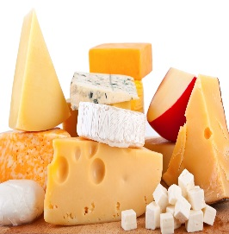
CHEESE – KÄSE – OST

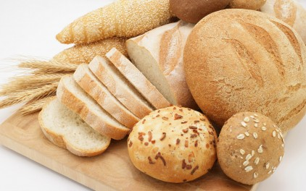

BREAD – BROT – BRÖD

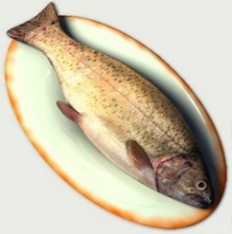
FISH – FISCH – FISK

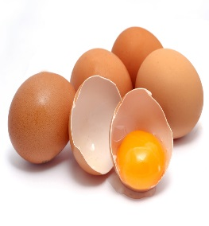

EGG – EI – ÄGG

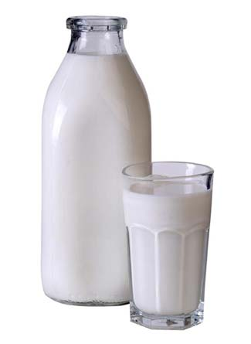
MILK – MILCH – MJÖLK

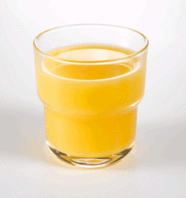
JUICE – SAFT – JUICE
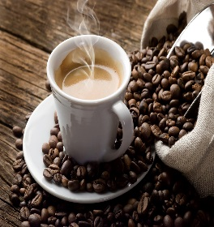
COFFEE – KAFFEE – KAFFE

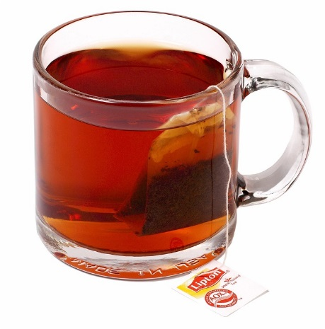
TEA – TEE- TE
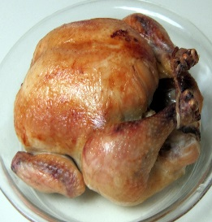

CHICKEN – HÄNCHEN – KYCKLING

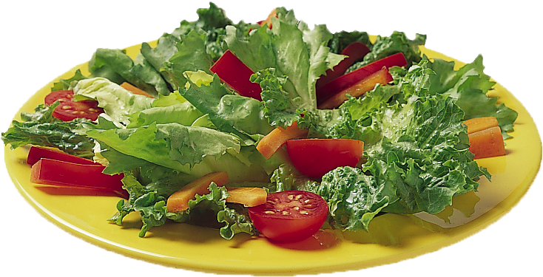
SALAD – SALAT – SALLAD
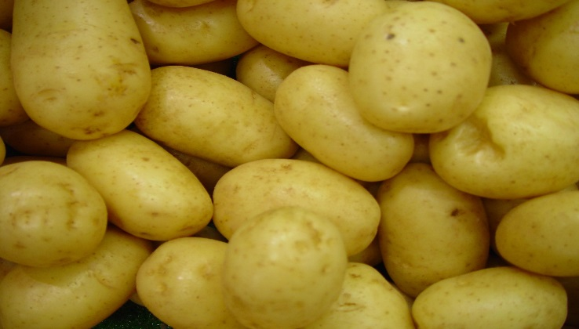

POTATO – KARTOFFEL – POTATIS

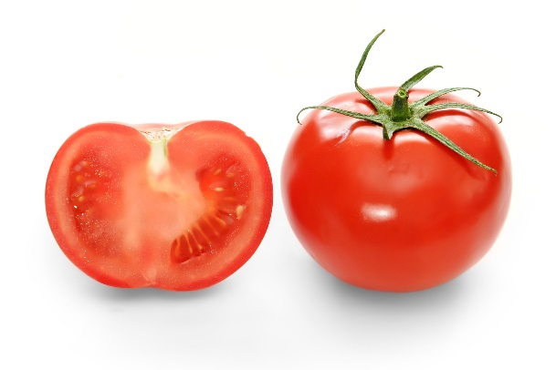
TOMATO – TOMATE – TOMAT
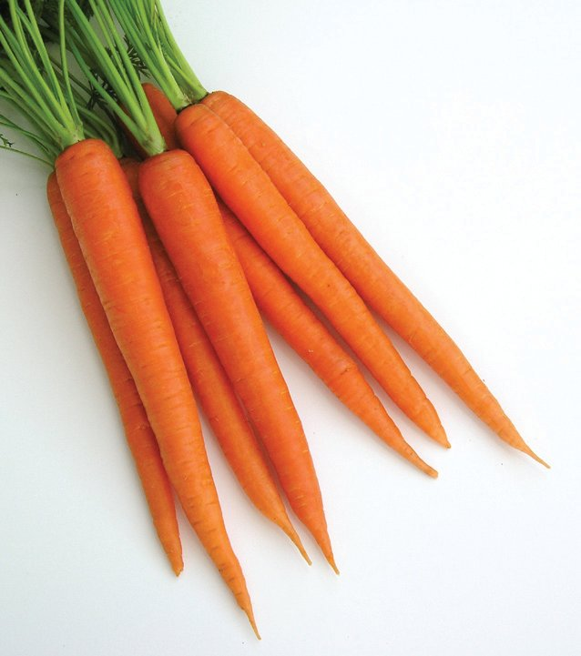
CARROT – KAROTTE – MOROT

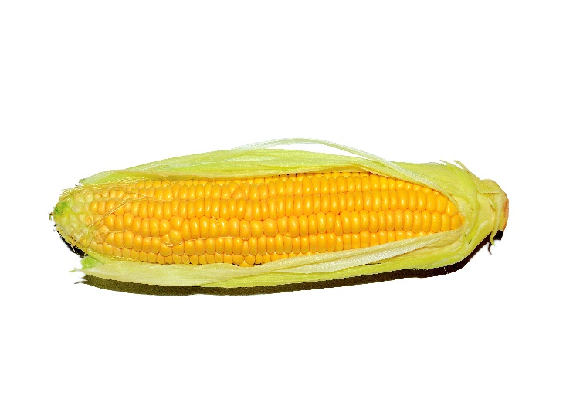
CORN – MAIS – MAJS
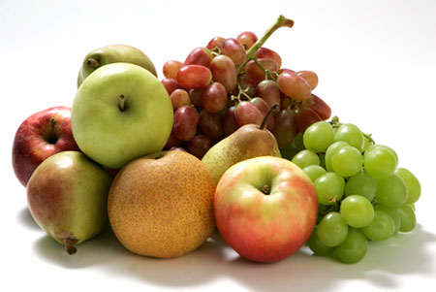
FRUITS – OBST/FRÜCHTE – FRUKT

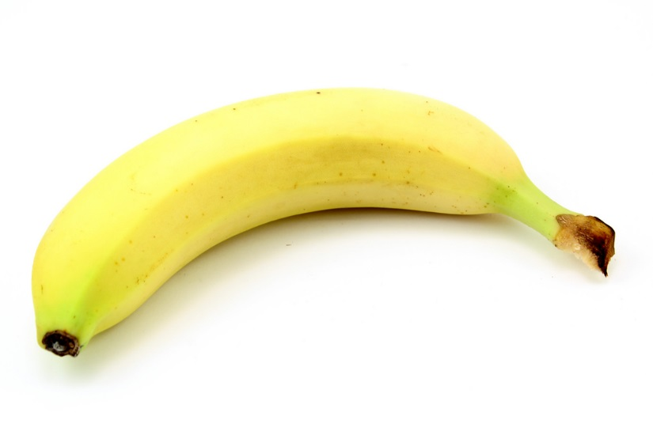
BANANA – BANANE – BANAN
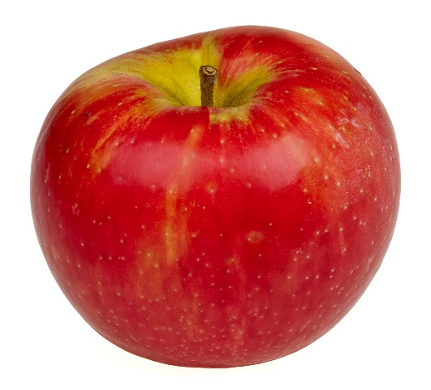
APPLE – APFEL – ÄPPLE

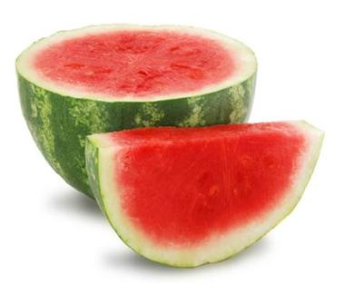
MELON – MELONE – MELON
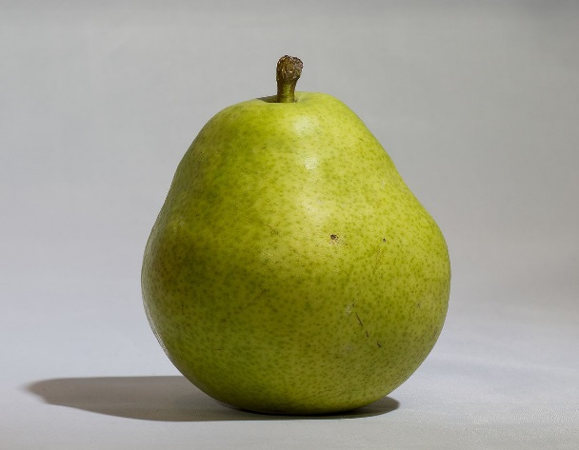
PEAR – BIRNE – PÄRON

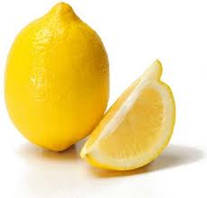
LEMON – ZITRONE – CITRON
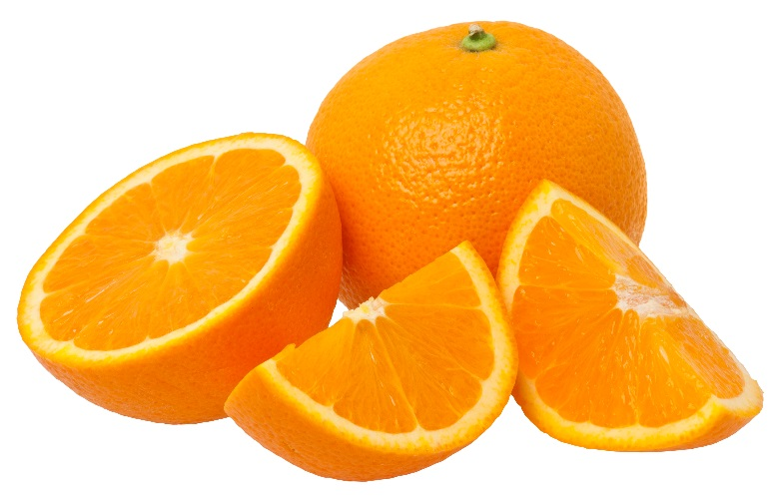
ORANGE – APFELSINE – APELSIN

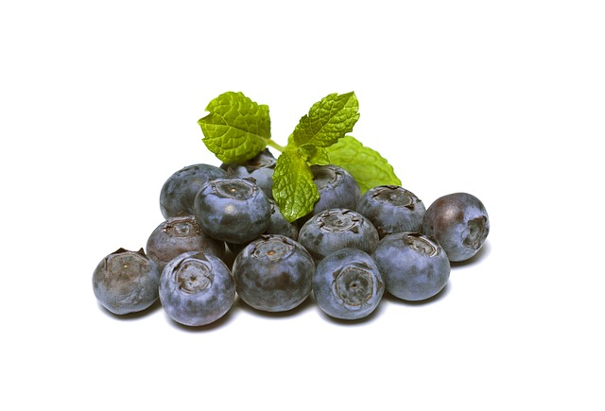
BLUEBERRY – BLAUBEERE – BLÅBÄR
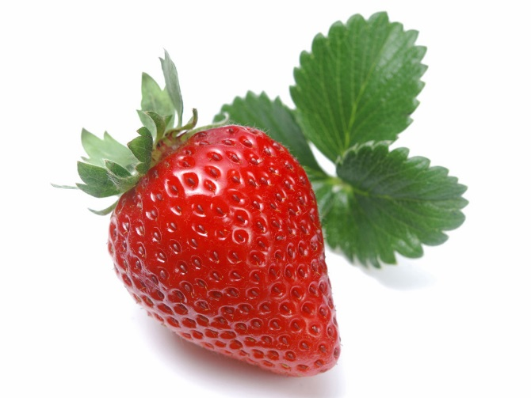
STRAWBERRY – ERDBEERE – JORDGUBB

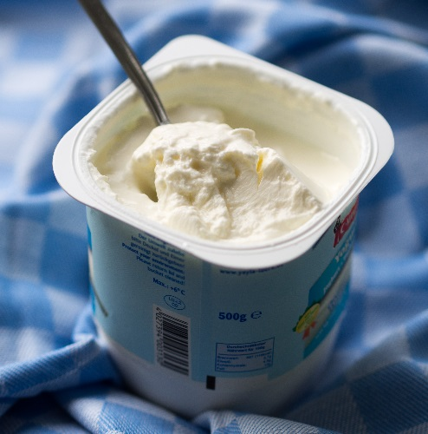
YOGHURT – JOGHURT – YOGHURT

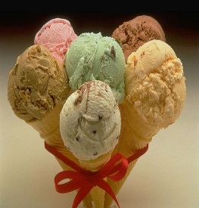
ICE CREAM – EIS – GLASS

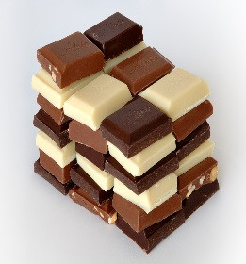
CHOCOLATE – SCHOKOLADE – CHOKLAD
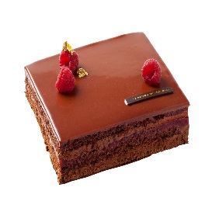
CAKE – KUCHEN – KAKA

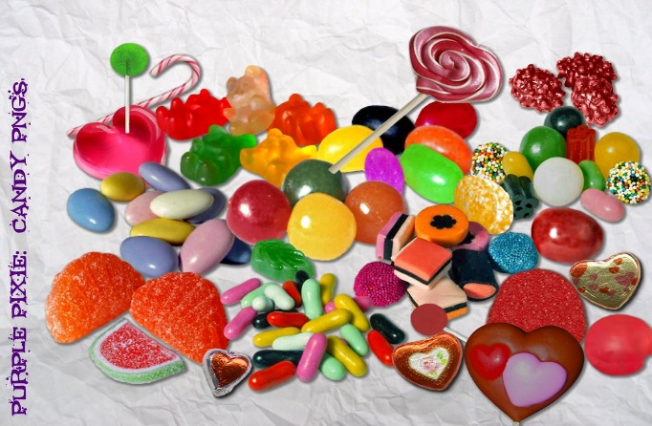
CANDY – BONBONS – GODIS
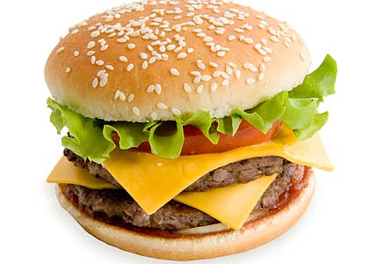
HAMBURGER – HAMBURGER – HAMBURGARE

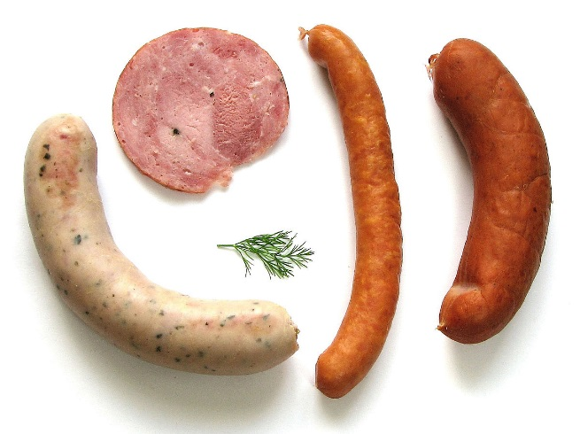
SAUSAGE – WURST – KORV
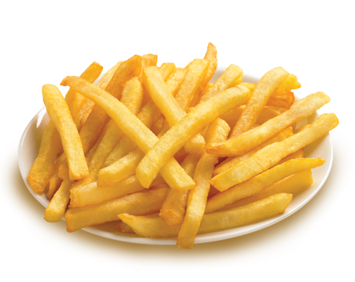
CHIPS – POMMES – FRANSK POTATIS

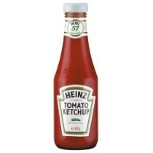
KETCHUP – KETCHUP - KETCHUP

