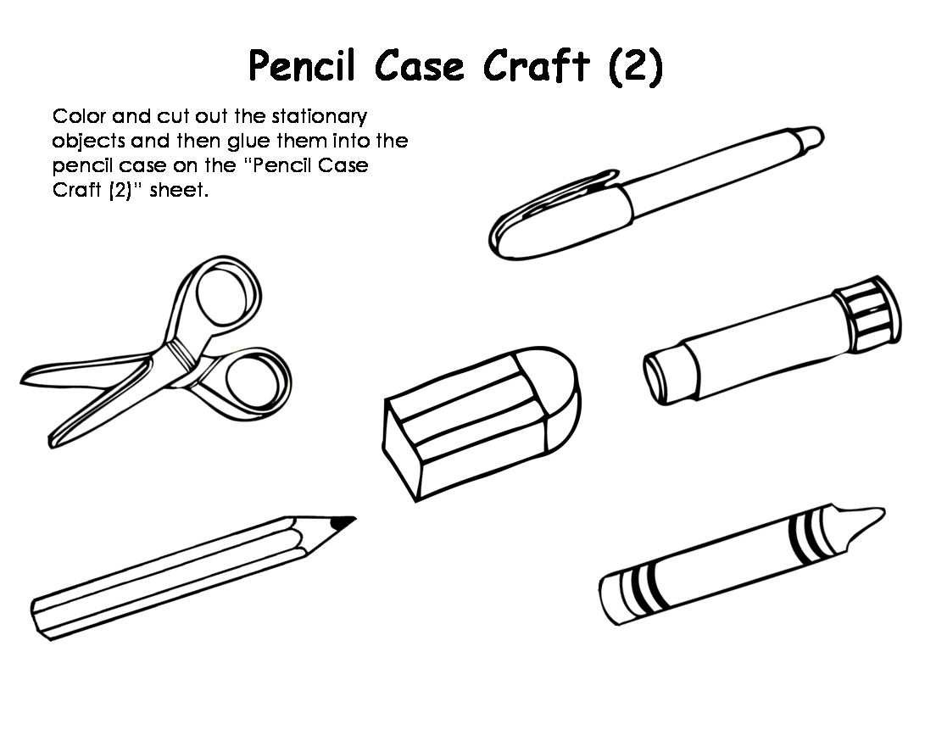

- COLOUR
- CUT
- GLUE ON THE PENCIL CASE
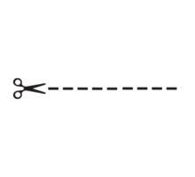
(NAME: ) __________________ ’S PENCIL CASE

