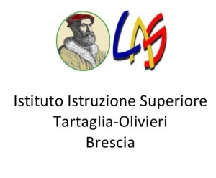ACTIVITY SCHEDULE. IIS TARTAGLIA OLIVIERI ITALY (22nd – 29th April, 2018)
Questa foto di Autore sconosciuo è concesso in licenza da CC BY-NC-ND
LUNEDI’ | MARTEDI’ | MERCOLEDI’ | GIOVEDI’ | VENERDI’ | SABATO
8.15 Welcoming ceremony and coffee break. (aula riunioni)  9.30 walk to the cinema Nuovo Eden 10.00 Documentary “Come un uomo sulla terra”.  11.15 Meeting with the Ethiopian director Dagmawi Yimer | 8.00 – 9.50 (Aula riunioni)  K-pax: immigration policies in Italy and in Brescia.  10.00-12.00 Emergency  Meeting with volunteers who work in war context. | Day of Liberation  (National celebration)  Free day | 7.00  Departure from school (by bus)  8.00 Museo di San Martino  10.00  LAKEFRONT PROMENADE/TREK  (Busatte-Tempesta) COMFORTABLE SHOES ARE RECOMMENDED | 8.00 -9.50  Amnesty International  Meeting with volunteers and activities about migrants’ issue.  10.05-12.00  (aula INFO2)  Tartaglia  Video-editing (Movie-maker) | 8.00 -9.50  Workshop about inclusion  10.05-12.00 making a world map of refugees
12.30 Lunch. Pizzeria Caprese Piazza Loggia | 12.10 Lunch at school |  | PACKED lunch | 12.10 Lunch at school | Free
14.00 – 16.00  Guided tour of Brescia city centre. | 14-00 -15.30  INFO 2 Tartaglia Video-editing (Movie maker). |  | 15.00: Sirmione  Visit to the Museum and the ruins of the ancient palace of Catullo  18.30 arrival to school. | 14.00-16.00  (Aula riunioni)  meeting with students involved in Tanzania project. | Free
 |  |  |  |  | 19.30-10.00 Farewell party Eva’s Coffee, Largo Formentone
22/04/2018
15.30 French team’s arrival at the school car park.
22.00 Finnish team’s arrival at the railway station of Brescia
29/04/2018
08.00 . French team’s departure from the school car park.
14.00 Finnish team’s departure from the railway station of Brescia.

