English Language

Form One Composition
Writing a description of a scene in a fast-food shop

Name: __________________ Class: ___________ Date:_______________
Look at the picture below. You are going to write a passage in not less than 120 words ,describing what you saw one day in a MacDuck’s Fast Food shop. Remember to divide your work up into paragraphs. Also you may find the questions below helpful to your work.
Para. 1 - Introduction
Para. 2 - What the restaurant was like – crowded? Empty? Hot and stuffy?
noisy or quiet?
Para. 3 - Who did you see in the restaurant? What were they doing?
Para. 4 - Describe what happened in the rest of the story. You may choose
your own ending.

1. Where was the restaurant? (shopping mall/at the corner of the street)
2. What were the boys doing? (eating/drinking/smoking/chatting)
3. What did the manager ask the boys to do? (stop eating/stop talking/stop smoking)
4. Who did the boys ignore? (manager/waiter)
5. Who did they see suddenly? (principal/discipline master)
6. Who was the boy blaming for?
7. Who gave the boys any punishment? (principal/discipline master)
8. What kind of punishment was given to the boys? (two-day suspension)
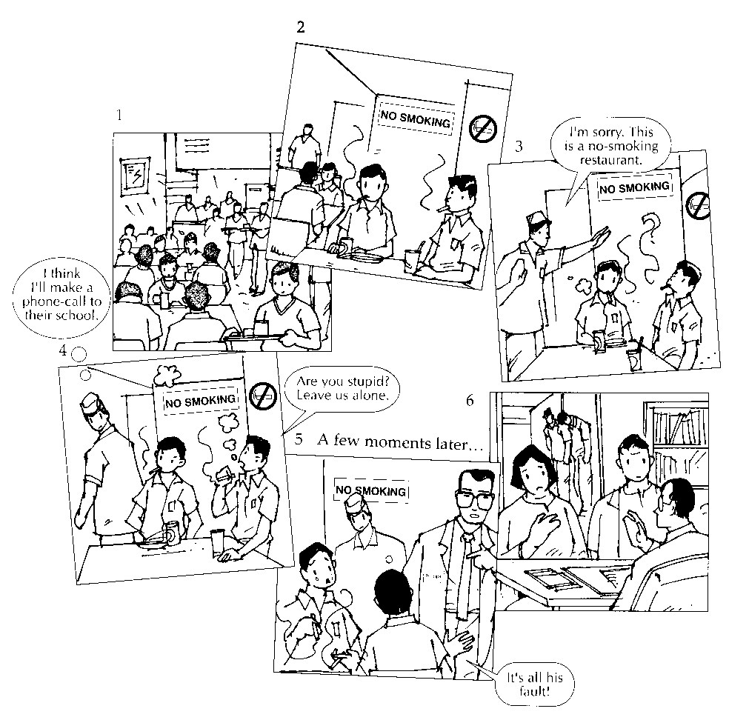
The End

