Ecology

The theme ecology is comprehensive. That is why we have chosen to keep the theme close to the children and their environment.

Again it was so great to work on another theme. In this e-magazine you can read about the activities we’ve done.
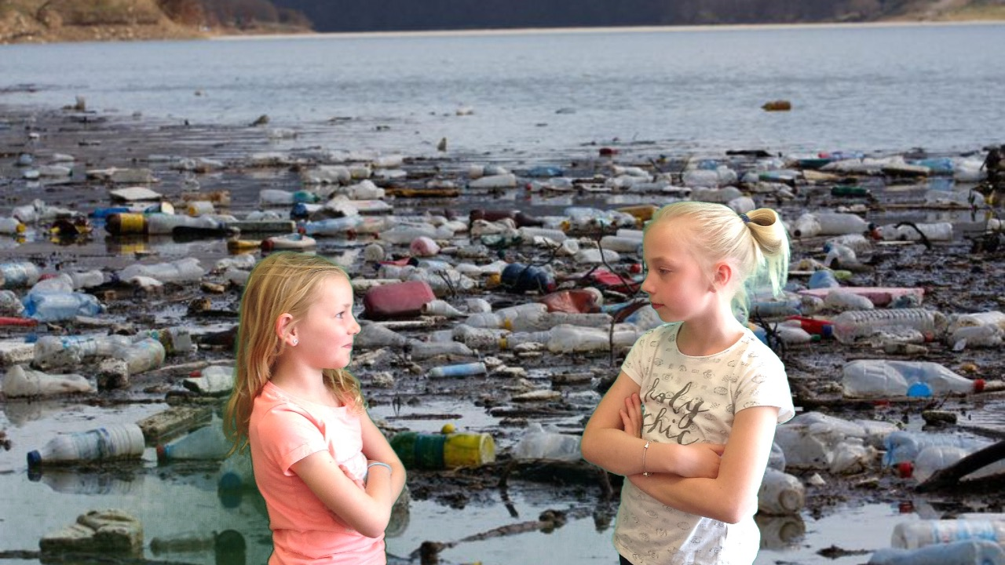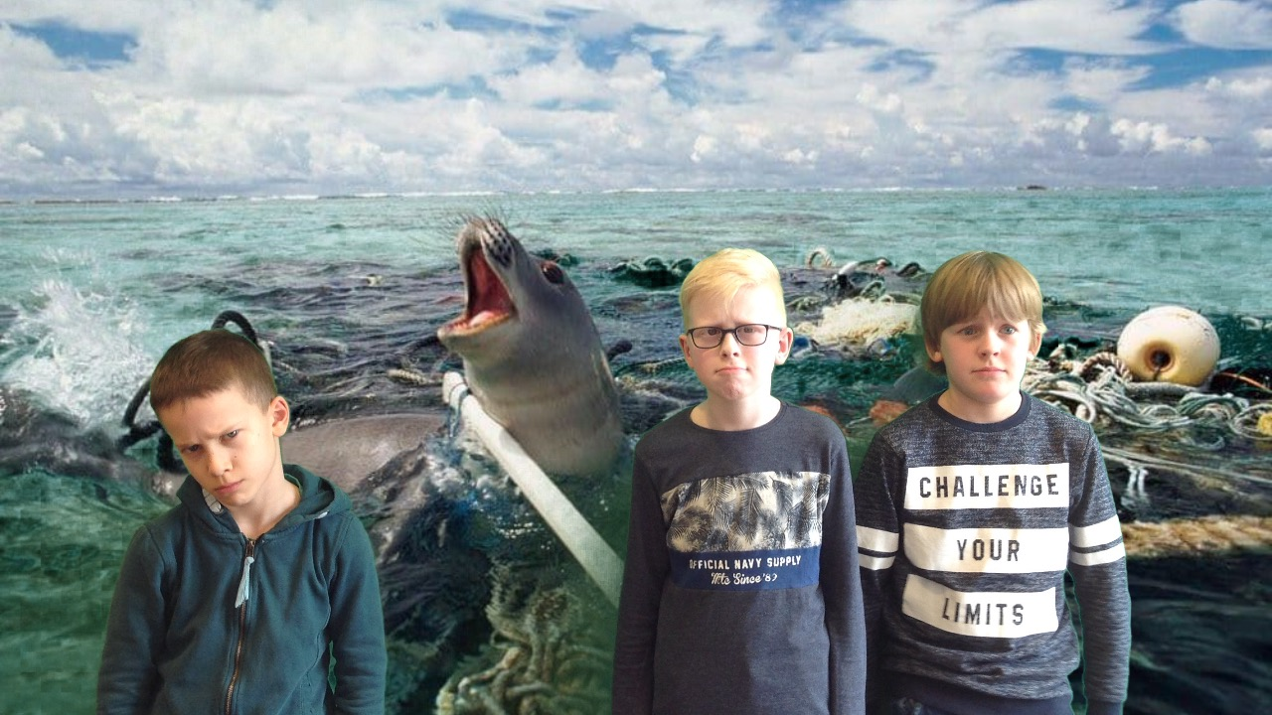
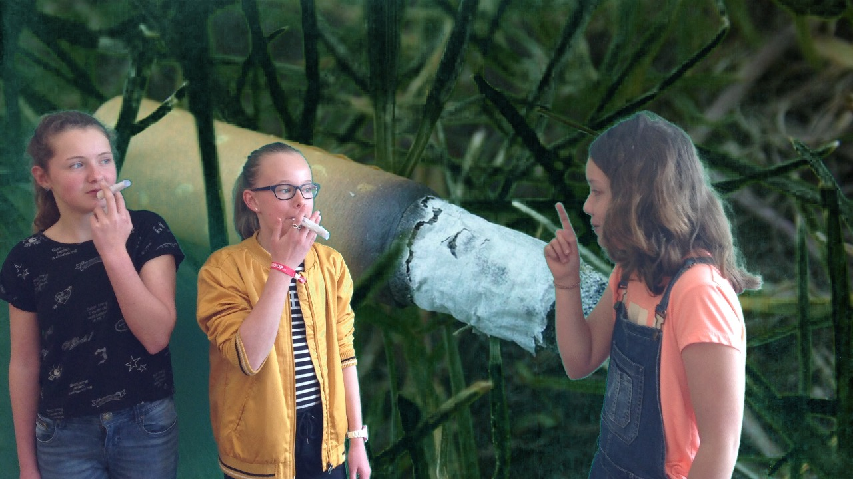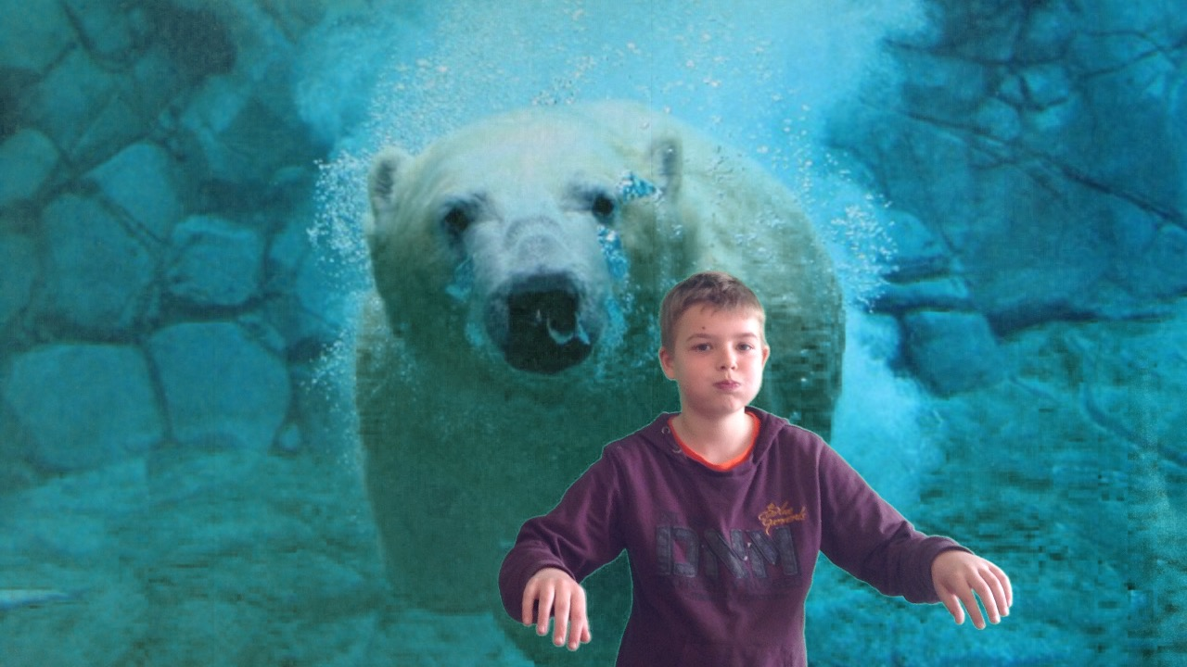
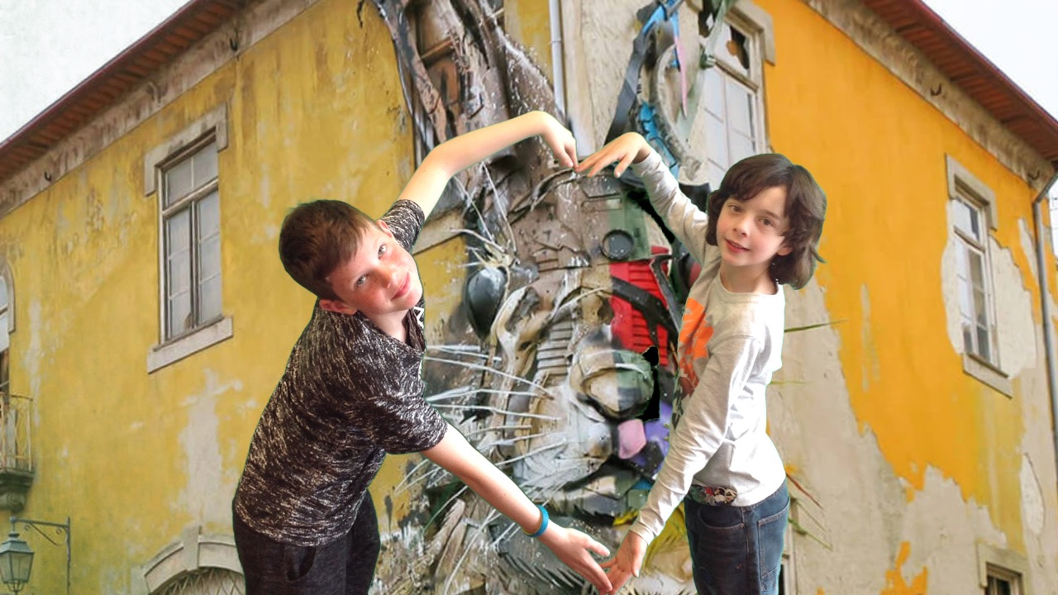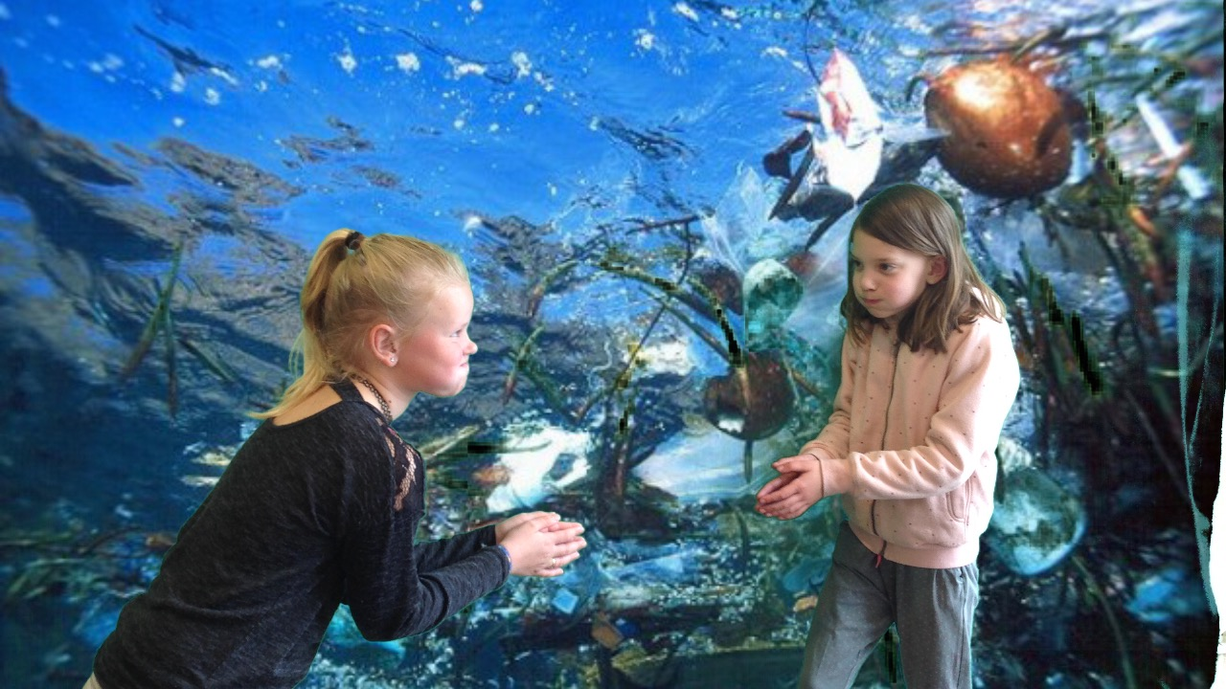
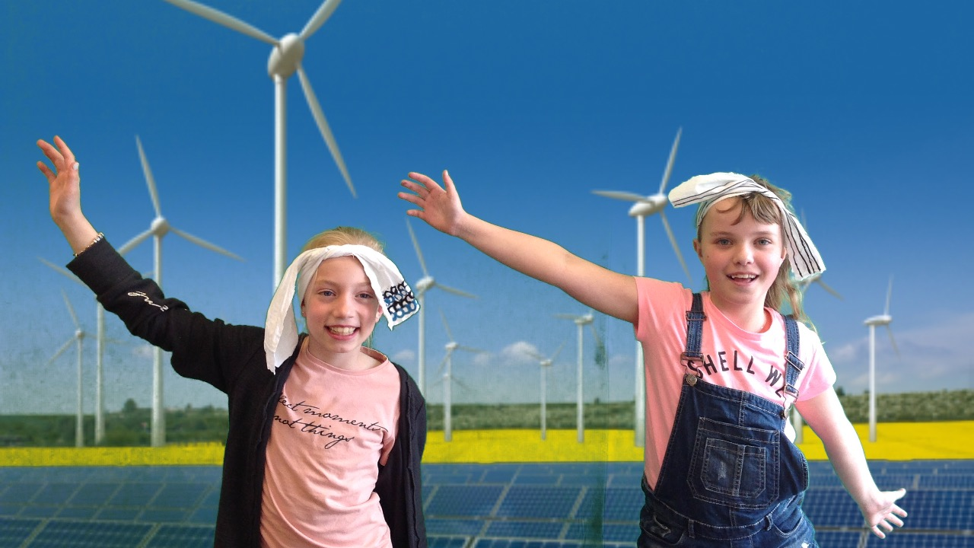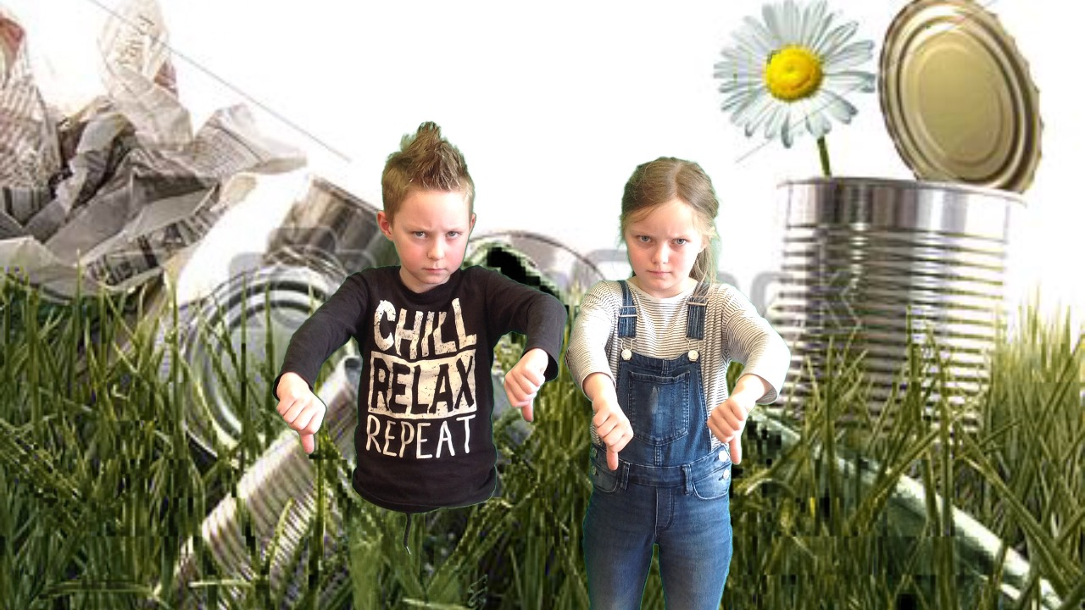
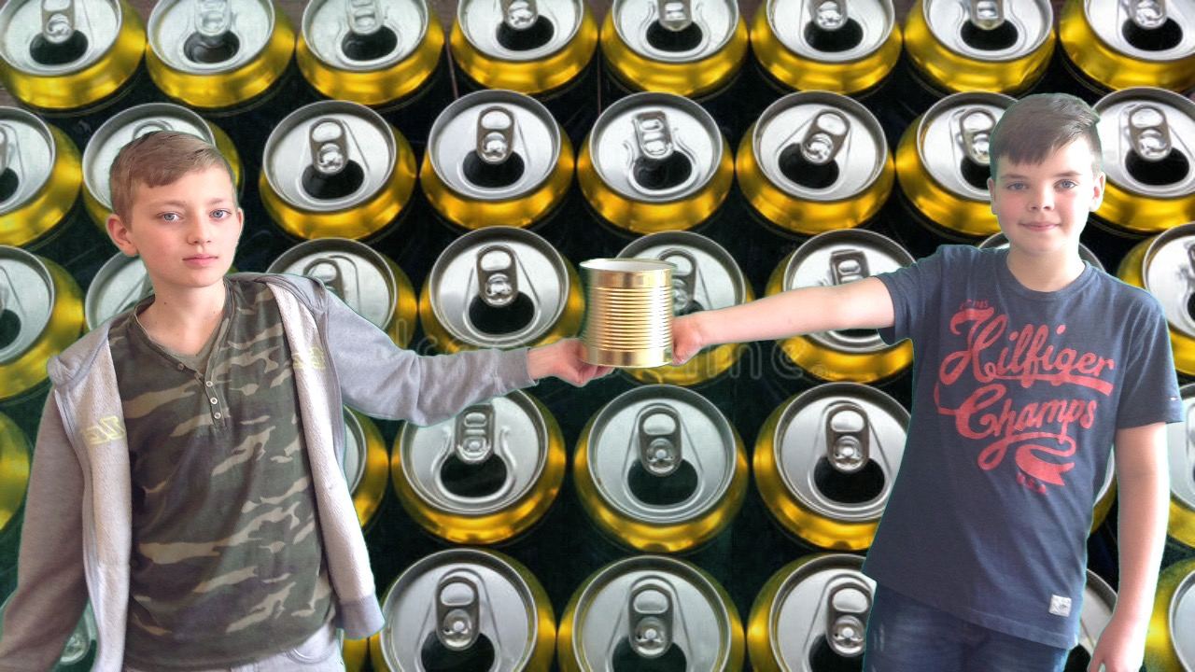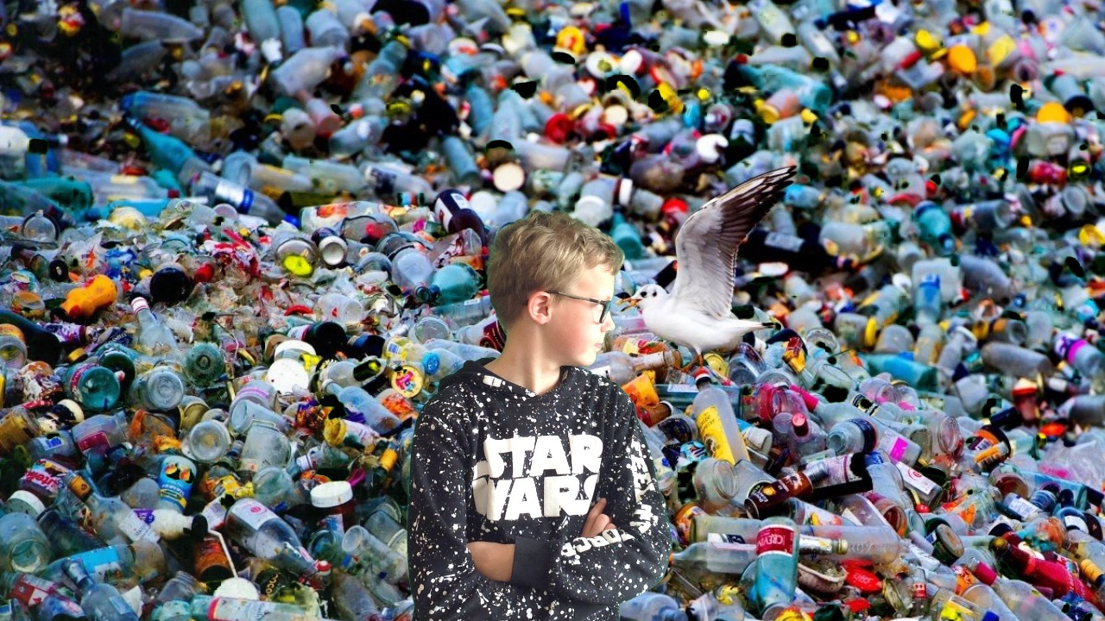

EARTH DAY

We participated with the whole school in a clean up action. We removed the trash from the environment of our school.
We love to have a clean environment where we can play!!
All children helped very good. The younger children have cleaned the schoolyard and the older children cleaned a few streets of our village.

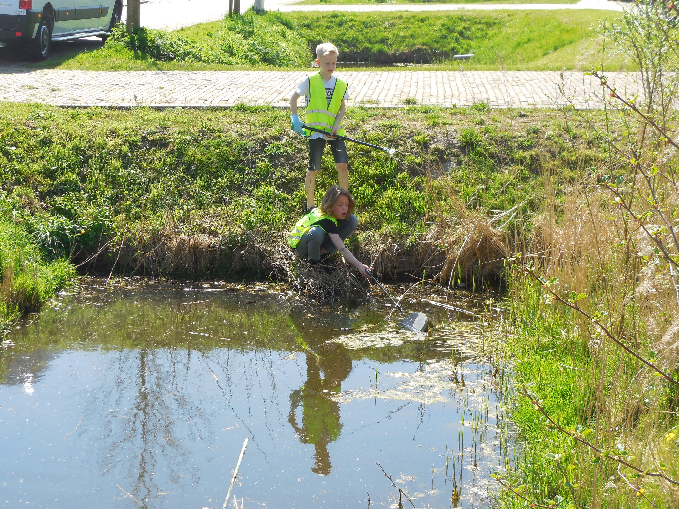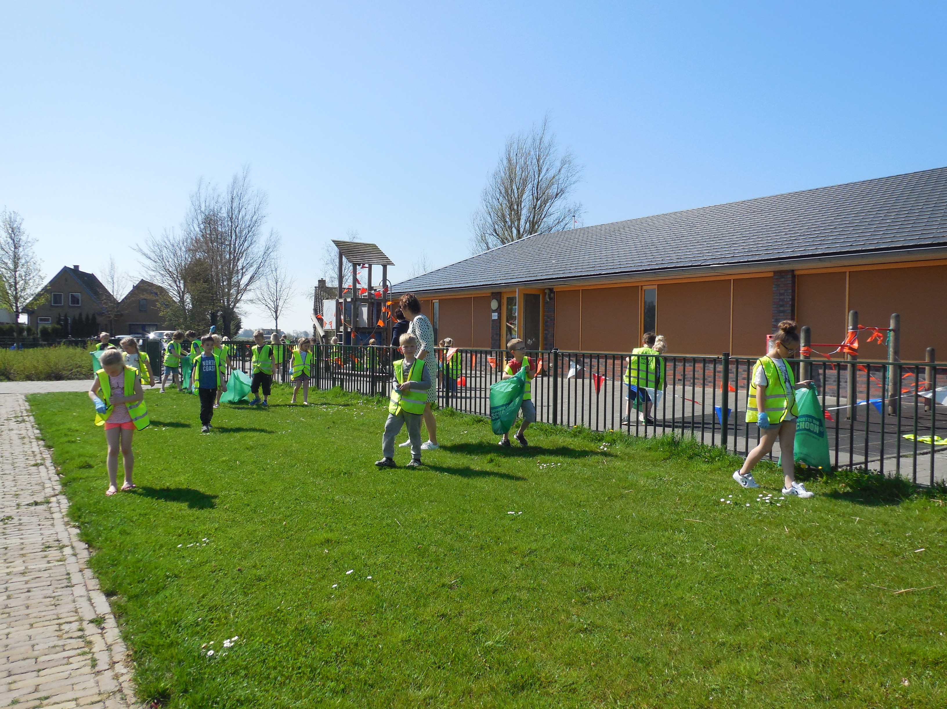
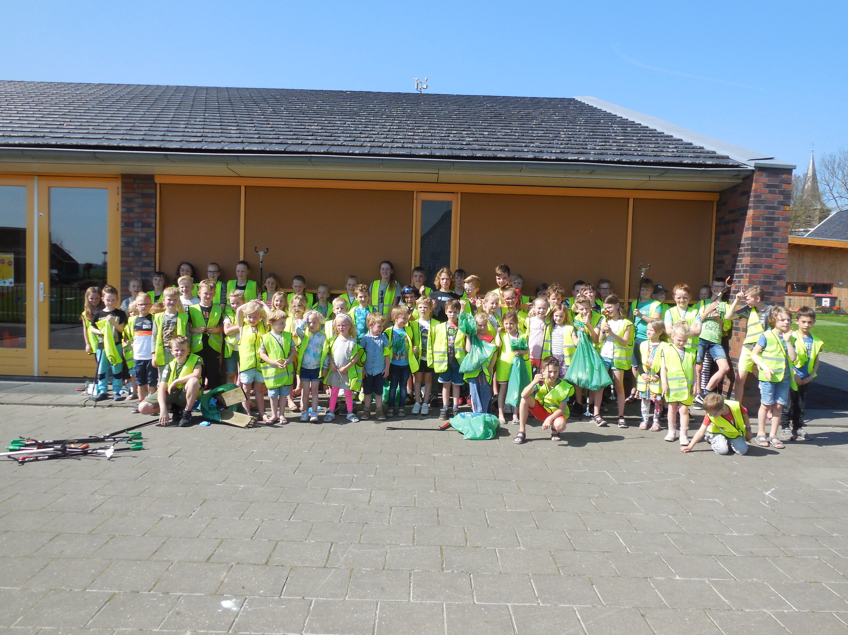

COMMON INVESTIGATION

Our common investigation was
‘a green school’

What activities are we doing in our school to improve our environment.

We had 5 activities:
- Using bicycles
- Collect empty batteries
- Trash and recycle station
- Recycle old paper
- Cleaning our schoolyard

It was so nice to see all the photos and films from other countries. There were such great ideas.
Finally we’ve deserved a third place with our activity cleaning our schoolyard!
Thank you

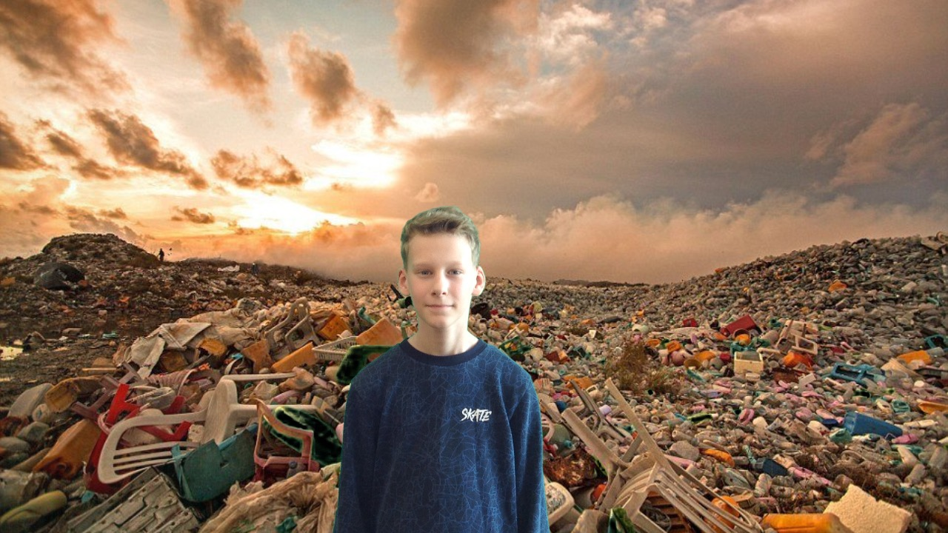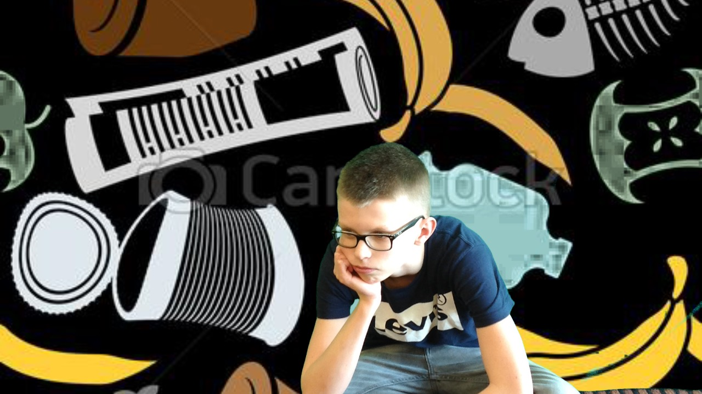
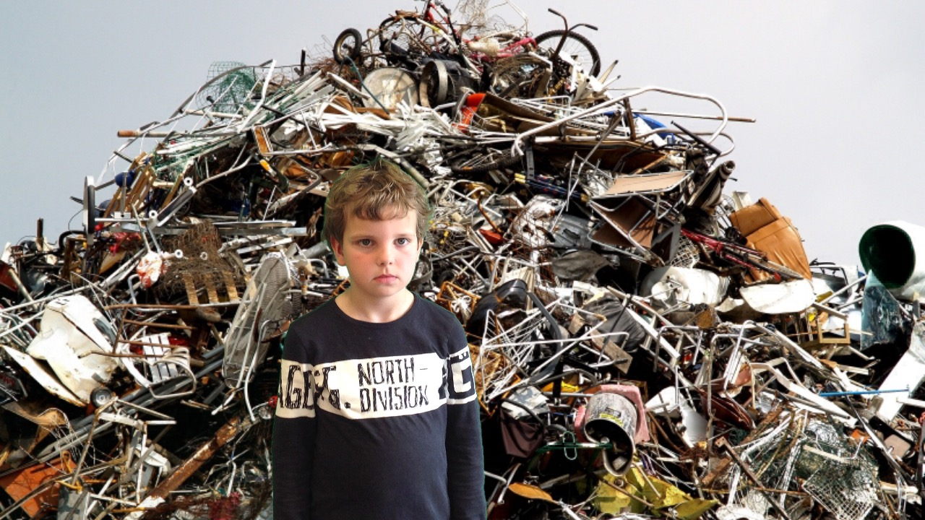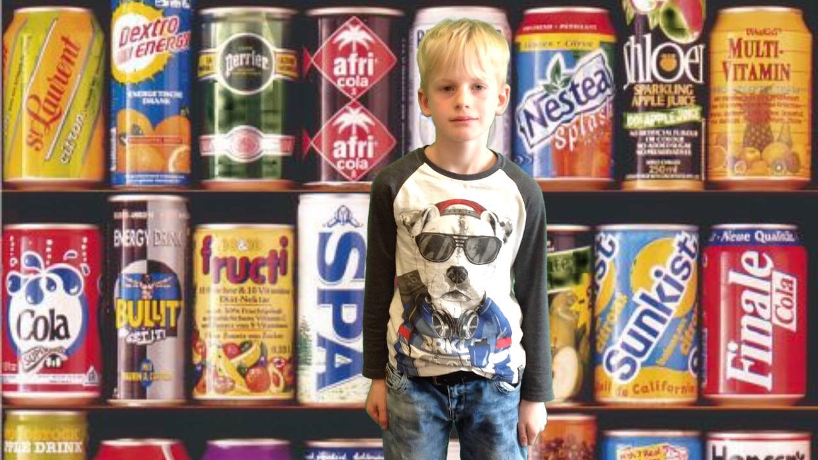
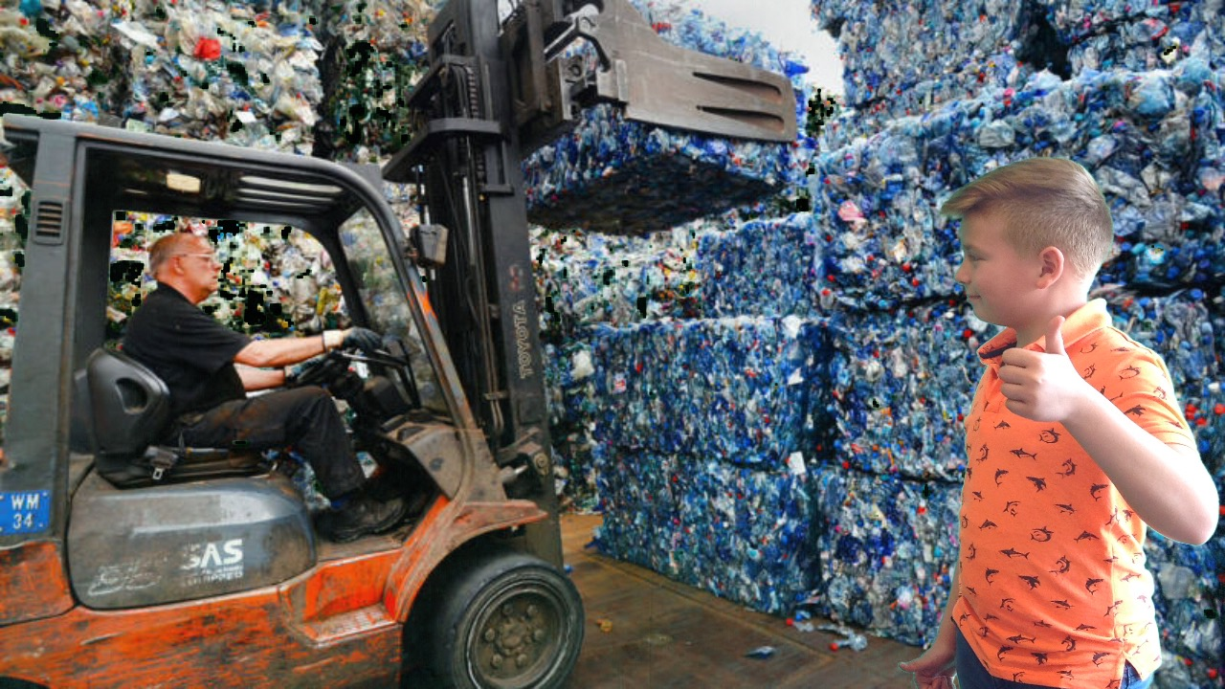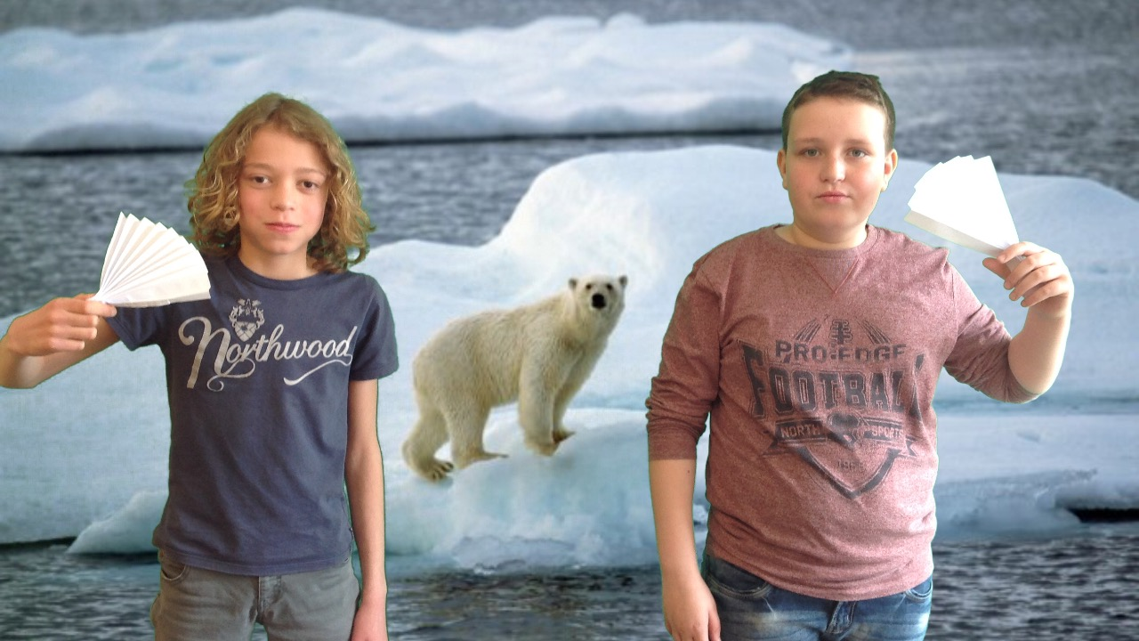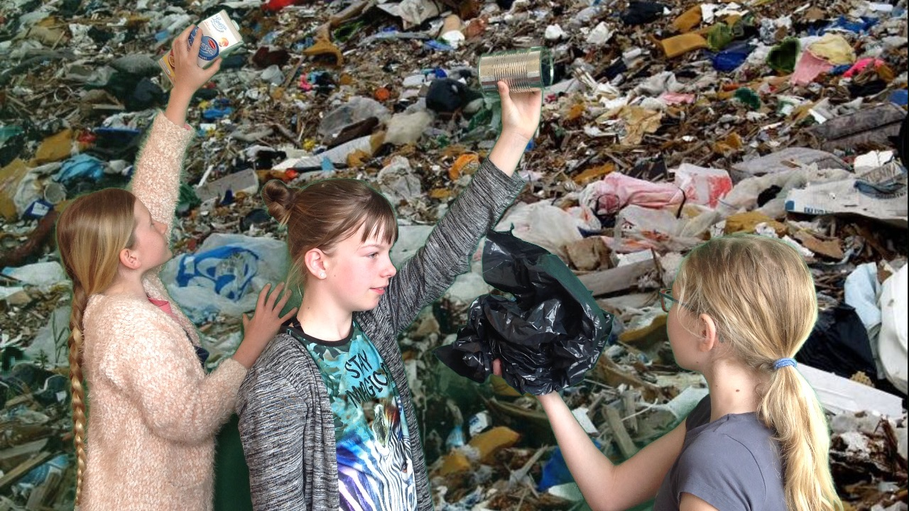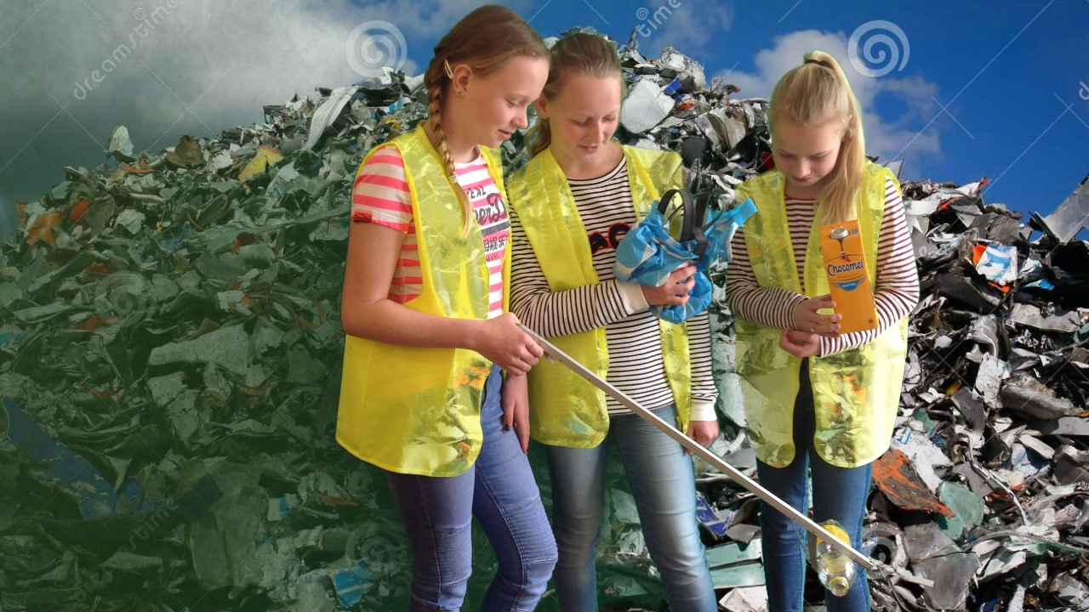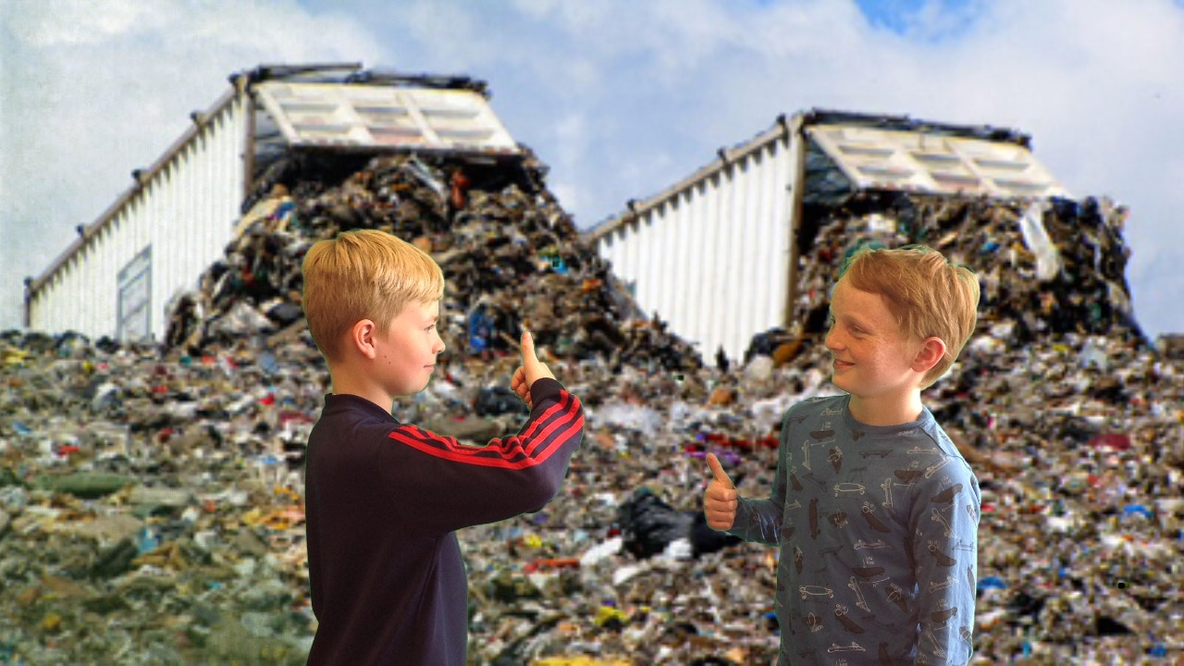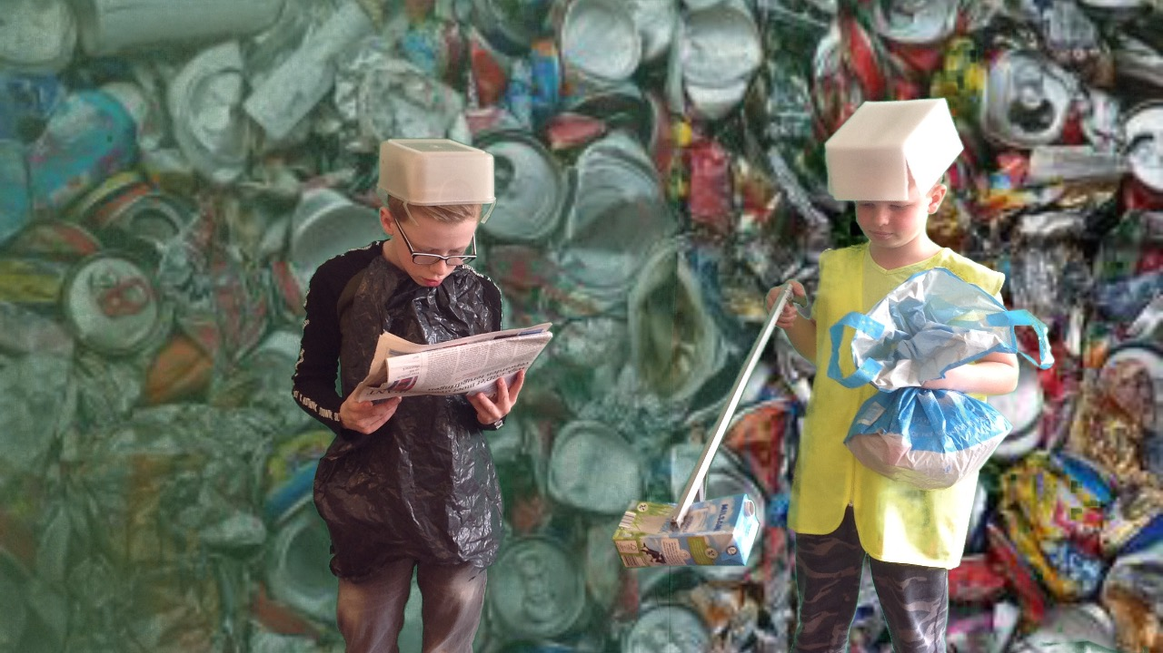
We’ve done several nice activities about the project in our school

Working on creative teampieces

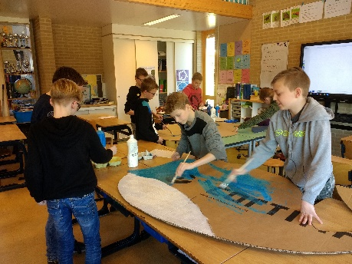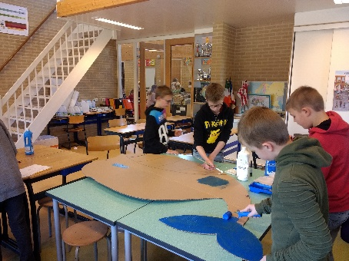
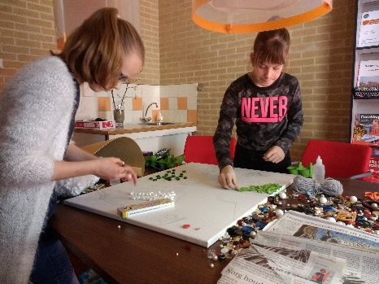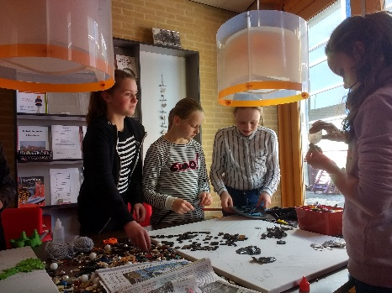
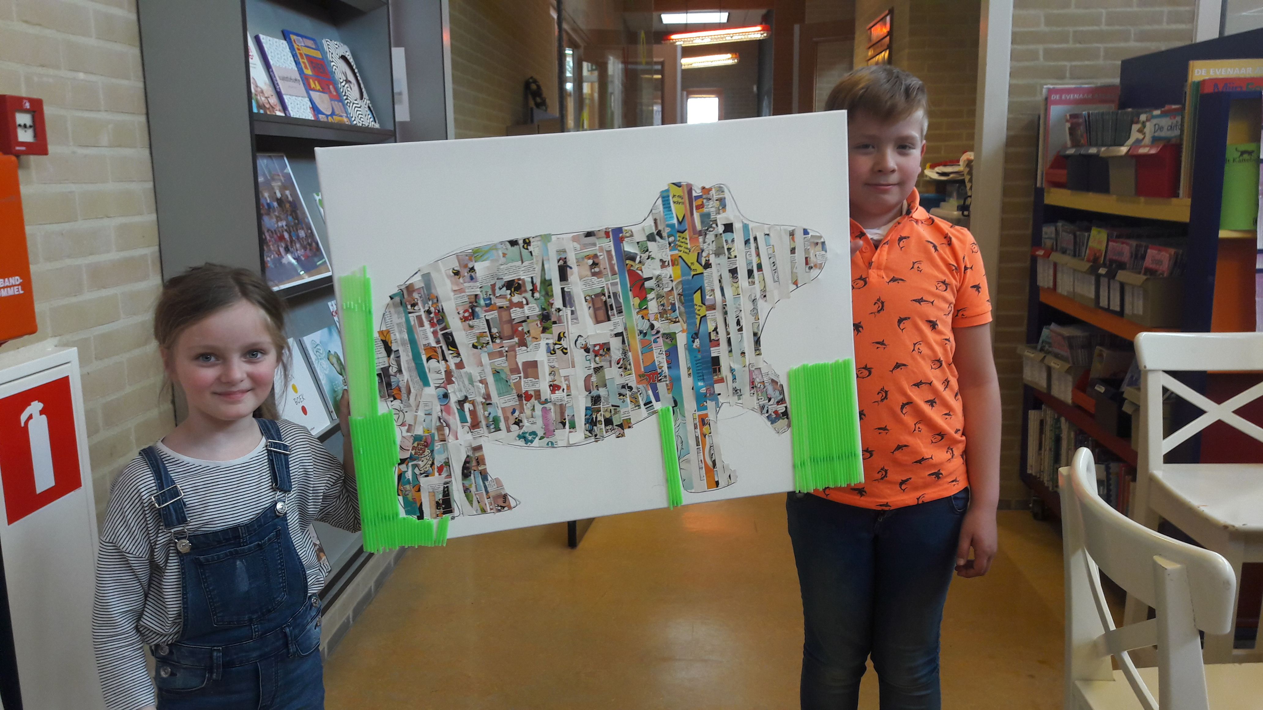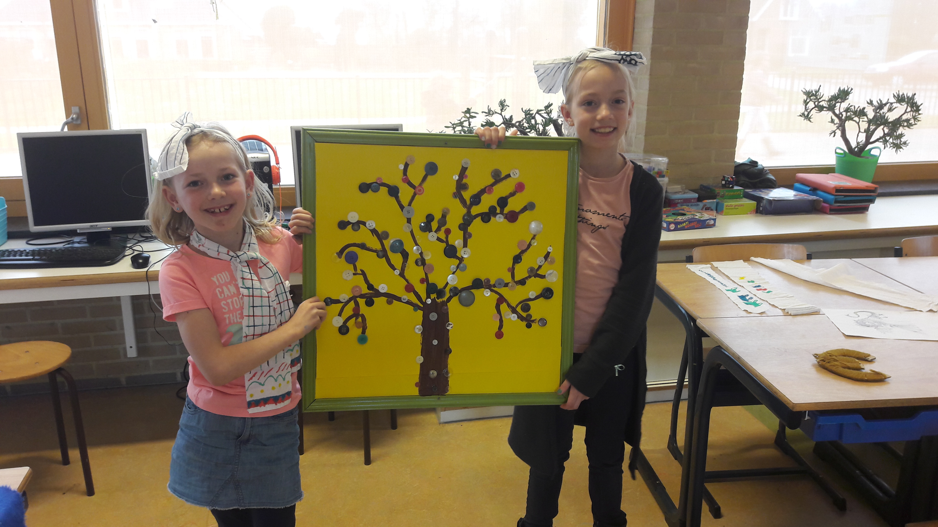

We made our own green village with houses, a hotel, a canal, boats etc. of cardboard and other materials.

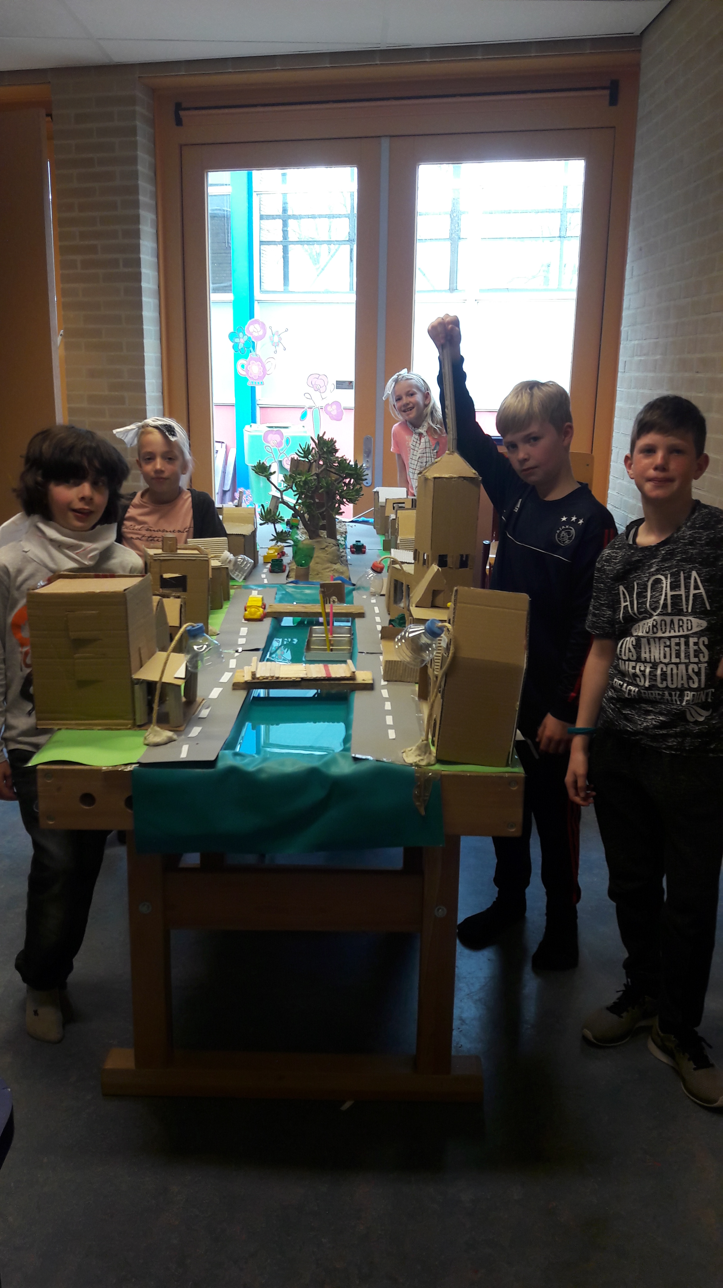

The girls have made hair bands of old sheets, the boys have turned themselves into thieves.

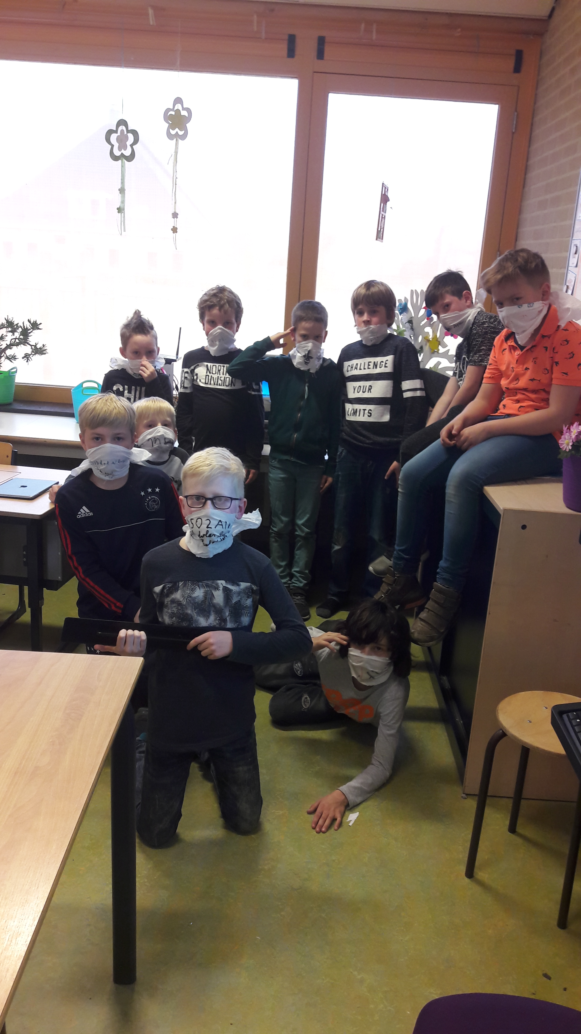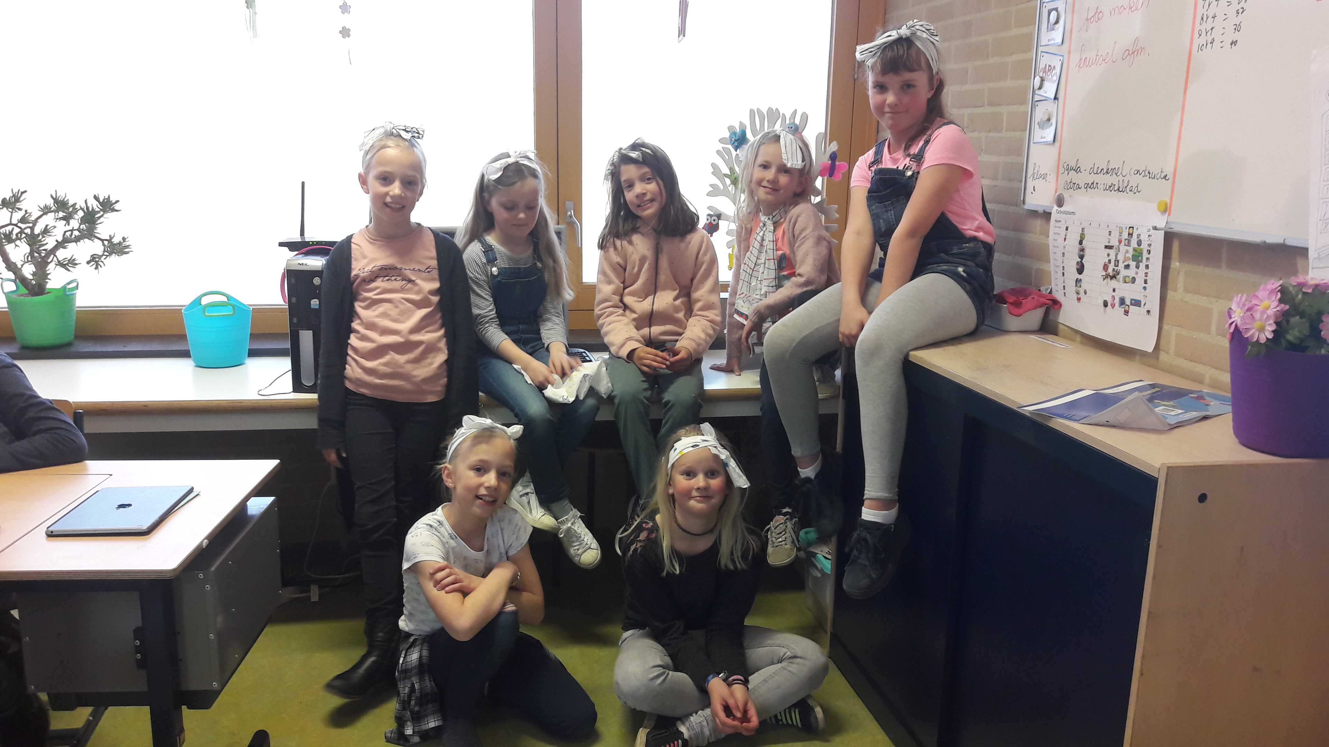

POSTER

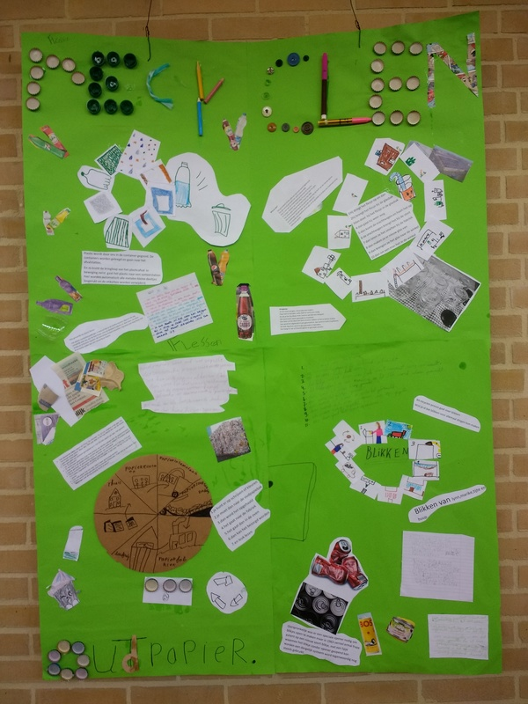

We made a poster about recycling.

CHALLENGE ‘KINGSPLAY’
(koningsspelen)

Our group, the 5th and 6th grade, had to organize the King games. This is us national sports day to celebrate the kings birthday. This is every year. This was the first time that kids had to organize the king games. We had to use trash materials to make the games. In the beginning this was very difficult but after a while we figured out how to do it. We split up in little groups to make games with trash. In every game there was one child that gave instructions about the game. Nine kids where leaders of a group of five or six children. We had nine groups so we had also nine games. It was a very successful and very fun day. Every child was dressed in orange clothes, because orange the national color.
This was, especially for us, a very nice day!

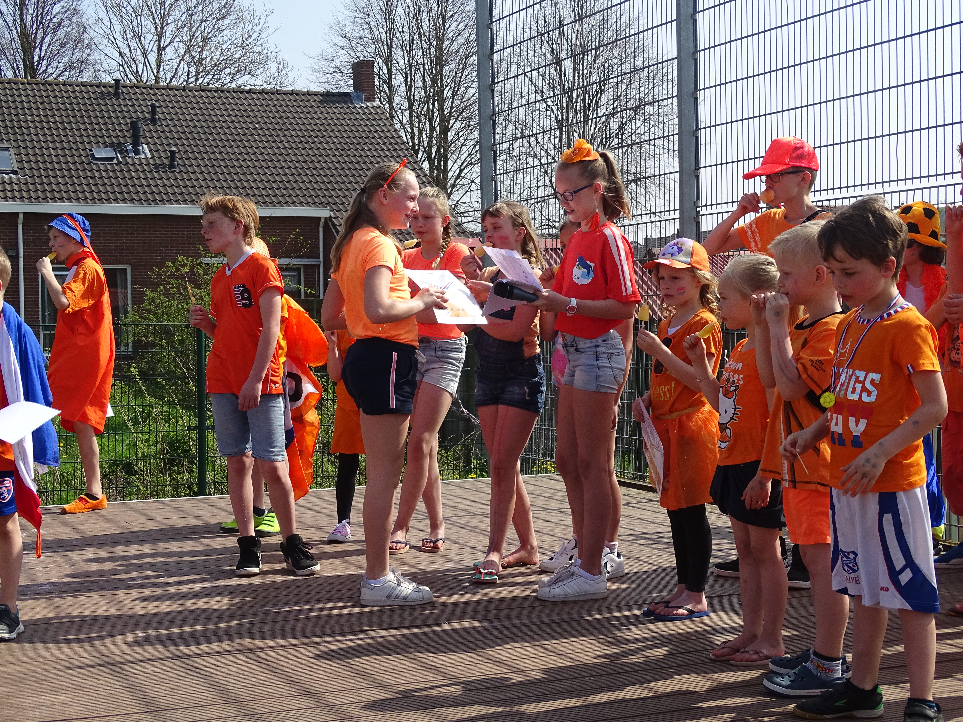

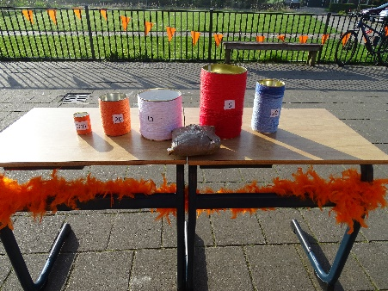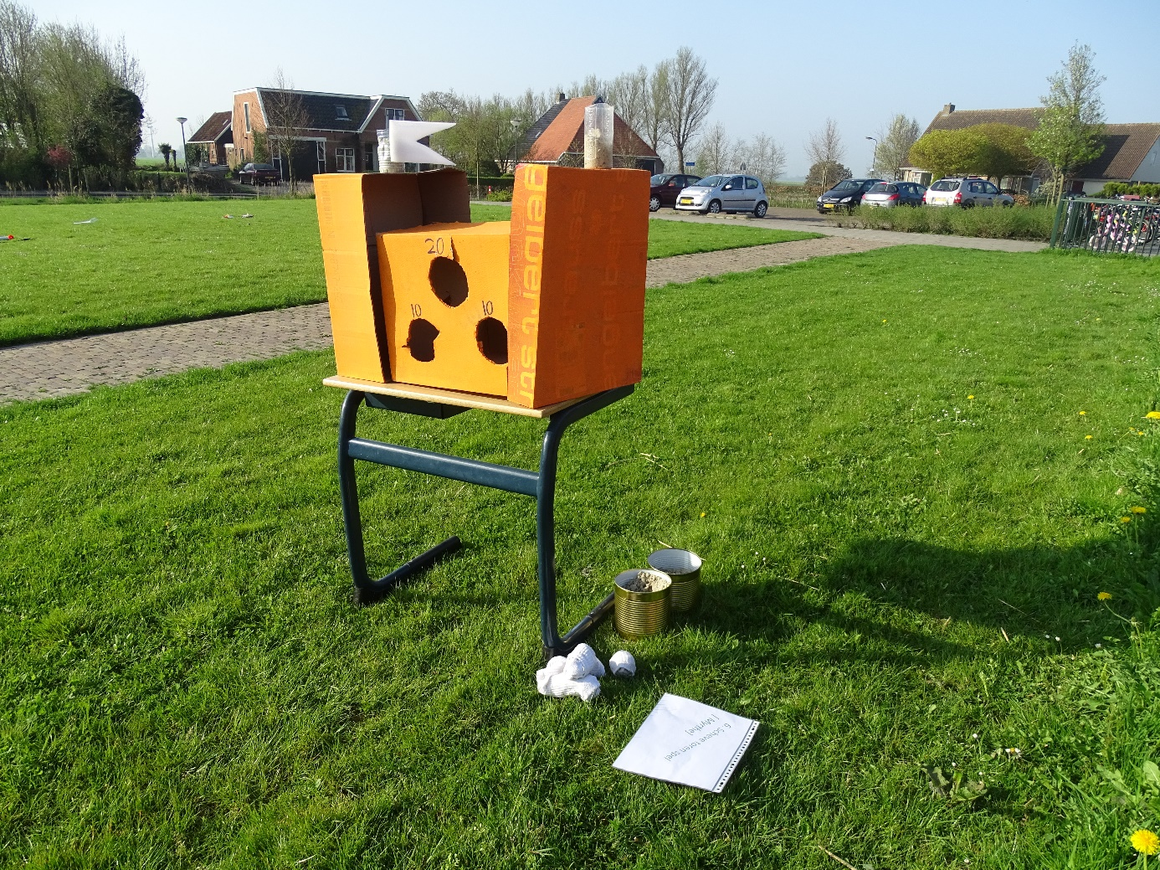

THE CONCLUSION OF THE PROJECT
OUR OWN ‘TRASHMUSEUM’

We turned our school into a museum. There was an exhibition of all our artworks. All parents and other interested people came by to take a look in our museum.
It was a big success!

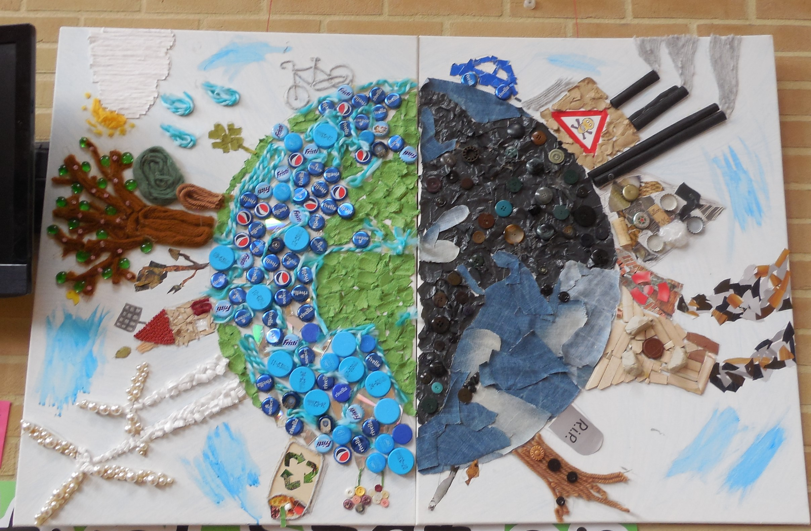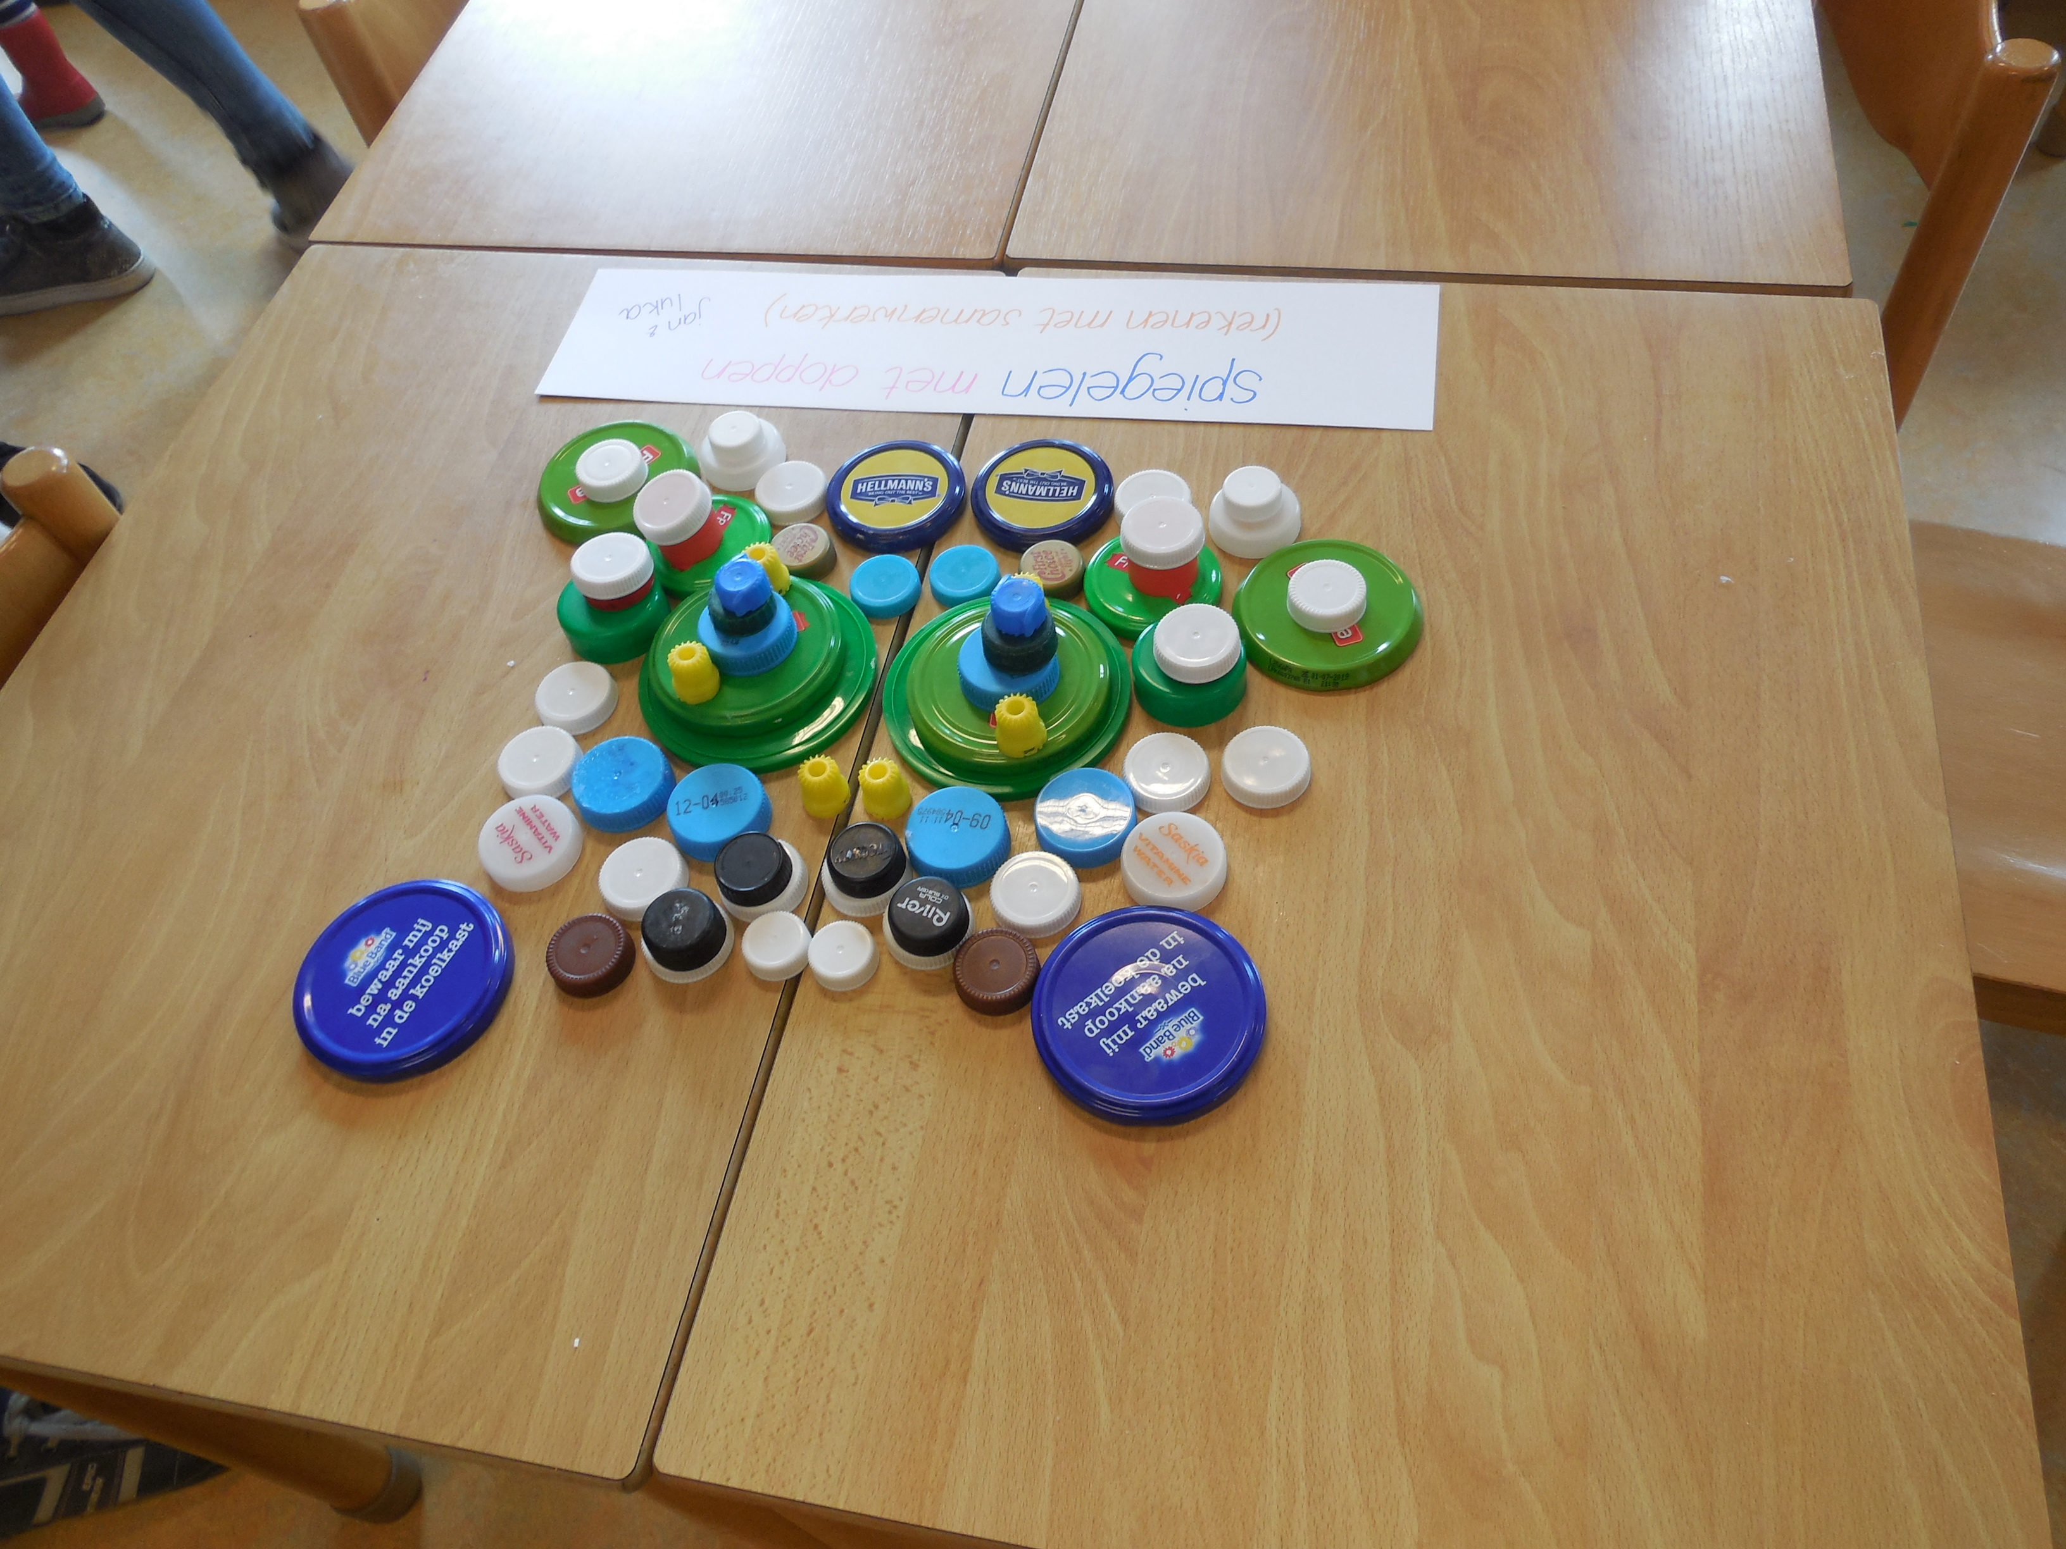
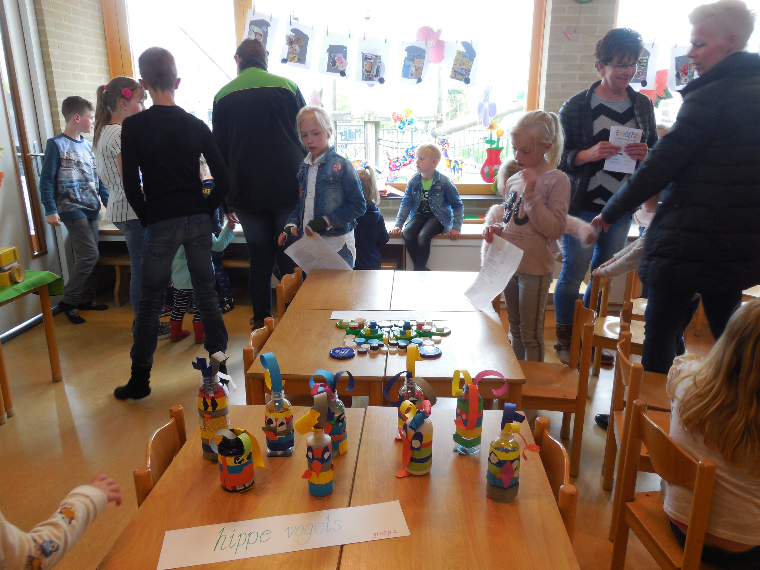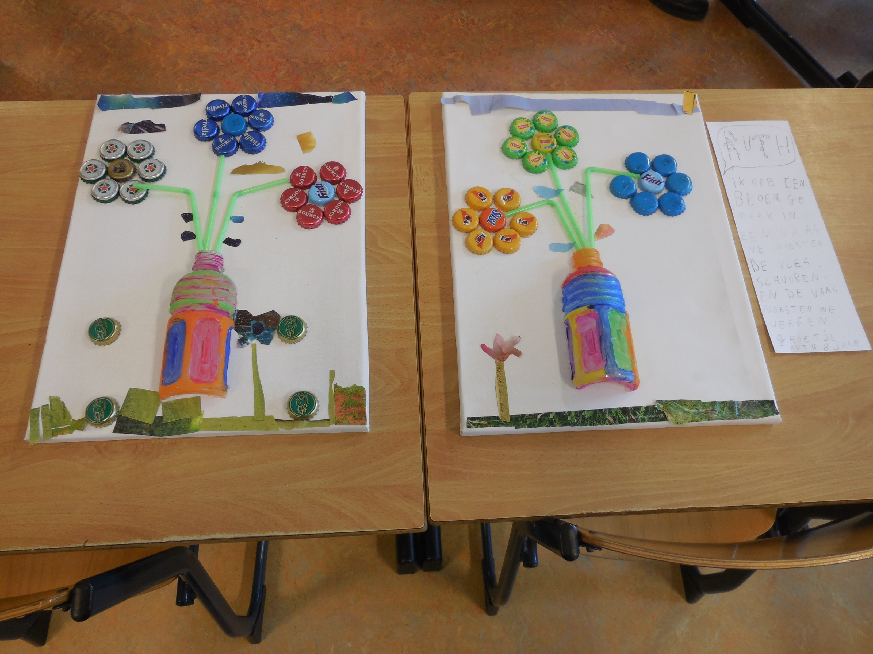
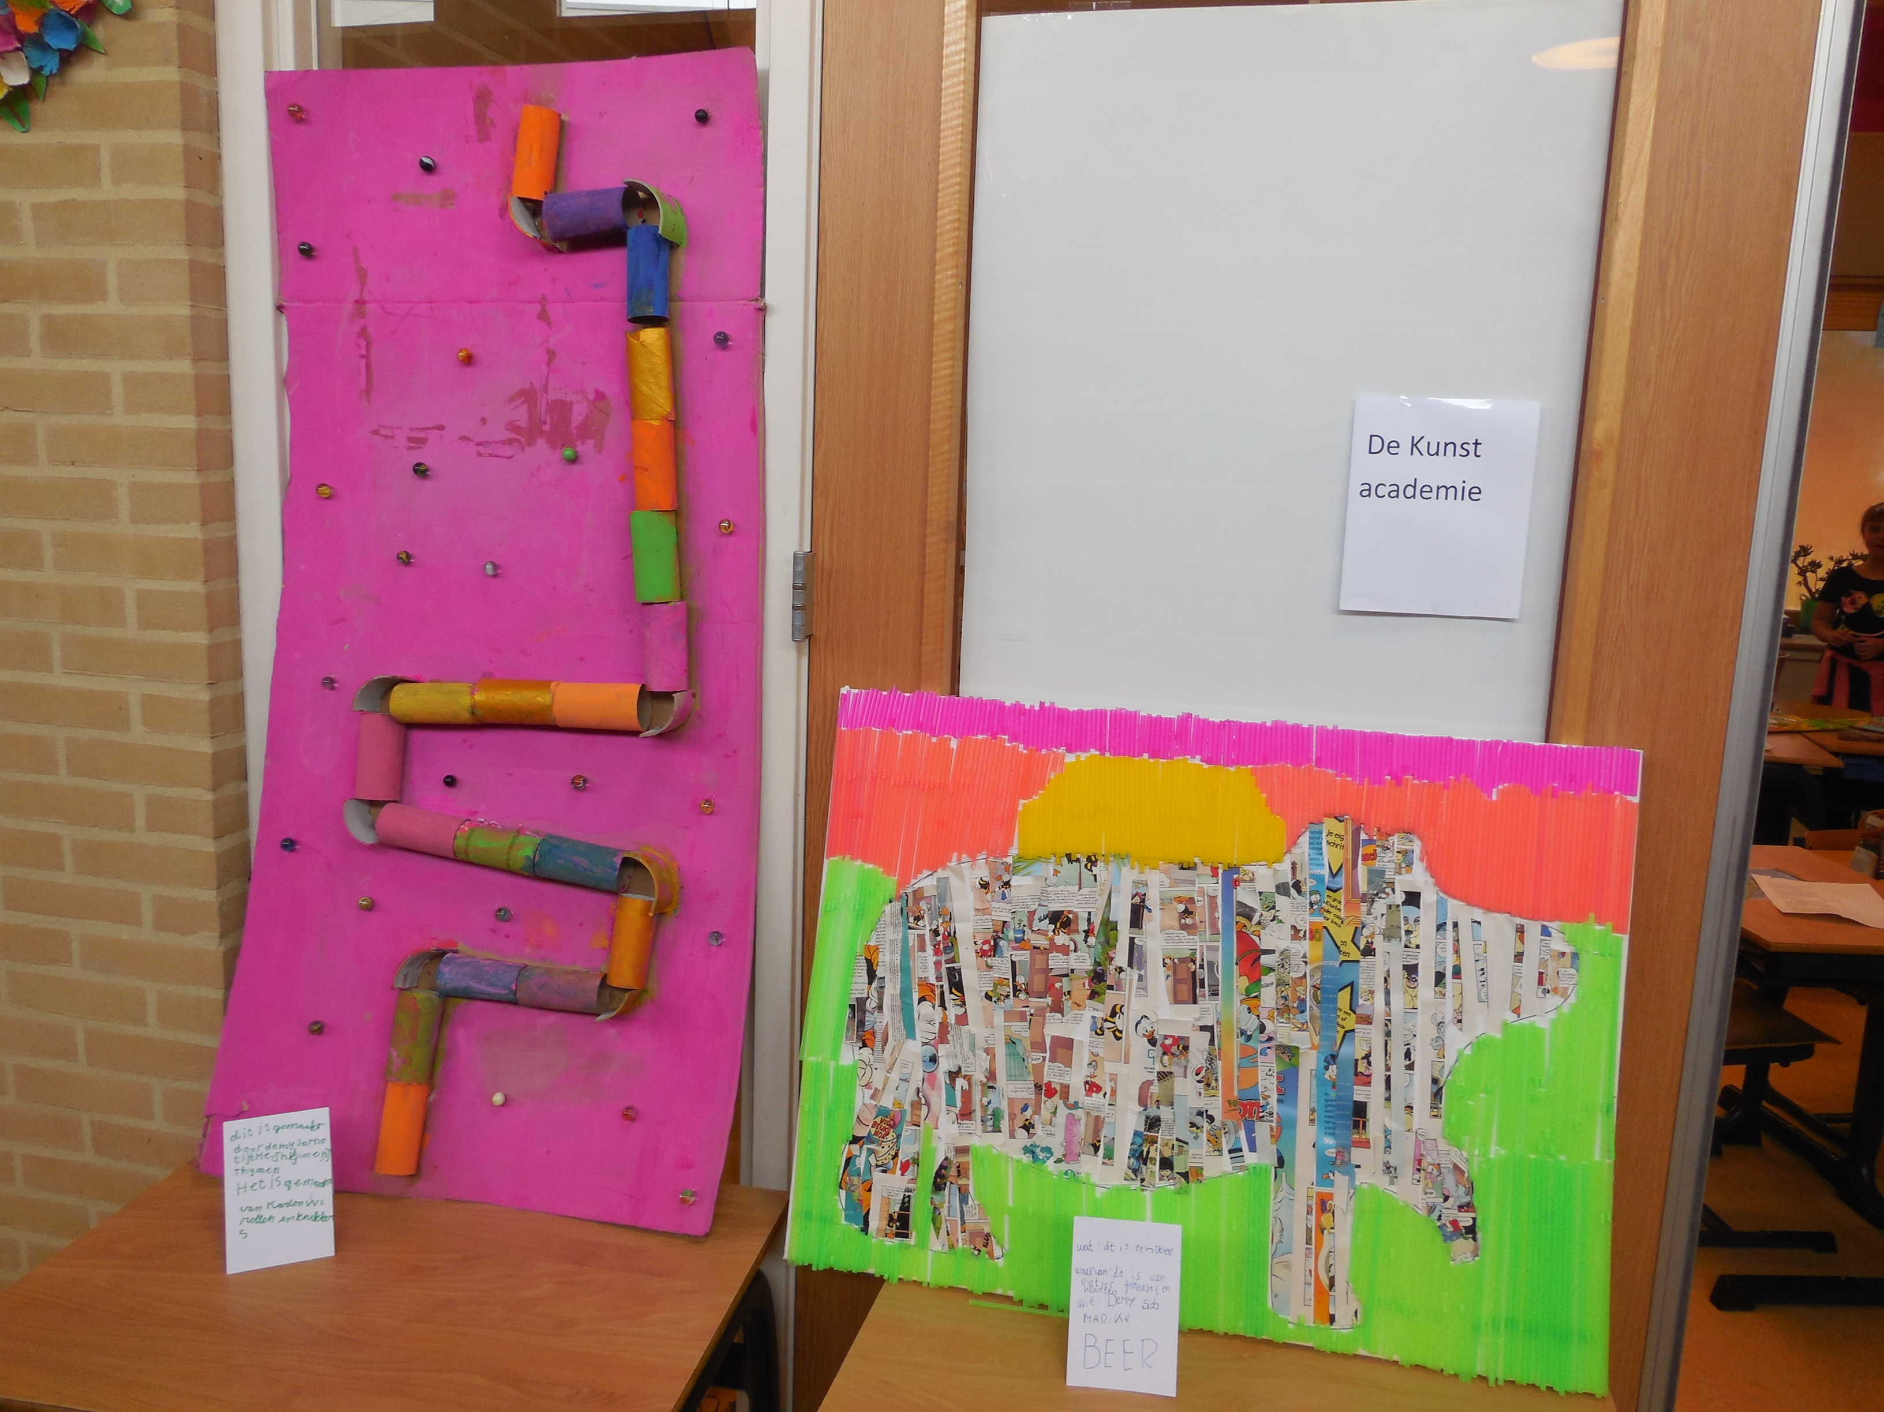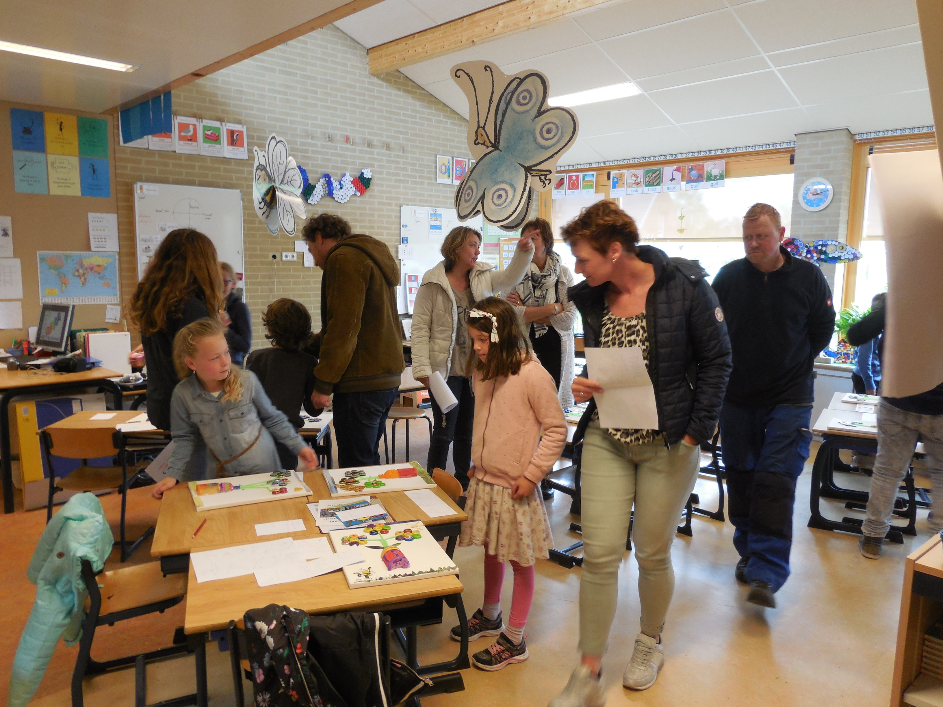
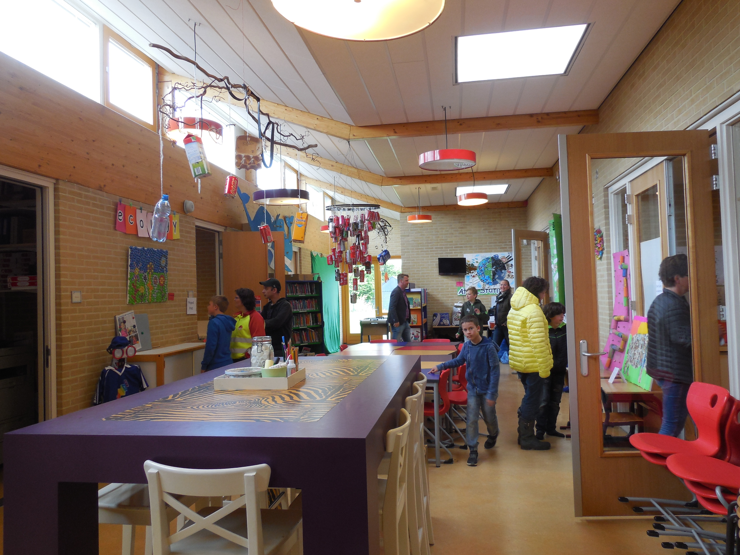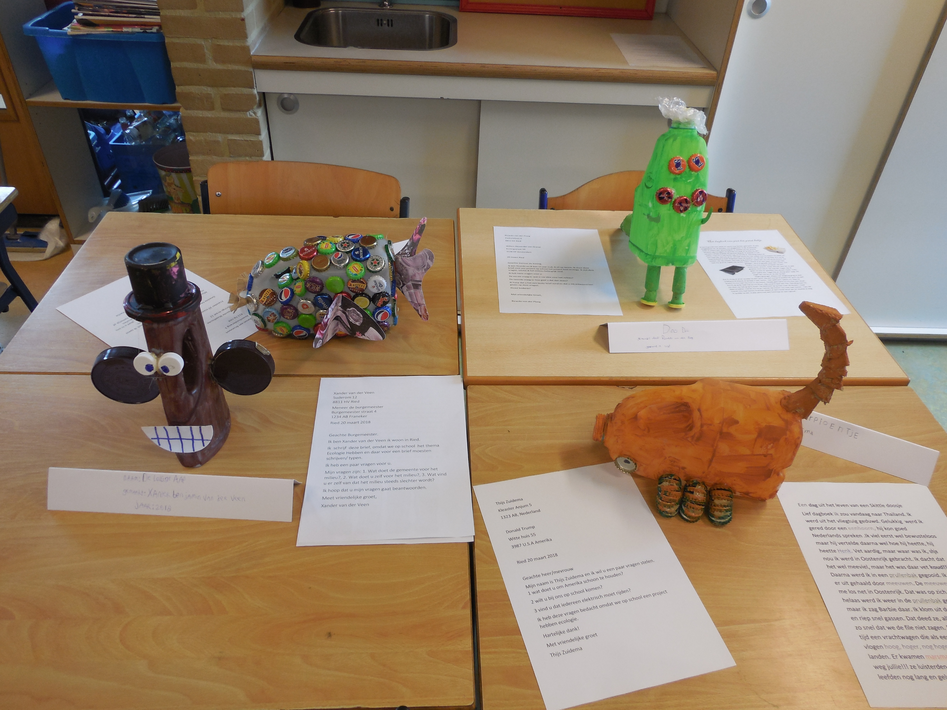

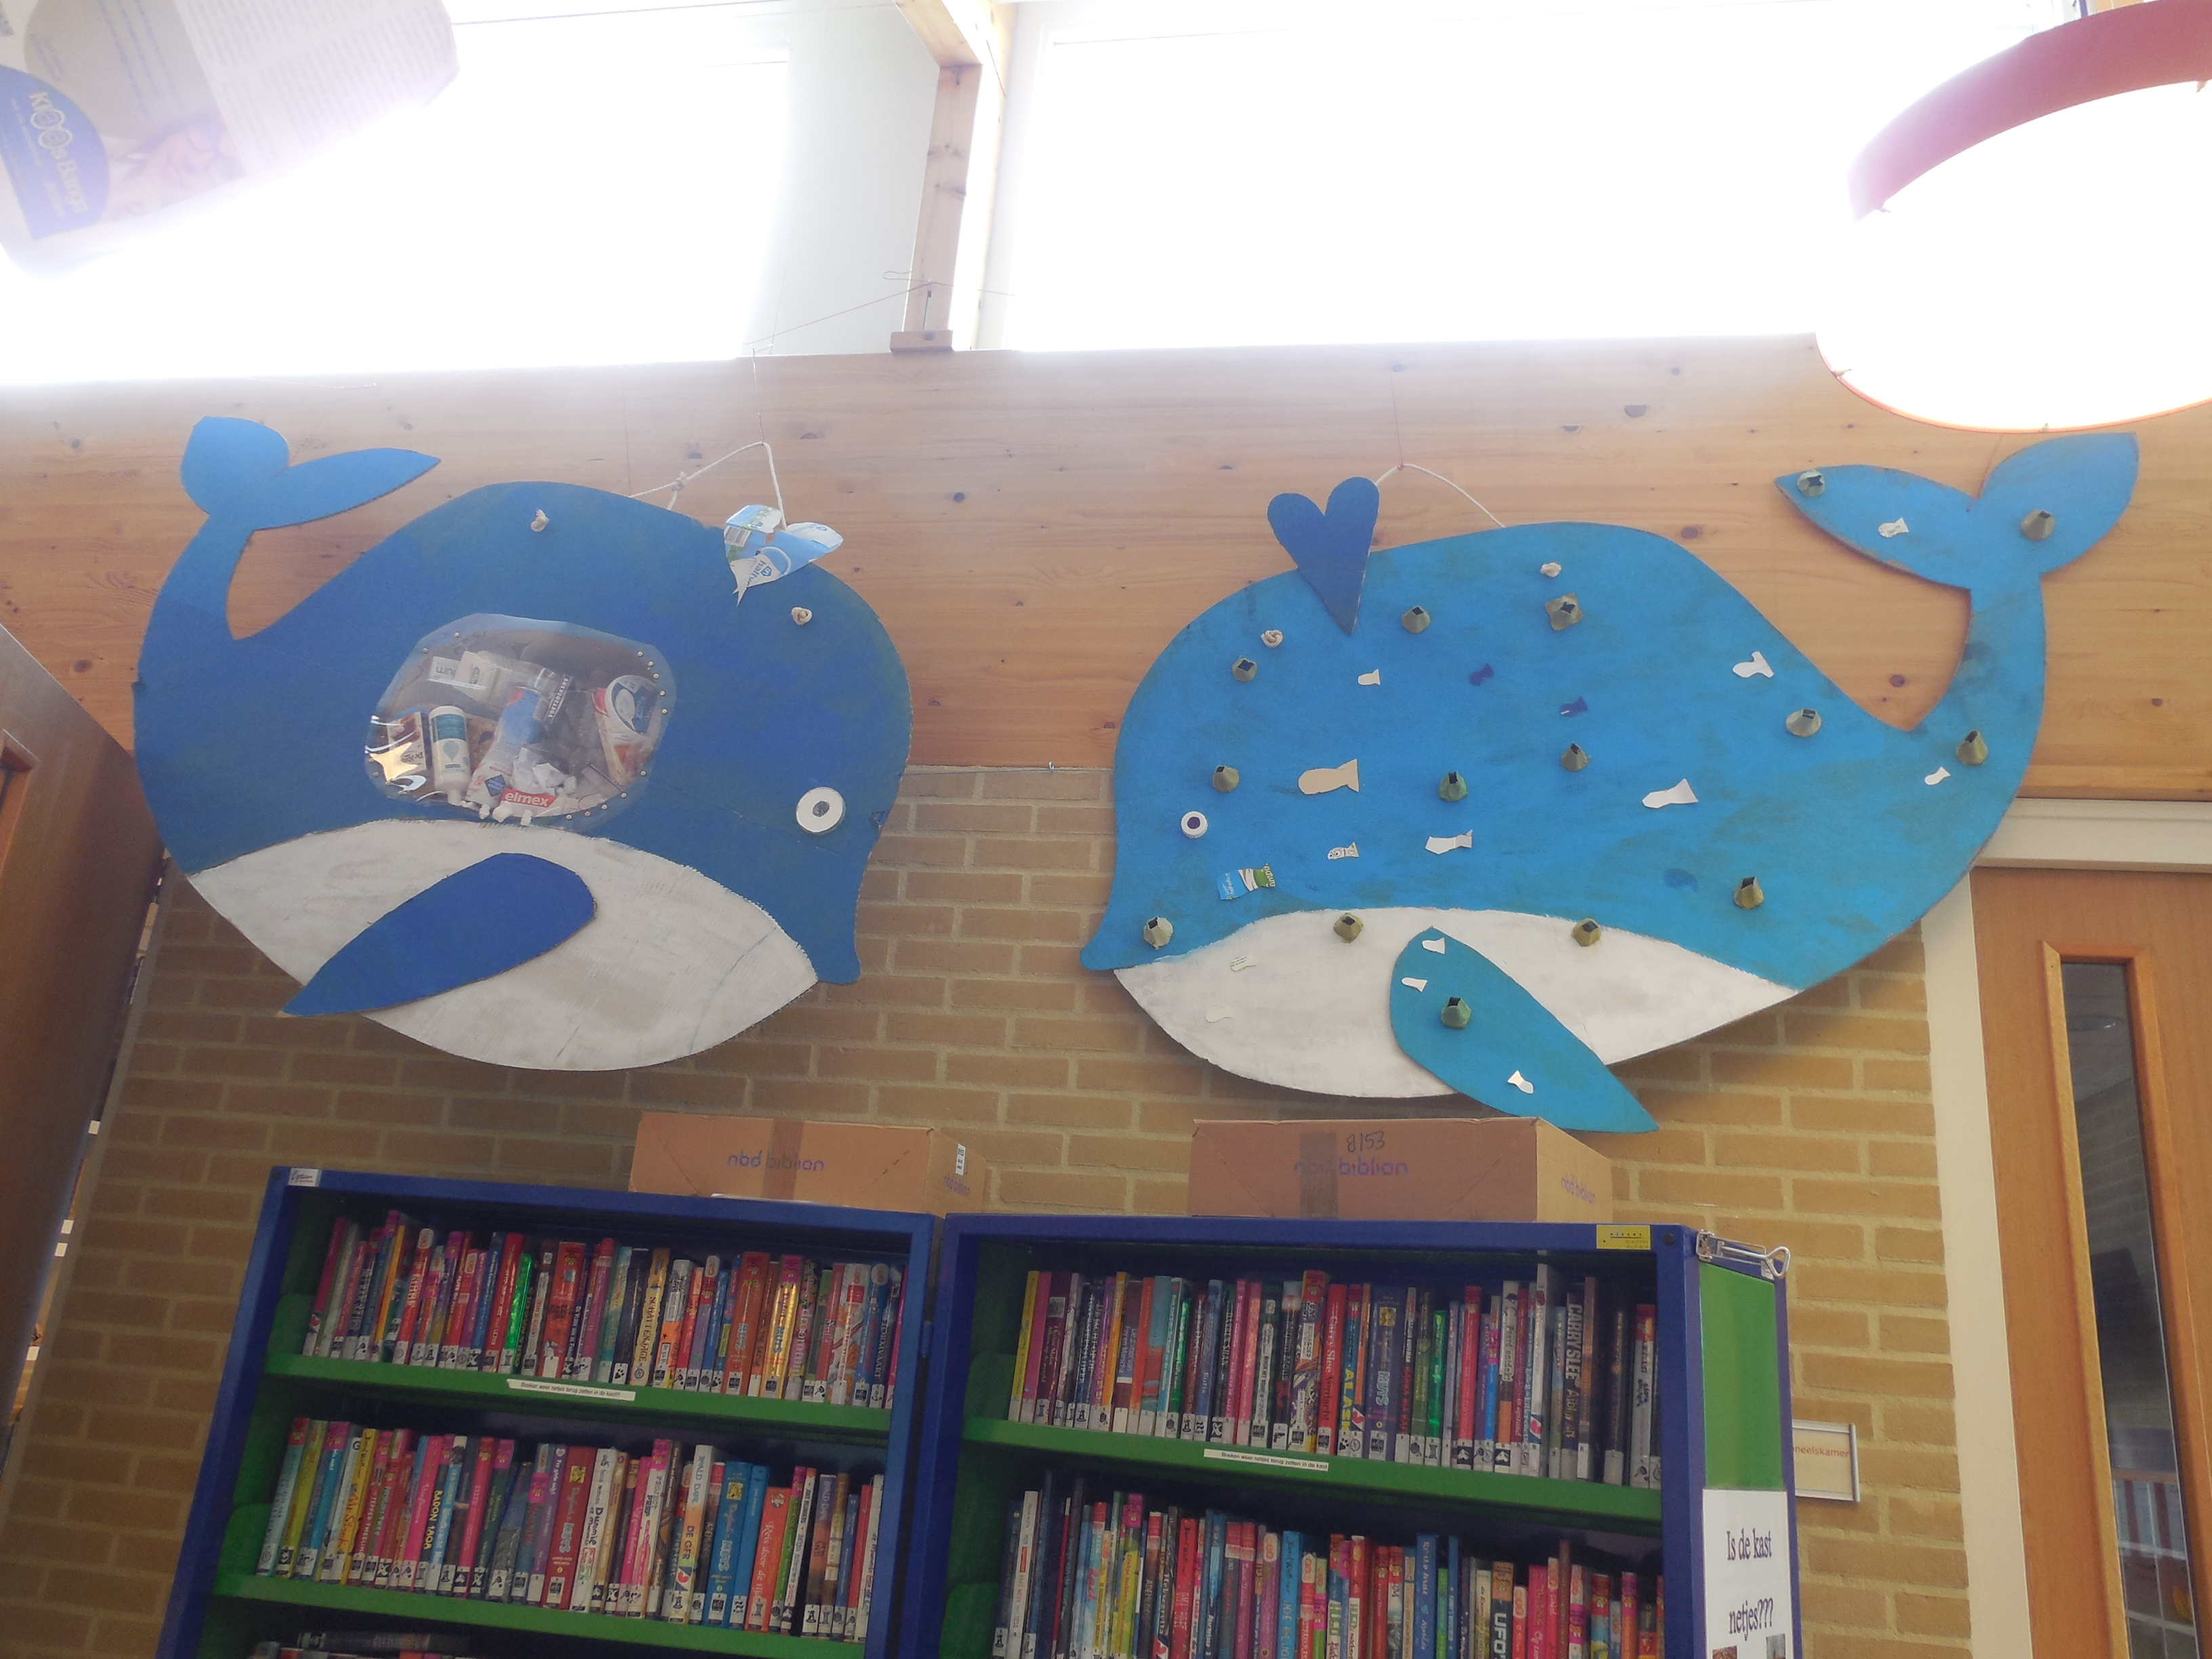

Did you know….

…. that in our oceans there are 5 huge islands of plastic, some of them are as big as Spain and France togehter!

…. that preventing, cleaning up and processing litter costs the Netherlands 250 million euros.

…. that every year 100.000 sea mammals and at least 1 million seabirds are killed by sea waste.

…. that on average 30 kilos of glass is handed in per person.

…. that an estimated 4.7 million tons of plastic landed in the sea each year.

…. that all girls of the 5th and 6th grade have made the good and the bad side of the earth of waste.

…. that all boys of the 5th and 6th grade have made 2 giantic wales.

Made by Yindee, Laura, Thijs en Damiën

Even the younger children joined the project ecology.

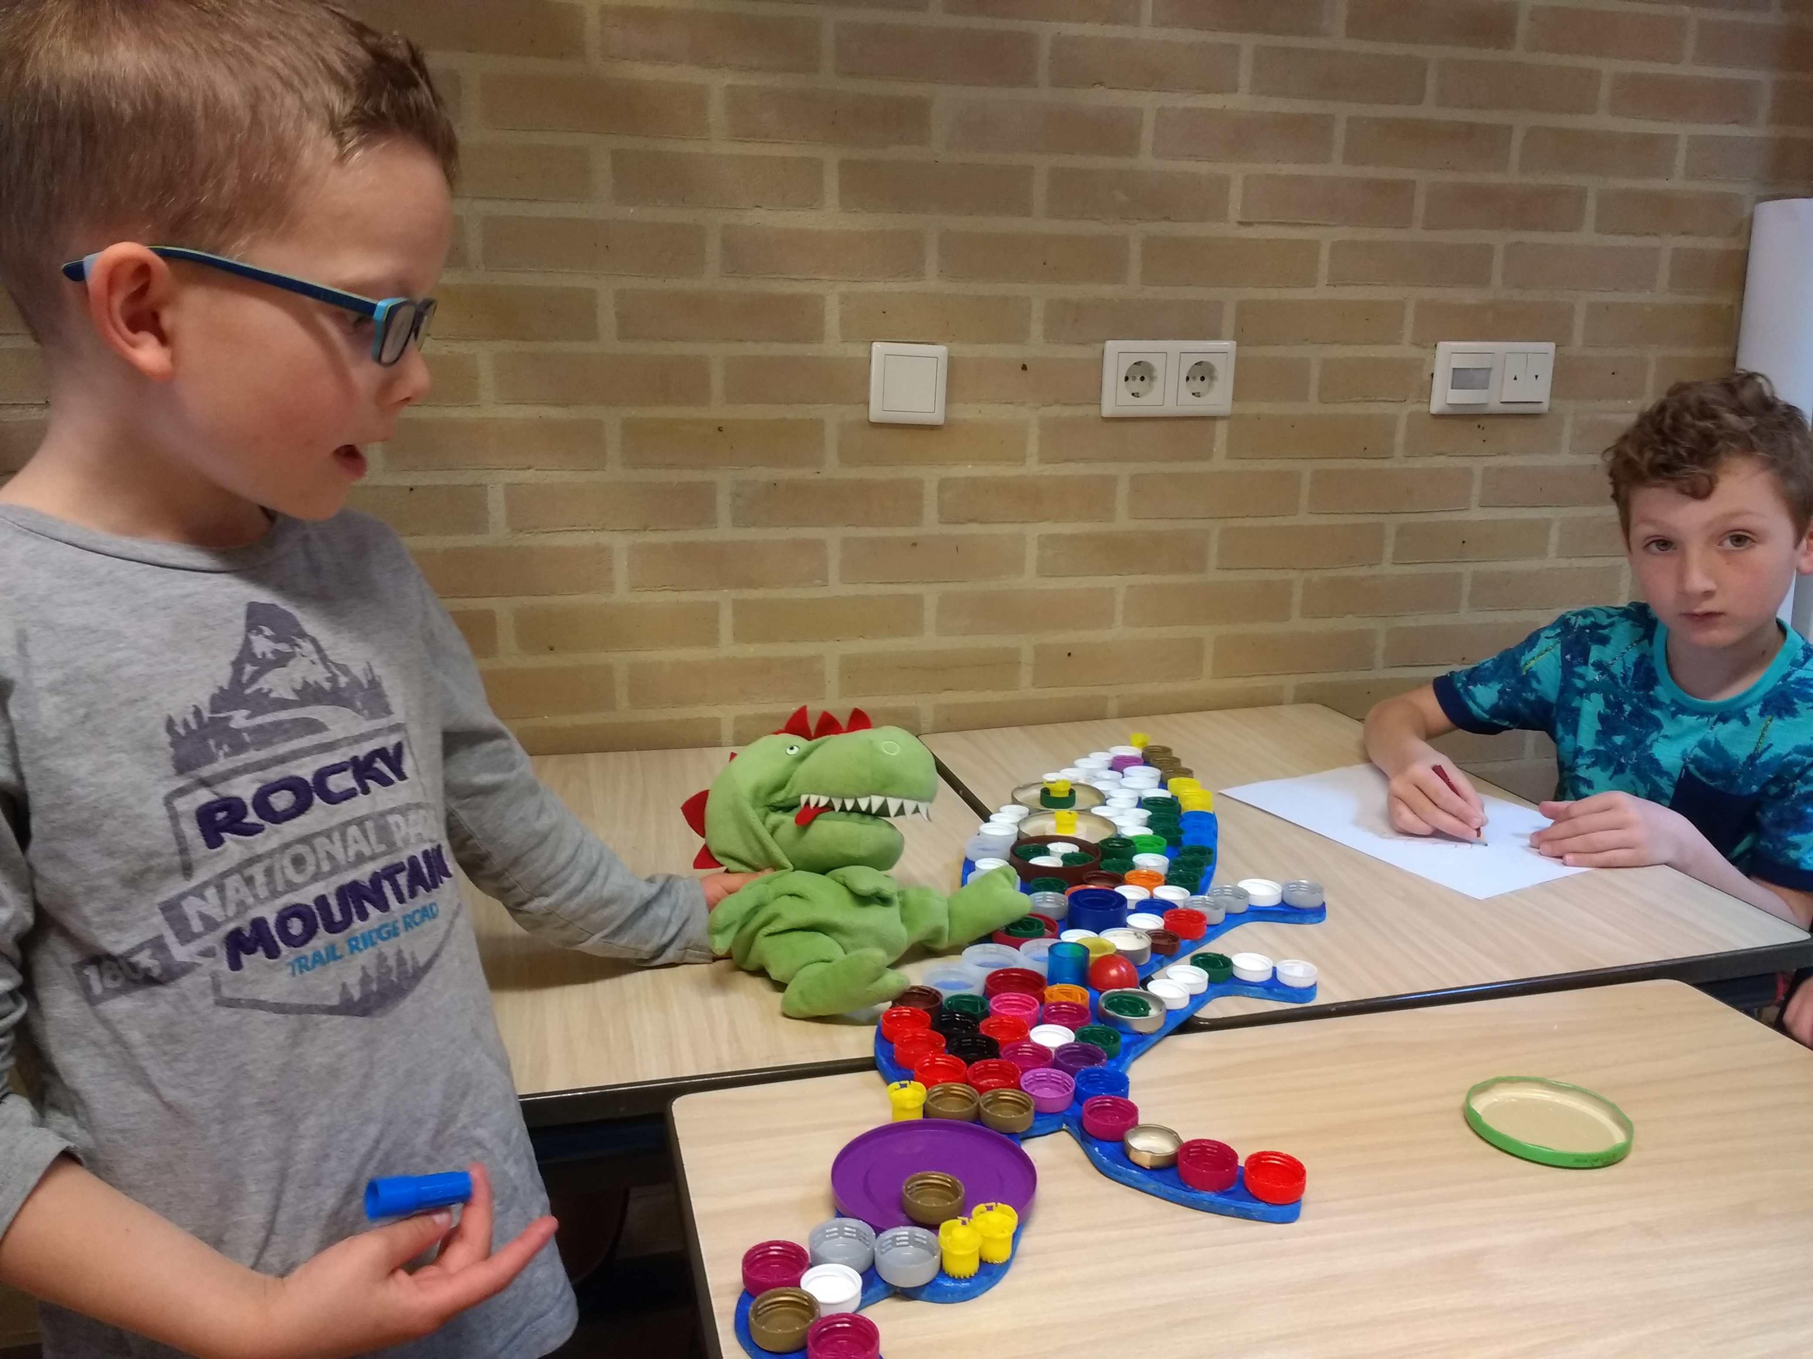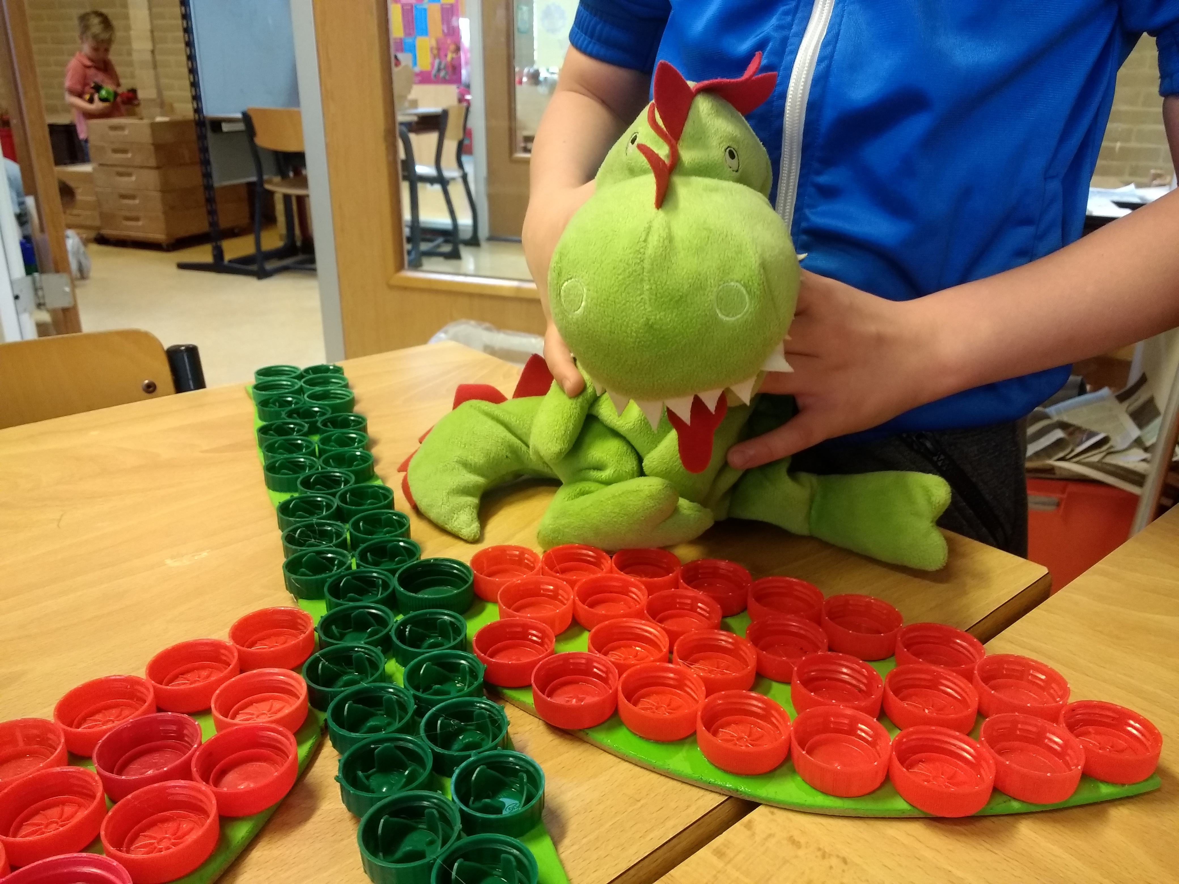

Making animals of caps and birdhouses.
Spanish ‘Puff’ is enjoying the children.

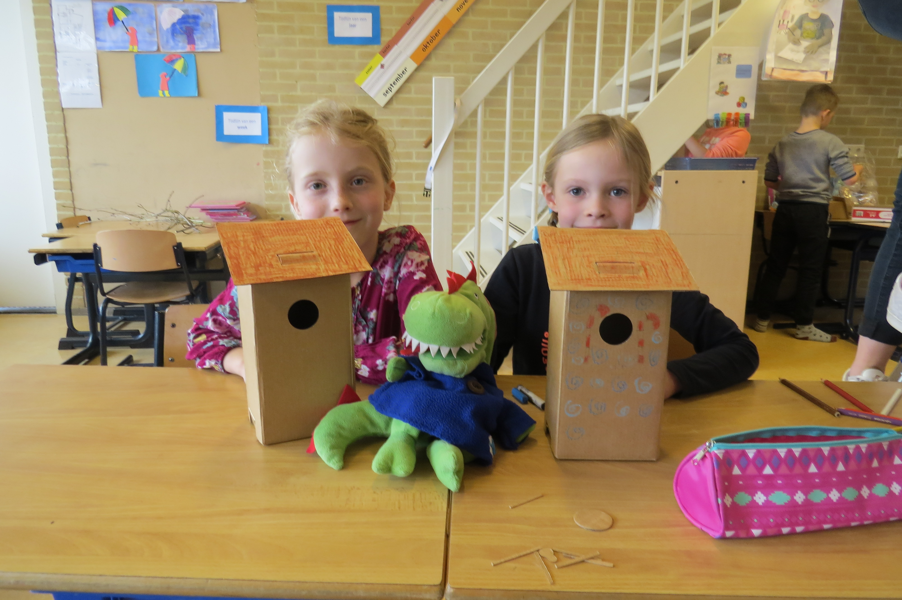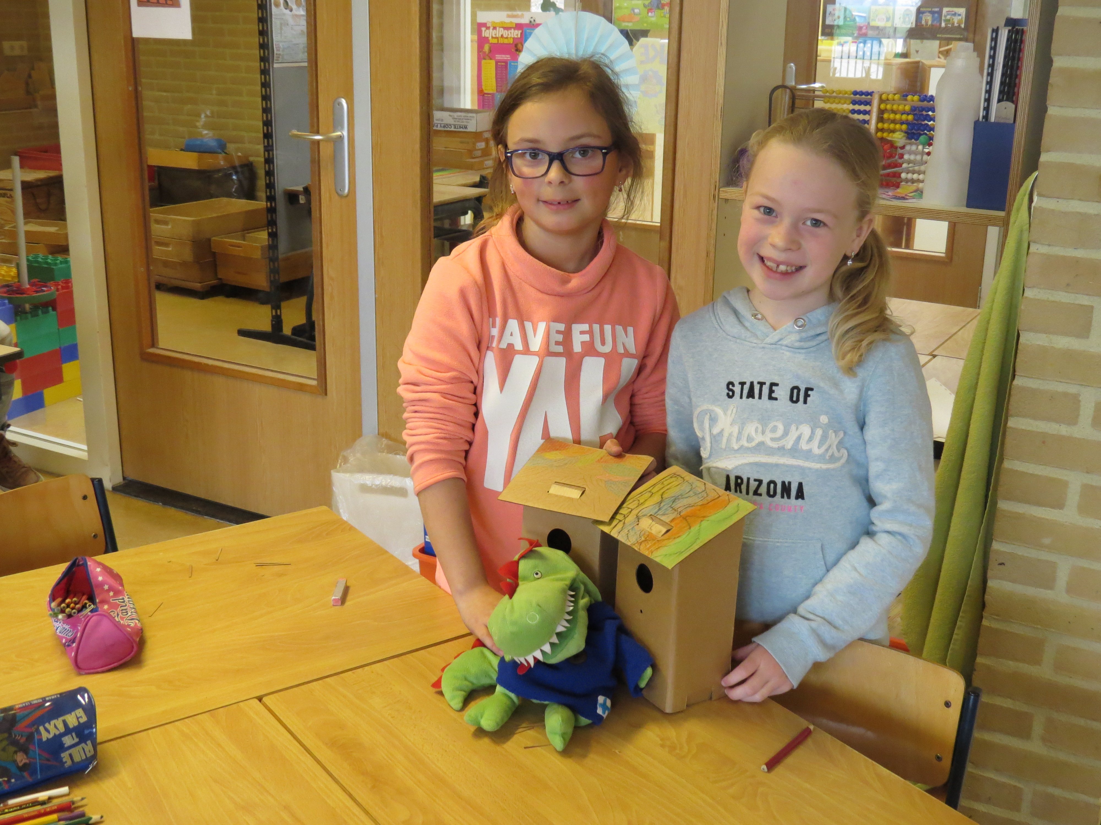

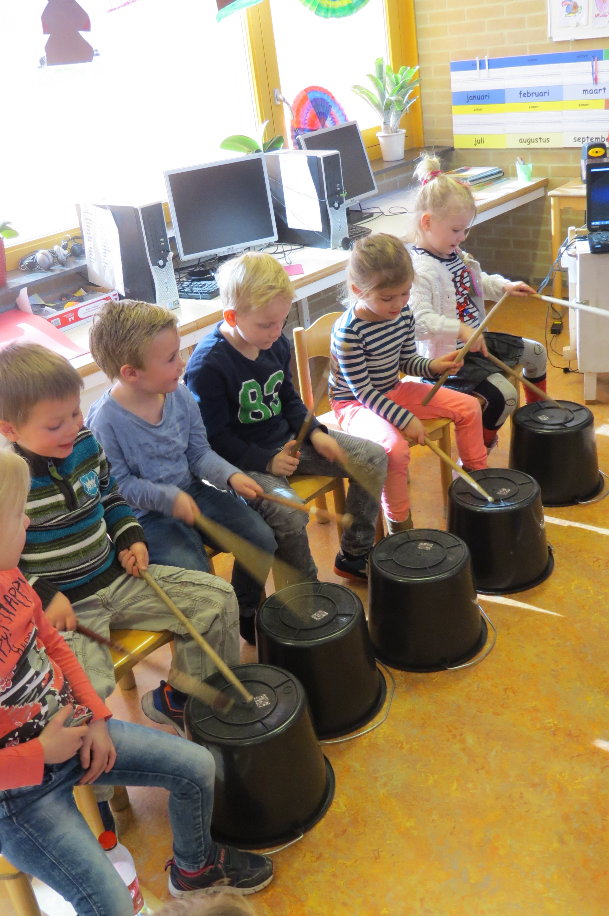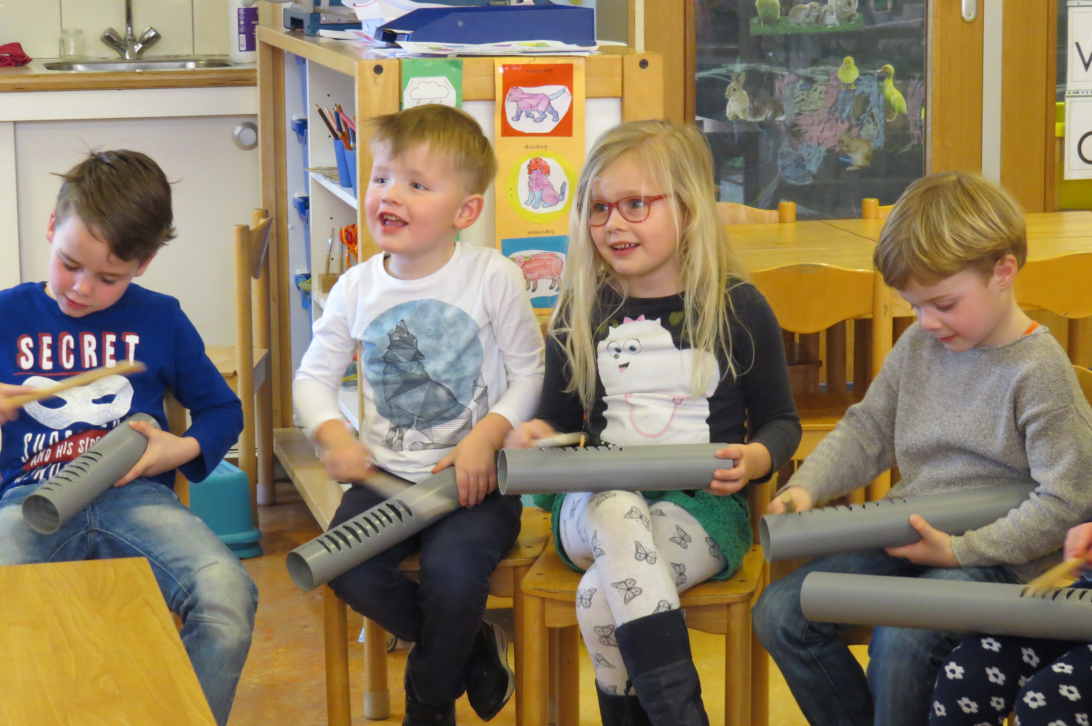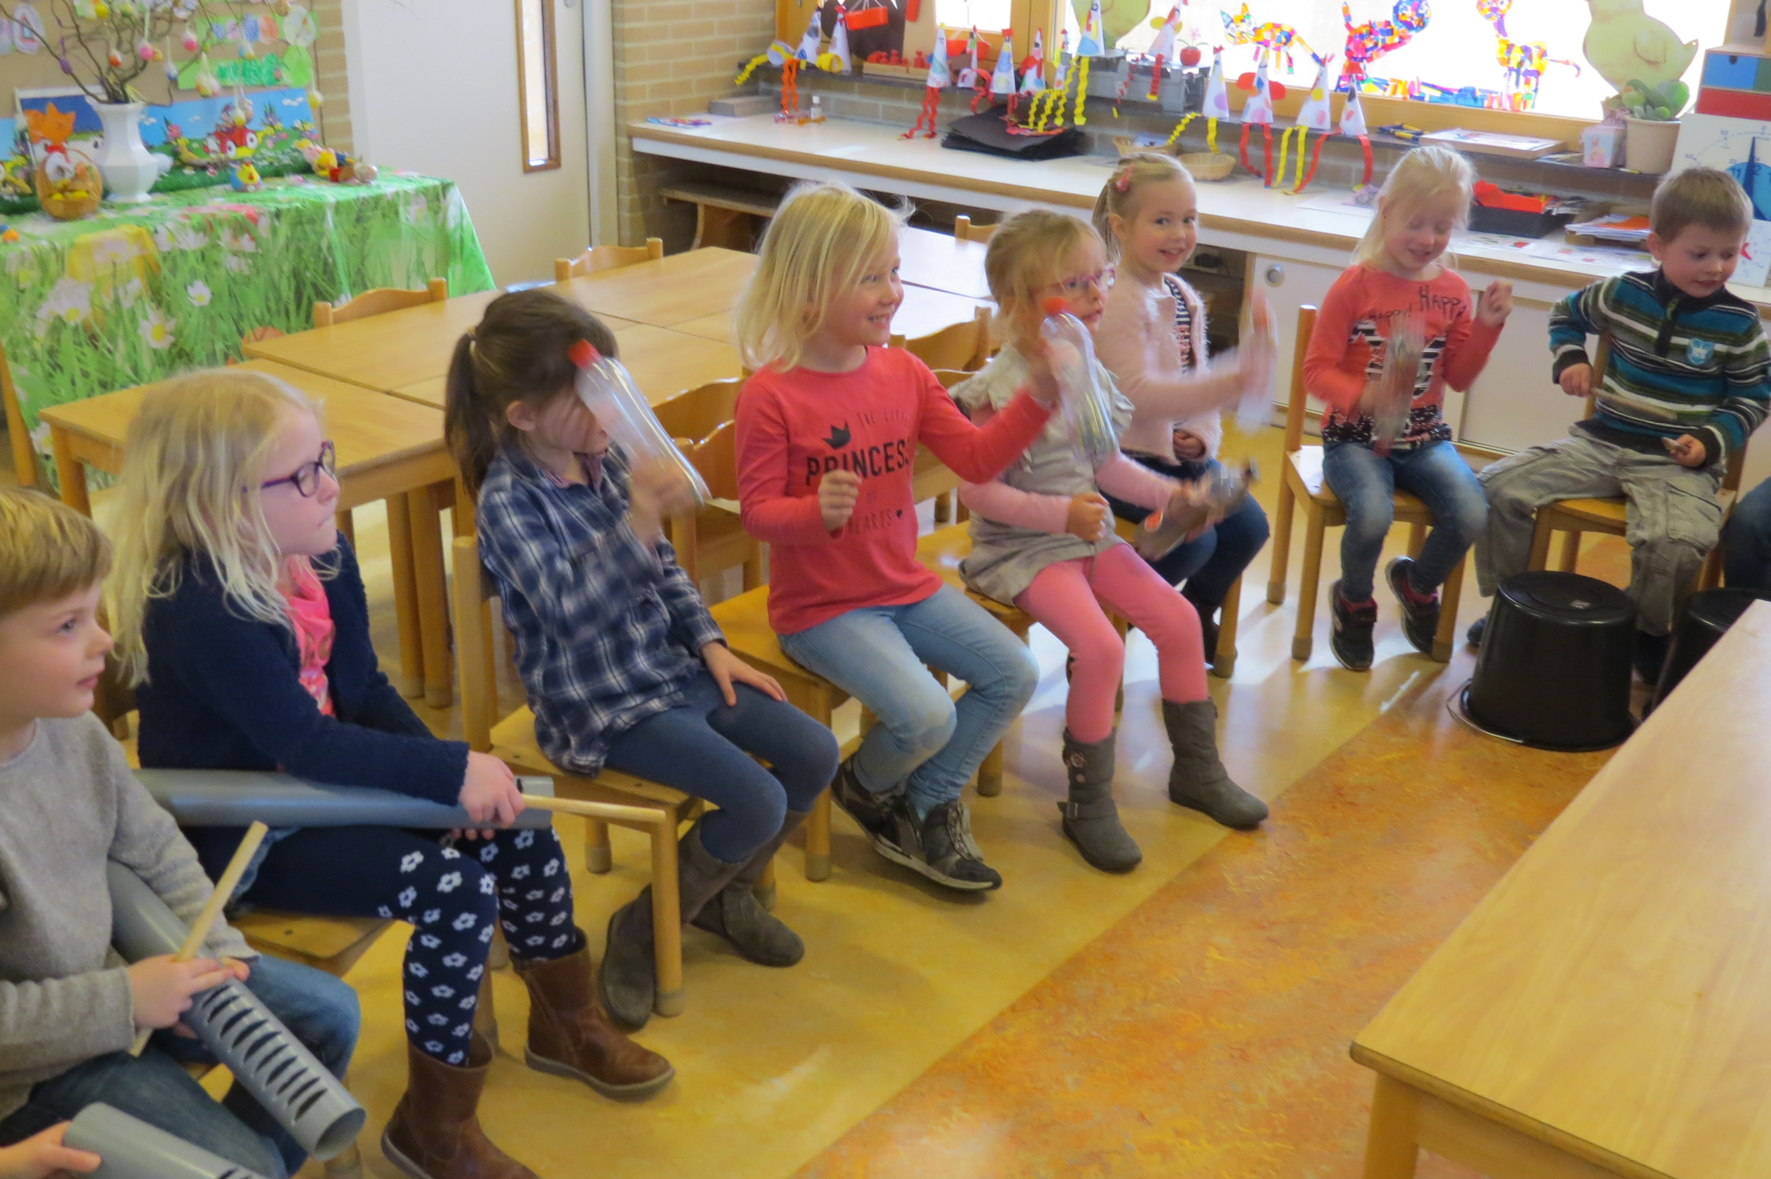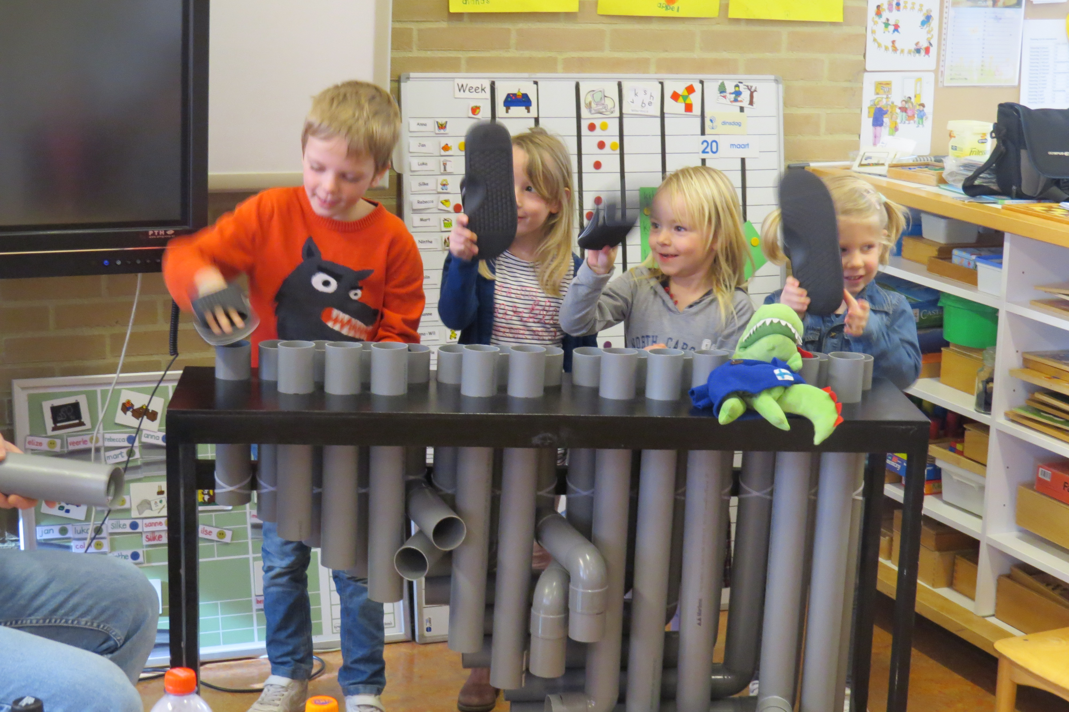

The children in the preschool made music with instruments made of waste

