Instructions
Continents of the World

-ing, -ed, -er and -est Fortune Teller

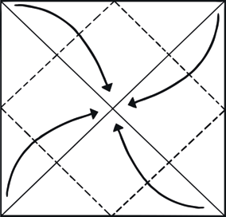
1
4

With pictures face down, fold on both diagonal lines. Unfold.
2
Fold all four corners to the centre.
Once again, fold all corners to the centre.
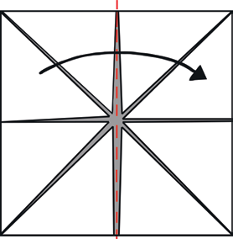
5
Fold paper in half and unfold.

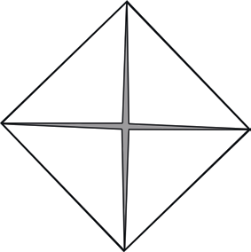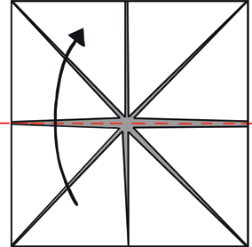
3
6


Turn paper over. Fold in half from top to bottom. Do not unfold.
7

Slide thumbs and forefingers under the squares and move the fortune teller back and forth to play.
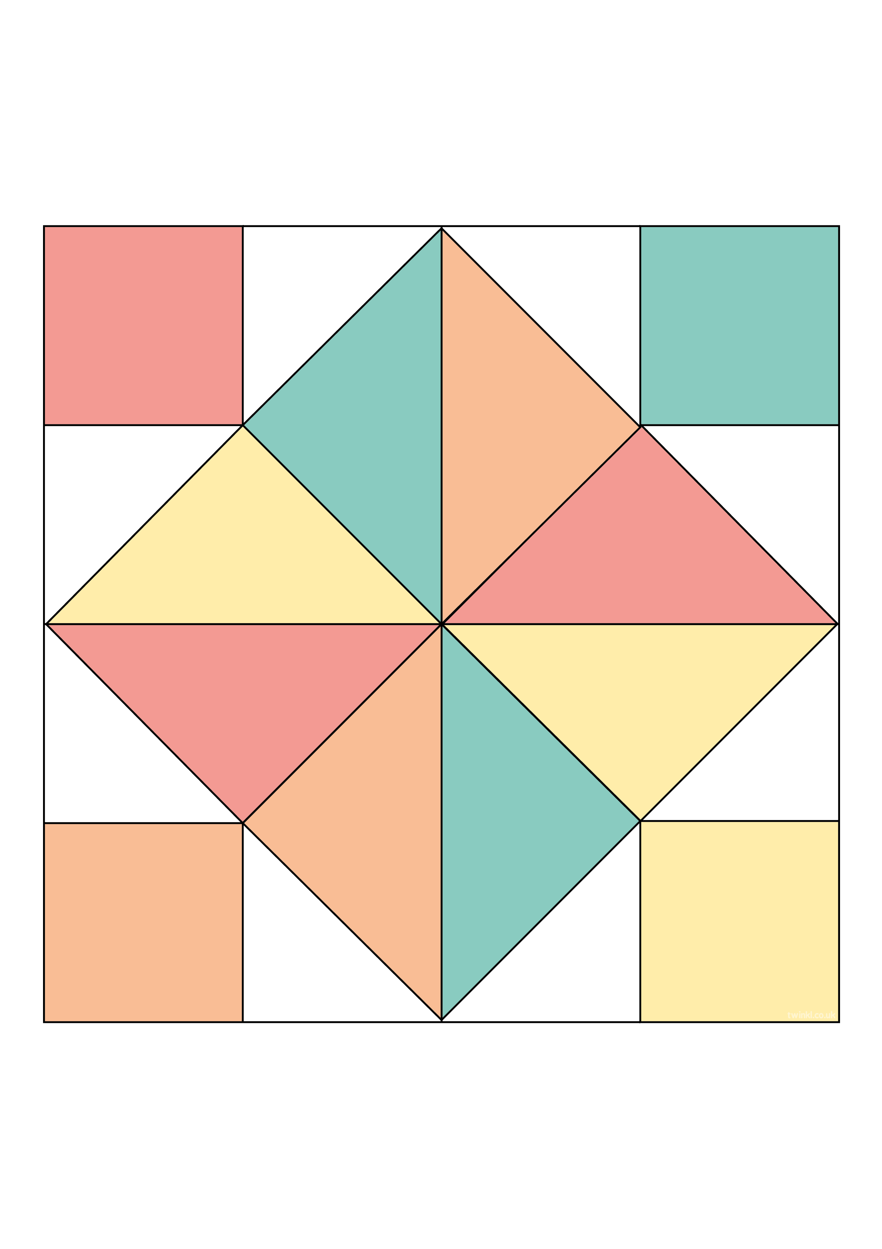
Are Australia,
New Zealand
and Fiji in?
Star
Challenge!
has no
countries?
are the
United Kingdom,
France and Italy in?
are the United
States of America,
Canada and Barbados in?
are Japan,
India and
China in?
are Brazil,
Argentina and Chile in?
are South Africa, Kenya and Egypt in?
Which continent…
Which continent…
Which continent…
Which continent…
Australasian/Oceania
Try naming
all the continents of the world!
Europe
Africa
Antarctica
Asia
South
America
North
America

