**Alcohol evaporation - Intermolecular Forces**

**Lab Summary**

Use a stainless steel temperature sensor and the Pasco Capstone software to determine the effects of molecular size and shape on the strength of intermolecular forces for different alcohols.

**Aim**

Determine the effects of molecular size and molecular shape on the strength of intermolecular forces by measuring and recording the evaporation temperature curves for different alcohols. You will use different alcohols within the same homologous series and two isomers of an alcohol.

**Materials used**

Temperature sensor with USB-link

Computer with Capstone software

Bottles with:

* Methanol
* Ethanol
* Propanol
* Pentanol
* 3-methyl-butan-1-ol

**Method**

1. Set up the hardware and the Capstone software as instructed
2. Alcohol 1:
   1. Place the thermo-sensor in the bottle with the chosen alcohol
   2. Start the measurement and wait until the temperature is stable
   3. Lift the thermo-sensor and keep it still in the air. At first the temperature decreases, record the temperature until the curve has started to rise again.
   4. Stop the recording, label and save your curve
3. Repeat this with all the given alcohols until you have measured all evaporation curves
4. How can you calculate the evaporation ***rate*** from your graphs? Calculate the initial evaporation rate for each alcohol.
5. Write an individual lab report according to the Lab report instructions and include:
6. The structural formula of all tested alcohols.
7. Explain why evaporation causes a decrease in temperature.
8. Describe the theoretical relationship between evaporation rate and the strength of intermolecular forces of attraction between molecules when you compare:
   1. … the size of molecules by comparing the straight-chain alcohols
   2. … the shape of molecules by comparing the two isomers

**Student’s evaluation:**

1. How did you contribute to the group’s work?
2. How did the other group members contribute to your task?
3. What have you learned from this task? Remember e.g. the use of the measuring equipment and software, data handling, calculations, theory, report writing, e.t.c.)
4. Which grade would you give yourself for the entire job?

|  |  |  |  |  |  |
| --- | --- | --- | --- | --- | --- |
|  | **I feel really insecure** | **... a little insecure** | **... quite secure** | **...really secure** | **Motivation** |
| I can set up the measuring equipment |  |  |  |  |  |
| I know how to use the software |  |  |  |  |  |
| I can follow instructions |  |  |  |  |  |
| I can perform the measurements |  |  |  |  |  |
| I can handle the data as needed |  |  |  |  |  |
| I can transform and handle the graph as needed |  |  |  |  |  |
| I understand and can do the needed calculations to get the answer to the research question |  |  |  |  |  |
| I understand and can do the needed uncertainty propagation calculations |  |  |  |  |  |
| I understand the theory behind this practical work. |  |  |  |  |  |

***Typical evaporation curves and teacher evaluation on next page:***

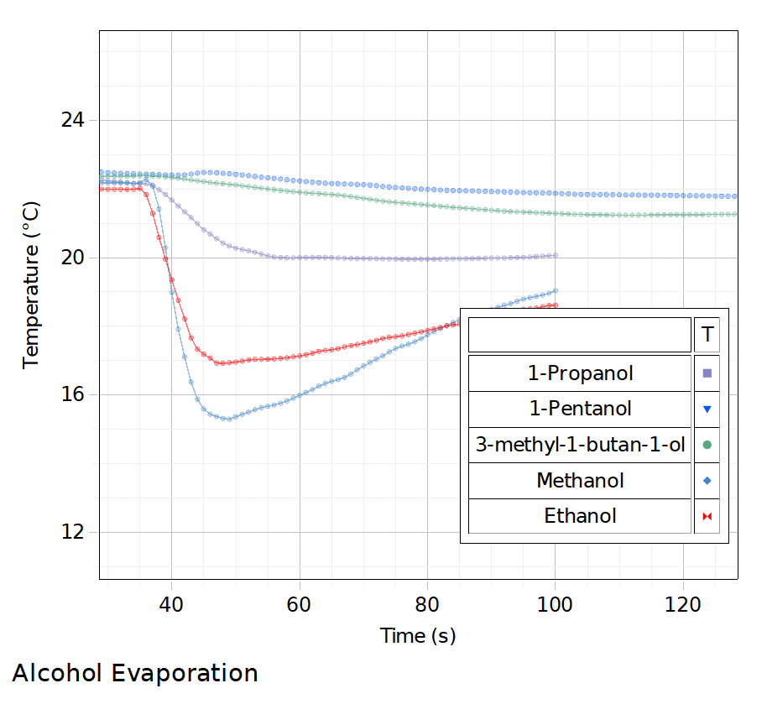

*Fig. 1: Typical evaporation curves for the alcohols in question*

**Teacher evaluation:**

1. The student’s engagement
2. The quality of the report according to given specifications
   1. Research question, variables
   2. Method description
   3. Raw data, quantitative including uncertainties as well as qualitative
   4. Data processing, graphs and calculations, including uncertainty propagation calculations
   5. Conclusion as well as justification of the conclusion based on the results
   6. Analysis of the result, including comparison with literature/tabulated value
   7. Evaluation of result and method, including strengths, suggestions for improvement as well as suggestions for extension of the investigation.
3. Has the student learned something?

These requirements are according to the IB practical work and report writing criteria, so the teacher must change the requirements according to what is realistic.