International workshop:

The goal of the workshop is to give you the experience of working together in an international team.
It is important that you as a team member participate with all your knowledge and a good spirit.

The Task for Monday:
The Task is to get a common international definition of what is a sustainable city:
To support that you need to find actual examples of sustainability from your hometown and Uppsala and Stockholm.
You may use your phone as a tool – make a list, save the result you will need them Friday.

The task for Friday:
The Team shall pitch a commercial Business idea that could improve the sustainability of a City. For that purpose, your team shall make a short pitch presentation based on the value proposition canvas, the presentation shall last 4-5 min.

1: Which customer segments are you targeting – and how do they feel?
2: What are the benefits?
3: What are the features?
4: What does it feel like to use your product?
5: An illustration of your product/service.

A LITTLE GUIDE TO UNDERSTANDING VALUE PROPOSITION CANVAS

the new product section of the canvas uses the widely accepted marketing syntax of features and benefits with the addition of a box for “experience” (taking from the fields of design thinking and UX architecture). The product understanding section includes:
- Features – A feature is a factual description of how your product works. The features are the functioning attributes of your product. The features also provide the ‘reasons to believe’. Many FMCG(fast moving consumer goods, example meat, candy) marketers deride the importance of features because features are no longer a point of difference in most FMCG marketing. But for technology products and innovative new services the features on offer can still be an important part of your value proposition.
- Benefits – A benefit is what your product does for the customer. The benefits are the ways that the features make your customer’s life easier by increasing pleasure or decreasing pain. The benefits of your product are the really core of your value proposition. The best way to list out the benefits of your product on the canvas is to imagine all the ways that your product makes your customer’s life better.
- Experience – The product experience is the way that owning your product makes the customer feel. It’s the sum total of the combined features and benefits. Product experience is different to features and benefits because it’s more about the emotional reasons why people buy your product and what it means for them in their own lives. The product experience is the kernel that will help identify the market positioning and brand essence that is usually built out of the value proposition.
The customer section draws on nuero-lingusitic programming and psychology research into motivation and choice architecture. It focuses less on “pains” and “gains” because people can be motivated by both pains and gains in different ways. The customer empathy sections include:
- Wants – The emotional drivers of decision making are things that we want to be, do or have. Our wants are usually conscious (but aspirational) thoughts about how we’d like to improve our lives. They sometimes seem like daydreams but they can be powerful motivators of action. The wants speak more to the pull of our hearts and our emotions. I may need a car to get from A to B, but I want a BMW.
- Needs – The customer’s needs are the rational things that the customer needs to get done. Interestingly, needs are not always conscious. Customers can have needs that they may not know about yet. Designers call these “latent needs“. The best example is that none of us knew that we needed a portable music player until we saw an iPod for the first time (we also then suddenly wanted an iPod rather than any other perfectly good music player). The needs speak more to the pull of our heads and rational motivations.
- Fears – The dark side of making a decision is that it often carries a fear of giving up optionality. Fear of making a mistake, fear of missing out, fear of loss and dozens of other related fears. Fears can be a strong driver of purchasing behaviour and can be the hidden source of wants and needs. Customer fears are often the secret reason that no one is buying your widget. For any product there is a secret “pain of switching“. Even if your product is better than the competition, it might not be a big enough improvement to overcome the inertia of the status quo.
- Substitutes – Some companies claim that they have no direct competitors. The substitutes on the canvas aren’t just the obvious competitors, instead look for the existing behaviours and coping mechanisms. This is on the canvas because it shocks us into remembering that our customers are real people with daily lives who have made it this far in life without our product. No matter how much better your product is than the competition, if it isn’t better than the existing solutions then you don’t have a real-world value proposition.
A key finding from the process of mapping a value proposition is often “we don’t have enough information to answer this section”. That is a perfect moment to adopt a lean startup approach and to get out of the building to ask existing customers and potential customers about their wants, needs and fears. A value proposition canvas can be a great place to begin the process of identifying and validating your assumptions.

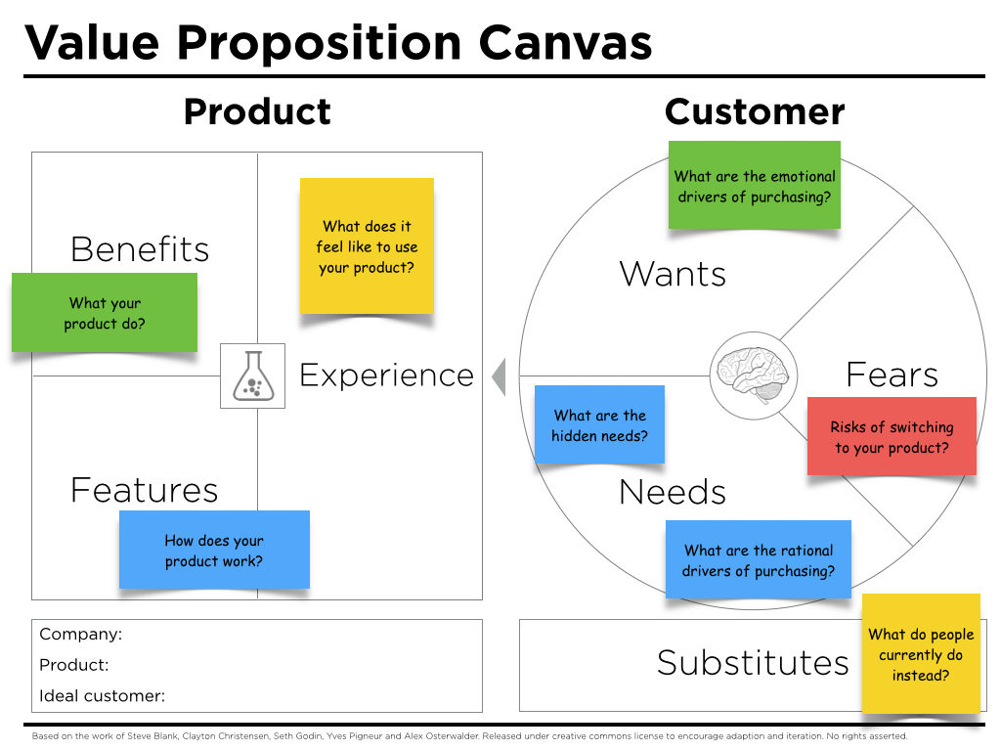

Example questions to help create a Value Proposition Canvas:
1. How does your product work?
2. What does your product do for your customers?
3. What does it feel like to use your product?
4. What are the rational drivers of purchasing?
5. What are the emotional drivers of purchasing?
6. What are your customers hidden needs?
7. What do people currently do instead?

