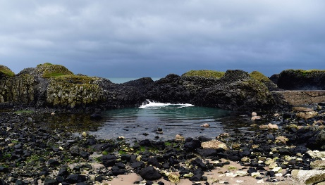
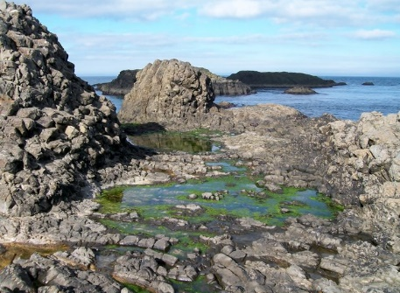
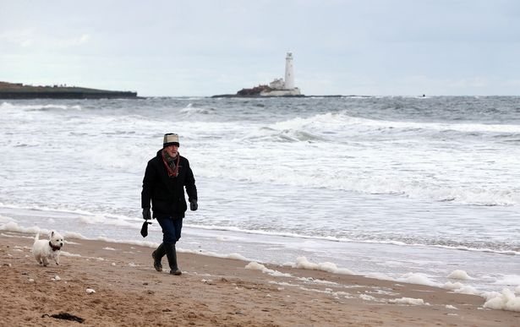
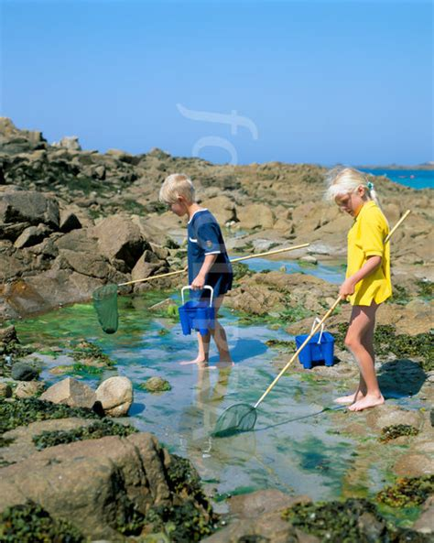
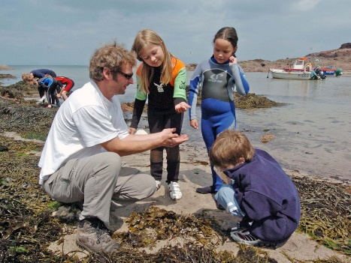
ROCK POOLS
Rock pools are like mini ponds. HOW ROCK POOLS ARE MADE: rock pools are made by washed up water and the fish get washed up too.
There are lots of rock pools in the Ireland due to the floods!
People fish in rock pools for food and for fun. Children have little nets and spends hours fishing for crabs and little fish. This is a common activity at the beach.
It is very cold in the sea in Northern Ireland when you are at the beach so many children prefer to wear a wetsuit
The sea can be different colours .

