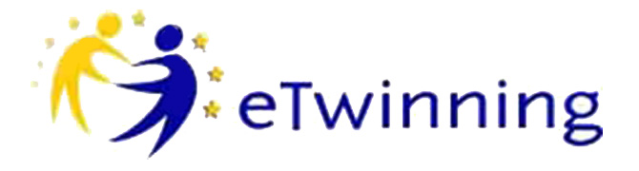
Planning your project with your partner(s)

Partners

Age of pupils/students involved
Number of students altogether
School subjects

Language(s) used in the project

Project duration and timeline
(hours per week / per month)

Title of the project
Brief description of the project
Aims (learning objectives and skills to be developed)

Work process (how responsibilities are shared and calendar of activities)
Expected results (final products, actions, changes in school culture)

Topics that you need to discuss:

Communication between the teachers (tools and methods)
Collaboration between students – (how will they work together?)
Digital tools used
Evaluation
Dissemination

