[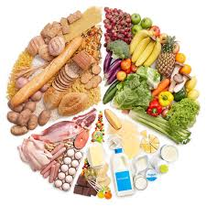](https://www.google.co.uk/url?sa=i&rct=j&q=&esrc=s&source=images&cd=&cad=rja&uact=8&ved=0ahUKEwio5OyEmvrXAhXhL8AKHeJ-ChcQjRwIBw&url=https://www.sunriseseniorliving.com/blog/march-2015/5-diseases-nutrition-can-help-prevent.aspx&psig=AOvVaw33GkM5Khn5FSjHviwf8LgM&ust=1512815218357046)[](http://www.google.co.uk/url?sa=i&rct=j&q=&esrc=s&source=images&cd=&cad=rja&uact=8&ved=0ahUKEwiLwJ2LlvrXAhUGIMAKHQLKBHwQjRwIBw&url=http://www.limerickleader.ie/news/sport/243326/limerick-minor-hurling-team-to-face-tipp-named.html&psig=AOvVaw0mftKGsd1Izn4g9Q14swgW&ust=1512814163383424)

[](https://www.google.co.uk/url?sa=i&rct=j&q=&esrc=s&source=images&cd=&cad=rja&uact=8&ved=0ahUKEwj_693vlvrXAhWBIcAKHZCpDP4QjRwIBw&url=https://www.irishtimes.com/sport/gaelic-games/gaelic-football-continues-to-lose-its-lustre-1.2297689&psig=AOvVaw2SY2XCGBZD5lzxiXqzOrWO&ust=1512814337758705)Healthy

eating

Healthy

Living

[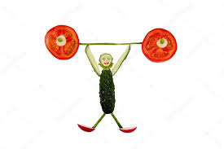](https://www.google.co.uk/url?sa=i&rct=j&q=&esrc=s&source=images&cd=&cad=rja&uact=8&ved=&url=https%3A%2F%2Fdepositphotos.com%2F45500399%2Fstock-photo-healthy-eating-funny-little-man.html&psig=AOvVaw0AKqMglkGAqRYlLZiycU2m&ust=1512818632767900)

[](https://www.google.co.uk/url?sa=i&rct=j&q=&esrc=s&source=images&cd=&cad=rja&uact=8&ved=0ahUKEwiWytnvqfrXAhXsC8AKHX_2DtsQjRwIBw&url=https%3A%2F%2Fwww.pinterest.co.uk%2Fpin%2F448671181597797513%2F&psig=AOvVaw1qDzMQ_BPBOf73q3QbEgd7&ust=1512819462189111)

Healthy eating is good for you like my strawberry