Pupils’ Breakfast Dietary Habits Questionnaire
- Target Group: 5th and 6th grades
- Groups: E_{1,}E_{2,} ST_{1,}ST₂
- Age : 10-11 years old
- Responses: 60
- Sch.year: 2017-2018
- Time: 1st week of November 2017

Time for breakfast kids! What are your breakfast habits?
- Do you have breakfast every day?
- Yes > 40
- No > 20
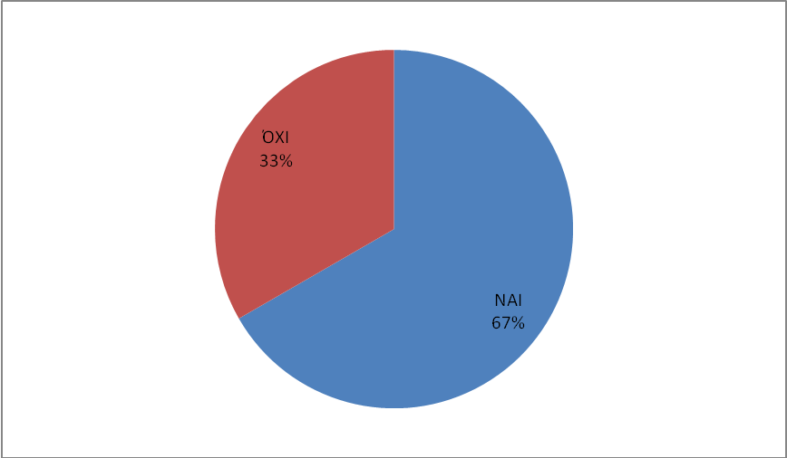

2. What do you usually drink for breakfast?
- Milk > 46
- Chocolate milk > 28
- Juice > 24
- Water > 41
- Tea > 6
- Nothing > 7
- Other > 3

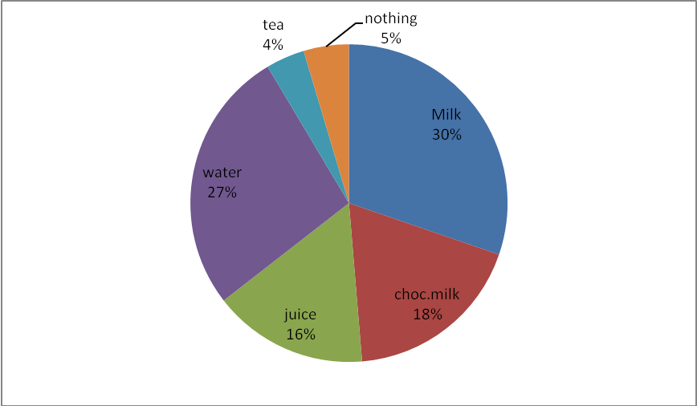

- What do you usually eat for breakfast?

- Bread & butter >33
- Cookies >32
- Rusks >13
- Fresh croissants >12
- Cereals >35
- Yoghurt > 9
- Eggs >15
- Honey >24
- Jam >14
- Cheese >15
- Fresh fruit >21

- Homemade cakes >23
- Other >10
- Nothing > 3

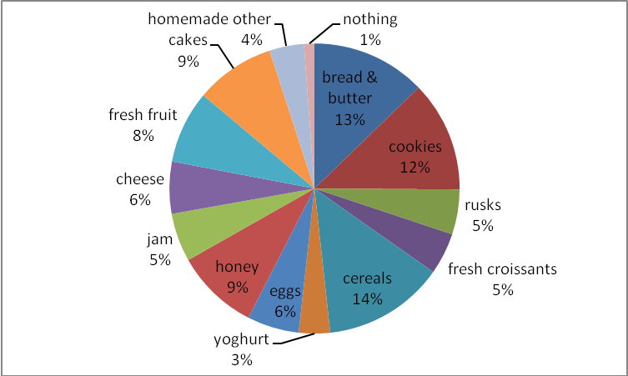

- What do you usually have during the school break?
The answers here varied from child to child
The most common answers were:
- a cheese pie or a toast with turkey ham and cheese
- a bar of chocolate or a cereal bar
- a sandwich with cheese and tomato or lettuce
- chocolate milk, fruit juice, water and biscuits
- fresh orange juice and sesame buns “koulouri” from the school canteen
- a piece of pizza or a piece of cake and croissants
- fruit like a banana or an apple

Comments: What is common for all the pupils is that almost all of them have a snack during the school breaks either buying it at the school canteen or bringing it from home.

- How do you feel during the first part of the school day if you have breakfast in the morning?

- Good / Happy >56

- How do you feel during the first part of the school day if you don’t have breakfast?
- Bad/Tired/Sad >52

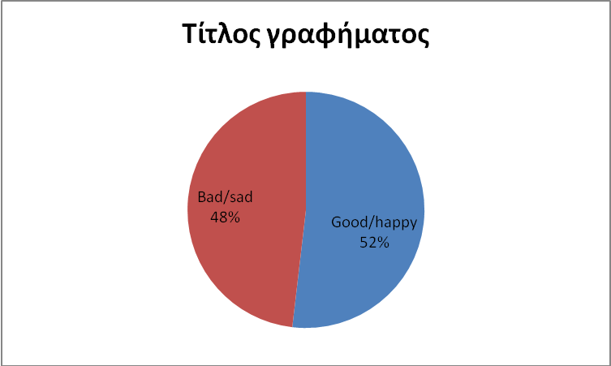

Comments: Some of the pupils here have said that it doesn’t make any difference to them either way, if they have breakfast or not.

- We picked up some nice replies here:

When I have breakfast …

I feel very good I am not hungry I feel full of energy
I want to sleep again?!! I feel happy
My mind is clear and I want to play!!!
I feel more concentrated during the lesson I feel cleverer!

When I don’t have breakfast….

I feel bored I feel tired I can’t pay attention in class
I am hungry I feel restless
I am looking forward to the first break to have a snack!

- We also asked those pupils who don’t have breakfast every day to justify their choice and the most common replies were:
“I get up late because I go to bed late”
“I want to stay in bed more”
“I haven’t got time for breakfast”
“Nobody is at home to prepare it for me”
- At the end of this survey we asked the target group if they would like to start the day having breakfast with their family.
The answer was “Yes! “ A unanimous Yes!

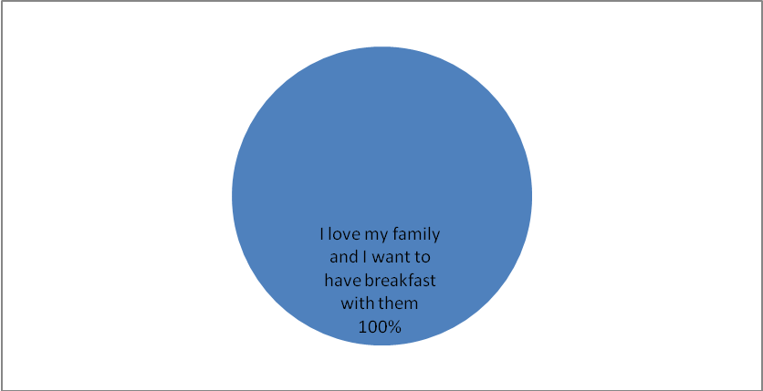
The 3rd Primary School, Ag. Anargyri Athens, Greece

