[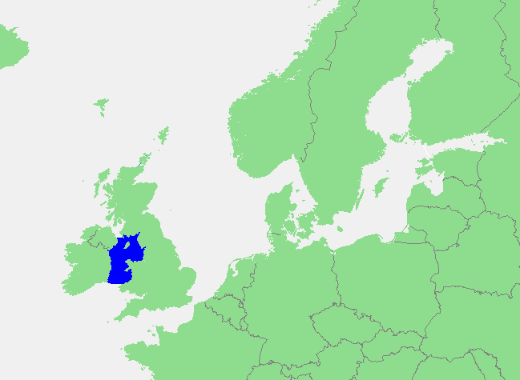](https://kids.kiddle.co/images/2/2d/Locatie_Ierse_Zee.PNG)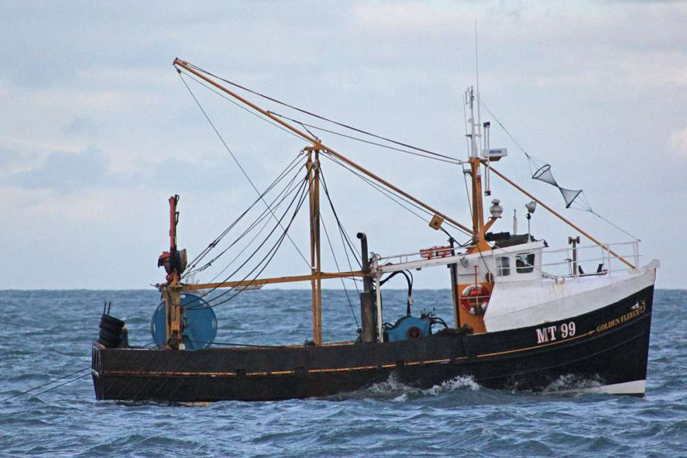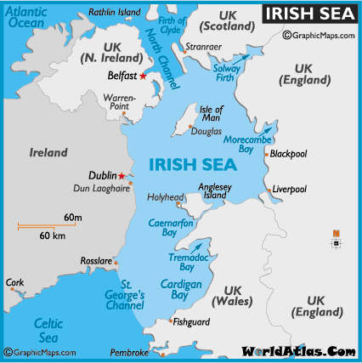

**Irish Sea**

Northern Ireland and Wales have a middle part called Isle of Man. The **Irish Sea** is a body of water that separates Ireland and Great Britain. Annual traffic between Great Britain and Ireland amounts to over 12 million passengers and 17 million tons 17,000,000 long tons 19,000,000 short tons of traded goods. The Irish sea covers 17,374 square miles and at its deepest point is 300 meters (980 ft.) deep. In 2008, about 38 million tons of fish were caught. Shell fish made up three quarters of this amount. The Blue in the picture below is where the Irish sea is. Britain