Wetsuits&Drysuits

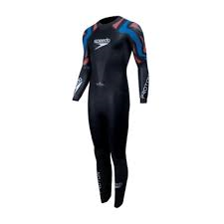

We need to wear wetsuits in Northern Ireland due to the cold sea. When the sea is cold we need to wear wetsuits so we don’t get cold, they also keep us warm and let us swim without feeling cold.

Fun Fact:

The highest wave in Northern Ireland was 20.4 meters high!

21 mph

**Humidity**

81%

ct:

Fun Fact 2: The first low tide at Portrush comes in at 04:31 am in the morning!

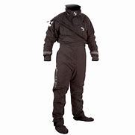Drysuits

Drysuits help when you’ve only come out of the sea, instead of drying yourself with a towel, you put on the drysuit and it absorbs water to help you dry quickly.